**Salman Ahmed Khan**

**19K-1043**

**SCD Lab 1**

**Q1**

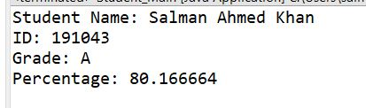

**Student.java**

**package** com.fast;

**public** **class** Task1_Student {

// Variables

**private** String student_name;

**private** **int** student_id;

**private** String stu_Department;

**private** String []subjects;

**private** **float** []obt_marks;

**private** **float** total_marks;

// Methods

Task1_Student()

{

setStudent_name("");

setStu_Department("");

setObt_marks(**new** **float**[6]);

setSubjects(**new** String[6]);

setTotal_marks(600);

setStudent_id(0);

}

**public** String getStudent_name() {

**return** student_name;

}

**public** **void** setStudent_name(String student_name) {

**this**.student_name = student_name;

}

**public** **int** getStudent_id() {

**return** student_id;

}

**public** **void** setStudent_id(**int** student_id) {

**this**.student_id = student_id;

}

**public** String getStu_Department() {

**return** stu_Department;

}

**public** **void** setStu_Department(String stu_Department) {

**this**.stu_Department = stu_Department;

}

**public** String [] getSubjects() {

**return** subjects;

}

**public** **void** setSubjects(String [] subjects) {

**this**.subjects = subjects;

}

**public** **float** [] getObt_marks() {

**return** obt_marks;

}

**public** **void** setObt_marks(**float** [] obt_marks) {

**this**.obt_marks = obt_marks;

}

**public** **float** getTotal_marks() {

**return** total_marks;

}

**public** **void** setTotal_marks(**float** total_marks) {

**this**.total_marks = total_marks;

}

**public** **void** Print_Data()

{

System.***out***.println("Student Name: " + **this**.student_name + "\nID: " + **this**.student_id);

**float** sum = 0;

**for** (**int** i=0; i < 6; i++)

{

sum += obt_marks[i];

}

**float** percentage = (sum / **this**.total_marks) * 100;

**if** (percentage >= 80)

{

System.***out***.println("Grade: A\nPercentage: " + percentage);

}

**else** **if** (percentage >= 60 && percentage < 80)

{

System.***out***.println("Grade: B\nPercentage: " + percentage);

}

**else**

{

System.***out***.println("Grade: C\nPercentage: " + percentage);

}

}

}

**StudentMain.java**

**package** com.fast;

**public** **class** Student_Main {

**public** **static** **void** main(String[] args) {

// **TODO** Auto-generated method stub

Task1_Student student_1 = **new** Task1_Student();

student_1.setStudent_id(191043);

student_1.setStudent_name("Salman Ahmed Khan");

student_1.setStu_Department("Software Engineering");

String []subj = {"SE", "CS", "DevOps", "WebEng", "Prob", "Programming"};

**float** []marks = {89, 59, 77, 90, 78, 88};

student_1.setSubjects(subj);

student_1.setObt_marks(marks);

student_1.Print_Data();

}

}

**Q2**

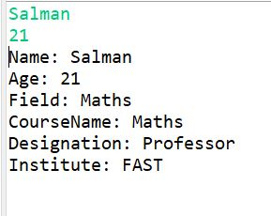

**Teacher.java**

**package** com.fast;

**public** **abstract** **class** Task2_Teacher {

**private** String Name;

**private** **int** age;

**private** String Institute;

**public** String getName() {

**return** Name;

}

**public** **void** setName(String name) {

Name = name;

}

**public** **int** getAge() {

**return** age;

}

**public** **void** setAge(**int** age) {

**this**.age = age;

}

**public** String getInstitute() {

**return** Institute;

}

**public** **void** setInstitute(String institute) {

Institute = institute;

}

}

**ScienceTeacher.java**

**package** com.fast;

**public** **class** Task2_ScienceTeacher **extends** Task2_Teacher {

**private** **final** String Field = "Science";

**private** String CourseName, Designation;

**public** String getField() {

**return** Field;

}

**public** String getDesignation() {

**return** Designation;

}

**public** **void** setDesignation(String designation) {

Designation = designation;

}

**public** String getCourseName() {

**return** CourseName;

}

**public** **void** setCourseName(String courseName) {

CourseName = courseName;

}

}

**HumanitiesTeacher.java**

**package** com.fast;

**public** **class** Task2_HumanitiesTeacher **extends** Task2_Teacher {

**private** **final** String Field = "Humanities";

**private** String CourseName, Designation;

**public** String getField() {

**return** Field;

}

**public** String getDesignation() {

**return** Designation;

}

**public** **void** setDesignation(String designation) {

Designation = designation;

}

**public** String getCourseName() {

**return** CourseName;

}

**public** **void** setCourseName(String courseName) {

CourseName = courseName;

}

}

**MathsTeacher.java**

**package** com.fast;

**public** **class** Task2_MathsTeacher **extends** Task2_Teacher{

**private** **final** String Field = "Maths";

**private** String CourseName, Designation;

**public** String getField() {

**return** Field;

}

**public** String getDesignation() {

**return** Designation;

}

**public** **void** setDesignation(String designation) {

Designation = designation;

}

**public** String getCourseName() {

**return** CourseName;

}

**public** **void** setCourseName(String courseName) {

CourseName = courseName;

}

}

**Main.java**

**package** com.fast;

**import** java.util.Scanner;

**public** **class** Task2_Main {

**public** **static** **void** main(String[] args) {

// **TODO** Auto-generated method stub

Scanner src = **new** Scanner(System.***in***);

Task2_MathsTeacher teacher = **new** Task2_MathsTeacher();

String name = src.nextLine();

**int** age = src.nextInt();

teacher.setName(name);

teacher.setAge(age);

teacher.setCourseName("Maths");

teacher.setDesignation("Professor");

teacher.setInstitute("FAST");

System.***out***.println("Name: " + teacher.getName() + "\nAge: " + teacher.getAge() + "\nField: " + teacher.getField() +

"\nCourseName: " + teacher.getCourseName() + "\nDesignation: " + teacher.getDesignation() + "\nInstitute: " + teacher.getInstitute());

}

}

**Q3**

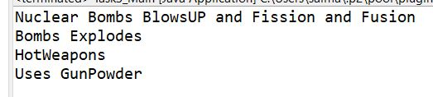

**Weapons.java**

**package** com.fast;

**interface** Task3_Weapons {

**void** WeaponName();

}

**HotWeapons.java**

**package** com.fast;

**public** **class** Task3_HotWeapons **implements** Task3_Weapons{

**public** **void** WeaponName() {

System.***out***.println("HotWeapons");

}

**public** **void** HotWeapons_Description() {

WeaponName();

System.***out***.println("Uses GunPowder");

}

}

**Bombs.java**

**package** com.fast;

**public** **class** Task3_Bombs **extends** Task3_HotWeapons{

**public** **void** Bombs_Description()

{

System.***out***.println("Bombs Explodes");

HotWeapons_Description();

}

}

**NuclearBombs.java**

**package** com.fast;

**public** **class** Task3_NuclearBombs **extends** Task3_Bombs{

**public** **void** NuclearBombs_Description()

{

System.***out***.println("Nuclear Bombs BlowsUP and Fission and Fusion");

Bombs_Description();

}

}

**Main.java**

**package** com.fast;

**public** **class** Task3_Main {

**public** **static** **void** main(String []args)

{

Task3_NuclearBombs nuclearBomb = **new** Task3_NuclearBombs();

nuclearBomb.NuclearBombs_Description();

}

}

**Q4**

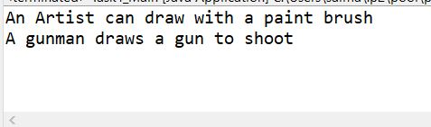

**Person.java**

**package** com.fast;

**public** **abstract** **class** Task4_Person {

**private** String Name, occupation;

**public** Task4_Person(String name, String occu)

{

**this**.Name = name;

**this**.occupation = occu;

}

**public** String getName() {

**return** Name;

}

**public** String getOccupation() {

**return** occupation;

}

**public** **void** Draw()

{

System.***out***.println("A person can draw in many ways");

}

}

**Artist.java**

**package** com.fast;

**public** **class** Task4_Artist **extends** Task4_Person{

**public** Task4_Artist() {

// **TODO** Auto-generated constructor stub

**super**("Salman", "Artist");

}

**public** **void** Draw() {

System.***out***.println("An Artist can draw with a paint brush");

}

}

**Gunman.java**

**package** com.fast;

**public** **class** Task4_Gunman **extends** Task4_Person{

**public** Task4_Gunman() {

// **TODO** Auto-generated constructor stub

**super**("Salman", "Gunman");

}

**public** **void** Draw() {

System.***out***.println("A gunman draws a gun to shoot");

}

}

**Main.java**

**package** com.fast;

**public** **class** Task4_Main {

**public** **static** **void** main(String[] args) {

// **TODO** Auto-generated method stub

Task4_Artist artist = **new** Task4_Artist();

artist.Draw();

Task4_Gunman gunman = **new** Task4_Gunman();

gunman.Draw();

}

}