**Salman Ahmed Khan**

**19K-1043**

**SCD Lab 2**

**Q1**

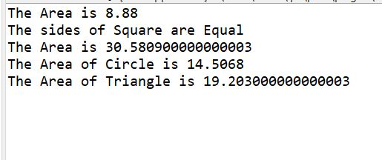

**IShape.java**

**package** com.fast;

**public** **interface** ShapeQ1 {

**public** **abstract** **void** generateArea();

}

**Rectangle.java**

**package** com.fast;

**public** **class** RectangleQ1 **implements** ShapeQ1{

**private** **double** length, width;

RectangleQ1(**double** l, **double** w)

{

**this**.setLength(l);

**this**.setWidth(w);

}

**public** **void** generateArea()

{

**double** resultArea = length * width;

System.***out***.println("The Area is " + resultArea);

}

**public** **double** getLength() {

**return** length;

}

**public** **void** setLength(**double** length) {

**this**.length = length;

}

**public** **double** getWidth() {

**return** width;

}

**public** **void** setWidth(**double** width) {

**this**.width = width;

}

}

**Square.java**

**package** com.fast;

**public** **class** SquareQ1 **extends** RectangleQ1{

SquareQ1(**double** sideLength)

{

**super**(sideLength, sideLength);

}

**public** **void** checkSides()

{

**if**(getLength() == getWidth())

{

System.***out***.println("The sides of Square are Equal");

}

**else**

{

System.***out***.println("The sides of Square are not Equal");

}

}

}

**Circle.java**

**package** com.fast;

**public** **class** CircleQ1 **implements** ShapeQ1{

**private** **double** radius;

CircleQ1(**double** r)

{

**this**.radius = r;

}

**public** **void** generateArea()

{

**double** resultArea = (2 * 3.14 * **this**.radius);

System.***out***.println("The Area of Circle is " + resultArea);

}

**public** **double** getRadius() {

**return** radius;

}

**public** **void** setRadius(**double** radius) {

**this**.radius = radius;

}

}

**Triangle.java**

**package** com.fast;

**public** **class** TriangleQ1 **implements** ShapeQ1{

**private** **double** height, base;

TriangleQ1(**double** h, **double** b)

{

**this**.setHeight(h);

**this**.setBase(b);

}

**public** **void** generateArea()

{

**double** resultArea = ((**this**.height * **this**.base) / 2);

System.***out***.println("The Area of Triangle is " + resultArea);

}

**public** **double** getHeight() {

**return** height;

}

**public** **void** setHeight(**double** height) {

**this**.height = height;

}

**public** **double** getBase() {

**return** base;

}

**public** **void** setBase(**double** base) {

**this**.base = base;

}

}

**Main.java**

**package** com.fast;

**public** **class** MainQ1 {

**public** **static** **void** main(String[] args) {

// **TODO** Auto-generated method stub

RectangleQ1 rectangle = **new** RectangleQ1(2.4, 3.7);

rectangle.generateArea();

SquareQ1 square = **new** SquareQ1(5.53);

square.checkSides();

square.generateArea();

CircleQ1 circle = **new** CircleQ1(2.31);

circle.generateArea();

TriangleQ1 triangle = **new** TriangleQ1(8.65, 4.44);

triangle.generateArea();

}

}

**Q2**

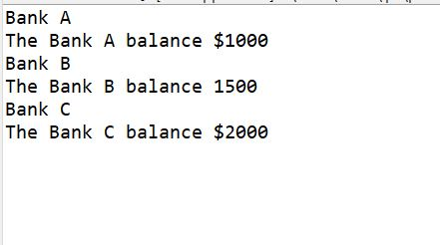

**Bank.java**

**package** com.fast;

**public** **abstract** **class** BankQ2 {

**int** getBalance()

{

**return** 0;

}

}

**BankA.java**

**package** com.fast;

**public** **class** BankAQ2 **extends** BankQ2{

BankAQ2() {

**super**();

System.***out***.println("Bank A");

}

**private** **int** balance;

**public** **int** getBalance() {

**return** balance;

}

**public** **void** setBalance(**int** balance) {

**this**.balance = balance;

}

}

**BankB.java**

**package** com.fast;

**public** **class** BankBQ2 **extends** BankQ2{

**private** **int** balance;

**public** BankBQ2() {

// **TODO** Auto-generated constructor stub

**super**();

System.***out***.println("Bank B");

}

**public** **int** getBalance() {

**return** balance;

}

**public** **void** setBalance(**int** balance) {

**this**.balance = balance;

}

}

**BankC.java**

**package** com.fast;

**public** **class** BankCQ2 **extends** BankQ2{

**private** **int** balance;

**public** BankCQ2() {

// **TODO** Auto-generated constructor stub

**super**();

System.***out***.println("Bank C");

}

**public** **int** getBalance() {

**return** balance;

}

**public** **void** setBalance(**int** balance) {

**this**.balance = balance;

}

}

**Main.java**

**package** com.fast;

**public** **class** MainQ2 {

**public** **static** **void** main(String[] args) {

// **TODO** Auto-generated method stub

BankAQ2 Bank_A = **new** BankAQ2();

Bank_A.setBalance(1000);

System.***out***.println("The Bank A balance $" + Bank_A.getBalance());

BankBQ2 Bank_B = **new** BankBQ2();

Bank_B.setBalance(1500);

System.***out***.println("The Bank B balance " + Bank_B.getBalance());

BankCQ2 Bank_C = **new** BankCQ2();

Bank_C.setBalance(2000);

System.***out***.println("The Bank C balance $" + Bank_C.getBalance());

}

}

**Q3**

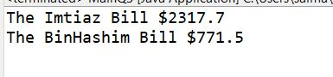

**Store.java**

**package** com.fast;

**public** **abstract** **class** StoreQ3 {

**abstract** **void** calculateBill();

}

**Imtiaz.java**

**package** com.fast;

**public** **class** ImtiazQ3 **extends** StoreQ3{

**private** **int** balance;

**public** ImtiazQ3(**int** b) {

// **TODO** Auto-generated constructor stub

**this**.balance = b;

}

**public** **void** calculateBill()

{

System.***out***.println("The Imtiaz Bill $" + (**this**.balance*0.7));

}

}

**BinHashim.java**

**package** com.fast;

**public** **class** BinHashimQ3 **extends** StoreQ3{

**private** **int** balance;

**public** BinHashimQ3(**int** b) {

// **TODO** Auto-generated constructor stub

**this**.balance = b;

}

**public** **void** calculateBill()

{

System.***out***.println("The BinHashim Bill $" + (**this**.balance*0.5));

}

}

**Main.java**

**package** com.fast;

**public** **class** MainQ3 {

**public** **static** **void** main(String[] args) {

// **TODO** Auto-generated method stub

ImtiazQ3 imt = **new** ImtiazQ3(3311);

imt.calculateBill();

BinHashimQ3 bh = **new** BinHashimQ3(1543);

bh.calculateBill();

}

}

**Q4**

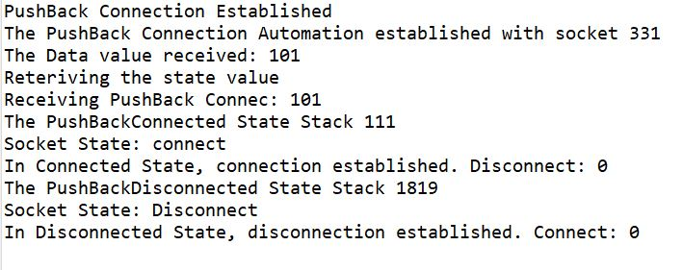

**package** com.fast;

**interface** IConnectionState {

**public** **void** connect();

**public** **void** disconnect();

**public** **int** receive();

**public** **void** send(**int** data);

}

**interface** IPushBackConnection **extends** IConnectionState{

**public** **void** pushBack(**int** value);

}

**class** ConnectedState **implements** IConnectionState {

**private** **int** Disconnect;

**private** String socket;

**public** **int** isDisconnect() {

**return** Disconnect;

}

**public** **void** setDisconnect(**int** disconnect) {

Disconnect = disconnect;

}

**public** String getSocket() {

**return** socket;

}

**public** **void** setSocket(String socket) {

**this**.socket = socket;

}

**public** **void** connect() {

setDisconnect(0);

setSocket("connect");

System.***out***.println("Socket State: " + socket);

System.***out***.println("In Connected State, connection established. Disconnect: " + Disconnect);

}

**public** **void** disconnect() {

setDisconnect(1);

setSocket("disconnect");

System.***out***.println("Socket State: " + socket);

System.***out***.println("In Connected State, connection disconnected. Disconnect: " + Disconnect);

}

**public** **int** receive() {

System.***out***.println("Receiving the Disconnect value");

**return** isDisconnect();

}

**public** **void** send(**int** data) {

System.***out***.println("The Data value received: " + data);

setDisconnect(data);

}

}

**class** DisconnectedState **implements** IConnectionState {

**private** **int** Connect;

**private** String socket;

**public** **int** isConnect() {

**return** Connect;

}

**public** **void** setConnect(**int** connect) {

Connect = connect;

}

**public** String getSocket() {

**return** socket;

}

**public** **void** setSocket(String socket) {

**this**.socket = socket;

}

**public** **void** connect() {

setConnect(0);

setSocket("Disconnect");

System.***out***.println("Socket State: " + socket);

System.***out***.println("In Disconnected State, disconnection established. Connect: " + Connect);

}

**public** **void** disconnect() {

setConnect(1);

setSocket("disconnect");

System.***out***.println("Socket State: " + socket);

System.***out***.println("In Disconnected State, connection connected. Connect: " + Connect);

}

**public** **int** receive() {

System.***out***.println("Receiving the Connect value");

**return** isConnect();

}

**public** **void** send(**int** data) {

System.***out***.println("The Data value received: " + data);

setConnect(data);

}

}

**class** PushBackConnection **implements** IPushBackConnection {

**private** **int** state;

**public** **void** pushBack(**int** value) {

setState(value);

System.***out***.println("The PushBack State Value: " + state);

}

**public** **int** getState() {

**return** state;

}

**public** **void** setState(**int** state) {

**this**.state = state;

}

**public** **void** connect() {

System.***out***.println("PushBack Connection Established");

}

**public** **void** disconnect() {

System.***out***.println("PushBack Connection is Disconnected");

}

**public** **int** receive() {

System.***out***.println("Reteriving the state value");

**return** getState();

}

**public** **void** send(**int** data) {

System.***out***.println("The Data value received: " + data);

setState(data);

}

**public** **void** createAutomation(**int** socket)

{

System.***out***.println("The PushBack Connection Automation established with socket " + socket);

}

}

**class** PushBackConnectedState **extends** ConnectedState **implements** IPushBackConnection

{

**private** **int** stack;

**public** **int** getStack() {

**return** stack;

}

**public** **void** setStack(**int** stack) {

**this**.stack = stack;

}

@Override

**public** **void** pushBack(**int** value) {

// **TODO** Auto-generated method stub

setStack(value);

System.***out***.println("The PushBackConnected State Stack " + getStack());

}

}

**class** PushBackDisconnectedState **extends** DisconnectedState **implements** IPushBackConnection

{

**private** **int** stack;

**public** **int** getStack() {

**return** stack;

}

**public** **void** setStack(**int** stack) {

**this**.stack = stack;

}

@Override

**public** **void** pushBack(**int** value) {

// **TODO** Auto-generated method stub

setStack(value);

System.***out***.println("The PushBackDisconnected State Stack " + getStack());

}

}

**public** **class** MainQ4 {

**public** **static** **void** main(String[] args) {

// **TODO** Auto-generated method stub

PushBackConnection pushBackconn = **new** PushBackConnection();

pushBackconn.connect();

pushBackconn.createAutomation(331);

pushBackconn.send(101);

System.***out***.println("Receiving PushBack Connec: " + pushBackconn.receive());

PushBackConnectedState pushBackConS = **new** PushBackConnectedState();

pushBackConS.pushBack(111);

pushBackConS.connect();

PushBackDisconnectedState pushBackDisS = **new** PushBackDisconnectedState();

pushBackDisS.pushBack(1819);

pushBackDisS.connect();

}

}