**Record Management implementing Confidentiality and Integrity**

**Information Security (IS)**

**Presented to:**

***Dr. Fahad Samad***

**By:**

***Salman Ahmed Khan 19K-1043***

**Dated: December 10, 2022**

Table of Contents

Abstract 3

Introduction 3

Existing System 4

1.1 System Architecture 4

Related Work/System 5

Adversary Model 6

System Design 6

System Implementation 7

I. Asymmetric Keys 7

II. Certificate Request & Digital Certificate 9

III. Certificate Authority Keys 10

IV. Confidentiality Tokenization Authentication 11

V. Add Student Record 11

VI. Edit Student Record 12

VII. View Student Record 14

System Evaluation 14

Technology 14

Conclusion 14

# Abstract

The record management system is a daily activity carried out in various organization including schools, college, universities, companies, factories etc. Due to large number of user’s details which contains sensitive information, it is difficult to make it in a secure fashion so that no one other then the authorize user of the system should carry out the amendments in the system. In order to tackle the physical record management system, I developed an automated record management system of the students in a university that ensure the integrity and confidentiality in the system. The integrity is maintained by using digital certificate authorized and issued by Certificate Authority (CA) upon providing Digital Certificate Request (CSR), creating digital signature of the data that is required to be store in the database and the confidentiality is maintained by authenticating the user, validating the user details and maintaining its token in the system.

# Introduction

A user details is an essential element that needs to be validated to prevent attack, manipulating and breaching of the data. The physical record management system is a tedious job that is carried out daily in the schools, universities etc. To ensure the system works perfectly, I will perform confidentiality and integrity.

The system will allow users to register within the system through which we will generate its public and private keys at runtime.

The user will be able to register with the system, keys will be generated and a private key will be provided to the user in hashed form on its email to perform digital signature from the browser/client.

The confidentiality will be maintained through authenticating user, validating user id and tokenization through which the system will allow the operations right to the user. There will exist a Certificate Authority (CA) that will issue a certificate to the user through which the system will maintain the confidence on the user. When the user wants to Edit the Record, the user will create a digital signature, digital certificate and data to the application server. The application server will then verify the certificate, obtain the public key from it and then verify the digital signature. After doing this, it will update the student record.

This system is built to secure the data of the users of the organization and by maintaining the confidentiality and integrity in the system.

# Existing System

## System Architecture

The system is built using Model View Controller (MVC) architecture. The system consists of three main entities server that include Client Server, Application Server and CA Server. The below system diagram displays the communication between these entities.

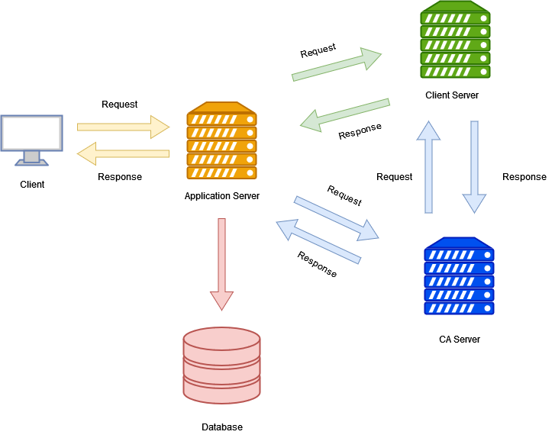

Figure 1 System Architecture

The responsibility of the Application Server is to handle all the request from the users. It also stores all the information in the database. The Application Server will pass the request of the creation of Asymmetric key to the Client Server. The Client Server is also responsible for creating the Certificate Request (CSR) and provide this request to the Certificate Authority (CA). The CA’s Server will issue a Certificate to the Client Server. The Client Server will create a Digital Signature. It will provide the Digital Signature and Digital Certificate to the Application Server. The Application Server will verify the Digital Signature provided by the Client Server and upon verification, it will then obtain the public key and verify the Digital Signature. After verification, it will then update the record.

# Related Work/System

The related record management does not implement confidentiality and integrity in the system. The client request is handled no security measures are taken to prevent the data access and data manipulation by third party. The data is being displayed to the user and all the data manipulation is carried out by just ensuring the login details of the user. Due to no security layer, if the user’s credentials are breach or stolen then anyone with the credential can access the system and manipulate the data. Below is the attached architecture figure of such system.



Figure 2 Related System

# Adversary Model

The system model as describe in the section Existing System.

# System Design

The System is designed using Model View Controller (MVC) pattern. Also, distributed system architecture is used to build the system. As per the security design is concerned, the user’s password is hashed with generated salt to make secure password. The tokenization is done to maintain the user’s session. The Public and Private keys are created to perform the digital signature. The Private key is then hashed and mailed to the user to perform certain actions. A Certificate Authority is used to issue the Digital Certificate to the user. Both the digital certificate and digital signature are used to maintain the integrity in the system.

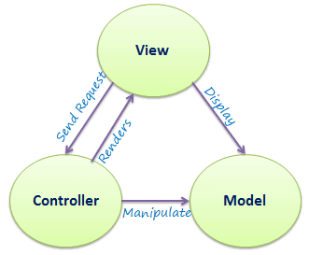

Figure 3 Software Architecture

Cookie Based Tokenization for Confidentiality contains the user’s id as the data payload.

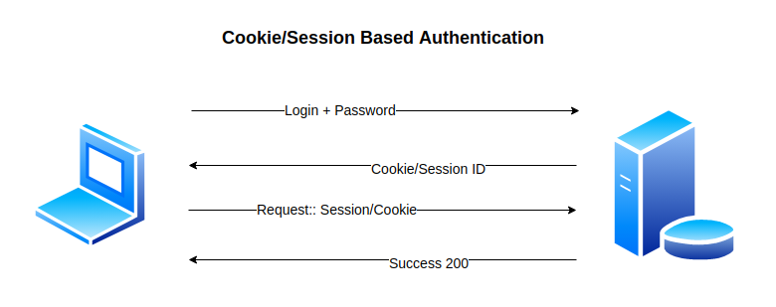

Figure 4 Tokenization Authentication

The user’s password is stored in a hashed form in the database.

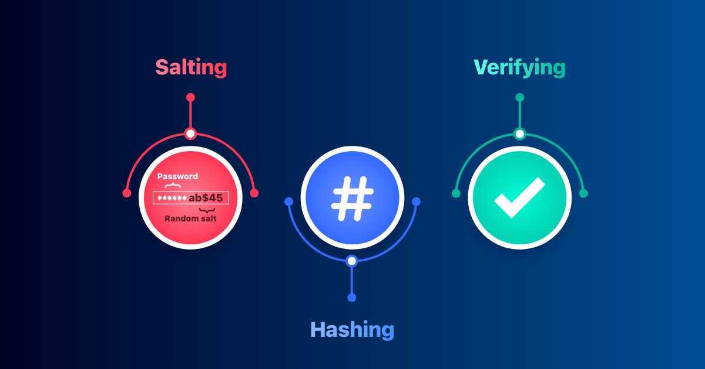

Figure 5 Salt Hashed Password

# System Implementation

The features of the system are:

* Signup
* Login
* Add Student Details
* View Students Details
* Edit Student Record

The system focuses on a single entity named admin. The user will signup the system. After signing in the system, the Asymmetric Keys that are RSA Public and RSA Private Key is created on the Client Server.

## Asymmetric Keys

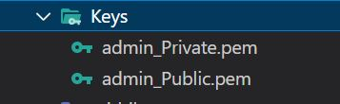

Figure 6 RSA Asymmetric Keys

The Public Key of the user.

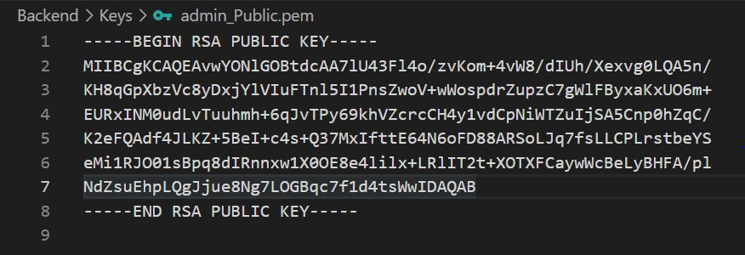

Figure 7 User Public Key

The Private Key of the user.

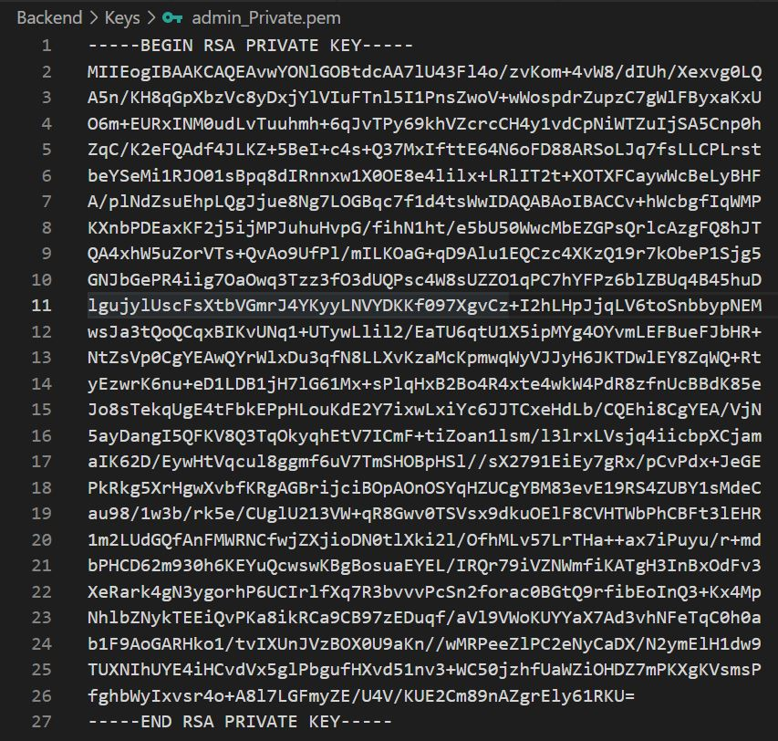

Figure 8 User Private Key

After the creation of Asymmetric Keys, an automated mail is done to the user email containing the user’s hashed private key used in the operation of Edit Student Record to create the digital signature as shown below.

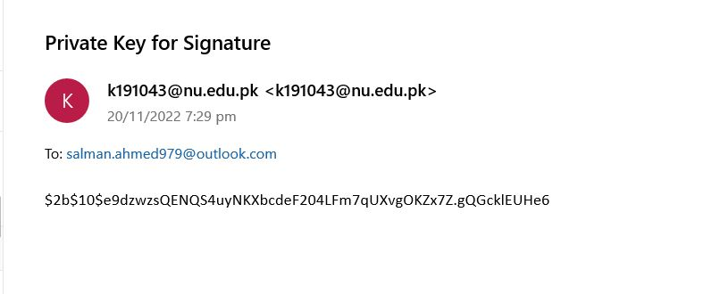

Figure 9 Email Hashed Private Key

## Certificate Request & Digital Certificate

The Certificate Request (CSR) is generated after the creation of Asymmetric Key Pair. The CSR is used to obtain a Digital Certificate from the Certificate Authority (CA). The CSR is displayed below.

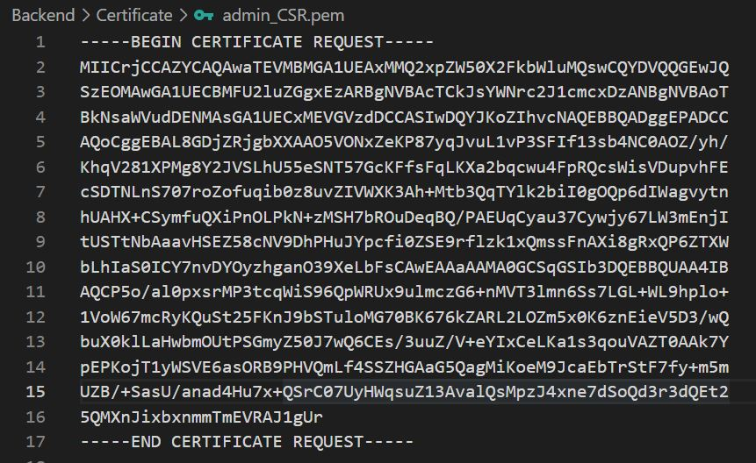

Figure 10 Certificate Request

The Certificate Request (CSR) is then passed to the Certificate Authority (CA)’s Server to obtain the Digital Certificate. The user’s issued Digital Certificate is shown below.

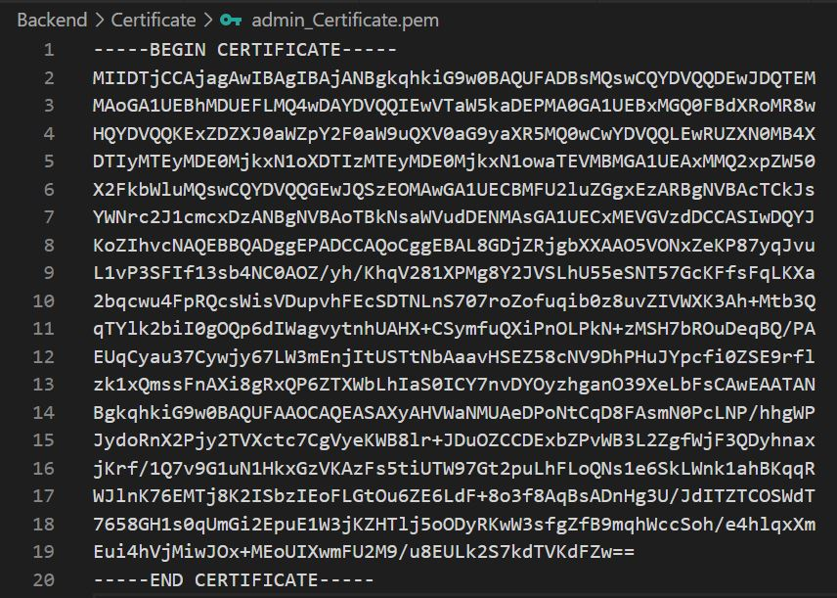

Figure 11 Digital Certificate of User

## Certificate Authority Keys

The Certificate Authority (CA) has already created its Asymmetric Key Pair on its Server.

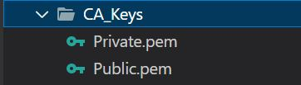

Figure 12 CA Asymmetric Key Pair

## Confidentiality Tokenization Authentication

After successful signup, the system redirects the user to the Login Page. The user provides its credentials and after the validation of its credentials, the authentication token is maintained in the cookie that provide system confidence on the user whenever a client request is generated, hence provide confidentiality.

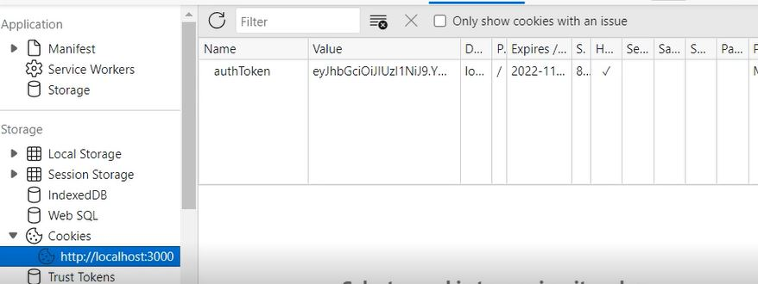

Figure 13 Authentication Token – Confidentiality

## Add Student Record

Adding Student Record is shown below. The Application Server gets the student data and stored in the database.

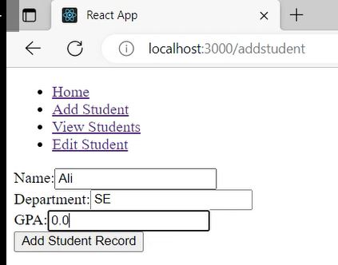

Figure 14 Add Student Record

## Edit Student Record

The Edit Student Record require the hashed Private Key from the user in order to generate the Digital Signature which is carried out by the Client Server. If the Private Key mismatched with the original Private Key stored on the Client Server, it then provides the unauthorize message to the user and the further procedure is terminated. The Client Server provides the Digital Signature and Digital Certificate to the Application Server. The Application Server then obtain a Digital Certificate from the Certificate Authority (CA), creates a CA Store and verify the issued Digital Certificate of the client. After successful verification of the Digital Certificate, the Application Server then obtain the Public Key from the Digital Certificate of the user and verify the Digital Signature provided by the Client Server. Upon successful verification, the data is then updated in the database.

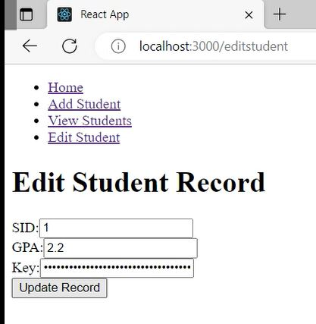

Figure 15 Edit Student Record

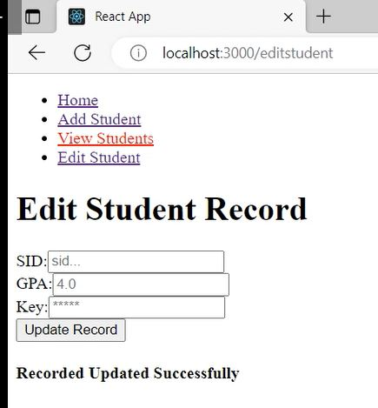

Figure 16 Edit Student Record Successful

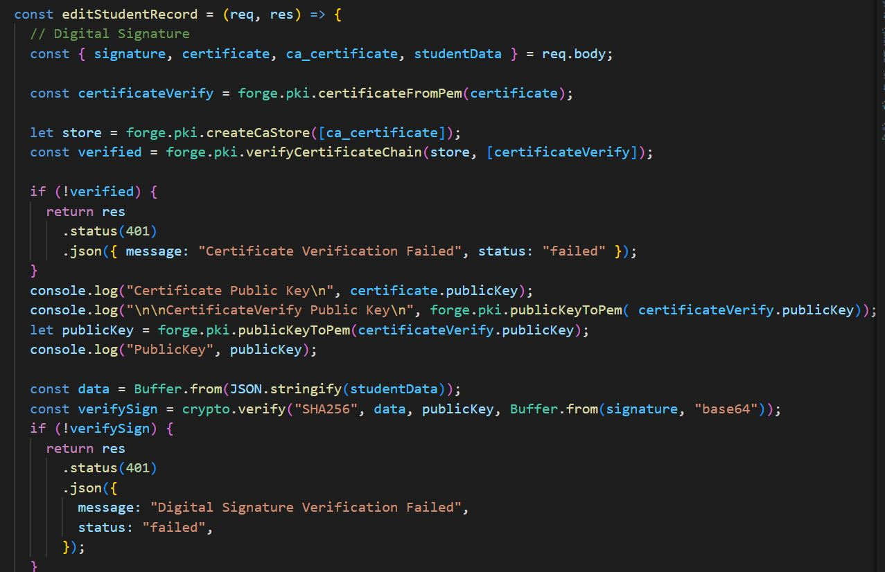

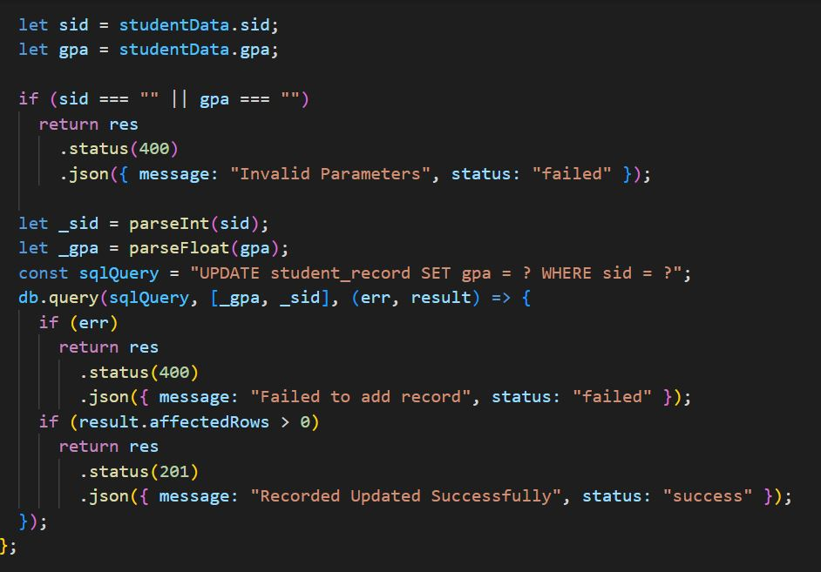

Figure 17 Edit Student Record - Digital Certificate & Digital Signature

## View Student Record

After the successful edit record, the data could be displayed in the view page.

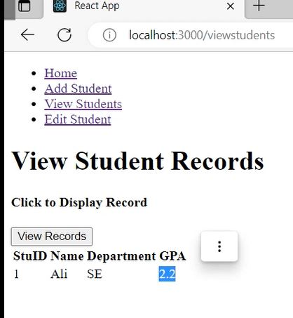

Figure 18 View Student Record

# System Evaluation

The system is evaluated using API testing using Postman API Testing tool. Moreover, the after the running the system, we could evaluate the system performance.

# Technology

* React JS (Frontend)
* Node JS + Express JS (Backend)
* Bcrypt (Hashing), Node-Forge (Digital Certificate + Certificate Request) + Crypto (Asymmetric Key Pair + Digital Signature)
* MySql (Database)

# Conclusion

The secure record management is necessary in the organization that could maintain the integrity and confidentiality in the system and does not allow any illegal and unauthorize of the system by any other party. Therefore, such a secure system is a must in an organization to protect their data from data breach and unauthorized data access.