Chayanika Das

Department Of Chemical Engineering

National Institute of Technology, Karnataka, Surathkal-575025

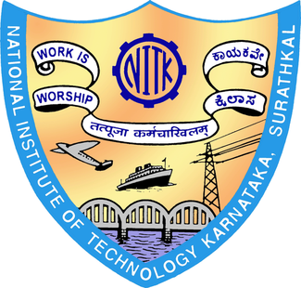

Email: chayanika7das@gmail.com

Phone: +919577819744, +918861896353

**OBJECTIVE:**

To consider my candidature for a summer research fellowship in a renowned Institute where I can work in a technically competitive environment and deliver my best in the task entrusted to me and further develop my field of interest.

**EDUCATIONAL QUALIFICATION:**

|  |  |  |  |
| --- | --- | --- | --- |
| **Year** | **Degree/Certificate** | **Institute/School, City** | **CGPA/% of Marks** |
| 2013 | Class X: Central Board of Secondary Education(CBSE) | St. Mary’s English High School, Maligaon  Guwahati, Assam | 10.00 |
| 2015 | Class XII: Central Board of Secondary Education(CBSE) | Don Bosco Senior Secondary School, Panbazar, Guwahati | 97.2 |
| 2015-2019 | B.Tech (Hons) (Chemical Engineering) 2nd year. | National Institute of Technology, Karnataka Surathkal | 8.67/10.00 (till 3rd semester) |

**ACADEMIC ACHIEVEMENTS :**

* Qualified JEE-Advanced 2015.
* Qualified JEE-Mains 2015 with All India Rank (AIR) 2297.
* 3rd rank in Department of Chemical Engineering in NITK based on JEE-Mains AIR.
* School topper in 12th boards (CBSE).

**TECHNICAL SKILLS:**

* Windows (XP,7,8,10), Linux (Ubuntu)

**PROJECTS UNDERTAKEN :**

1. **Generation of Biogas from Mess Waste** (ongoing)

Analyzing the amount of bio-gas that can be produced from the waste of the Girls Hostel mess; to be further extended to all the messes and the subsequent calculation of the energy and cost savings that can be achieved.

**EXTRA CURRICULUR ACTIVITIES:**

* Won the Governor Award in Junior Red Cross of the Red Cross Society of India.
* Executive Member of the Institution of Engineers, NITK Chapter.
* Member of the Literary, Stage and Debating Society of NITK.
* Member of the Marketing and Chemical Engineering Events Committees for Engineer (Annual Technical Symposium of NITK) 2016.
* Member of the EngiPress Committee for Engineer 2015.
* Member of the Marketing Committee for Incident (annual cultural festival of NITK) 2016.
* Attended various seminars on Chemical Engineering in NITK, Surathkal.

**HOBBIES:**

* Reading different genres of novels and an avid reader of current affairs.
* Debating
* Content Writing

**PERSONAL INFORMATION:**

|  |  |
| --- | --- |
| **Date of Birth:** | 07 April, 1997 |
| **Sex:** | Female |
| **Mother's Name** | Smt. Pranati Deka |
| **Father's Name** | Shri Dulal Chandra Das |
| **Nationality:** | Indian |
| **Present Address:** | Room No 247, Girls Hostel (GH)-3  NITK Hostels, National Institute of Technology, Karnataka Surathkal  Mangalore-575025, Karnataka |
| **Permanent Address:** | Professor Chuburi, Anirban Path,  Gotanagar, Guwahati-781011,  Assam |