**MD. SALMAN HOSSEN MARJAN**

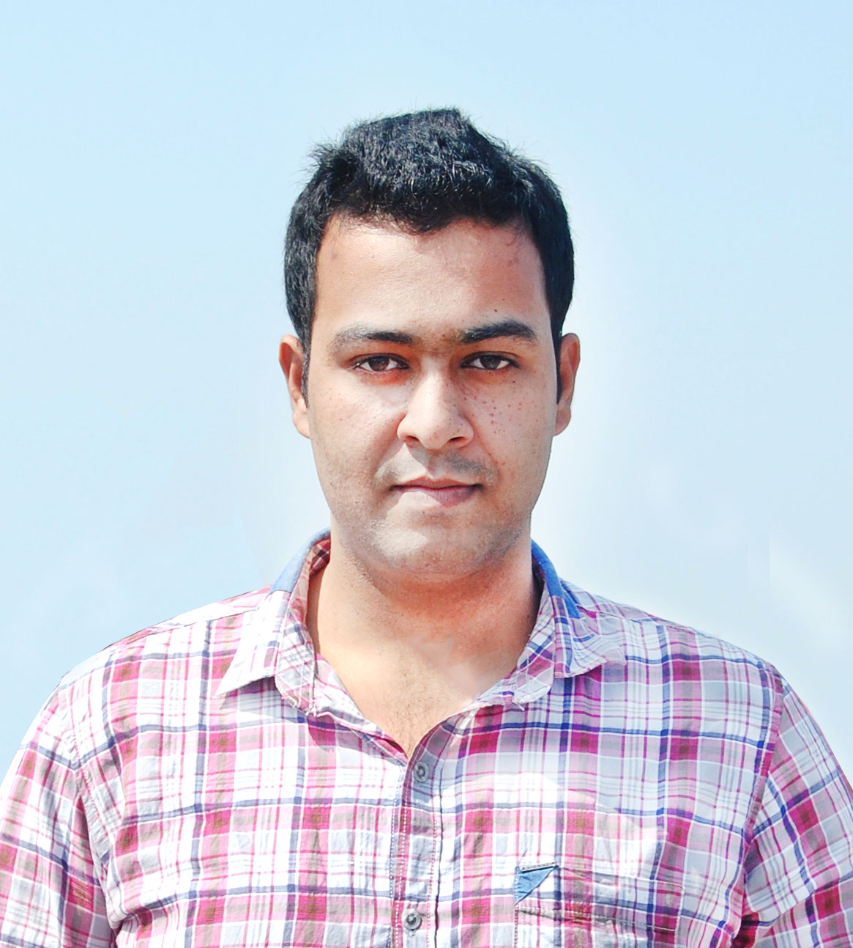

Back-End Web Developer

**Contact**

Email : [salmanhossen.me@gmail.com](mailto:salmanhossen.me@gmail.com)

Phone: +8801725585255

Website : <https://www.salmanhossen.me>

Skype: Salman_Hossen

Linkedin: <https://www.linkedin.com/in/salman-hossen/>

**Objective**

Pursuing a challenging professional with a creative work environment in information Technology related fields to enhance knowledge and expertise in web application development. Always want to take new challenges and always set myself high standards and work towards that goal. I am quick learner with the desire and willingness to learn new skills. Hard working and committed a person on responsible to do the work with confidence individually as well as in a team with the effective potentials in communicating with other people.

**Web Development Skills**

● HTML5 ● Jquery ● Bootstrap

● CSS3 ● Ajax ● Python

● PHP ● Anguler JS ● Django

● MySQL ● Codeigniter

● JAVASCRIPT ● Wordpress Theme Development

**Work Experience**

April, 2017 - Present Back-End Web Developer

Frndz It

Sylhet – 3100, Bangladesh

Url: <http://www.frndzit.com>

Industry: Computer / IT

**Education**

2016 B.Sc. Engineering in Computer Science and Engineering

Metropolitan University, Al-Hamra, Zinda Bazar, Sylhet.

Obtained Grade: B- (2.88)

2010 Higher Secondary Certificate (H.S.C)

Business Studies Group.

Ragib Rabeya College, Bishwanath, Sylhet.

Obtained Grade: C (2.70)

2008 Secondary School Certificate (S.S.C)

Science Group.

Hazi Yeasin Ullah Betsandi Dipakkhik High School, Bishwanath, Sylhet.

Obtained Grade: C (2.38)

**Personal Information**

Name : Md. Salman Hossen Marjan

Father’s Name : Kabirul Islam Khasru

Mother’s name : Mst. Fatema Begum Jakia

Present Address : Vill - Borotola, P/O - Ponaullah Bazar, P/S - Bishwanath, Sylhet.

Permanent Address : Vill - Borotola, P/O - Ponaullah Bazar, P/S - Bishwanath, Sylhet.

Date of Birth : 10th October 1991

Religion : Islam (Sunni)

Nationality : Bangladeshi by Birth

Marital Status : Unmarried

Blood Group : O (+ve)

Sex : Male



Signature