Import numpy as np
Import pandas as pd
Import matplotlib.pyplot as plt
!pip install seaborn
Import seaborn as sns

a=np.array(df)
a=np.array([1,2,3])
a.ndim
a.shape
a.dtype
a[r,c]
a[:,2]
np.min(a,axis=0)
.sum()
.max()

series=pd.Series(data) #data can be both list, and dictionary(keys become index)
pd.DataFrame(data)

df=pd.read_csv(‘sales_data.csv’)
df.head(5)
df.tail(5)

df[‘name’]=[sthelse, sthelse, sthelse]

df.loc(rowlabel,columnlabel)
df.iloc[rowindex,columnindex] #can do slicing

df.drop(‘salary’, axis=1, inplace=True)
df.describe()
df.dtypes
df.isnull().sum()
df.fillna(0)
df[‘sales’].fillna(df[‘sales’].mean(), inplace=True]

df["Embarked"].fillna(df["Embarked"].mode()[0], inplace=True)

import pandas as pd

# Sample data
df = pd.DataFrame({
'Color': ['Red', 'Blue', 'Green', 'Blue']
})

# One-hot encoding
encoded_df = pd.get_dummies(df, columns=['Color'])

Q1 = df['Fare'].quantile(0.25)
Q3 = df['Fare'].quantile(0.75)
IQR = Q3 - Q1

lower = Q1 - 1.5 * IQR
upper = Q3 + 1.5 * IQR

df = df[(df['Fare'] >= lower) & (df['Fare'] <= upper)]

x=[2023,2024,2025, 2026]
y=[15,25,30,20]
plt.plot(x,y) #simple line chart
plt.plot(x,z)
plt.title(‘sth’)
plt.xlabel(‘sthx’)
plt.show(y)

categories=np.array(['cricket', 'football'])
values=np.array([2,1])
plt.bar(categories,values)
plt.show()

plt.scatter(x,y)
plt.legend()
plt.show()

plt.hist(scores,bins=10)
plt.show()

sns.boxplot(x=”day”, y=”tips”, data=datasetname)
sns.boxplot(y=datasetname["tips"])

sns.heatmap(dataset.corr(), annot=True)

from sklearn.preprocessing import StandardScaler
from sklearn.model_selection import train_test_split
scaler = StandardScaler()
X_train, X_test, y_train, y_test = train_test_split(X, y, test_size=0.2)

X_train_scaled = scaler.fit_transform(X_train)
X_test_scaled = scaler.transform(X_test)

Encoding

from sklearn.preprocessing import OrdinalEncoder
import pandas as pd

df = pd.DataFrame({
'Size': ['Small', 'Medium', 'Large', 'Medium']
})

encoder = OrdinalEncoder(categories=[['Small', 'Medium', 'Large']])

encoded = encoder.fit_transform(df[['Size']])

df['Size_Encoded'] = encoded

print(df)

df.drop_duplicates(inplace=True)

df['detected_language'].unique()

df.shape

df['views'].dtype

KNN
from sklearn.neighbors import KNeighborsClassifier

from sklearn.metrics import accuracy_score, recall_score, f1_score, precision_score, confusion_matrix

knn = KNeighborsClassifier(n_neighbors=5, metric='minkowski', p=2)#p=1 manhattan p=2 euclidean
knn.fit(X_train, y_train)

y_pred = knn.predict(X_test)

#k=root(n) n-data points but u can choose from cross validation(try multiple)
print("Accuracy:", accuracy_score(y_test, y_pred))

Naive Bayes
from sklearn.naive_bayes import GaussianNB
gnb = GaussianNB()
y_pred = gnb.fit(X_train, y_train).predict(X_test)

Use knn when data is small or complex
Avoid naive bayes when data too correlated

features = ['Pclass','Sex','Age','SibSp','Parch','Fare','Embarked']
X = data[features]
y = data['Survived']

# convert categorical columns manually
X_np['Sex'] = X_np['Sex'].map({'male':0, 'female':1})
X_np['Embarked'] = X_np['Embarked'].map({'S':0,'C':1,'Q':2})

Decision tree
- CART- gini(t)-gini(s)
1-sigmapi^2

ID3- entropy and info gain, info gain=entropy(t)- entropy(s)
-9/14log9/14 -5/14log5/14

from sklearn.tree import DecisionTreeClassifier
from sklearn.model_selection import train_test_split, cross_val_score, KFold

clf = DecisionTreeClassifier(random_state=42, max_depth=5, criterion="entropy" )#by default gini

clf.fit(X_train, y_train)

y_pred = clf.predict(X_test)

acc = accuracy_score(y_test, y_pred)
cm = confusion_matrix(y_test, y_pred)
plt.figure(figsize=(6, 4))
sns.heatmap(cm, annot=True, fmt='d', cmap='Blues')
plt.title('Confusion Matrix')
plt.xlabel('What the Machine Guessed')
plt.ylabel('What Actually Happened')
plt.show()

from sklearn.model_selection import KFold, cross_val_score
model = DecisionTreeClassifier()

# K-Fold setup
kfold = KFold(n_splits=5, shuffle=True, random_state=42)

# Cross-validation
scores = cross_val_score(model, X, y, cv=kfold, scoring='accuracy')
print(scores)

X = features, y = target

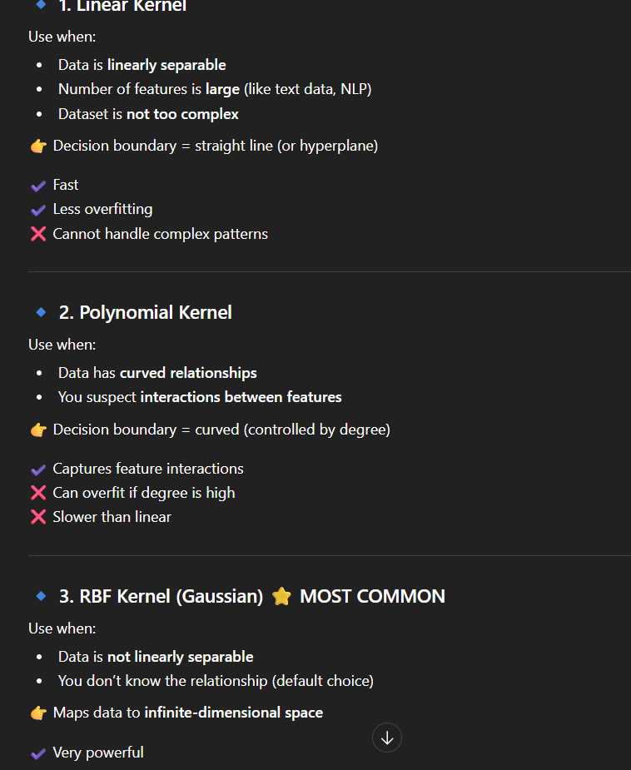
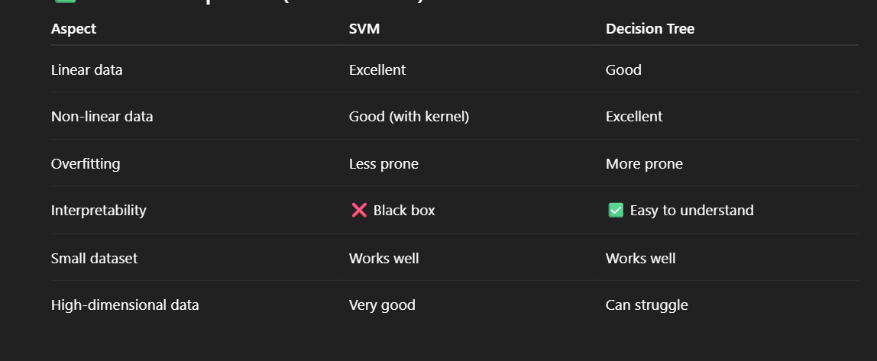

Slack is controlled by hyperparameter C in soft boundary, prevents risk of overfitting and

from sklearn.svm import SVC
svm_model = SVC(kernel='rbf')

svm_model.fit(X_train, y_train)

svm_predictions = svm_model.predict(X_test)

from sklearn.tree import DecisionTreeClassifier
from sklearn.ensemble import RandomForestClassifier
rf = RandomForestClassifier(n_estimators=200, max_depth=25, min_samples_split=5 ,random_state=42)
rf.fit(X_train, y_train)

y_pred_rf = rf.predict(X_test)

from sklearn.model_selection import cross_val_score
from sklearn.ensemble import RandomForestClassifier
import numpy as np

rf = RandomForestClassifier(
n_estimators=200,
max_depth=25,
min_samples_split=5,
random_state=42
)

scores = cross_val_score(rf, X, y, cv=5, scoring='accuracy')

Logistic Regression
Used for classification problems (Yes/No, 0/1)
P(Y=1)=1+1/e^-z

Linear regression
from sklearn.linear_model import LinearRegression
from sklearn.metrics import (mean_absolute_error, mean_squared_error,
r2_score)

Simple linear regression
X_simple = df[['bmi']]
y= df['target'] # target variable

X_train_s, X_test_s, y_train_s, y_test_s = train_test_split(
X_simple, y, test_size=0.2, random_state=42)
slr = LinearRegression()
slr.fit(X_train_s, y_train_s)
y_pred_s = slr.predict(X_test_s)

Multiple linear regression
X_multi = df.drop(columns=['target'])
y = df['target']

X_train_m, X_test_m, y_train_m, y_test_m = train_test_split(
X_multi, y, test_size=0.2, random_state=42)

mlr = LinearRegression()
mlr.fit(X_train_scaled, y_train_m)

y_pred_m = mlr.predict(X_test_scaled)
from sklearn.preprocessing import PolynomialFeatures

poly = PolynomialFeatures(degree=2)

X_train_poly = poly.fit_transform(X_train_scaled)
X_test_poly = poly.transform(X_test_scaled)

lr_poly = LinearRegression()
lr_poly.fit(X_train_poly, y_train)

y_pred_poly = lr_poly.predict(X_test_poly)

from sklearn.linear_model import LogisticRegression

model = LogisticRegression()
model.fit(X_train, y_train)

y_pred = model.predict(X_test)

r^2=1 good 0- predicts mean . <0 kinda bad

# Lasso Regression Setup with Cross-Validation
from sklearn.linear_model import LassoCV

# Using the same multiple features
X_lasso = df[['Total Revenue', 'Total Cost', 'Units Sold']]
y = df['Total Profit']

# Split
X_train_l, X_test_l, y_train, y_test = train_test_split(X_lasso, y, test_size=0.2, random_state=42)

# Train with LassoCV to find the optimal alpha
# cv=5 performs 5-fold cross-validation
lasso_model = LassoCV(cv=5, random_state=42)
lasso_model.fit(X_train_l, y_train)

print(f"Best Alpha found: {lasso_model.alpha_}")

# Predict
y_pred_l = lasso_model.predict(X_test_l)

# Metrics
mae_l = mean_absolute_error(y_test, y_pred_l)
mse_l = mean_squared_error(y_test, y_pred_l)
r2_l = r2_score(y_test, y_pred_l)

print("\n--- Lasso Regression Metrics (with CV) ---")
print(f"MAE: {mae_l:.4f}")
print(f"MSE: {mse_l:.4f}")
print(f"R\u00b2: {r2_l:.4f}")

# Plotting
plt.figure(figsize=(8, 5))
plt.scatter(y_test, y_pred_l, color='orange', alpha=0.5)
plt.plot([y_test.min(), y_test.max()], [y_test.min(), y_test.max()], 'k--', lw=2)
plt.title('Lasso Regression: Actual vs Predicted Profit')
plt.xlabel('Actual Profit')
plt.ylabel('Predicted Profit')
plt.show()

Just replace LassoCV with RidgeCV and done.

from sklearn.cluster import KMeans, DBSCAN, SpectralClustering
from sklearn.metrics import silhouette_score

wcss = []

for i in range(1, 11):
kmeans = KMeans(n_clusters=i, random_state=42)
kmeans.fit(X_scaled)
wcss.append(kmeans.inertia_)

# Plot
plt.plot(range(1, 11), wcss, marker='o')
plt.title("Elbow Method")
plt.xlabel("Number of clusters (k)")
plt.ylabel("WCSS")
plt.show()

kmeans = KMeans(n_clusters=5, random_state=42)
kmeans_labels = kmeans.fit_predict(X_scaled)
kmeans_score = silhouette_score(X_scaled, kmeans_labels)

from sklearn.neighbors import NearestNeighbors
import numpy as np

neighbors = NearestNeighbors(n_neighbors=5)
neighbors_fit = neighbors.fit(X_scaled)
distances, indices = neighbors_fit.kneighbors(X_scaled)

distances = np.sort(distances[:, 4]) # 5th nearest neighbor
plt.plot(distances)
plt.show()

For each point:
- Find distance to its k-th nearest neighbor
- (k = min_samples)
Sort all those distances
Plot them

dbscan = DBSCAN(eps=0.5, min_samples=5)
dbscan_labels = dbscan.fit_predict(X_scaled)

# Handle DBSCAN issue
if len(set(dbscan_labels)) > 1 and -1 not in set(dbscan_labels):
dbscan_score = silhouette_score(X_scaled, dbscan_labels)
else:
dbscan_score = -1

Silhouette score- +1(good)
0(clusters overlap)
-1 wrong cluster

📐 Formula (core idea)
For each point:
- a = average distance to points in the same cluster
- b = average distance to points in the nearest other cluster

Then:
s=b−amax⁡(a,b)s = \frac{b - a}{\max(a, b)}s=max(a,b)b−a​

