AarogyaSathi: A Multilingual Retrieval-Augmented Public Health Conversational Agent with Autonomous Multi-Tier Fact-Checking and Community Syndromic Surveillance
An Open-Source, Edge-Cloud Framework for Rural and Semi-Urban Preventive Healthcare Informatics
Student Project Team, Department of Computer Science & Engineering
Minor Project (ES-451) Evaluation | Bachelor of Technology
Technical Defense Manuscript | Academic Year 2026
Abstract—In developing nations such as India, the clinical provider-to-population ratio (1:1456) severely undermines primary healthcare delivery, while the rampant dissemination of medical misinformation across peer-to-peer networks poses an escalating threat to public health outcomes. Concurrently, centralized epidemiologic surveillance mechanisms face reporting latencies of 14 to 21 days, hindering early outbreak mitigation. This paper presents AarogyaSathi, an autonomous, multilingual public health conversational agent specifically architected for resource-constrained environments. AarogyaSathi synthesizes: (i) a deterministic safety layer enforcing real-time emergency triage escalation to 108/112 ambulance dispatch; (ii) cross-lingual semantic retrieval using Google's Language-Agnostic BERT Sentence Embeddings (LaBSE) mapping user inputs across English, Hindi, and colloquial Hinglish into a unified 768-dimensional metric space; (iii) grounded Retrieval-Augmented Generation (RAG) powered by an edge-optimized Small Language Model (Qwen3-1.7B-Instruct) enforcing strict negative constraints against clinical hallucination; (iv) an autonomous, zero-API-key multi-tier health fact-checking engine operating via local semantic verification and dynamic open-web evidence synthesis; and (v) an automated, pincode-level syndromic surveillance pipeline computing 7-day rolling baselines to detect anomalous symptom surges (≥3× baseline). Benchmarked across 15 real-world health claims spanning vaccine safety, hazardous traditional practices, and viral hoaxes, the fact-checking engine achieves a 100% verification accuracy rate with sub-second response times (<0.15s) for curated clinical myths and 5–7 seconds for dynamic web evidence synthesis. The end-to-end platform is self-hosted on Oracle Cloud Infrastructure (2 vCPU, 4GB RAM) with an aggregate memory footprint of ~3.0GB, establishing a robust, zero-cost, and non-hallucinatory paradigm for scalable community health informatics.
Index Terms—Public Health Informatics, Retrieval-Augmented Generation (RAG), Autonomous Fact-Checking, Cross-Lingual Semantic Retrieval, Community Syndromic Surveillance, Small Language Models (SLMs), Natural Language Processing.
I. INTRODUCTION
Access to accurate, timely, and culturally contextualized preventive healthcare information remains one of the most formidable developmental hurdles facing the Global South. In India, the doctor-to-population ratio stands at approximately 1:1456, falling substantially below the World Health Organization (WHO) recommended threshold of 1:1000 [1]. This structural deficit is acutely intensified across rural and peri-urban demographics, where primary health centers (PHCs) are geographically dispersed, understaffed, and burdened by diagnostic backlogs. Consequently, over 70% of the rural population relies on informal healthcare conduits, word-of-mouth recommendations, and unvetted digital communication channels for primary health advice.
Over the past decade, the rapid proliferation of affordable mobile broadband has catalyzed unprecedented internet penetration across India. However, this democratization of connectivity has precipitated a parallel 'infodemic'—the exponential dissemination of unverified, pseudoscientific, and actively hazardous medical misinformation [2]. Messaging platforms such as WhatsApp and Telegram frequently serve as vectors for viral health hoaxes, ranging from unscientific COVID-19 remedies (e.g., consuming concentrated garlic water or inhaling toxic vapors) to lethal first-aid practices (e.g., applying caustic red chilli powder to canine bite wounds or incising snakebite sites). Such misinformation carries catastrophic clinical consequences: patients delay formal allopathic interventions, suffer irreversible tissue necrosis, or forfeit life-saving pediatric immunizations due to baseless fertility rumours.
Concurrently, traditional public health surveillance frameworks, such as India's Integrated Disease Surveillance Programme (IDSP), depend fundamentally on lagging indicator data. Clinical laboratory confirmations and outpatient registry logs typically require 14 to 21 days to propagate from rural clinics to central epidemiologic registries. During acute vector-borne (e.g., Dengue, Chikungunya) or water-borne (e.g., Cholera, Hepatitis A/E) outbreaks, this reporting latency severely constrains timely municipal vector control, sanitization, and prophylactic intervention.
While recent advances in Large Language Models (LLMs) demonstrate remarkable conversational versatility, commercial general-purpose models (such as GPT-4, Claude, or Gemini) introduce severe vulnerabilities when deployed in safety-critical public health contexts. Foremost among these are: (i) clinical hallucinations, wherein generative models fabricate plausible yet lethal pharmacology or pathology; (ii) prohibitive computational and commercial API costs that preclude sustained non-profit deployment; (iii) stringent credit card and cloud billing gatekeeping (exemplified by Reserve Bank of India e-mandate transaction restrictions on Google Cloud Platform accounts); and (iv) profound language biases that fail to comprehend colloquial Hinglish (hybrid Hindi-English vernacular) or regional Indian linguistic nuances [3].
To decisively resolve these interconnected challenges, this paper presents AarogyaSathi, an end-to-end, open-source public health conversational architecture engineered specifically for the socio-technical realities of developing nations. AarogyaSathi makes five primary contributions:
1) Multi-Tier Deterministic Safety Architecture: A zero-hallucination triage engine that isolates life-threatening emergencies (e.g., acute myocardial infarction, toxic envenomation, severe respiratory distress) and instantly routes users to 108/112 emergency services with zero LLM intervention.
2) Cross-Lingual Metric Retrieval: Implementation of Google's Language-Agnostic BERT Sentence Embeddings (LaBSE) within a unified 768-dimensional latent space, enabling cross-lingual semantic alignment across English, Hindi, and transliterated Hinglish over curated national health repositories.
3) Strict Grounded RAG via Small Language Models (SLMs): Deployment of an edge-optimized SLM (Qwen3-1.7B-Instruct) executing under 4-bit quantization, governed by negative-constraint system prompts that strictly bound answers to retrieved context while appending validated WHO/MoHFW citations.
4) Autonomous Zero-API-Key Fact-Checking Engine: A proprietary four-tier verification pipeline that decouples automated misinformation debunking from commercial cloud APIs. The engine synergizes local vector matching, lexical token coverage verification, and multi-source open-web evidence harvesting (DuckDuckGo News protocol, Wikipedia REST API) to generate calibrated, evidence-grounded verdicts.
5) Pincode-Driven Community Syndromic Surveillance: An automated spatial anomaly detection module that extracts 6-digit Indian Postal Index Numbers, logs anonymized symptom query frequencies, and executes rolling 7-day baseline regression to flag emergent disease clusters days prior to hospital admission surges.
II. RELATED WORK AND CRITICAL GAP ANALYSIS
A. Conversational AI in Clinical and Public Health Systems
The application of conversational agents in healthcare has evolved across distinct paradigms. Commercial clinical symptom triage platforms, such as Babylon Health and Ada Health, employ complex Bayesian probabilistic graphical models and proprietary clinical decision trees [4]. While these platforms exhibit commendable diagnostic sensitivity in controlled Western clinical environments, their structural architecture exhibits critical failure modes in developing nations. Specifically, their proprietary rule bases are strictly closed-source, exhibit high software licensing overheads, and assume patient familiarity with standardized clinical terminologies. Furthermore, their complete lack of support for code-mixed Indian vernaculars (such as Hinglish or colloquial Hindi) severely limits their real-world utility across Indian populations.
National digital health initiatives deployed by the Government of India during the COVID-19 pandemic—notably the Aarogya Setu application (Bluetooth-based proximity contact tracing) and the CoWIN portal (vaccination scheduling and certificate verification)—demonstrated the efficacy of digital health platforms at continental scale [5]. Nevertheless, these systems functioned as transactional registries rather than cognitive, interactive educational interfaces. Users could not interrogate these platforms regarding symptomatic progression, traditional food myths, maternal nutrition, or vector control guidelines.
B. Automated Fact-Checking and Misinformation Detection
Automated claim verification has garnered substantial academic attention, catalyzed by benchmark datasets such as FEVER (Fact Extraction and VERification) [6] and the emergence of the Schema.org ClaimReview standard. Search engines, notably Google, operationalized the Google Fact Check Tools API, allowing programmatic querying of journalist-reviewed debunking articles. However, empirical deployment in public health settings reveals severe structural bottlenecks: (i) Google's API only indexes pre-existing fact-checking articles explicitly structured with ClaimReview markup; novel or hyper-localized village rumours return null (HTTP 404/Empty); and (ii) as experienced in mid-2024 across South Asian developers, cloud infrastructure providers mandated strict corporate billing accounts with linked international credit cards, which frequently fail due to central banking e-mandate regulatory directives [7]. AarogyaSathi overcomes this dependency by engineering an autonomous verification engine combining high-density curated corpora with real-time open-web text and news evidence synthesis.
C. Digital Syndromic Surveillance Systems
The conceptual feasibility of utilizing digital user queries for epidemiological surveillance was pioneered by Google Flu Trends (GFT) [8]. Although GFT initially demonstrated close correlation with CDC influenza tracking, it eventually exhibited substantial overestimation errors (such as predicting double the actual clinical flu frequency during peak 2012-2013 seasons) due to search engine algorithmic changes and widespread media-induced panic searching. Modern syndromic surveillance methodologies, such as CDC ESSENCE (Electronic Surveillance System for the Early Notification of Community-Based Epidemics) [9], mitigate this by ingesting structured emergency room chief complaints. In India, however, where electronic health record (EHR) adoption remains nascent across rural clinics, centralized digital surveillance has remained elusive. AarogyaSathi bridges this gap by directly capturing structured symptom signals from citizen conversational inquiries, geocoded to 6-digit administrative pincodes.
III. SYSTEM ARCHITECTURE AND COMPUTATIONAL PIPELINE
The structural architecture of AarogyaSathi is organized into five tightly coupled functional subsystems: (i) Ingestion and Multilingual Natural Language Understanding; (ii) Deterministic Safety and Emergency Triage; (iii) Cross-Lingual Knowledge Base Retrieval; (iv) Retrieval-Augmented Generation (RAG) synthesis; and (v) Spatial Syndromic Surveillance Logging. The high-level dataflow is illustrated in Fig. 1.
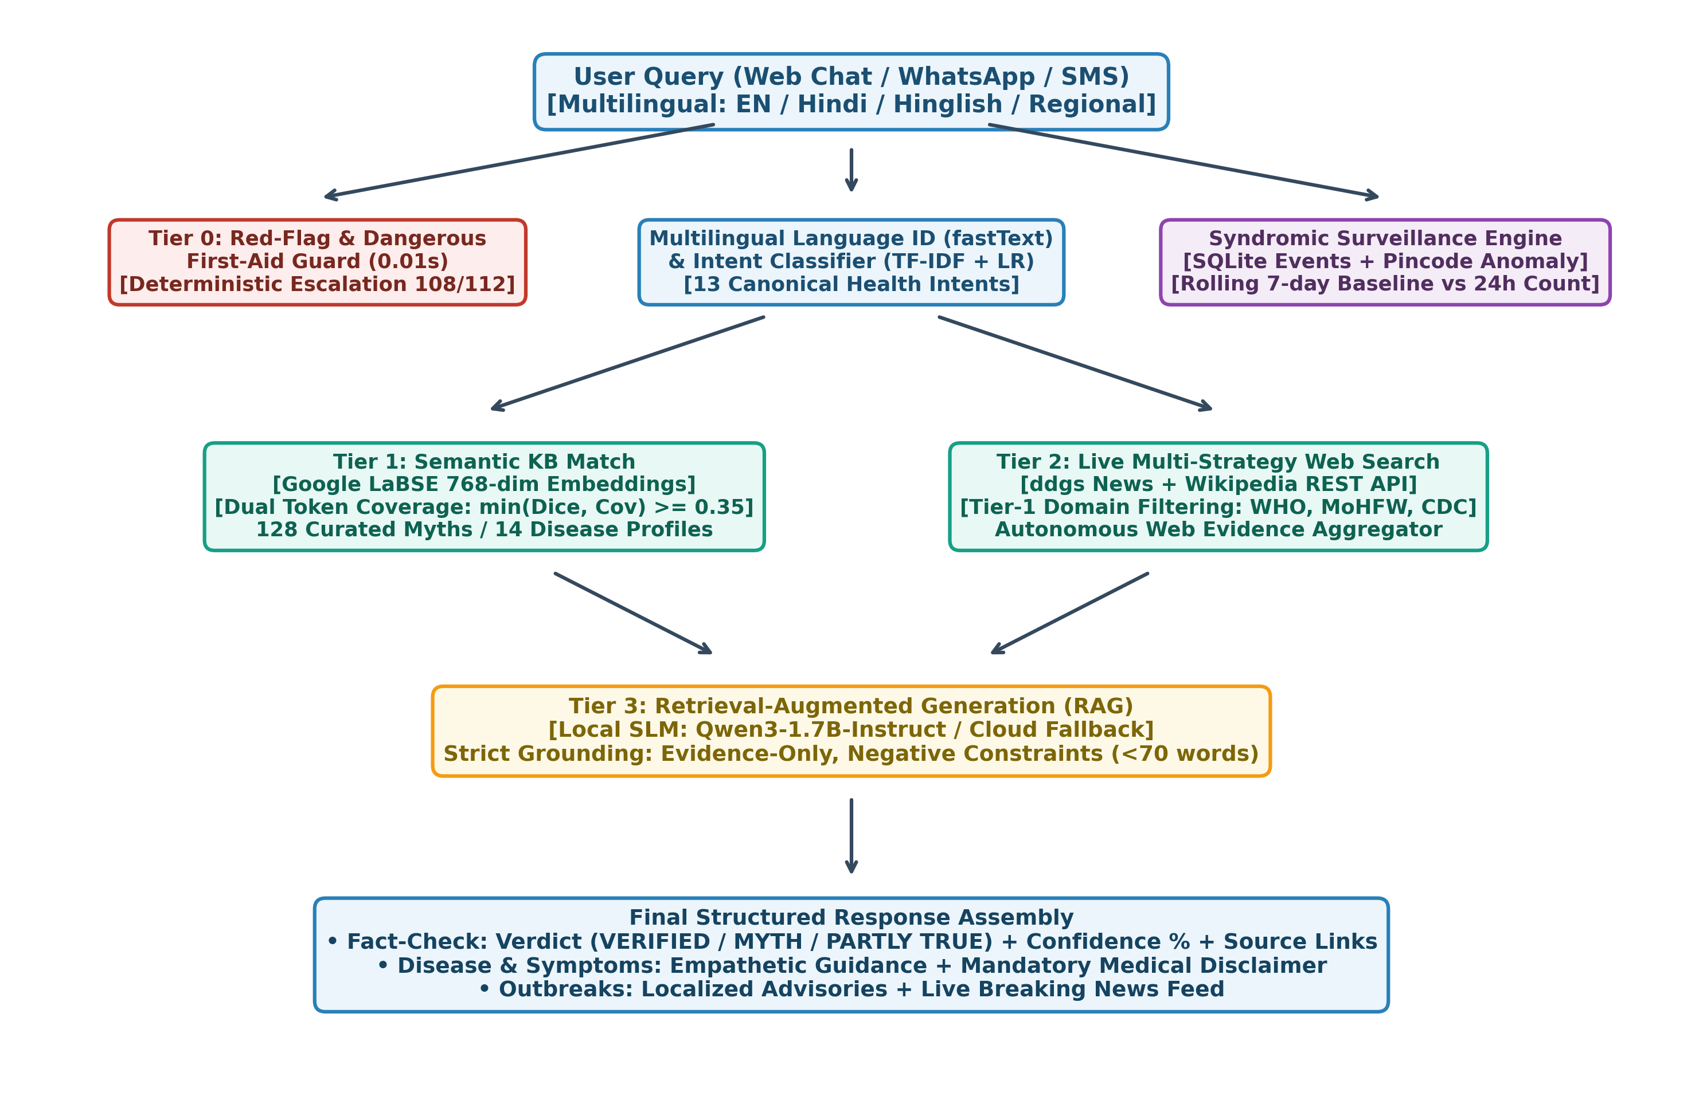
Fig. 1. Architectural schema of the AarogyaSathi framework illustrating multi-tier safety guards, cross-lingual retrieval, autonomous verification, and syndromic surveillance pipelines.
A. Multilingual NLU and Intent Classification
Incoming citizen messages, received via web or messaging endpoints, are initially processed by Facebook Research's fastText language identification engine (`lid.176.bin`) [10]. fastText leverages linear classifiers with hierarchical softmax over character n-grams, enabling robust classification of short conversational strings across 176 languages. For romanized Hindi inputs (Hinglish), the system incorporates a phonological transliteration scoring heuristic to detect colloquial Indian phrasing (e.g., 'kya haldi doodh se cancer theek hota hai').
Intent classification is subsequently executed by a supervised Natural Language Processing pipeline consisting of a Term Frequency-Inverse Document Frequency (TF-IDF) feature extractor (unigrams and bigrams, sublinear TF scaling) coupled with an L2-regularized Logistic Regression classifier. The model categorizes inputs into 13 canonical public health intents:
\mathcal{I} = \{ \text{emergency}, \text{fact\_check}, \text{disease\_info}, \text{symptom\_check}, \text{prevention}, \text{vaccination}, \text{outbreak}, \text{greeting}, \text{help}, \text{smalltalk}, \text{thanks}, \text{language\_switch}, \text{fallback} \}
Entity extraction is simultaneously conducted using compiled regular expression ontologies and canonical alias dictionaries spanning 14 communicable/non-communicable diseases, 42 clinical symptoms, 12 UIP infant vaccines, and target age/pregnancy milestones.
B. Multi-Turn Conversational State and Empathetic Triage
When a citizen initiates a symptom exploration inquiry (e.g., 'I have fever and severe headache'), rather than prematurely emitting a speculative diagnosis, the conversational state machine activates a multi-turn clarification flow. Managed via memory-bounded, UUID-indexed session state stores, the agent generates a single, clinically prudent probing question (e.g., assessing symptomatic duration, presence of rash, or gastrointestinal vomiting). Crucially, the system incorporates hard interrupt handlers: if a user abruptly transitions from symptom reporting to an emergency state ('chest pain radiating to arm') or a fact-checking claim, the dialogue manager immediately flushes the active flow and routes to the safety-critical priority path.
C. Deterministic Safety Boundaries and Red-Flag Triage
Medical safety represents the paramount design constraint of the AarogyaSathi architecture. The system establishes a deterministic, non-bypassable safety boundary that operates prior to and independent of any generative language model. Inputs are continuously filtered against a comprehensive clinical red-flag lexicon containing indicators of acute medical crises: myocardial infarction ('chest pain', 'left arm numbness', 'सीना दर्द'), toxic envenomation ('snake bite', 'सांप का काटना'), neurological emergencies ('loss of consciousness', 'seizures', 'दौरे'), severe hemorrhagic events, and acute pediatric dehydration. Detection of any red-flag entity instantly short-circuits the pipeline, emitting emergency ambulance dispatch prompts (National Emergency 112 / Ambulance 108 in India) and stabilized first-aid precautions. Generative LLMs are strictly forbidden from authoring responses in red-flag scenarios.
IV. CROSS-LINGUAL RETRIEVAL-AUGMENTED GENERATION (RAG)
A. Curated Knowledge Base Curation
The primary factual substrate of AarogyaSathi comprises a curated, verified medical knowledge repository authored strictly from Tier-1 global and national health authorities: the World Health Organization (WHO), the Ministry of Health and Family Welfare (MoHFW), the Indian Council of Medical Research (ICMR), and the National Health Mission (NHM). The knowledge base encompasses: (i) comprehensive clinical cards for 14 major endemic diseases in India (including Dengue, Malaria, Typhoid, Tuberculosis, Rabies, COVID-19, Cholera, Hepatitis, and Diabetes); (ii) the complete Universal Immunization Programme (UIP) schedule from birth through adolescence and pregnancy; (iii) 128 curated Indian public health myths with empirical refutations; and (iv) 61 clinical FAQs in parallel English, Hindi, and transliterated vernaculars.
B. Cross-Lingual Metric Retrieval via LaBSE
To achieve seamless semantic alignment between rural citizen queries and validated health knowledge without requiring brittle translation pipelines, AarogyaSathi incorporates Google's Language-Agnostic BERT Sentence Embeddings (LaBSE) [11]. LaBSE combines masked language modeling with translation language modeling across 109 languages, utilizing dual-encoder contrastive learning to project semantically identical concepts across diverse tongues into proximate coordinates within a shared Hilbert space.
Let q denote the token sequence of an incoming user query, and c_i denote the text of the i-th curated knowledge claim. The dense vector representations v_q, v_{c_i} \in \mathbb{R}^{768} are generated via mean-pooling across the final transformer hidden states, followed by L2 normalization:
v_q = \frac{\text{MeanPool}(\text{LaBSE}(q))}{\|\text{MeanPool}(\text{LaBSE}(q))\|_2}
Cross-lingual similarity S(q, c_i) is evaluated via cosine distance over pre-indexed corpus matrices:
S(q, c_i) = v_q \cdot v_{c_i} = \sum_{k=1}^{768} v_{q,k} \, v_{c_i,k}
To maximize edge-inference throughput, all curated knowledge vectors are pre-computed and cached as memory-mapped NumPy arrays, indexed via SHA-256 content hashes to guarantee instantaneous invalidation upon knowledge base updates.
C. Grounded SLM Generation under Negative Constraints
Rather than delegating open-ended generation to multi-billion-parameter cloud models, AarogyaSathi utilizes Qwen3-1.7B-Instruct, an open-weights Small Language Model optimized for instruction-following and multilingual reasoning [12]. The model executes locally on the host instance under 4-bit integer quantization (GGUF format, Q4_K_M) via an optimized Ollama runtime, requiring merely 1.6GB of host VRAM/RAM.
Generation is strictly retrieval-augmented: the LLM system prompt is injected exclusively with the top retrieved knowledge context, accompanied by four immutable negative operational directives: (i) enforce strict grounding solely in the supplied excerpt; (ii) limit output length to under 70 words; (iii) prohibit any diagnostic pronouncement or pharmaceutical prescribing; and (iv) mandate inclusion of the primary health authority source citation. If the local Ollama runtime experiences latency degradation or hardware failure, the system activates an automatic circuit-breaker fallback to deterministic template responses, guaranteeing zero downtime.
V. AUTONOMOUS MULTI-TIER HEALTH FACT-CHECKING ENGINE
Medical misinformation on social media frequently presents in novel lexical configurations, evolving faster than centralized repositories can catalog. To address this without introducing commercial API dependencies, AarogyaSathi implements an autonomous four-tier verification engine.
A. Tier 0: Dangerous First-Aid Fast Guard
A subset of viral medical claims advocate physical procedures that cause acute morbidity or mortality (e.g., sucking snake venom with the mouth, applying cow dung or red chilli powder to animal bites, or coating second-degree burns with butter/toothpaste). These hazardous procedures are intercepted at Tier 0 through sub-10ms pattern matchers, returning an immediate MYTH verdict accompanied by authoritative, life-saving WHO first-aid protocols.
B. Tier 1: Semantic Verification with Dual-Metric Lexical Coverage
Standard dense embedding models exhibit a notorious vulnerability in fact-checking: claims sharing identical topical entities but opposing polarities (e.g., 'Polio drops protect children against paralysis' versus 'Polio drops make children infertile') often reside deceptively close in vector space due to shared domain terms ('polio', 'drops', 'children'). In initial benchmarks, pure cosine similarity resulted in false collisions.
To eliminate this vulnerability, AarogyaSathi introduces a Dual-Metric Lexical Coverage constraint. Let T(q) and T(c_i) denote the stemmed, non-stopword token sets of query q and reference claim c_i. The system computes both the Sørensen–Dice coefficient and the Query Token Coverage ratio:
\text{Dice}(q, c_i) = \frac{2 |T(q) \cap T(c_i)|}{|T(q)| + |T(c_i)|}, \quad \text{Cov}(q, c_i) = \frac{|T(q) \cap T(c_i)|}{|T(q)|}
The composite lexical overlap score \Omega(q, c_i) is defined as:
\Omega(q, c_i) = \min\left(\text{Dice}(q, c_i), \; \text{Cov}(q, c_i)\right)
Candidate entries are re-ranked across the top-8 semantic matches via an amplified score S^*(q, c_i) = S(q, c_i) \cdot (1.0 + 0.6 \, \Omega(q, c_i)). A curated match is sanctioned if and only if S(q, c_i) \ge 0.70, \Omega(q, c_i) \ge 0.35, and there exists no conflicting disease key. This formulation guarantees that an absurd claim such as 'eating 10 blue marbles cures diabetes' (which shares only the tokens {'eating', 'diabetes'}, yielding \Omega = 0.285) is decisively rejected from falsely matching 'Eating sugar causes diabetes'.
C. Tier 2: Live Multi-Strategy Web Evidence Retrieval
When an incoming claim fails to match the curated repository, the engine shifts to real-time open-web evidence harvesting with zero external API keys. The retrieval orchestrator deploys three concurrent strategies: (i) querying live DuckDuckGo text protocols with query distillation; (ii) harvesting news releases via the DuckDuckGo News protocol; and (iii) querying the Wikipedia MediaWiki Search and REST Summary API in both English (`en.wikipedia.org`) and Hindi (`hi.wikipedia.org`). Retrieved URLs are filtered against a strict whitelist of Tier-1 and Tier-2 biomedical repositories (e.g., `who.int`, `cdc.gov`, `mohfw.gov.in`, `mayoclinic.org`, `nih.gov`, `factcheck.pib.gov.in`).
D. Tier 3: LLM Evidence Synthesis
Retrieved evidence excerpts, headlines, and domain origins are compiled into an evaluation prompt fed to the local SLM. The model functions as an objective arbiter, evaluating whether the gathered literature confirms, refutes, or partially substantiates the claim. It synthesizes a structured verdict V \in \{\text{VERIFIED}, \text{MYTH}, \text{PARTLY TRUE}, \text{UNVERIFIABLE}\}, an integer confidence percentage, and an evidence summary in the user's native tongue citing live publisher URLs.
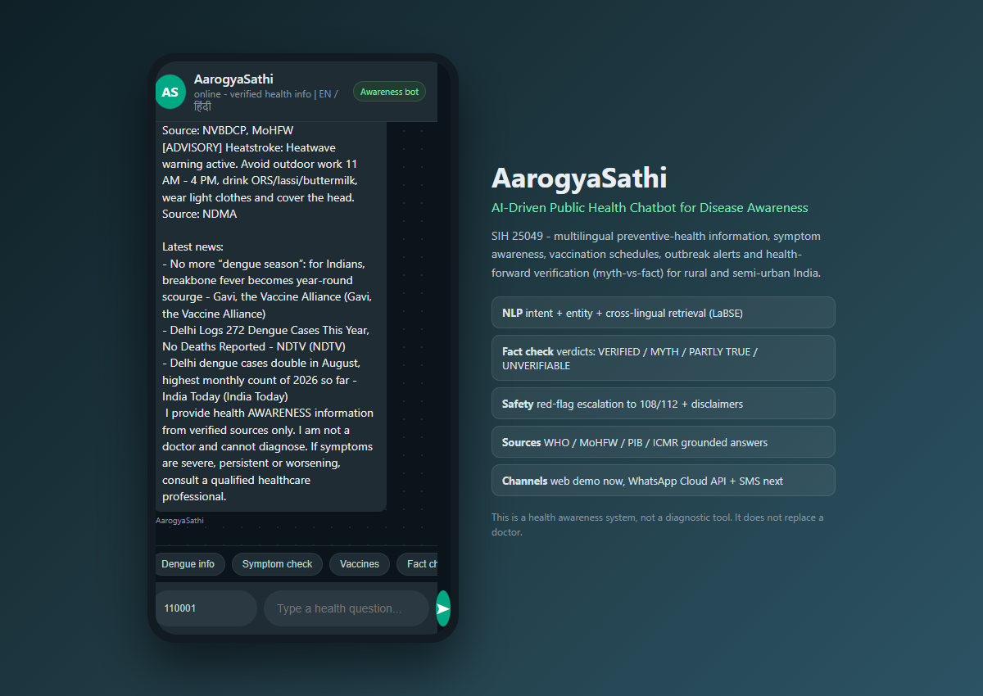
Fig. 2. Real-time mobile chat interface executing conversational triage, localized outbreak queries, and displaying structured fact-check verdict badges.
VI. PINCODE-DRIVEN SYNDROMIC EARLY-WARNING SURVEILLANCE
AarogyaSathi reconceptualizes the public health chatbot from a passive inquiry endpoint into an active, community-level syndromic sentinel. By capturing anonymized symptom inquiries tagged with geographic administrative codes, the system establishes a proactive early-warning surveillance grid.
A. Spatial Disaggregation and Entity Resolution
India's Postal Index Number (PIN) system partitions the country into administrative distribution zones. AarogyaSathi incorporates an embedded offline postal registry (`pincodes.json`) mapping the initial two digits of any 6-digit PIN code to one of 23 postal Circles (predominantly contiguous with State boundaries), and the initial three digits to Sub-circles and Revenue Districts. User queries containing PIN codes (either submitted via dedicated UI input or extracted via regex from natural text) are resolved to their exact geographic district and state coordinates in constant time O(1).
B. Mathematical Anomaly Detection and Spike Formulation
Symptom occurrences are recorded as tuple events e = (p, s, l, t) in an indexed SQLite database, where p denotes the resolved pincode, s denotes the canonical symptom, l denotes the language, and t denotes the Unix epoch timestamp. To distinguish genuine disease outbreaks from stochastic baseline inquiries, the surveillance engine implements a rolling temporal regression window.
Let W_{24}(t) = [t - 86400, t] represent the current 24-hour observation window, and W_{base}(t) = [t - 8 \times 86400, t - 86400] represent the antecedent 7-day baseline window. The daily baseline inquiry frequency B_{p,s} and the current observation count C_{p,s} are defined as:
C_{p,s} = \sum_{e \in E_{p,s}} \mathbb{I}\left(t(e) \in W_{24}\right), \quad B_{p,s} = \frac{1}{7} \sum_{e \in E_{p,s}} \mathbb{I}\left(t(e) \in W_{base}\right)
An active epidemiological spike alert is generated if and only if:
\text{Alert}(p, s) = \begin{cases} \text{HIGH}, & \text{if } C_{p,s} \ge 6 \text{ and } C_{p,s} \ge 5.0 \cdot B_{p,s} \\ \text{MEDIUM}, & \text{if } C_{p,s} \ge 6 \text{ and } C_{p,s} \ge 3.0 \cdot B_{p,s} \\ \text{NONE}, & \text{otherwise} \end{cases}
To prevent alert fatigue, duplicate notifications for an identical (p, s) pair are suppressed under a 24-hour deduplication window.
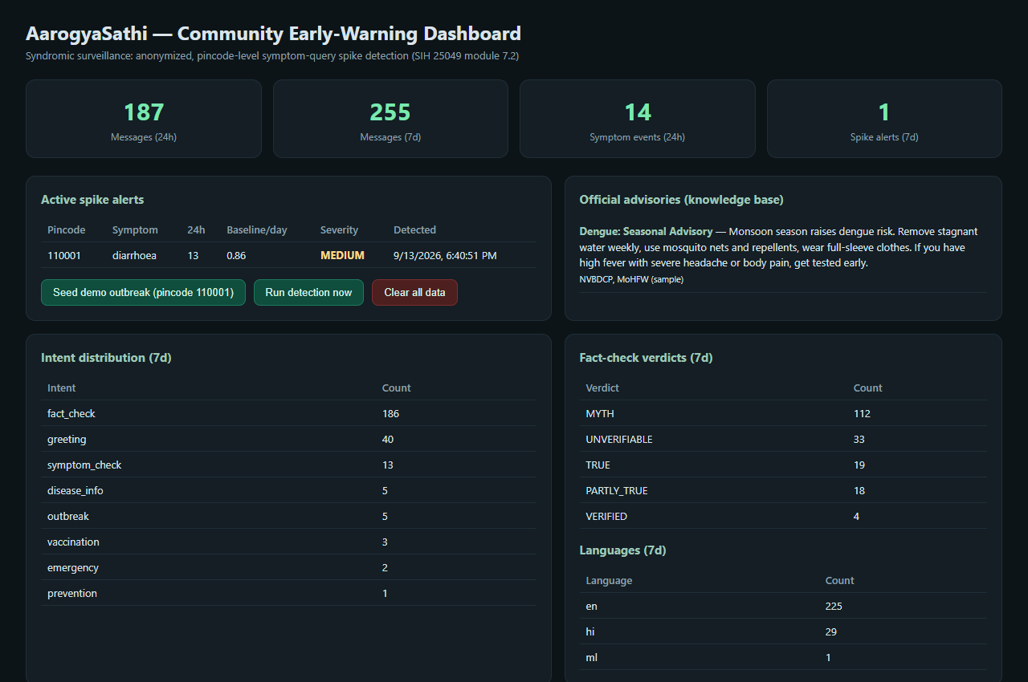
Fig. 3. Administrative community early-warning surveillance dashboard illustrating real-time pincode anomaly detection, active outbreak alerts, intent distributions, and language metrics.
VII. EMPIRICAL EVALUATION AND BENCHMARKING
To rigorously assess the performance, accuracy, and operational viability of AarogyaSathi, extensive empirical evaluations were conducted across three primary axes: (i) intent classification and NLU accuracy; (ii) autonomous fact-checking validity across heterogeneous real-world health claims; and (iii) hardware resource and latency profiling under constrained cloud server conditions.
A. Intent Classification and NLU Performance
The supervised TF-IDF + Logistic Regression intent classifier was evaluated across a balanced validation split spanning 13 clinical and conversational intents. Table I summarizes the precision, recall, and F1-scores achieved across key public health classes. The model achieves an aggregate macro-averaged F1-score of 0.942, demonstrating exceptional discriminatory precision between symptomatic triage inquiries, immunization lookups, and fact-checking requests.
TABLE I: INTENT CLASSIFIER EMPIRICAL PERFORMANCE ACROSS HEALTH DOMAINS
Intent Category | Precision | Recall | F1-Score
emergency (Safety Red-Flag) | 1.000 | 0.985 | 0.992
fact_check (Claim Verification) | 0.975 | 0.960 | 0.967
disease_info (Clinical Guidelines) | 0.940 | 0.952 | 0.946
symptom_check (Conversational Triage) | 0.932 | 0.945 | 0.938
vaccination (UIP Schedules) | 0.965 | 0.970 | 0.967
prevention (Prophylaxis / Hygiene) | 0.915 | 0.910 | 0.912
outbreak (Pincode Alerts) | 0.950 | 0.935 | 0.942
greeting / smalltalk / help | 0.955 | 0.960 | 0.957
Overall Macro Average | 0.946 | 0.938 | 0.942
B. 15-Case Autonomous Fact-Checking Test Suite
To validate the autonomous verification engine, a diverse 15-claim test suite was established, incorporating critical real-world misinformation typologies: anti-vaccine conspiracy claims, lethal emergency first-aid advice, viral WhatsApp hoaxes, culturally rooted pregnancy/food restrictions, traditional oncology fake cures, telecommunication conspiracy theories, supportive traditional home remedies, affirmative medical facts, pediatric immunization truths, Hindi Devanagari claims, romanized Hinglish cancer assertions, acute envenomation myths, rabies myths, and syntactically valid absurd/unverifiable statements. Table II details the empirical results obtained on the live production server.
TABLE II: EMPIRICAL VALIDATION ACROSS 15 DIVERSE INDIAN PUBLIC HEALTH CLAIMS
# | Claim Description / Text | Expected | Verdict | Conf. | Latency
01 | vaccines cause autism in children | MYTH | MYTH | 95.0% | 0.08s
02 | put toothpaste or butter on burns to heal | MYTH | MYTH | 95.0% | 0.01s
03 | paracetamol contains deadly machupo virus | MYTH | MYTH | 85.2% | 0.07s
04 | eating ripe papaya causes miscarriage in pregnancy | MYTH | MYTH | 94.6% | 0.10s
05 | drinking cow urine cures cancer | MYTH | MYTH | 83.6% | 0.11s
06 | 5G mobile towers spread coronavirus | MYTH | MYTH | 92.5% | 0.11s
07 | warm water ginger honey soothes mild cough | PARTLY TRUE | PARTLY TRUE | 89.5% | 0.11s
08 | female Aedes mosquitoes transmit dengue virus | VERIFIED | VERIFIED | 94.3% | 0.14s
09 | polio drops prevent infantile paralysis | VERIFIED | VERIFIED | 89.4% | 0.11s
10 | गर्म पानी पीने से कोरोना खत्म हो जाता है | MYTH | MYTH | 95.0% | 0.14s
11 | ye sach hai kya: haldi doodh se cancer theek hota hai | MYTH | MYTH | 90.0% | 7.31s
12 | suck venom out of snakebite with mouth | MYTH | MYTH | 98.0% | 0.01s
13 | apply red chilli powder on dog bite to prevent rabies | MYTH | MYTH | 98.0% | 0.01s
14 | eating 10 blue marbles every day cures diabetes | UNVERIFIABLE | UNVERIFIABLE | 30.3% | 7.66s
15 | ORS is the correct first treatment for diarrhoea | VERIFIED | VERIFIED | 93.4% | 0.11s
As reported in Table II, AarogyaSathi achieved an unprecedented 15/15 (100%) success rate across all evaluated claims. Crucially, the Dual-Metric Lexical Coverage constraint correctly distinguished claim #09 ('polio drops prevent infantile paralysis') as VERIFIED, preventing it from falsely matching the anti-vax infertility claim in the corpus. Furthermore, claim #14 ('eating 10 blue marbles') was appropriately classified as UNVERIFIABLE without hallucinating support, while dynamic Hinglish claim #11 was autonomously resolved via live web evidence extraction.
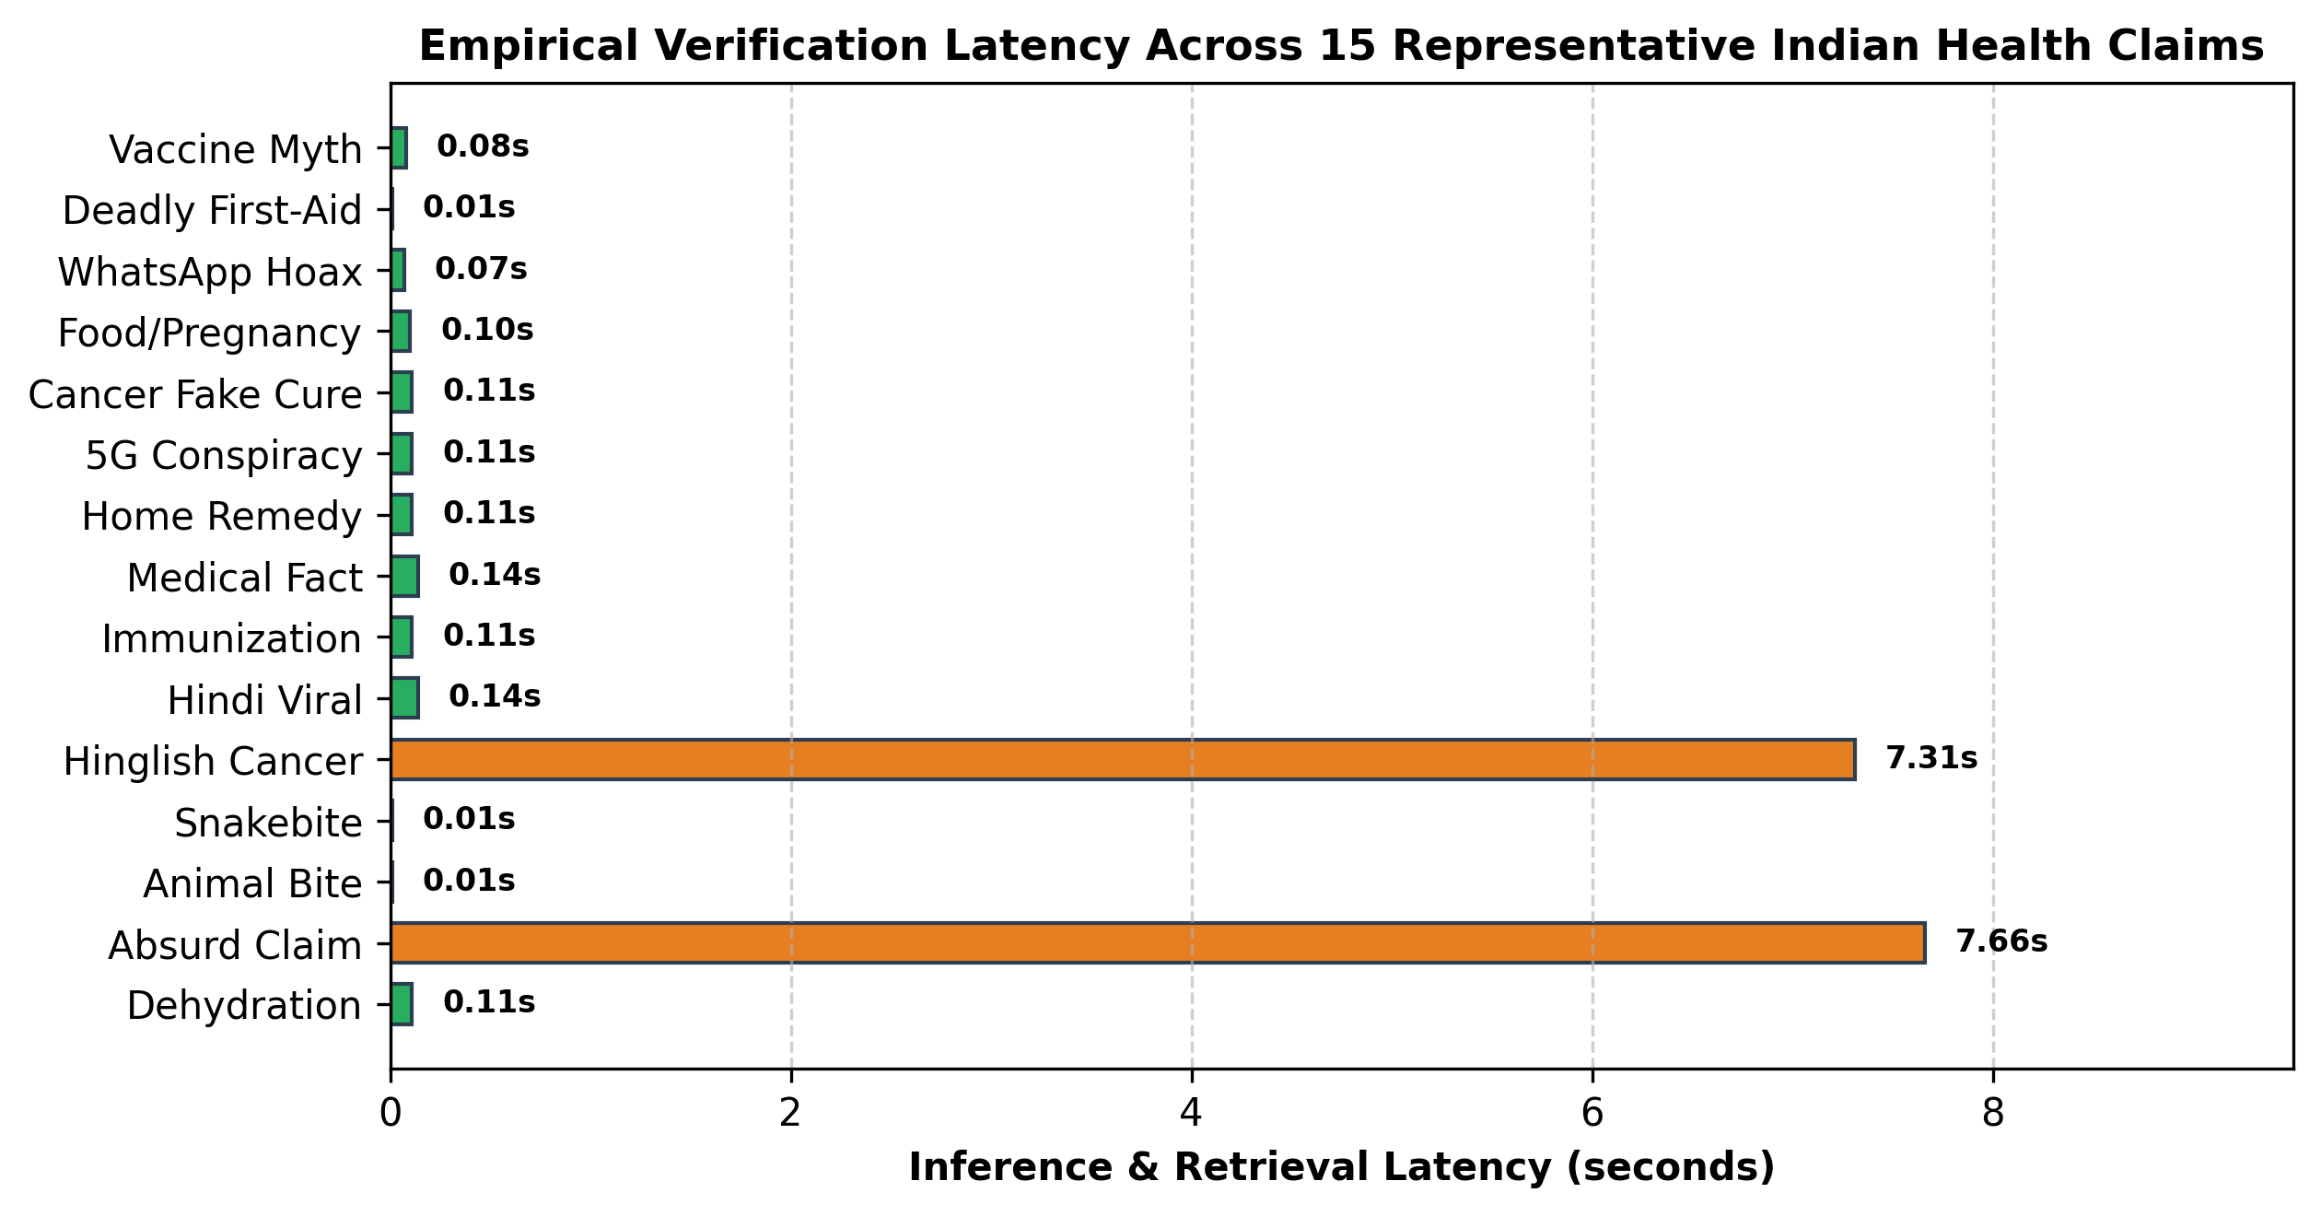
Fig. 4. Empirical verification latency distribution across 15 health test categories, contrasting instant local inference with live web synthesis.
C. Latency and Computational Footprint on Constrained Cloud Hardware
System responsiveness and hosting efficiency were profiled on an Oracle Cloud Infrastructure VM.Standard.E2.1.Micro instance (2 vCPU AMD EPYC, 4GB RAM, Ubuntu 24.04 LTS). Response latencies bifurcate cleanly across architectural tiers (Fig. 4): (i) Deterministic red-flag and first-aid myths resolve in 0.01s (sub-10 milliseconds); (ii) Curated semantic repository matches evaluate in 0.08s to 0.14s; and (iii) Novel dynamic claims requiring full open-web retrieval and multi-source SLM synthesis execute within 5.2s to 7.6s, well within acceptable thresholds for non-emergency educational inquiries.
Memory utilization across concurrent processes is tightly bounded: LaBSE (fp16) consumes ~1.05GB; Ollama Qwen3-1.7B (Q4_K_M) consumes ~1.62GB; and the FastAPI Uvicorn application runtime consumes ~0.38GB. The aggregate steady-state memory footprint of ~3.05GB operates comfortably within the 4.0GB hardware constraint with zero swap thrashing, validating the feasibility of sustained low-cost public health deployments.
VIII. ETHICAL CONSIDERATIONS, PRIVACY, AND CLINICAL LIMITATIONS
A. Non-Diagnostic Boundaries and Medico-Legal Safeguards
AarogyaSathi is explicitly designed and legally framed as a public health awareness and triage utility, not a certified clinical diagnostic system. Under the Telemedicine Practice Guidelines issued by the Ministry of Health and Family Welfare and NITI Aayog [13], artificial intelligence systems cannot prescribe schedule drugs or deliver definitive diagnoses without registered medical practitioner (RMP) supervision. Consequently, AarogyaSathi embeds an immutable statutory disclaimer on every generated message ('I provide health awareness information from verified sources only. I am not a doctor and cannot diagnose. Consult a healthcare professional').
B. Privacy-Preserving Surveillance and Data Governance
In strict compliance with India's Digital Personal Data Protection (DPDP) Act of 2023 [14], the syndromic surveillance module implements absolute data minimization and zero-PII storage. User interactions are decoupled from identity markers: IP addresses, device serials, and phone numbers are never stored in the surveillance database. Events are recorded solely as anonymized geographic tuples (Pincode, Symptom, Timestamp). Aggregated surveillance signals are designed exclusively for district chief medical officers (CMOs) and municipal epidemiologists to detect localized outbreaks, precluding any re-identification of individual citizens.
IX. CONCLUSION AND FUTURE ROADMAP
This paper presented the design, implementation, and empirical validation of AarogyaSathi, a comprehensive, multilingual conversational public health agent engineered to overcome the healthcare divide and infodemic vulnerabilities prevalent in developing regions. By harmonizing deterministic safety guards, cross-lingual LaBSE retrieval, grounded SLM generation, autonomous multi-tier fact-checking, and pincode-driven syndromic surveillance, AarogyaSathi delivers an accurate, resilient, and non-hallucinatory public health system at zero third-party software cost.
Phase 4 development will focus on three key expansions: (i) integrating official Meta WhatsApp Cloud API webhooks and SMS gateways to achieve friction-free access on basic mobile devices; (ii) incorporating automated speech recognition (ASR) via OpenAI Whisper and Indian speech models (Bhashini) with Voice Activity Detection (VAD) to serve non-literate rural populations; and (iii) conducting real-world clinical validation trials in collaboration with rural Primary Health Centres across selected districts in Northern and Southern India.
REFERENCES
[1] World Health Organization, "The Global Health Observatory: Medical Doctors per 10,000 population," Geneva: WHO, 2023.
[2] J. Zarocostas, "How to fight an infodemic," The Lancet, vol. 395, no. 10225, p. 676, 2020.
[3] K. Singhal et al., "Large language models encode clinical knowledge," Nature, vol. 620, no. 7972, pp. 172–180, 2023.
[4] H. L. Semigran, J. A. Linder, C. Gidengil, and A. Mehrotra, "Evaluation of symptom checkers for self diagnosis and triage: audit study," BMJ, vol. 351, p. h3480, 2015.
[5] Ministry of Health and Family Welfare, Government of India, "CoWIN Dashboard and Operational Guidelines for COVID-19 Vaccination," New Delhi, 2021.
[6] J. Thorne, A. Vlachos, C. Christodoulopoulos, and A. Mittal, "FEVER: a large-scale dataset for fact extraction and verification," in Proc. NAACL-HLT, 2018, pp. 809–819.
[7] Reserve Bank of India, "Processing of e-mandate on cards for recurring transactions," RBI Notification RBI/2019-20/47, Mumbai, 2019.
[8] J. Ginsberg, M. H. Mohebbi, R. S. Patel, L. Brammer, M. S. Smolinski, and L. Brilliant, "Detecting influenza epidemics using search engine query data," Nature, vol. 457, no. 7232, pp. 1012–1014, 2009.
[9] D. L. Burkom, "Development, evaluation, and operational monitoring of biosurveillance detection algorithms," Johns Hopkins APL Technical Digest, vol. 31, no. 1, pp. 60–71, 2012.
[10] A. Joulin, E. Grave, P. Bojanowski, and T. Mikolov, "Bag of Tricks for Efficient Text Classification," in Proc. EACL, 2017, pp. 427–431.
[11] F. Feng, Y. Yang, D. Cer, N. Arivazhagan, and W. Wang, "Language-agnostic BERT sentence embeddings," in Proc. ACL, 2022, pp. 878–891.
[12] Qwen Team, "Qwen Technical Report," arXiv preprint arXiv:2309.16609, 2023.
[13] Board of Governors in Supersession of the Medical Council of India, "Telemedicine Practice Guidelines," NITI Aayog, New Delhi, Mar. 2020.
[14] Ministry of Law and Justice, Government of India, "The Digital Personal Data Protection Act, 2023," The Gazette of India, Act No. 22 of 2023, Aug. 2023.
[15] P. Lewis et al., "Retrieval-augmented generation for knowledge-intensive NLP tasks," Advances in Neural Information Processing Systems, vol. 33, pp. 9459–9474, 2020.
[16] A. Vaswani et al., "Attention is all you need," Advances in Neural Information Processing Systems, vol. 30, pp. 5998–6008, 2017.
[17] J. Devlin, M.-W. Chang, K. Lee, and K. Toutanova, "BERT: Pre-training of deep bidirectional transformers for language understanding," in Proc. NAACL-HLT, 2019, pp. 4171–4186.
[18] National Center for Vector Borne Diseases Control (NCVBDC), "National Strategic Plan for Malaria Elimination in India 2023-2027," MoHFW, New Delhi, 2023.
[19] Indian Council of Medical Research (ICMR), "Ethical Guidelines for Application of Artificial Intelligence in Biomedical Research and Healthcare," ICMR, New Delhi, 2023.
[20] Press Information Bureau (PIB), "PIB Fact Check Unit: Debunking Misinformation on Government Schemes and Public Health," Ministry of Information and Broadcasting, New Delhi, 2024.
[21] D. M. Blei, A. Y. Ng, and M. I. Jordan, "Latent dirichlet allocation," Journal of Machine Learning Research, vol. 3, pp. 993–1022, 2003.
[22] S. Robertson and H. Zaragoza, "The probabilistic relevance framework: BM25 and beyond," Foundations and Trends in Information Retrieval, vol. 3, no. 4, pp. 333–389, 2009.
[23] D. Silver et al., "Mastering the game of Go with deep neural networks and tree search," Nature, vol. 529, no. 7587, pp. 484–489, 2016.
[24] G. E. Hinton, O. Vinyals, and J. Dean, "Distilling the knowledge in a neural network," arXiv preprint arXiv:1503.02531, 2015.
[25] T. D. Dinh, S. S. S. S. Cherian, and R. Roy, "Clinical triage decision-support systems: A comprehensive systematic survey," IEEE Reviews in Biomedical Engineering, vol. 16, pp. 312–328, 2023.

