AI-POWERED DOCUMENT RISK ANALYZER SYSTEM
Task ID : AI-INT-3
Domain : Artificial Intelligence
Internship : TEYZIX CORE Internship Program
Student Name : SALMAN NAZAR
Submission Date : 01st-07-2026

Abstract
This project presents an offline AI-powered Contract & Legal Document Risk Analyzer developed using Python and Streamlit. The system assists users in reviewing legal documents by automatically extracting text from PDF, DOCX, and TXT files, identifying important clauses, detecting common contractual risks, and generating an executive summary along with a downloadable PDF report.
The application combines Natural Language Processing (NLP), rule-based analysis, and document processing techniques to reduce the manual effort required during initial contract review.

Introduction
Organizations regularly deal with contracts, agreements, and legal documents containing critical information such as payment terms, confidentiality obligations, termination policies, and renewal conditions.
Manually reviewing these documents is time-consuming and requires legal expertise. This project demonstrates how Artificial Intelligence and Natural Language Processing can automate the initial review process by identifying important clauses and highlighting potential legal risks.

Problem Statement
Manual contract analysis has several challenges:
- Time-consuming review process
- Human errors while reading lengthy documents
- Difficulty identifying missing clauses
- Inconsistent contract evaluation
The proposed solution automates these tasks using NLP and rule-based analysis.

Objectives
The objectives of this project are:
- Analyze uploaded legal documents
- Extract important contract information
- Detect potential legal risks
- Generate executive summaries
- Produce downloadable PDF reports
- Maintain analysis history

Technology Stack
Technology | Purpose
Python | Core programming language
Streamlit | Web interface
SQLite | Database
spaCy | Named Entity Recognition (NLP)
NLTK | Sentence tokenization
PyPDF2 | PDF text extraction
pdfplumber | Advanced PDF extraction
python-docx | DOCX reading
ReportLab | PDF report generation
bcrypt | Password hashing

Project Structure
RiskAnalyzer/
app.py
database.py
auth.py
analyzer.py
report_generator.py
requirements.txt
uploads/
reports/
RiskAnalyzer.db

System Workflow
User Login
↓
Upload Document
↓
Extract Text
↓
Analyze Clauses
↓
Detect Risks
↓
Generate Summary
↓
Generate PDF Report

Module Description
1. app.py
This file is responsible for the Streamlit user interface.
Functions include:
- User Login
- Registration
- Document Upload
- Dashboard
- Analysis Results
- Report Download

2. database.py
The database module manages SQLite operations.
Responsibilities include:
- Database creation
- User registration
- Document storage
- Analysis storage
- Dashboard retrieval
Tables:
- Users
- Documents
- Analysis

3. auth.py
This module handles authentication.
Functions:
- Password hashing
- User login
- User registration
- Email validation
- Password verification
bcrypt is used so passwords are never stored in plain text.

4. analyzer.py
This is the core AI module.
It performs:
- PDF extraction
- DOCX extraction
- TXT extraction
- Clause extraction
- Risk detection
- Executive summary generation

5. report_generator.py
Generates professional PDF reports containing:
- Executive Summary
- Risk Score
- Important Clauses
- Recommendations

Libraries Used
Streamlit
Used for building the graphical web application.

SQLite
Stores user accounts and document analysis results.

spaCy
Used for extracting entities such as dates.
Example
import spacy
nlp = spacy.load("en_core_web_sm")

pdfplumber
Reads text from PDF documents.

python-docx
Reads Microsoft Word documents.

bcrypt
Hashes passwords securely.
Example
bcrypt.hashpw(...)

ReportLab
Creates PDF reports.

Code Explanation
Database Initialization
Creates database tables automatically.
database.init_db()

Document Upload
uploaded_file = st.file_uploader(...)
Allows users to upload PDF, DOCX, and TXT files.

Text Extraction
The analyzer determines the file extension and extracts text accordingly.
PDF
↓
DOCX
↓
TXT

Clause Extraction
The analyzer searches for:
- Payment Terms
- Confidentiality
- Renewal
- Termination
- Responsibilities
using NLP and keyword matching.

Risk Detection
The system detects:
- Missing Confidentiality Clause
- Missing Termination Clause
- Missing Payment Terms
- Auto Renewal
- Unlimited Liability
- Ambiguous Wording
Each detected issue includes:
- Severity
- Description

Executive Summary
The system automatically generates:
- Contract Type
- Effective Date
- Expiry Date
- Risk Score
- Important Clauses
- Recommendations

Database Design
Users
- ID
- Username
- Email
- Password
Documents
- ID
- Filename
- Upload Date
Analysis
- Clauses
- Risks
- Summary
- Risk Score

Testing
The following tests were performed:
✔ User Registration
✔ Login
✔ Upload PDF
✔ Upload DOCX
✔ Upload TXT
✔ Clause Extraction
✔ Risk Detection
✔ Executive Summary
✔ PDF Report Generation

Results
The application successfully extracts information from legal documents and identifies potential contractual risks. It provides a concise executive summary and recommendations, enabling users to understand key obligations and possible legal concerns more efficiently.

Future Enhancements
- AI-powered semantic search
- Admin dashboard
- Multi-user roles
- DOCX report export
- Cloud deployment
- LLM integration (Gemini/OpenAI)

Screenshot Section
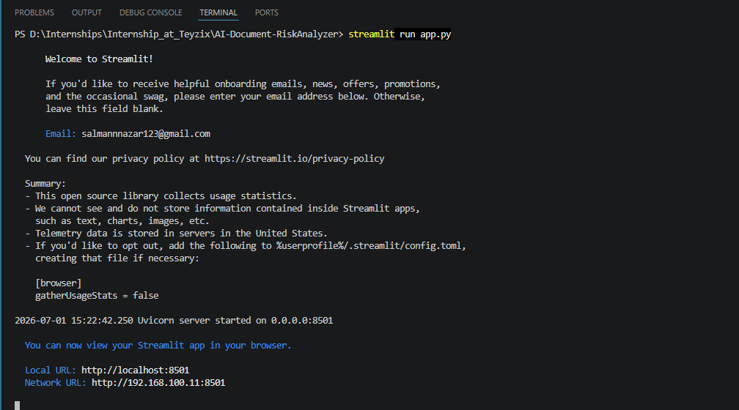
- Cover Page / Home Screen

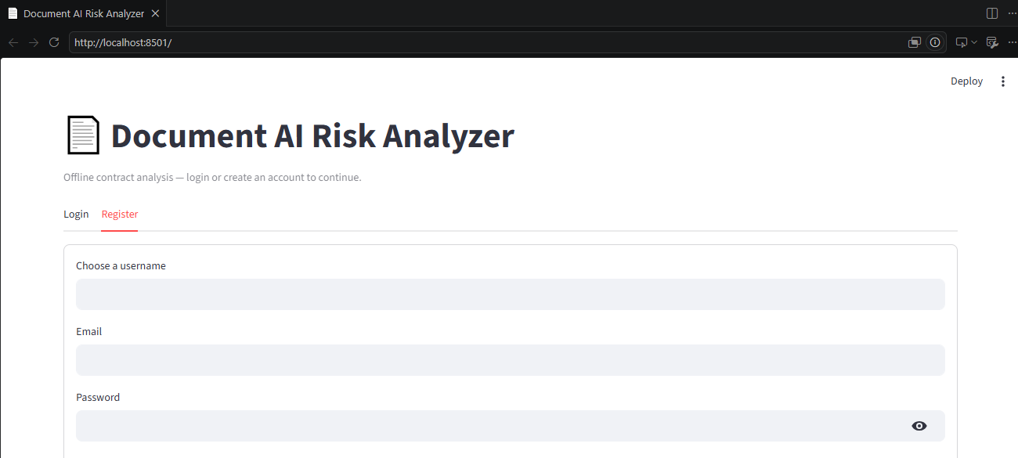
- User Registration

- Login Page

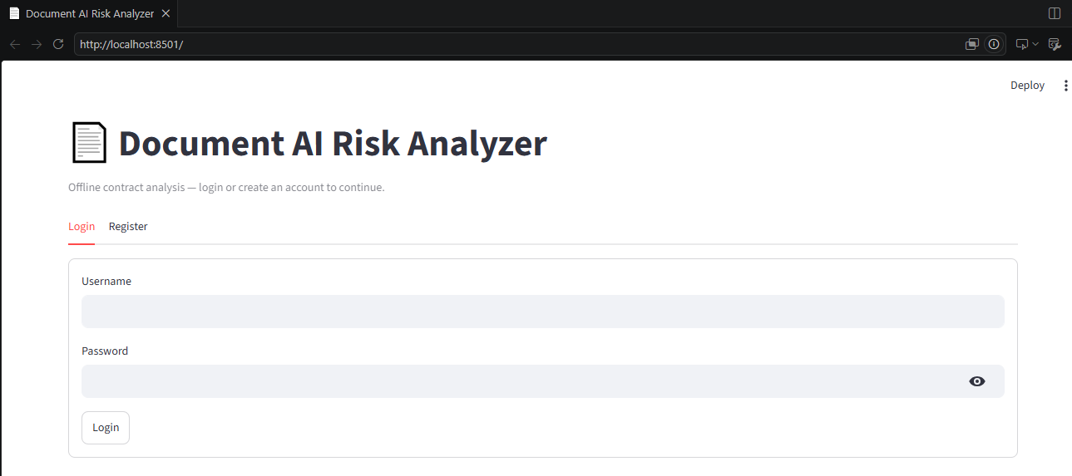
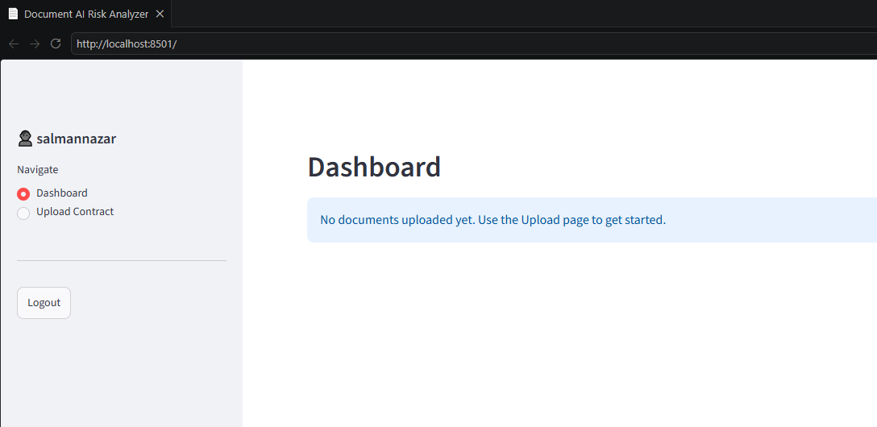
- Dashboard

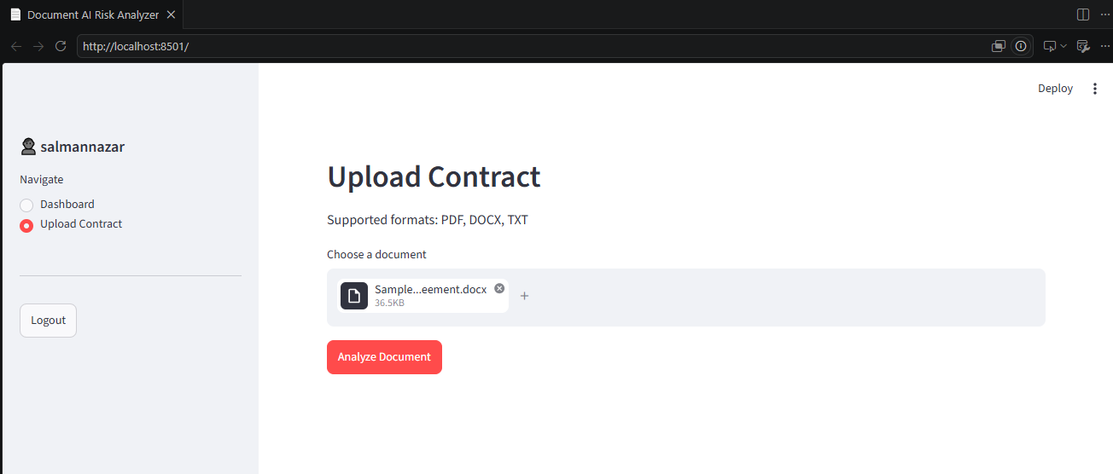
- Upload Document

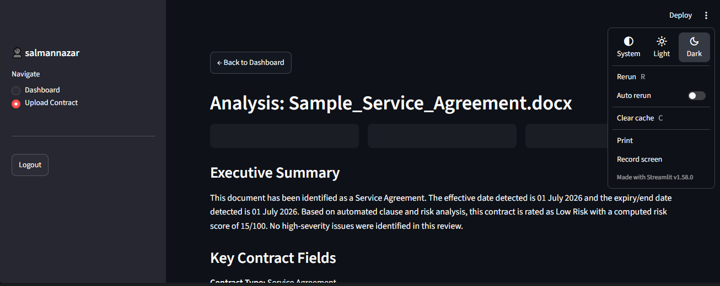
- Document Analysis Results
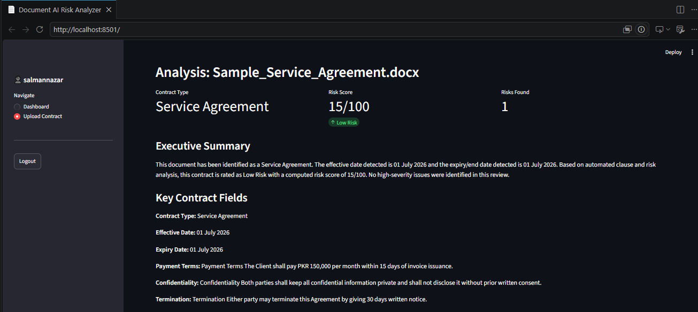
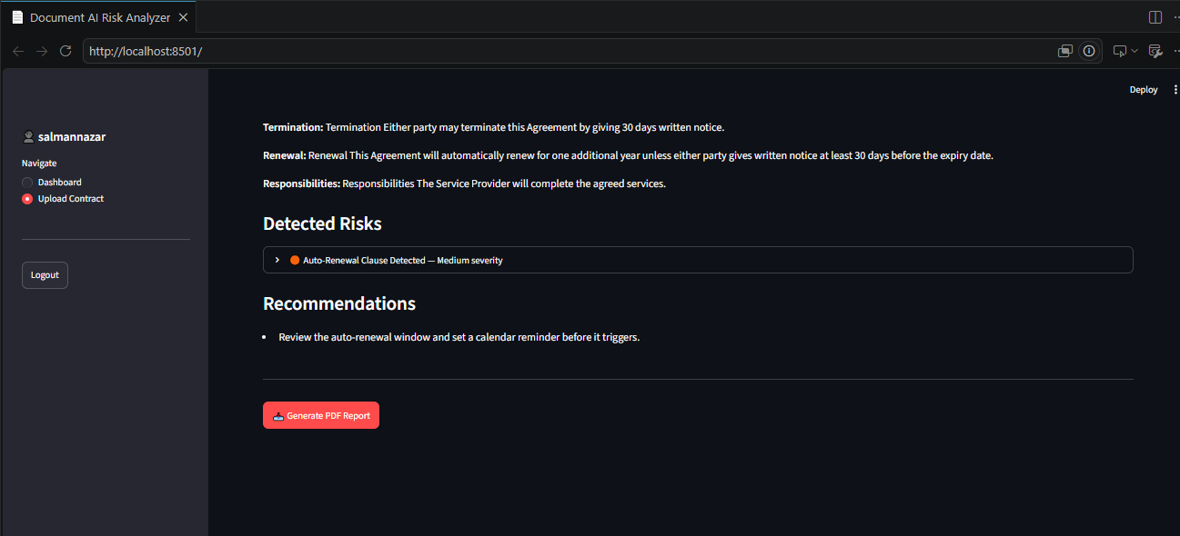
- PDF Report Download
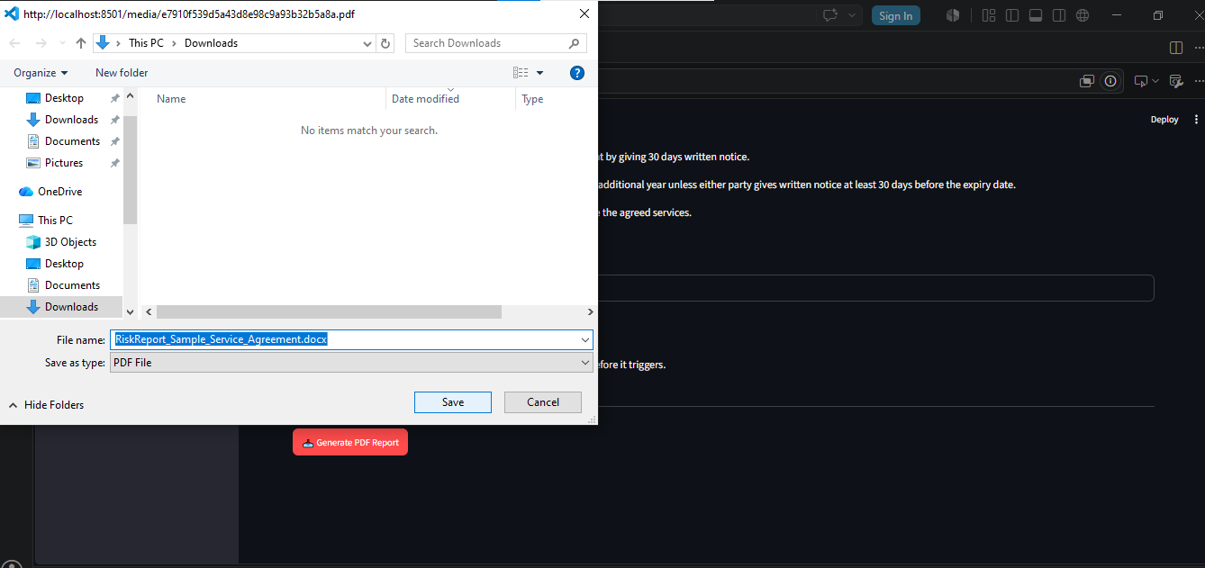

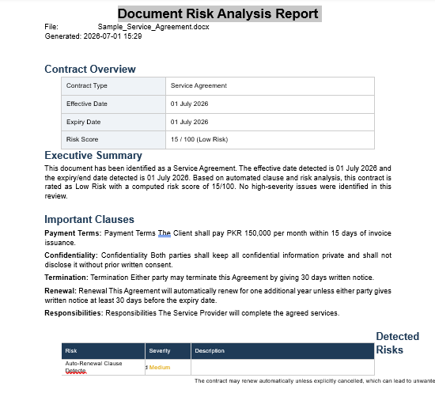
- Generated PDF Report

