PROJECT

1. Create a directory called ""my_folder"", navigate into it, and create a file named ""my_file.txt"" with some text. Then, create another file named ""another_file.txt"" with some text. Concatenate the content of ""another_file.txt"" to ""my_file.txt"" and display the updated content. Finally, list all files and directories in the current directory.

**Folder name**: my_folder

**File name1**: my_file.txt

**File name2**: another_file.txt

Concatenate 2 files to another file(concatenate.txt)

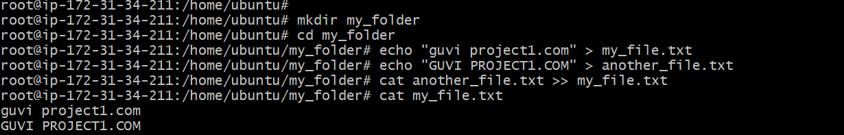



2.Create 20 files with .txt extensions and rename the first 5 files to .yml extension and Print the latest created top 5 files among the total no of files".

