**Step-One**

Download DNN install zip, unzip it and put it in your website Folder

**Step-Two**

IIS Setup as pic on1

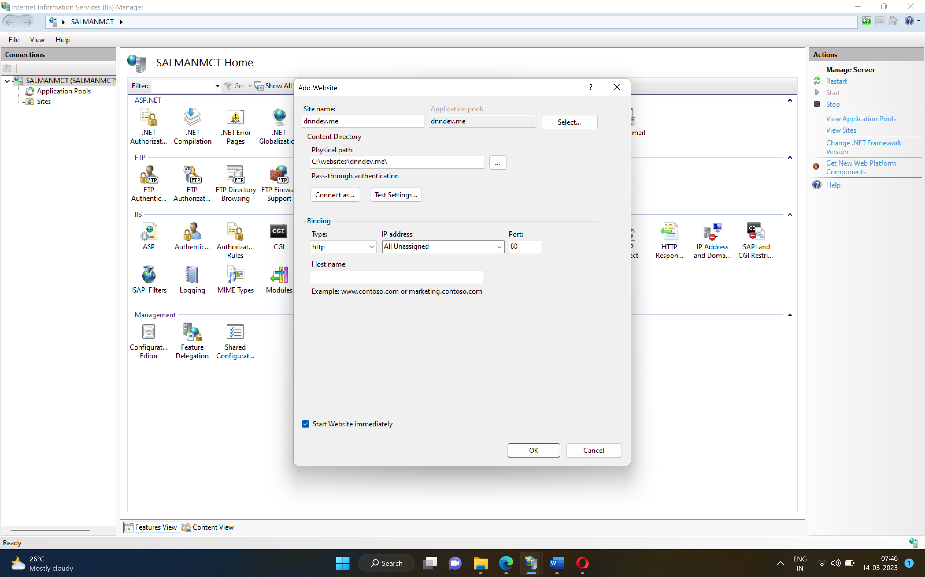

**Step-Three**

**Setting Security for website folder to make it access able to**

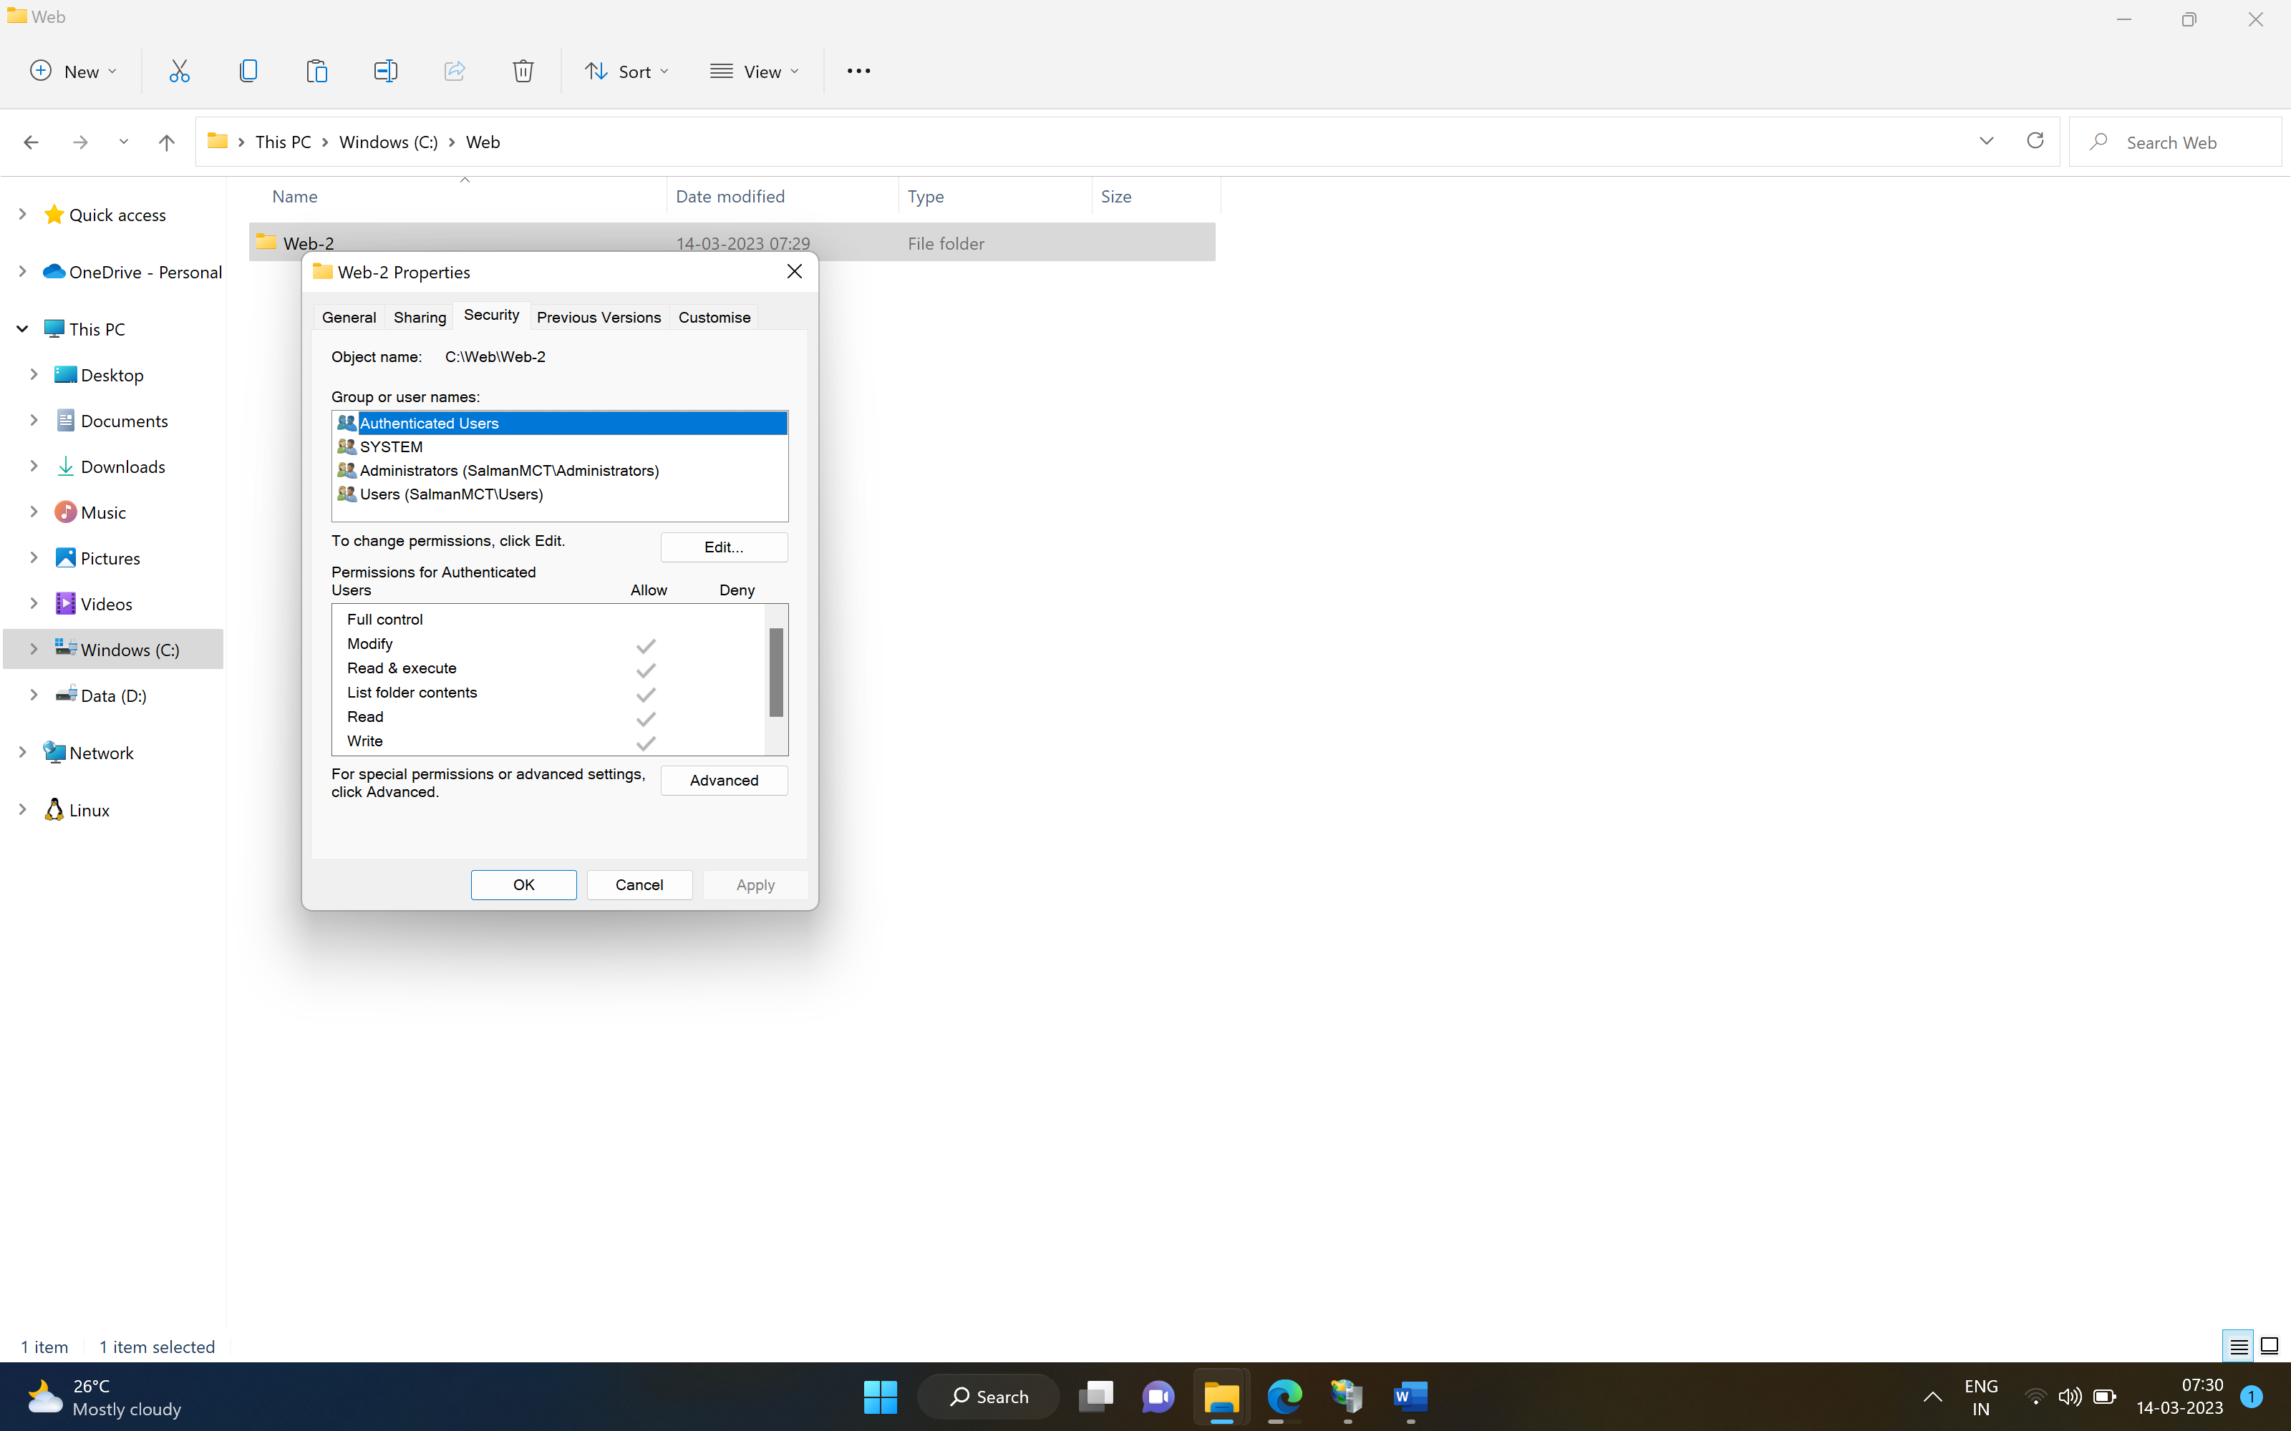

**Step-3**

**Security -> Edit -> Add**

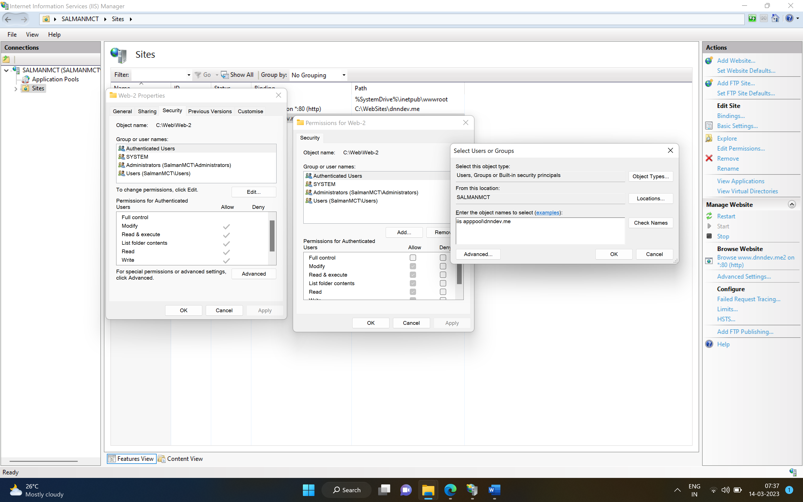

Setp-4

Check Name

