**MIGHTY HOOK SITE CHANGES AS OF 11/26/19 (DESKTOP VERSION)**

Home page

- custom engineered image- starts off scrolling over gray- the image should be behind- check the current site for how it should function - **Done**

YOUR ACCOUNT - at Top Should say Login (just to reflect the same language the customers are used to) - **Done**

2nd Slide Picture – Hanging Density slide button should say “Shop Load Bars) - **Done**

3rd Slide Picture – Wrong text. It should read “Hooks, Racks & Masking” and under it “Products for all your Coating needs”- **Done**

4th Slide Picture – Wrong text under Custom Angle Pivot. It should read “ The time-saving solution for your shop”- **Done**

Banner images

- sometimes the banner images are loading slowly and the button drops down before anything else. Could be image load times but is this something we can fix or control with a change of style if needed?

-

On the current site Contact Us is at the bottom of the home page. On the test site you have Recent blog posts. I am confirming which one should stay. Be back to you on this.

 - **waiting for conformation.**

External Rotators/Angle Pivot VIDEOS - <https://www.mightyhook.com/blog/angle-pivot/custom-rotators>

- there are still categories on the side- please remove and match to this page: <https://www.mightyhook.com/blog/angle-pivot/custom-rotators>. Should Not have a blog entry date and the same with the Angle Pivot Video page here: - **Done** <https://www.onlinemagedemo.com/Mightyhook231/blog/angle-pivot>. The Contact Us link does not work and needs to be fixed as well.

- **Done**

On Custom Solutions Page at the bottom the Contact link does not work. It should go to the Contact Us Custom Solutions form (see current site) <https://www.onlinemagedemo.com/Mightyhook231/custom-solutions>

- **Done**

Process Improvement Page <https://www.onlinemagedemo.com/Mightyhook231/blog/process-improvement>

– Contact us Link at bottom doesn’t work and the two downloads to PDF do not work

- **Done**

On the Custom Solutions Discuss Page (<https://www.onlinemagedemo.com/Mightyhook231/contact>) – we do not need a Google Map - **Done**

On the Blog Page – I thought you had put in separators for the posts but when I just checked they are gone?

**Following is the feedback from the client for MightyHook MOBILE VIEW**

Please take a look at the current site and make the changes on the test site to reflect the current. I also can’t login on mobile on the test site with my testing credentials. Here are some examples I found on mobile: - **Done**

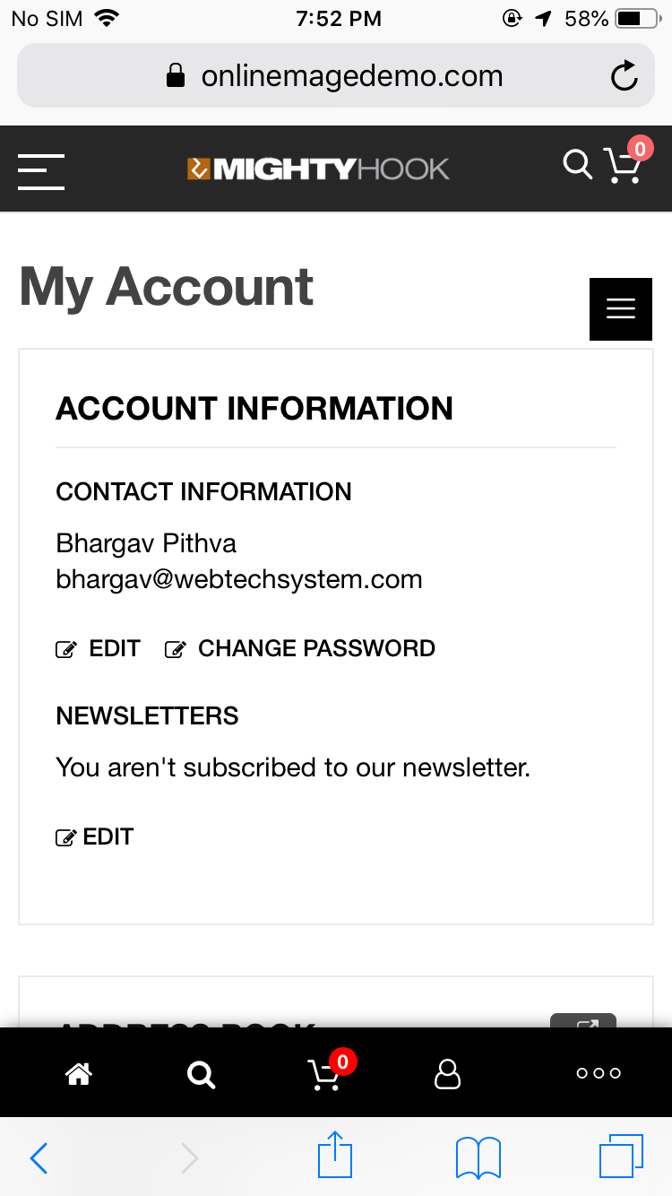

HOME PAGE – The slides are cut off in the Mobile View and the Buttons and secondary text under the headers don’t drop in at all. There is also a white line at the end of the header that isn’t there on desktop view. - **Done**

SIDE NAVIGATION - Under Account please remove “default welcome msg” tab. The Navigation Menu should reflect the same as the current site. See current site and make those reflections. - **Done**

Shop – with Drop Down to Each of the product categories

- **Done**

About

- **Done**

Custom Solutions – with drop down to each of those pages

- **Done**

News

- **Done**

Contact Us

- **Done**

Login for Current Customers

- **Done**

Register for New

- **Done**

On the Test Site there is a black bar at the bottom of the page where none of the icons work. We either can get rid of that with the changes above or the icons need to go to the proper page/perform the correct action.

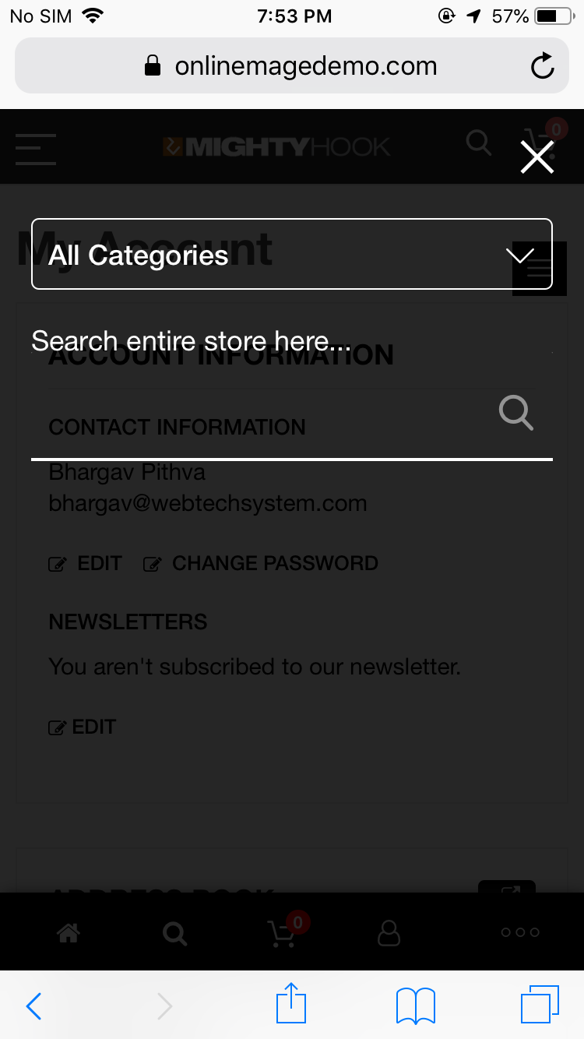

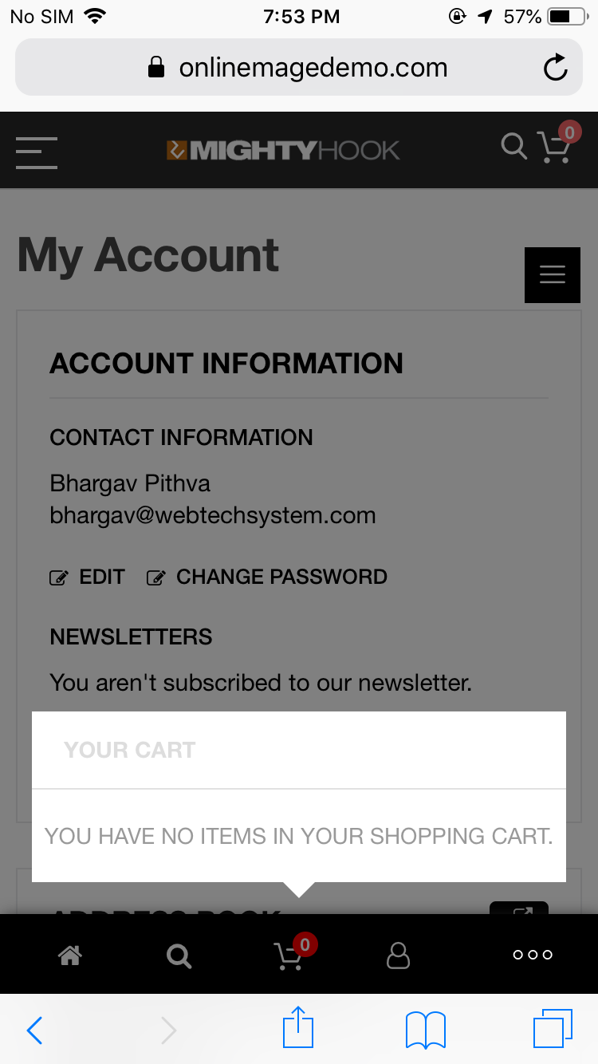

Above points are for mobile view.