OmniStack: AI-Integrated Automated Deployment Platform for Private Servers
(Project Proposal)

Project Code
OmniStack
Project Advisor
Mr. Amir Zia (internal)
Project Manager
Dr Ilyas
Project Team
Talha Saleem — BSCS51F23S012 — Team Lead / AI & ML
Salman Khalid — BSCS51F23S045 — Team Member / DevOps & Platform
Submission Date
October 13, 2026
Project Manager’s Signature: ______________________________
Table of Contents
1. Abstract 2
2. Background and Justification 2
3. Project Methodology 3
4. Project Scope 3
5. High level Project Plan 4
6. References 4

1. Abstract
Private, self-hosted servers are increasingly used by small teams and students to run their own applications instead of relying on costly, vendor-locked cloud platforms. However, deploying and maintaining applications on self-hosted infrastructure is largely manual: existing open-source deployment tools (e.g., Coolify) automate container deployment but provide little intelligence about the health of containers once they are running. Administrators must manually watch dashboards to notice early warning signs, such as rising memory usage, CPU spikes and crash loops, before a service actually fails. Most monitoring tools also use fixed rules like "alert if CPU is above 80%", which give false alarms during normal busy times and miss slow problems like a small memory leak.
This project proposes OmniStack, an AI-Integrated Automated Deployment Platform for private servers. It combines (a) a deployment engine that takes an application from GitHub, builds it with Docker and runs it on a self-hosted server, and (b) an AI/ML-based Container Health Anomaly Detector that continuously checks the resource metrics of each container (CPU, memory, restart count, network I/O) and uses an unsupervised machine learning model (Isolation Forest) to flag containers whose behavior is different from normal operation. The results are shown to the user on a simple web dashboard.
The objective is to deliver a working, evaluated anomaly-detection model integrated with a functioning private-server deployment pipeline, demonstrating that container health can be monitored intelligently without a third-party cloud provider. To achieve this we will take the following steps: (1) learn the required tools (Docker, Linux, Git, scikit-learn); (2) build the deployment engine and the dashboard; (3) collect normal container metrics and create abnormal data by injecting faults such as memory leaks, CPU spikes and crash loops; (4) train and test the Isolation Forest model and compare it with a simple fixed-threshold rule; (5) connect the model to the platform so the health status is visible on the dashboard; and (6) test the full system with sample applications.
This benefits small teams and students who self-host applications by giving earlier, more reliable warning of failing services, and gives the project team hands-on, defensible experience applying classical machine learning to a real infrastructure problem.

2. Background and Justification

2.1 Why This Area and Problem Matter
Today most applications run in containers (Docker). Cloud platforms like Heroku, Vercel and AWS make deployment easy, but they charge monthly fees, and this is hard for students and small teams. Many of them rent or own a private server instead. The problem is that running apps on a private server is mostly manual work, and nobody tells you that a container is slowly getting sick. A memory leak can eat the RAM for days and then the whole server crashes. Simple uptime checks only tell us after the service is already down.

2.2 Existing Solutions
Table 1 shows the tools people use now. Coolify [5], Portainer [6] and Dokku [7] help to deploy and manage containers on private servers. Prometheus with Alertmanager [8] is a popular monitoring tool. All of them depend on fixed alert rules or on a person watching the graphs.
Feature | Coolify | Portainer / Dokku | Prometheus + Alertmanager | OmniStack (proposed)
Deploy from GitHub | Yes | Dokku: yes (CLI); Portainer: limited | No | Yes
Health monitoring | Basic status and metrics | Raw Docker stats / none | Metric graphs and alerts | Metrics + AI health status
Warns before a crash | No (alerts after failure) | No | Only if a fixed limit is crossed | Yes (Isolation Forest)
Needs labelled failure data | Not applicable | Not applicable | Not applicable | No (unsupervised)

2.3 Gap and Our Contribution
The gap is that deployment tools do not have any intelligence about container health, and fixed-threshold rules need constant tuning (they give false alarms in busy times and miss slow problems). OmniStack fills this gap by joining a simple deployment platform with an Isolation Forest health detector in one project. Our contribution is a working end-to-end system that is tested using injected faults, not only a model in a notebook.

2.4 How We Will Measure Success, Benchmarks and Competitive Approach
We will compare our model with a simple fixed-threshold rule (alert if CPU > 80% or RAM > 80%), which is how most basic monitoring works. Both will be tested on the same normal and fault-injected data. The numbers below are our targets and will be confirmed by testing.
What we measure | How we measure it | Target
Detection quality | Precision and recall on injected faults (memory leak, CPU spike, crash loop) | Recall ≥ 85%, higher than the threshold rule
False alarms | Wrong alerts on normal running containers | ≤ 10% of normal readings
Early warning | How early the problem is flagged compared with the threshold rule | Earlier for memory leaks
Deployment | Time from GitHub link to running app on 3 sample apps | Under 10 minutes each
Table 2: Evaluation measures and targets.

3. Project Methodology
We will work in two tracks at the same time: the platform track (Salman Khalid) and the AI/ML track (Talha Saleem). In the end we will join them. Before starting, we agree on a simple JSON format for metrics and results so both tracks can work separately.
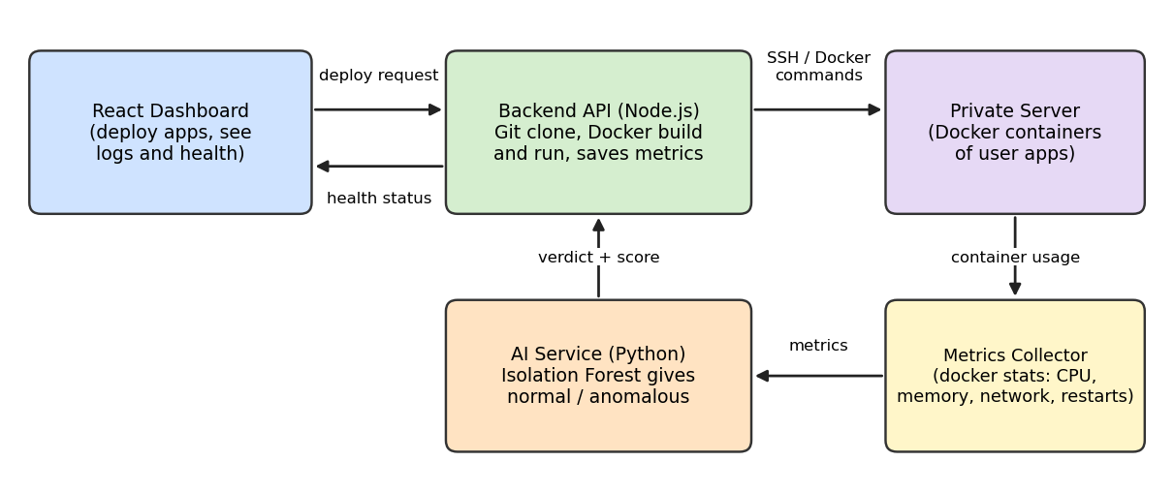
Figure 1: Block diagram of OmniStack.

3.1 Components and Why We Need Them
- React dashboard: the user gives a GitHub link, starts the deployment and sees the app list and health status in one place.
- Backend API (Node.js): clones the repository, builds the Docker image and runs the container on the private server (over SSH or locally). It also saves the metrics and talks to the AI service.
- Metrics collector: reads CPU %, memory %, network I/O and restart count of each container using docker stats every few seconds. Network and restart values are converted to per-second and per-10-minute rates, because Docker only gives lifetime totals.
- AI service (Python + scikit-learn): holds the trained Isolation Forest model and returns a verdict (normal / anomalous) with a score for each container.

3.2 AI/ML Steps
- Run sample apps (Node.js and Python) under normal load and record normal metrics.
- Create abnormal data with fault scripts: memory leak, CPU spike and crash loop. This gives a test set with known answers.
- Clean the data, scale the 4 features (CPU, memory, network rate, restart rate) and split into training and test sets.
- Train Isolation Forest on normal data only, then tune its settings (number of trees, contamination) using the test set.
- Measure precision, recall and false-alarm rate and compare with the threshold rule.
- Wrap the model in a small API (FastAPI) so the backend can send metrics and get a verdict.
Tools: React, Node.js, Docker, Git/GitHub, Python, scikit-learn, FastAPI, Prometheus, Grafana, MS Project for planning. We work in weekly sprints and meet the advisor regularly.

4. Project Scope
Inside the scope (the system will provide) | Outside the scope (the system will not provide)
• Deploy a Node.js app from a GitHub link using Docker on a private server  • Web dashboard with deployed apps, status and logs  • Collection of CPU, memory, network I/O and restart count  • Isolation Forest model that marks containers normal or anomalous  • Fault-injection scripts for testing the model  • Health status shown on the dashboard | • Many servers, Kubernetes or Docker Swarm  • Auto-restart or self-healing of containers  • AI chatbot and automatic log explanation (possible future work)  • Automatic domain names and SSL setup (future work)  • Cloud provisioning (AWS/GCP/Azure), user billing and multiple tenants  • Redis for chaching (most probable future work)  • Large-scale testing with many containers

5. High level Project Plan
The project is planned for 32 weeks (12 Oct 2026 to 21 May 2027) in MS Project. It shows the activities, the time given to each (in weeks), the resource who does it, and the university deadlines (proposal 13 Oct, SRS 10 Nov, design document 18 Dec, all before class).
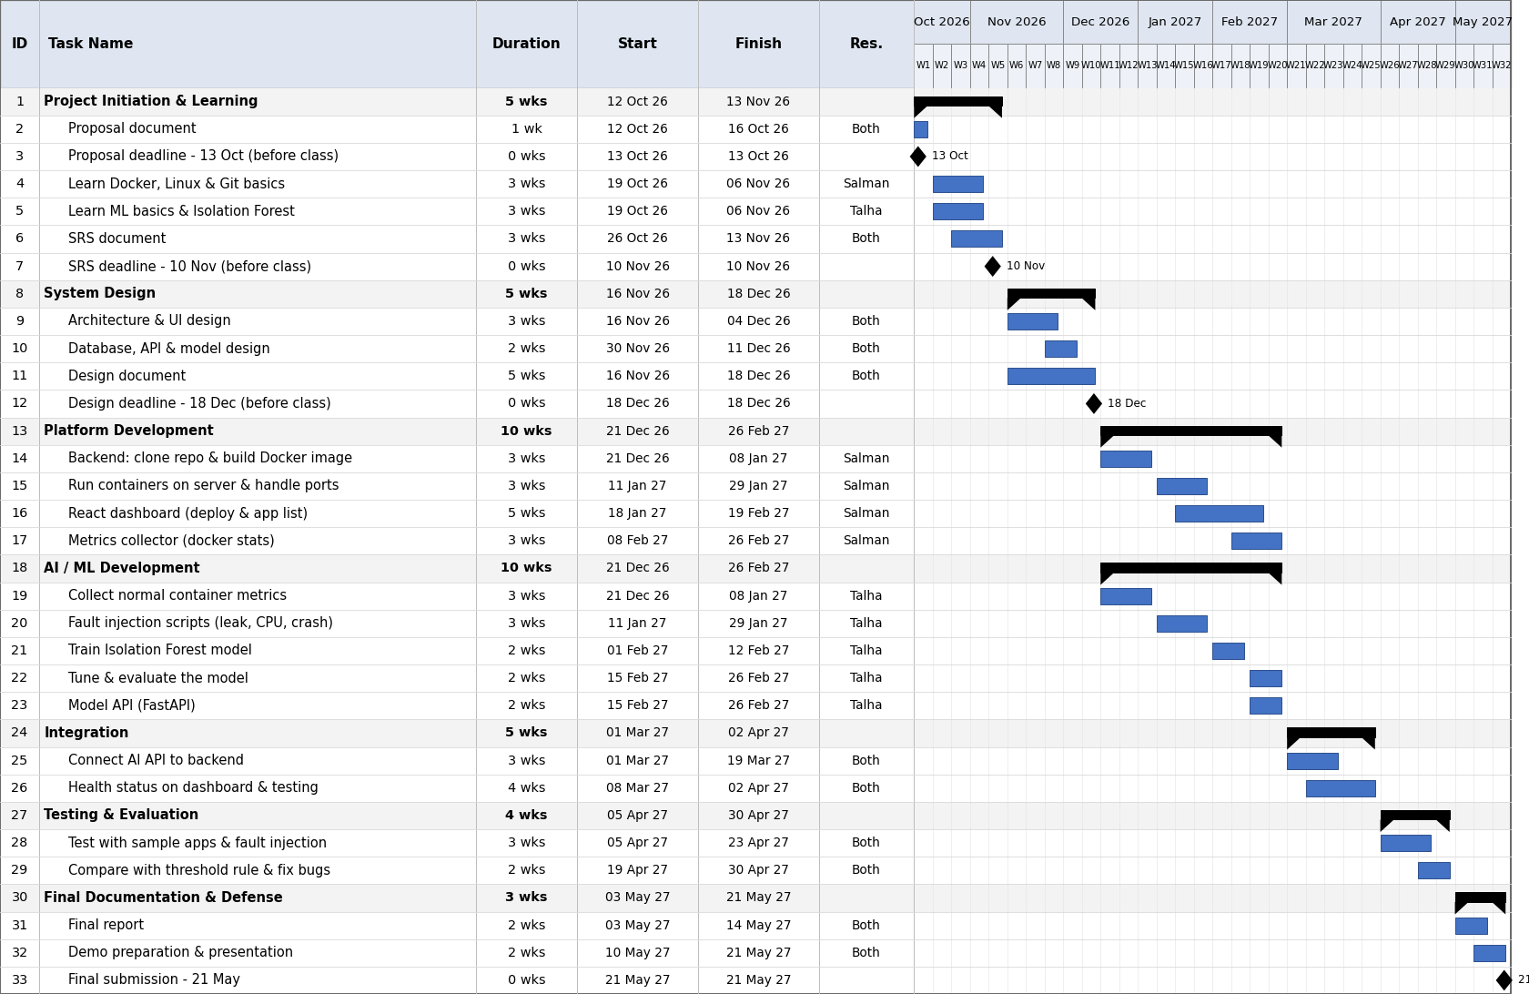
Figure 2: Project plan in MS Project (Gantt chart). Talha = AI/ML, Salman = DevOps/platform.

6. References
[1] Coolify, open-source self-hosted platform (our reference platform): https://coolify.io/docs and https://github.com/coollabsio/coolify

[2] Dokku docs: https://dokku.com/docs

[3] Prometheus Alertmanager docs: https://prometheus.io/docs/alerting/latest/alertmanager/

[4] YouTube: StatQuest with Josh Starmer (https://www.youtube.com/@statquest) and TechWorld with Nana (https://www.youtube.com/@TechWorldwithNana), used to understand Isolation Forest and Docker monitoring.

[5] AI conversations with Claude (Anthropic) and ChatGPT (OpenAI), Oct 2026, used for ideas on fault injection and project planning.

[6] Cloud With Varjosh: https://www.youtube.com/watch?v=wj8ELsJ-S5Q&t=40409s

Advisor consulted: Mr. Amir Zia.

