Javascript ES6

1.Difference between var and let, const

2.Difference between normal string and template Strings

3.Diffeence between normal function and Arrow function

4.Destructing of Array and Object

5.Array Built in functions

6.Spread and Rest Operator

7.Class

8.Class-Inheritance

9.Difference between sync and async

10.Call Back Function

11.Promise

12.Chain of Promise

13.Ternary operator

14.Map Function

15.find,findIndex,for of, for in,forEach,filter,includes

Reactjs:

Part 1- Project – Functional Component

Topics:

1.Base Setup

2.Creating functional component

3.JSX

4.CSS styling

5.Dynamic data

6.Props

7.Adding javascript logic in component

8.Splitting the component

9.Assignment

ScreenShot1:

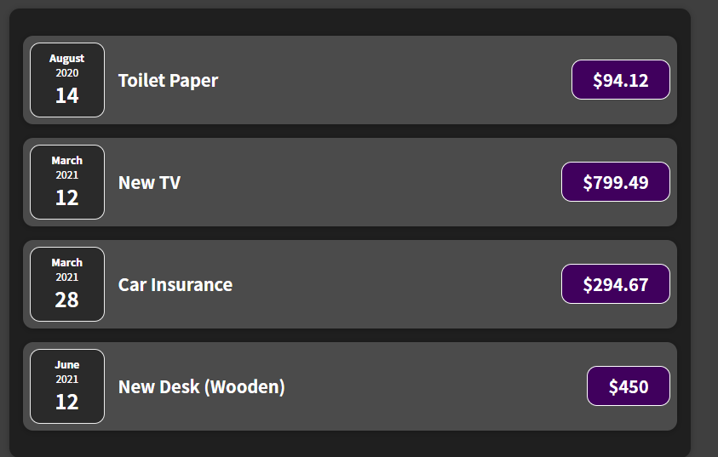

Section 2: Using Functional Component

1.Working with State

2.Input elements

3.Multiple State

4.Forms Handling

5.Two way Binding

6.Update State

7.Assignment

ScreenShot1:

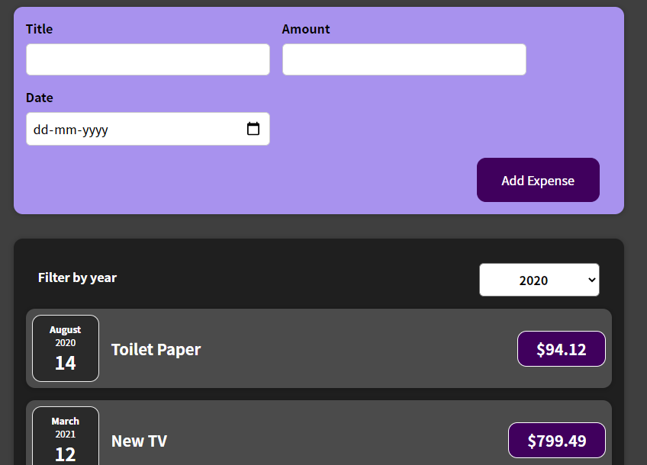

Section 3:Functional Component

1.Maps

2.Statefull list

3.Understanding keys

4.Conditional operator

5.Assigment

Screenshot:1

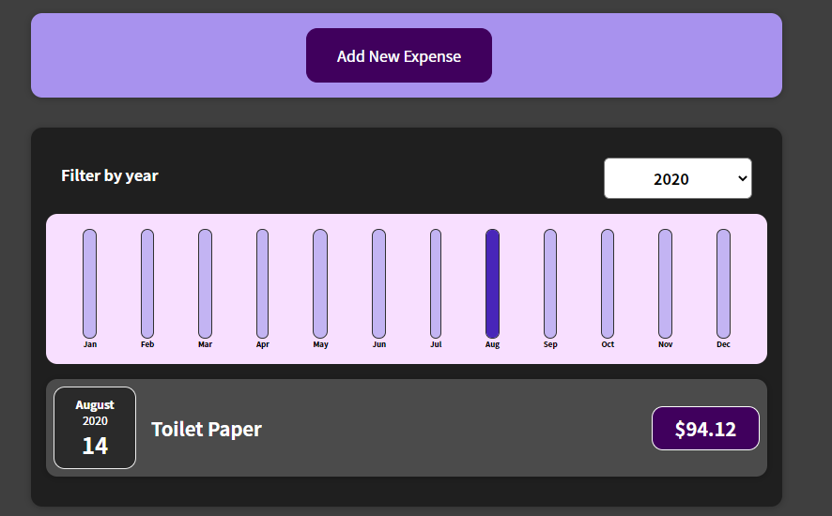

Section 4: React Hooks(Functional Component)

1.UseEffect

2.useReducer

3.useRef

4.useContext

5.useMemo

6.useCallBack

7.React Fragments

Project 2: Class Based Component

1.First Class Component

2.Working with State

3.Life Cycle Methods

4.Forms

Screenshot1:

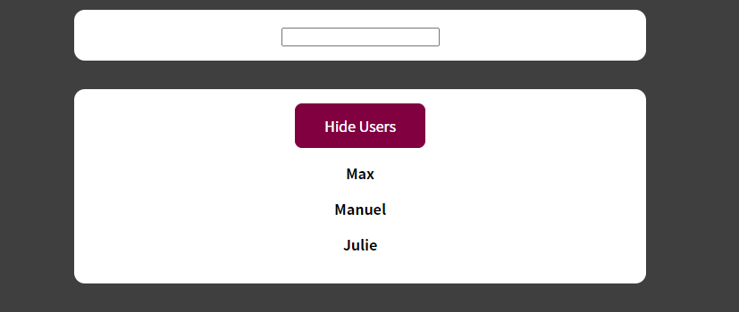

Project 3:HTTP Request (axios)

1.GET

2.POST

3.PUT

4.DELETE

5.INTERCEPTOR

ScreenShot1:

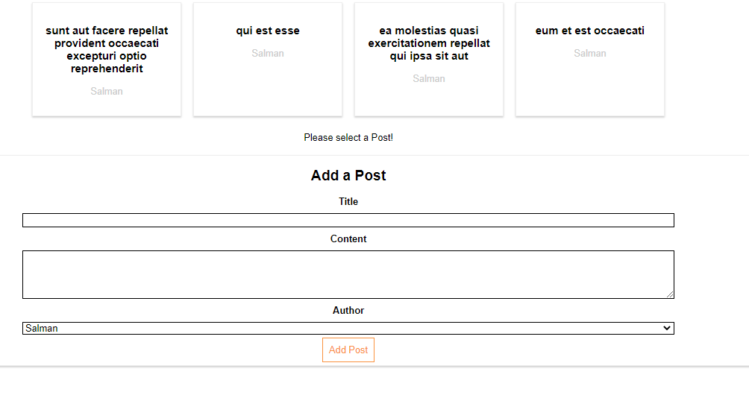

Project 4:Router And Redux

1.Router Setup

2.Router and link

3.Browser Router

4.Router with component

5.Router with Link

6.Introduction to OneStore.

7 Provider Component

8Actions.

9 Reducers.

10. Dispatchers

11. View Controllers

12.Selector

ScreenShot1:

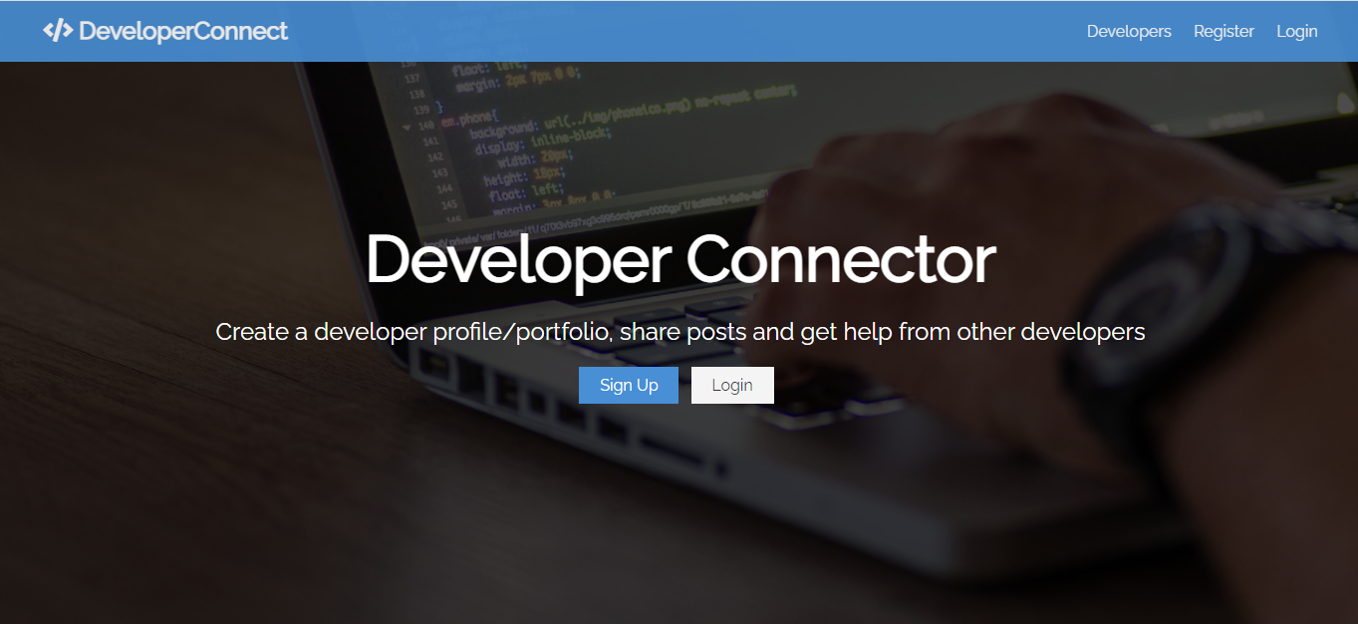

ScreenShot2:

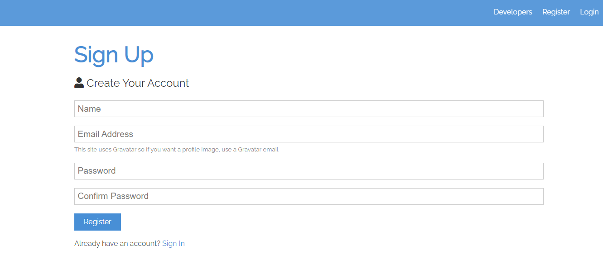

ScreenShot 3:

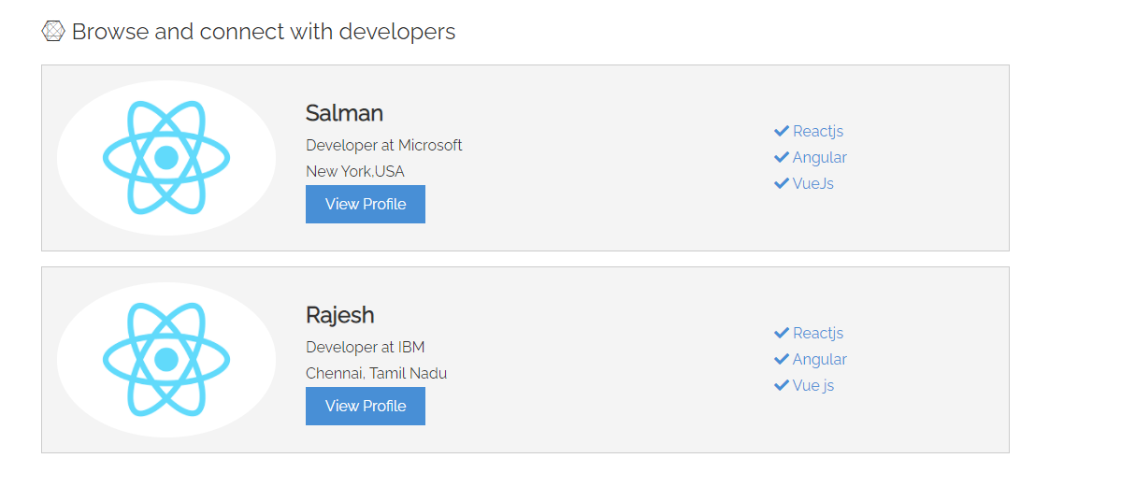

ScreenShot 4:

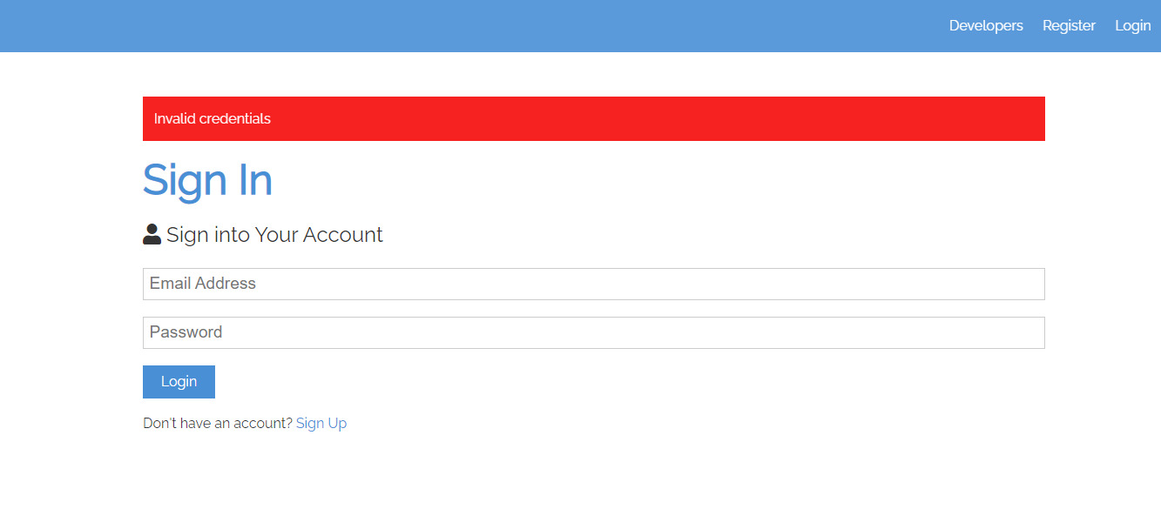

Project 5:Final Assignment: 1:

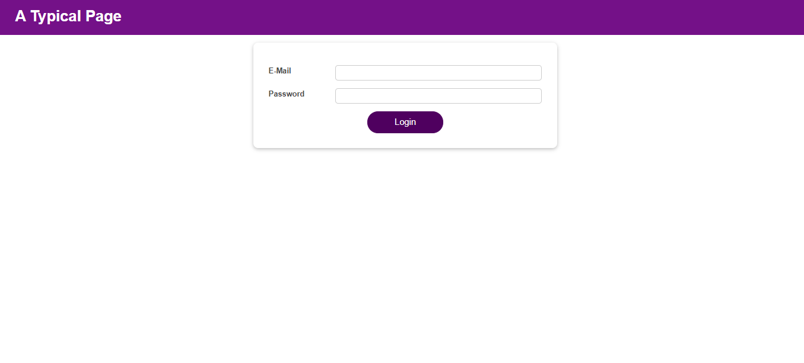

Dashboard

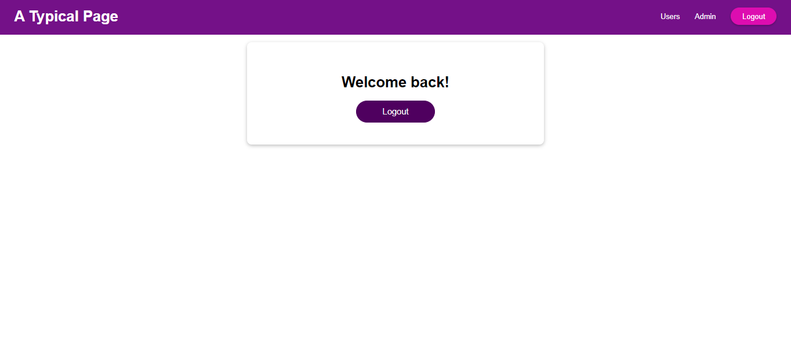

Food App:

