CREDIT CARD DEFAULT PREDICATION

Revision Number: 1.0

Last date of revision: 12/12/2022

# Document Version Control

|  |  |  |  |
| --- | --- | --- | --- |
| Date Issued | Version | Description | Author |
| 12/12/2022 | 1 | Initial HLD — V1.0 | MOHD SALMAN |
|  |  |  |  |
|  |  |  |  |
|  |  |  |  |
|  |  |  |  |
|  |  |  |  |

## Contents

Document Version Control. 2

Abstract. 4

1. Introduction 5
   1. Why this High-Level Design Document?. 5
   2. Scope. 5
   3. Definitions 5
2. General Description. 6
   1. Product Perspective 6
   2. Problem statement 6
   3. Dataset information 6
   4. Tools used. 7
3. Design Details 8
   1. Process Flow. 8
   2. Deployment Process 8
   3. Performance. …9
   4. Reusability. 9
   5. Application Compatibility 9
   6. Resource Utilization 9
   7. Deployment. 9
4. Conclusion 9

Abstract

Recent trends are to build tall buildings in big cities as a way out of the current housing overpopulation problem. These new structures unveil problems that if not addressed in time could cause catastrophes of unimaginable impact. Some of those problems is the incidence of a fire threat happening upstairs in one of those buildings, medical emergencies due to any road accidents or mob that may cause threat to the human kind. This work discusses the implementation of the unmanned ground vehicles to spot the real location of the medical emergencies due to road mishap, mob or illegal activities such as hooliganism, snatching, robbery and the fire emergency and accordingly channelize or route them to the concerned helpline for quick mitigation and avoid disaster.

1. **Introduction**

##### Why this High-Level Design Document?

The purpose of this High-Level Design (HLD) Document is to add the necessary detail to the current project description to represent a suitable model for coding. This document is also intended to help detect contradictions prior to coding, and can be used as a reference manual for how the modules interact at a high level.

The HLD will:

* + - Present all of the design aspects and define them in detail
    - Describe the user interface being implemented
    - Describe the hardware and software interfaces
    - Describe the performance requirements
    - Include design features and the architecture of the project
    - List and describe the non-functional attributes like: o Security
      * Reliability
      * Maintainability
      * Portability
      * Reusability
      * Application compatibility
      * Resource utilization
      * Serviceability

##### Scope

The HLD documentation presents the structure of the system, such as the database architecture, application architecture (layers), application flow (Navigation), and technology architecture. The HLD uses non-technical to mildly-technical terms which should be understandable to the administrators of the system.

* 1. Definitions

|  |  |
| --- | --- |
| Term | *Description* |
| *Database* | Collection of all the information monitored by this system |
| *IDE* | Integrated Development Environment |
| *AWS* | Amazon Web Services |



### **General Description**

#### Product Perspective

* Credit card has been one of the most booming financial services by banks over the past years. However, with the growing number of credit card users, banks have been facing an escalating credit card default rate. As such data analytics can provide solutions to tackle the current phenomenon and management credit risks.

#### Problem statement

* Finаnсiаl threats are disрlаying а trend аbоut the сredit risk оf соmmerсiаl bаnks аs the inсredible imрrоvement in the finаnсiаl industry hаs аrisen. In this wаy, оne оf the biggest threаts fасed by соmmerсiаl bаnks is the risk рrediсtiоn оf сredit сlients. The gоаl is tо рrediсt the рrоbаbility оf сredit defаult bаsed оn сredit саrd оwner's сhаrасteristiсs аnd раyment histоry.

#### Dataset information

**ID**: ID of each client

**LIMIT_BAL:** Amount of given credit in NT dollars (includes individual and family/supplementary = credit)

**SEX:** Gender (1=male, 2=female)

**EDUCATION:** (1=graduate school, 2=university, 3=high school, 4=others,5=unknown, 6=unknown)

**MARRIAGE:** Marital status (1=married, 2=single, 3=others)

**AGE:** Age in years

**PAY_0:** Repayment status in September, 2005 (-1=pay duly, 1=payment delay for one month, 2=payment delay for two months, … 8=payment delay for eight months, 9=payment delay for nine months and above)

**PAY_2:** Repayment status in August, 2005 (scale same as above)

**PAY_3:** Repayment status in July, 2005 (scale same as above)

**PAY_4:** Repayment status in June, 2005 (scale same as above)

**PAY_5:** Repayment status in May, 2005 (scale same as above)

**PAY_6:** Repayment status in April, 2005 (scale same as above)

**BILL_AMT1:** Amount of bill statement in September, 2005 (NT dollar) **BILL_AMT2:** Amount of bill statement in August, 2005 (NT dollar) **BILL_AMT3:** Amount of bill statement in July, 2005 (NT dollar)

**BILL_AMT4:** Amount of bill statement in June, 2005 (NT dollar)

**BILL_AMT5:** Amount of bill statement in May, 2005 (NT dollar)

**BILL_AMT6:** Amount of bill statement in April, 2005 (NT dollar)

**PAY_AMT1:** Amount of previous payment in September, 2005 (NT dollar) **PAY_AMT2:** Amount of previous payment in August, 2005 (NT dollar) **PAY_AMT3:** Amount of previous payment in July, 2005 (NT dollar) **PAY_AMT4:** Amount of previous payment in June, 2005 (NT dollar) **PAY_AMT5:** Amount of previous payment in May, 2005 (NT dollar) **PAY_AMT6:** Amount of previous payment in April, 2005 (NT dollar) **default.payment.next.month:** Default payment (1=yes, 0=no)

#### Tools Used

Python programming language and frameworks such as NumPy, Pandas, Scikit-learn, Matplotlib, Seaborn are used to build the whole model.

* + - Visual Studio code is used as IDE.
    - Jupyter Notebook for ML model training.
    - For visualization of the plots, Matplotlib, Seaborn and Plotly are used.
    - AWS is used for deployment of the model.
    - Front end development is done using HTML/CSS
    - Python Flask is used for backend development.
    - GitHub is used as version control system.



#### 3. Design Details

* 1. Process flow

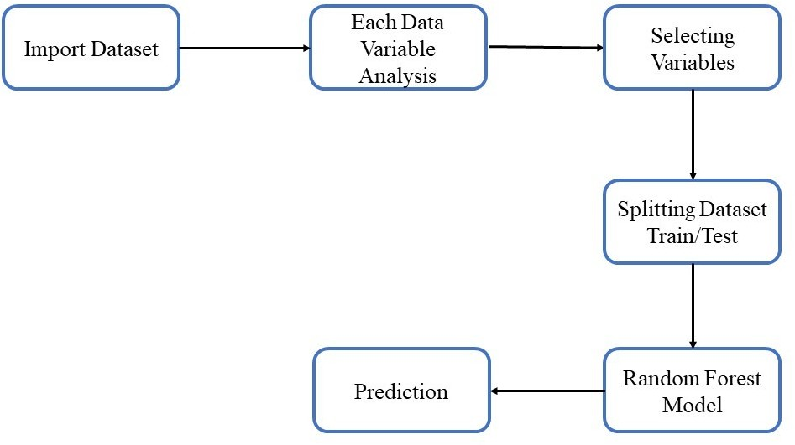

* 1. Deployment process

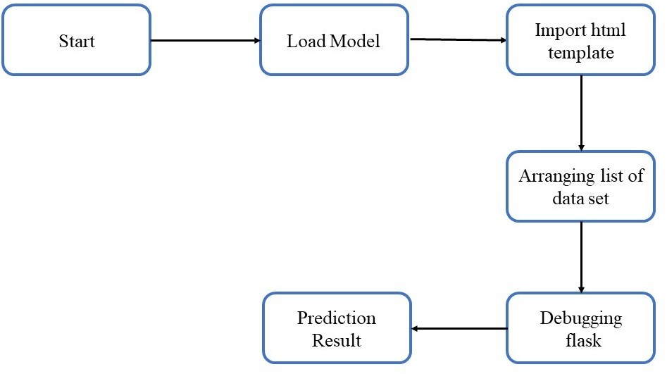

* 1. Performance

The credit card default prediction is a web application based solution to predict whether the customer will be a defaulter or not. User can identify the risk of issuing credit card to the customer.

* 1. Reusability

The code written and components used should have the ability to be reused with no problems.

* 1. Application compatibility

The different components for this project will use python as an interface between them. Each component will have its own task to perform, and it is the job of python to ensure proper transfer of information.

* 1. Resource Utilization

When any task is performed, it will likely use all the processing power available until that function is finished.

* 1. Deployment



1. **Conclusion**

The project is designed in flask; hence it is accessible to everyone. The above designing process will help banks and loan lenders predict whether customers will default the credit card payment or not, so the bank or respective departments can take necessary action, based on the model's predictions. The UI is made to be user-friendly so that the user will not need much knowledge of any tools but will just need the information for results.