**Tutorial Video:**

[**https://drive.google.com/file/d/1aIdIViznlep6ZORwhR631nf0KMoiyPMT/view?usp=drive_link**](https://drive.google.com/file/d/1aIdIViznlep6ZORwhR631nf0KMoiyPMT/view?usp=drive_link)

**Game Installation Steps:**

**Step 1:**

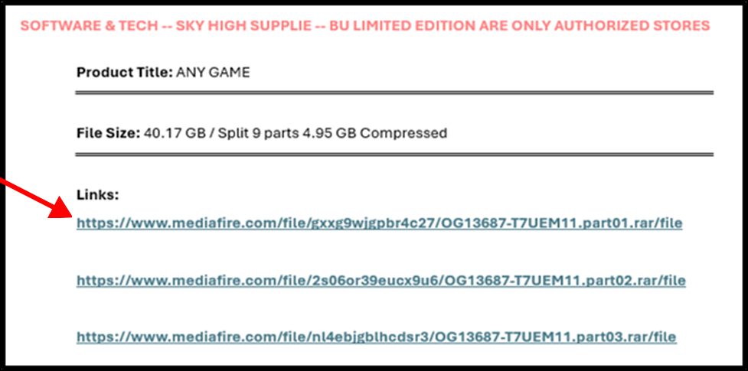

**Then**

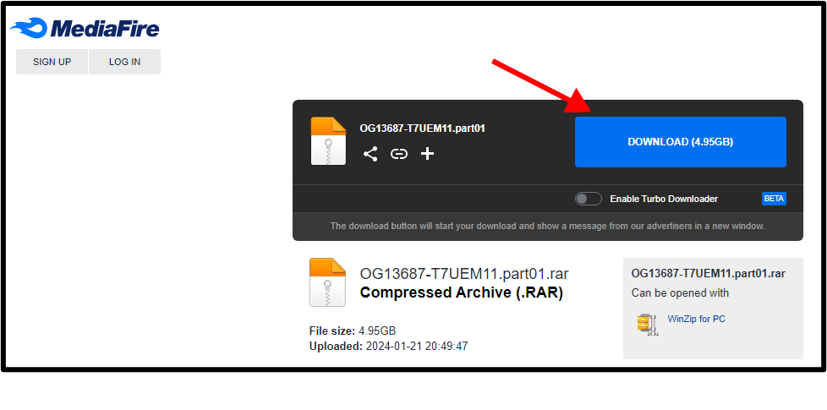

**Click on the link and download all parts one by one.**

**Step 2:**

**After downloading all parts place all parts in same folder**

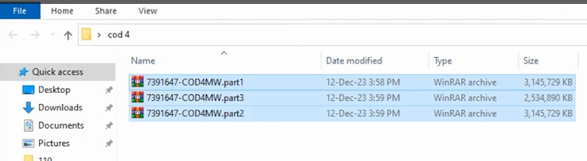

**Step 3:**

**Select all parts and right click then click on extract here.**

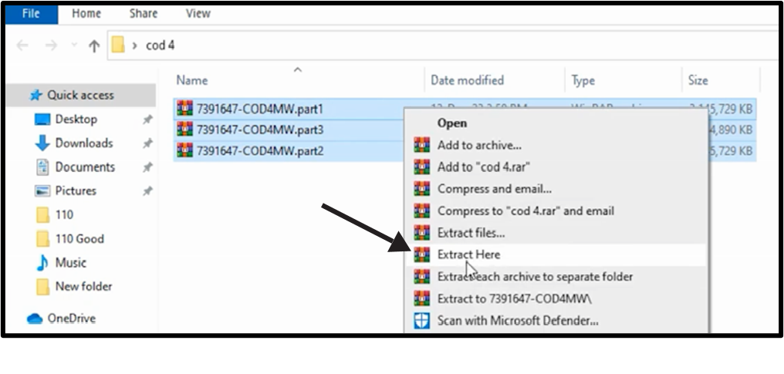

**Note**

* **Must select all parts and then extract (by choosing extract here option).**
* **If WinRAR does not work, use 7-zip extraction software.**

**Step 3:**

**After extraction a new folder is created, open folder and install game**

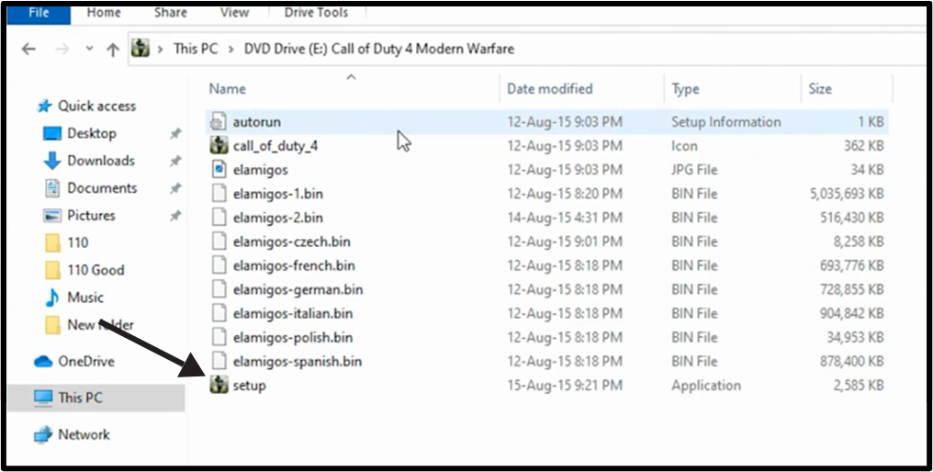

**THANKS FOR SHOPPING**

**Join WhatsApp Channel Link for New Amazing Products:** <https://whatsapp.com/channel/0029VaCnKPJATRShfY6FlD1i>

**SOFTWARE & TECH** [ <https://www.daraz.pk/shop/software-and-tech> ]

**SKY HIGH SUPPLIE** [ <https://www.daraz.pk/shop/sky-high-supplie> ]

**BU LIMITED EDITION** [ <https://www.daraz.pk/shop/sky-high-supplie> ]

Visit Stores for More Exciting Products 😊🎮