WebShield
SQL Injection and Cross-Site Scripting (XSS) Demonstration and Prevention Platform
Project Report
Student name: Salman Mugharbel
Course: Technology of Development of Cryptographic Systems
Instructor: Pyrcova
Date: 2 November 2026

Table of Contents
Table of Contents
1. Abstract and Introduction
2. Objectives, Scope and Technology
3. System Architecture
4. Database Design
5. Authentication Module (Module B)
6. SQL Injection Laboratory (Module C)
7. XSS Laboratory (Module D)
8. Security Comparison, Activity Logs and Documentation (Modules E–G)
9. Security Controls Protecting the Main Application
10. Testing and Results
11. Conclusion, Limitations and Future Work
Limitations
Future work
Appendix: Installation and Running

Right-click the table and choose Update Field if page numbers are missing.

1. Abstract and Introduction
WebShield is a locally hosted web application that runs an intentionally vulnerable and a secure version of the same code side by side. This shows how SQL Injection (SQLi) and Cross-Site Scripting (XSS) happen and how to prevent them. It is built with Python Flask, SQLite and HTML/CSS/JavaScript. All 39 automated test cases and a browser-level isolation check passed.
SQLi and XSS are both injection flaws, listed under OWASP Top 10 category A03: Injection. Each one happens when an application mixes untrusted data with code:
- SQL Injection: user input is concatenated into a SQL statement, and the database runs it as SQL.
- Cross-Site Scripting: user input is inserted into an HTML page, and the browser runs it as JavaScript.
The fix follows the same principle in both cases: keep data separate from code. For SQL that means parameterised queries. For HTML it means context-aware output encoding. WebShield demonstrates both through interactive laboratories. All vulnerable demonstrations use fictional data and run in isolated sandboxes on 127.0.0.1.

2. Objectives, Scope and Technology
The project had five objectives:
- Demonstrate how unsafe SQL construction lets an attacker bypass a login.
- Demonstrate reflected, stored and DOM-based XSS.
- Implement a secure version of every vulnerable example and compare the two directly.
- Show what the client, the server and the database are each responsible for.
- Keep the main application secure even though it contains vulnerable demonstrations.
Scope: the application runs only on a student laptop, bound to 127.0.0.1. It uses fictional accounts and test data. No real websites, systems or user accounts are targeted.
Layer | Technology | Purpose
Frontend | HTML5, CSS3, JavaScript (no framework) | User interface, forms, responsive dark dashboard theme
Backend | Python 3.14, Flask 3.1, Flask sessions | Routing, authentication, validation, lab logic
Database | SQLite via Python sqlite3 | Users, posts, comments, activity logs
Security libraries | Werkzeug (scrypt hashing), MarkupSafe / Jinja2 | Password storage, output encoding
Testing | pytest, Playwright with Microsoft Edge | Automated tests, browser verification, screenshots

I left out Bootstrap, which was optional, so the application works fully offline and the page's security policy can block every external source.

3. System Architecture
WebShield has a three-layer architecture: the browser (client), the Flask server and the SQLite database. Every request passes through the same security controls in order. Requests flow down through the server's controls, and responses flow back up encoded. Vulnerable demonstrations branch off into isolated sandboxes and never reach the main database or page.
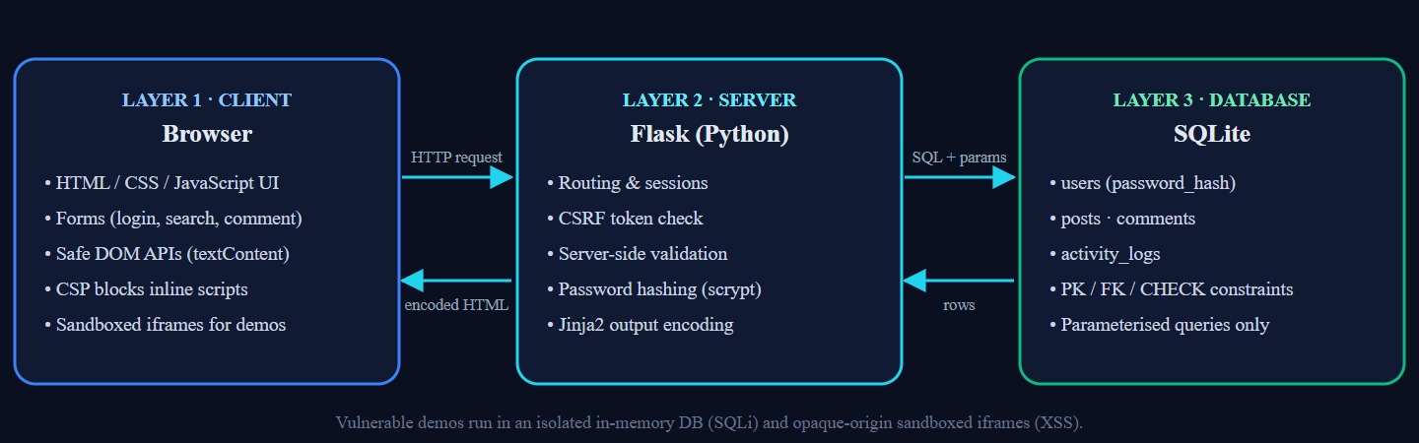
Figure 1 – Three-layer architecture of WebShield
Layer | Responsibilities | Main files
1. Client | Displays the UI and forms, gives basic HTML validation, uses textContent for untrusted data, follows the page's security policy, runs vulnerable demos only in sandboxed iframes | templates/, static/js/main.js, static/css/style.css
2. Server | Routing, sessions, CSRF checks, server-side validation, password hashing, authorisation, parameterised SQL, output encoding, activity logging | app.py, routes/, security/
3. Database | Stores users, posts, comments and logs with primary key, foreign key, UNIQUE and CHECK constraints; stores only password hashes | database/schema.sql, database/db.py

The intentionally vulnerable code is kept apart in vulnerable/sqli_sandbox.py and templates/vulnerable/. Every file there carries a warning banner.
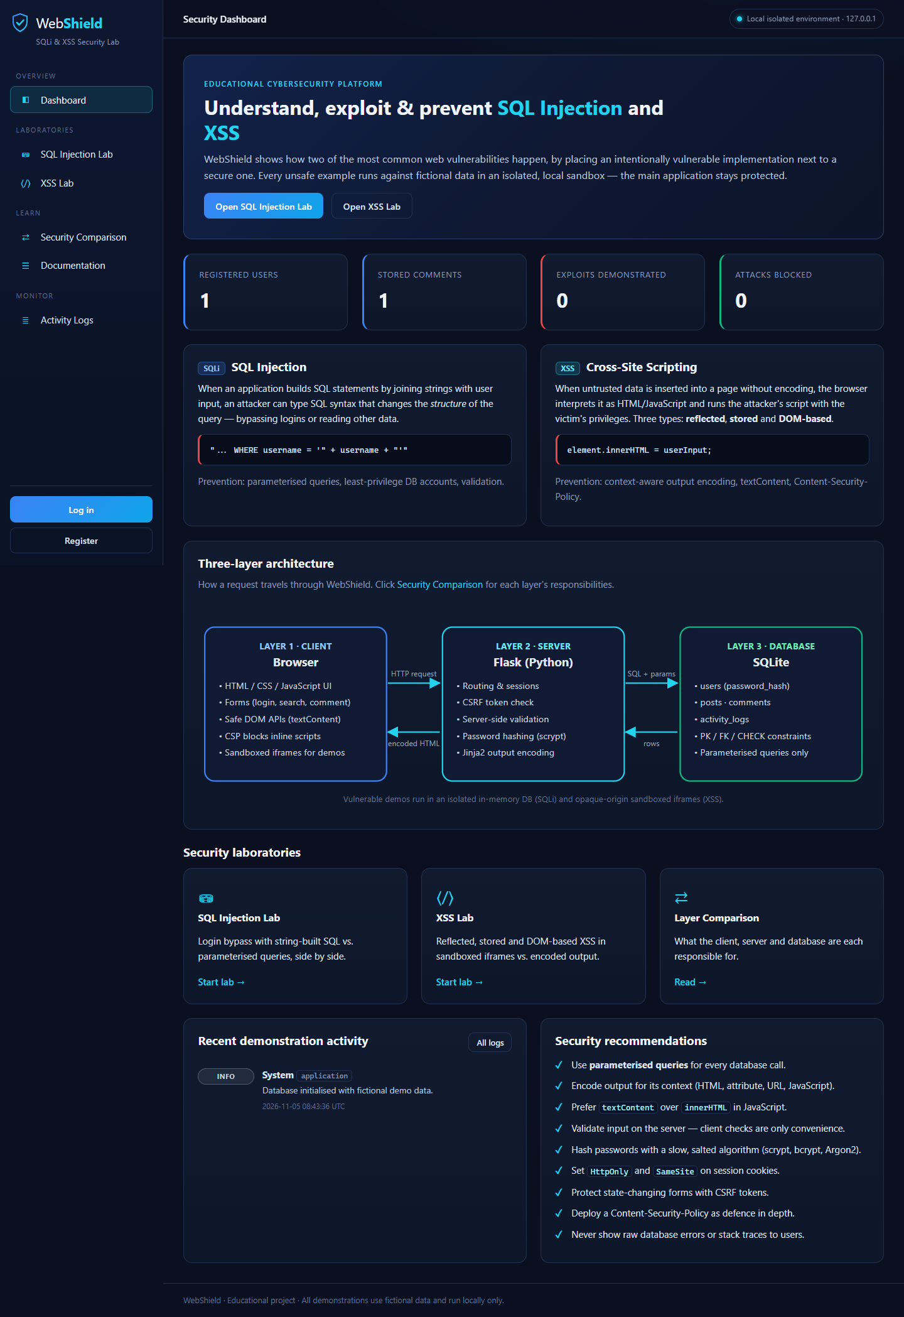
Figure 2 – Dashboard (Module A): introduction, SQLi and XSS overviews, architecture, labs, recent activity and recommendations

4. Database Design
The main database has four tables. The rules that keep the data valid are enforced by the database itself, not only by the application.
Table | Columns | Keys and constraints
users | id, username, password_hash, created_at | PK id; username UNIQUE, NOT NULL, length 3–30; password_hash NOT NULL
posts | id, user_id, title, content, created_at | PK id; FK user_id → users.id (ON DELETE CASCADE); title 1–120 chars; content ≤ 5000 chars
comments | id, post_id, user_id, comment_content, created_at | PK id; FK post_id → posts.id and user_id → users.id (CASCADE); content 1–500 chars
activity_logs | id, event_type, implementation, description, security_status, created_at | PK id; implementation CHECK IN (vulnerable, secure, application); security_status CHECK IN (EXPLOITED, BLOCKED, DETECTED, NORMAL, INFO)

Relationships: one user writes many posts and many comments, and one post has many comments. activity_logs stands on its own and holds no personal data. I added the implementation column to the required log columns so that every entry shows which version produced it.
Passwords are never stored in plaintext. The application hashes them with Werkzeug's salted scrypt before the INSERT. Foreign keys are enforced on every connection with PRAGMA foreign_keys = ON.
The SQL Injection lab uses a separate in-memory database. It has one table, lab_users, with three fictional accounts, and it is rebuilt for every request. The vulnerable code never opens the main webshield.db file.
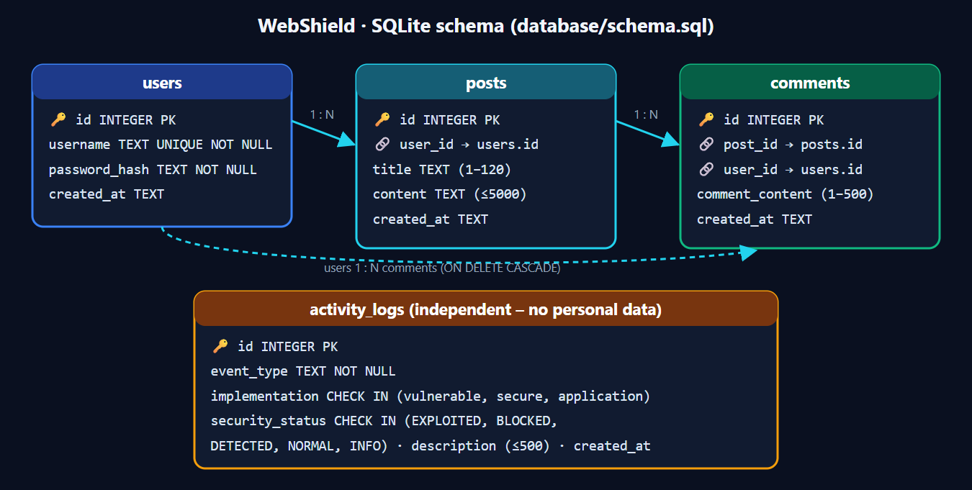
Figure 3 – Database schema diagram (docs/database_schema.svg)

5. Authentication Module (Module B)
The application's real login and registration are the secure implementation. Logging in with ' OR '1'='1' -- is refused (test AUTH-05).
- Registration: the server re-checks the username (3–30 letters, digits or underscore) and the password (8–128 characters, including a letter and a digit). It then hashes the password with scrypt and stores it with a parameterised INSERT. A duplicate username is rejected by the UNIQUE constraint.
- Login: the user is looked up with SELECT … WHERE username = ? and the password is checked with check_password_hash(). Unknown usernames and wrong passwords get the same message, so attackers can't tell which usernames exist.
- Sessions: the session cookie is signed, HttpOnly and SameSite=Strict, and expires after 30 minutes. It is cleared and recreated at login, which prevents session fixation.
- CSRF: every POST form carries a random token stored in the session. A request without the matching token is rejected with HTTP 400.
- Authorisation: the labs and logs require a login. Users can delete only their own comments.
- Logout: a CSRF-protected POST that clears the session.
The controlled SQL Injection demonstration for this module is in the SQL Injection lab (Section 6). It uses its own isolated test database and fictional accounts, never the real login.
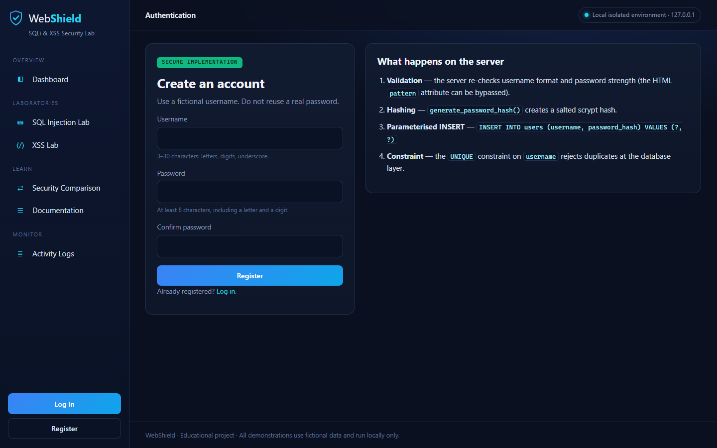
Figure 4 – Registration page showing the server-side steps: validation, hashing, parameterised INSERT and the UNIQUE constraint
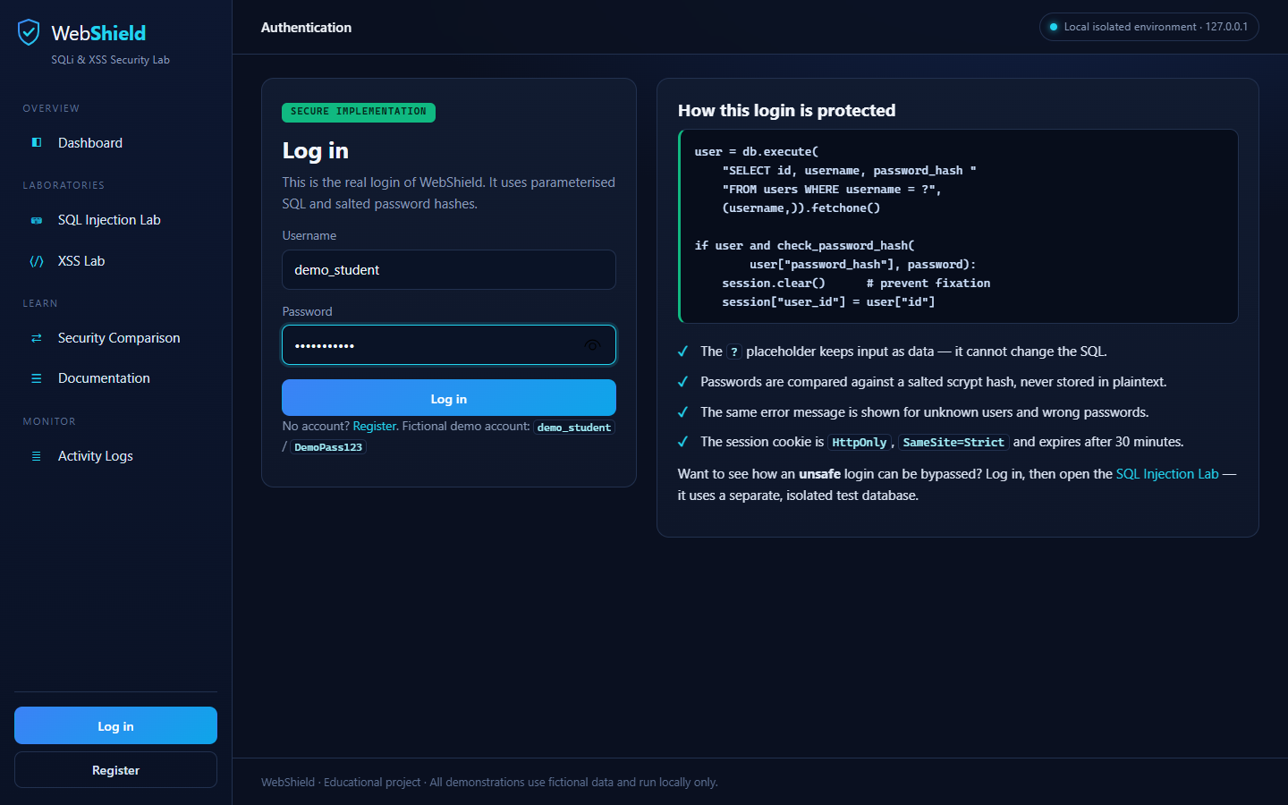
Figure 5 – Secure login page with the parameterised query and session protections explained beside the form

6. SQL Injection Laboratory (Module C)
With username lab_admin' --, the vulnerable login gave administrator access with no password, while the parameterised login refused the same input. The lab sends each username and password pair to both implementations and shows the exact SQL each one ran.
Vulnerable implementation (vulnerable/sqli_sandbox.py) – the input is pasted into the SQL text:
query = ("SELECT id, username, role FROM lab_users "
"WHERE username = '" + username + "' "
"AND password_hash = '" + sha256(password) + "'")
conn.execute(query)
Secure implementation – the SQL text is fixed and the values are bound as parameters:
query = ("SELECT id, username, role FROM lab_users "
"WHERE username = ? AND password_hash = ?")
conn.execute(query, (username, sha256(password)))
The input lab_admin' -- produces this vulnerable query:
SELECT id, username, role FROM lab_users
WHERE username = 'lab_admin' --' AND password_hash = '...'
The quote closes the string early and -- turns the password check into a comment, so the database returns the administrator row. With placeholders, the database compiles the statement before it sees the values. The input can therefore only be compared as a literal username, and no such user exists.
Input (username) | Vulnerable result | Secure result
alice / Wonderland1 | Login as alice | Login as alice
alice / wrong password | Refused | Refused
' OR '1'='1' -- | Bypassed – logged in as alice | Refused
lab_admin' -- | Bypassed – logged in as administrator | Refused
x' UNION SELECT 1, sqlite_version(), 'injected' -- | Attacker-chosen row returned | Refused
O'Brien (legitimate name) | SQL syntax error | Handled correctly
x'; DROP TABLE lab_users; -- | Rejected: one statement only; table intact | Refused

Isolation of the lab:
- It uses a fresh in-memory database for each request.
- A SQLite authorizer allows only SELECT and read operations, so INSERT, DROP, ATTACH, PRAGMA and recursive queries are denied.
- A progress handler stops queries that run too long.
- Inputs are limited to 200 characters.
- Users see only generic error messages, never the raw database error.
Vulnerable implementation | Secure implementation
Unsafe SQL construction | Parameterised SQL
User input can alter query structure | User input is treated as data
Demonstrates SQL Injection | Prevents this injection technique

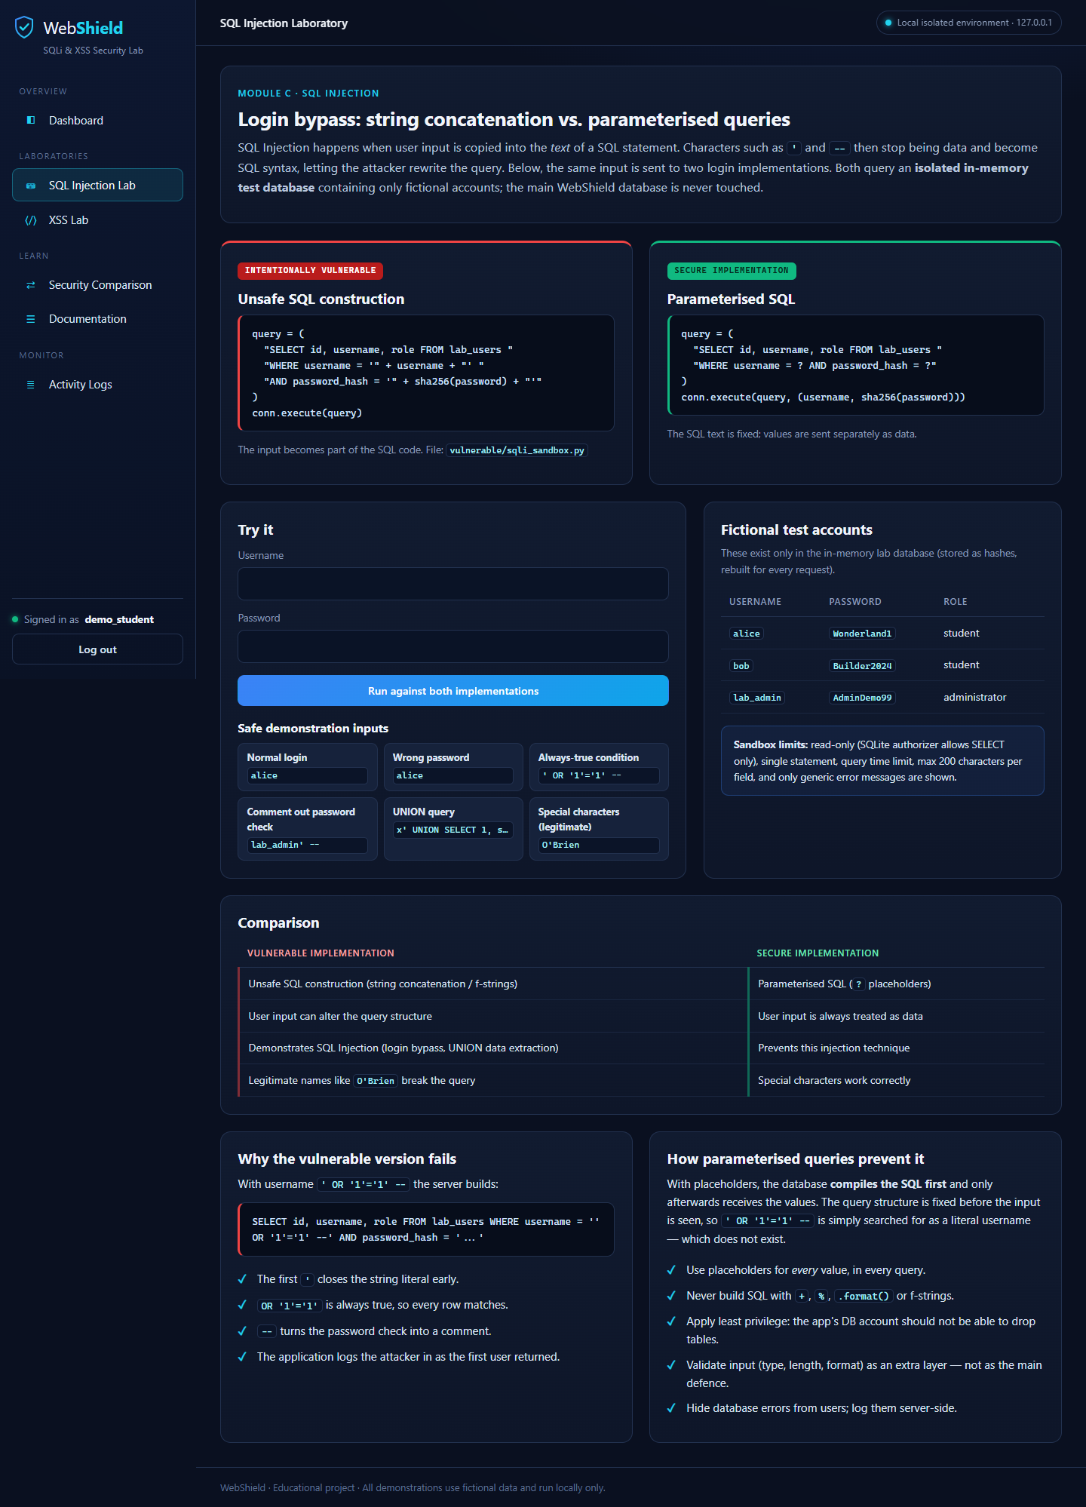
Figure 6 – SQL Injection lab with both implementations, example inputs and fictional test accounts
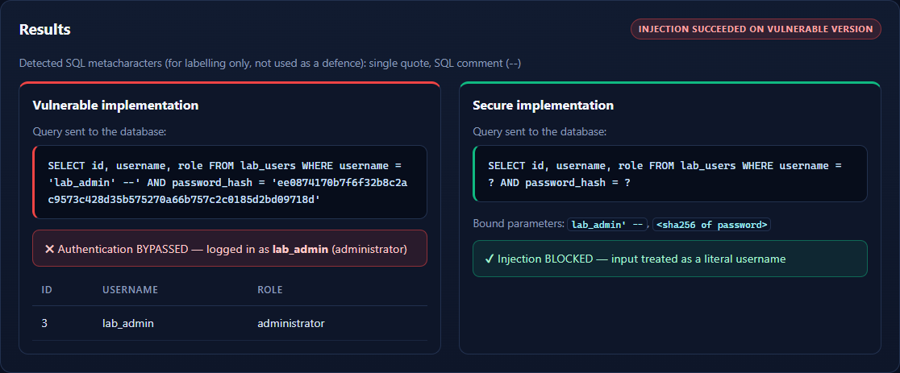
Figure 7 – Injection result for lab_admin' --: the vulnerable panel shows Authentication BYPASSED; the secure panel shows Injection BLOCKED
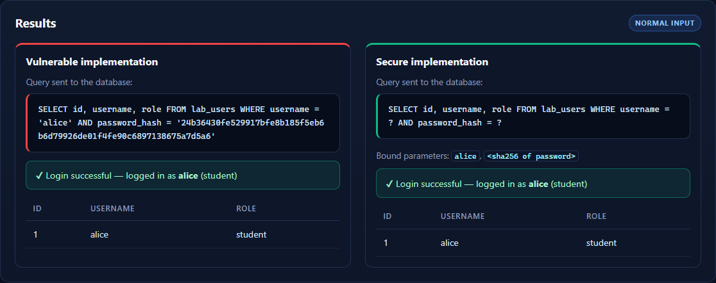
Figure 8 – Normal login (alice / Wonderland1): both implementations behave the same for legitimate input

7. XSS Laboratory (Module D)
In all three XSS demonstrations, the injected script ran only inside the sandbox, while the secure panel showed the same input as plain text. Each demonstration renders one input twice:
- Unsafely, inside <iframe sandbox="allow-scripts allow-modals">, with the page served under a Content-Security-Policy: sandbox header.
- Safely, in the main page, using Jinja2 auto-escaping or textContent.
The sandbox runs in an opaque origin with no network access, so it can't read WebShield's cookies or page content.
Type | Demonstration | Unsafe code | Secure code
Reflected | Search form; the search term is echoed back in the results | {{ q|safe }} | {{ q }} (auto-escaped)
Stored | Comments saved in the SQLite comments table and shown to every visitor | {{ comment_content|safe }} | {{ comment_content }}
DOM-based | JavaScript reads location.hash and writes it into the page | out.innerHTML = "Hello, " + v | out.textContent = "Hello, " + v

Reflected XSS: the payload is part of the request, for example in a crafted link, and is echoed straight back. In the secure version, <script> reaches the browser as &lt;script&gt;, which the browser displays but does not run.
Stored XSS: the comment is saved exactly as typed, using a parameterised INSERT. The danger comes when it is rendered. The vulnerable sandbox runs the script for every viewer; the secure list shows the raw characters. The lesson is to encode on output.
DOM-based XSS: the server is not involved at all. A <script> tag inserted with innerHTML does not run, but an event handler such as <img src=x onerror=...> does. textContent never parses HTML.
Prevention of each type:
- Reflected and stored: context-aware output encoding, keeping template auto-escaping on, never using |safe or Markup() on user data, and validating input length.
- DOM-based: safe DOM APIs (textContent, setAttribute, createElement) instead of innerHTML, document.write or eval.
- All types: a Content-Security-Policy without 'unsafe-inline', and HttpOnly cookies to limit the damage.
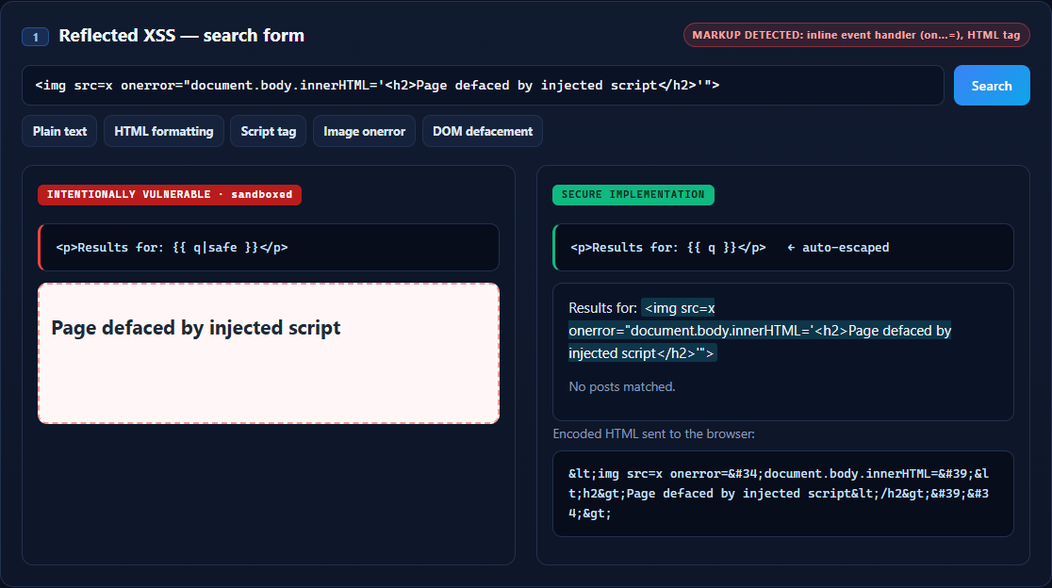
Figure 9 – Reflected XSS: the image-onerror payload defaces the sandboxed result; the secure panel shows the text and its encoded HTML
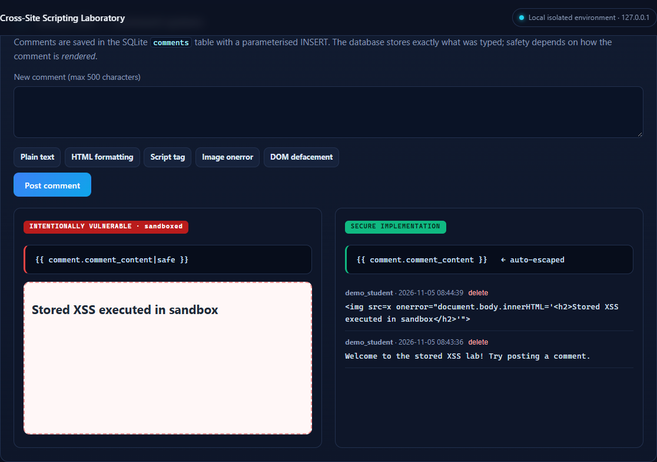
Figure 10 – Stored XSS: the stored comment runs in the sandbox; the secure comment list shows it as text
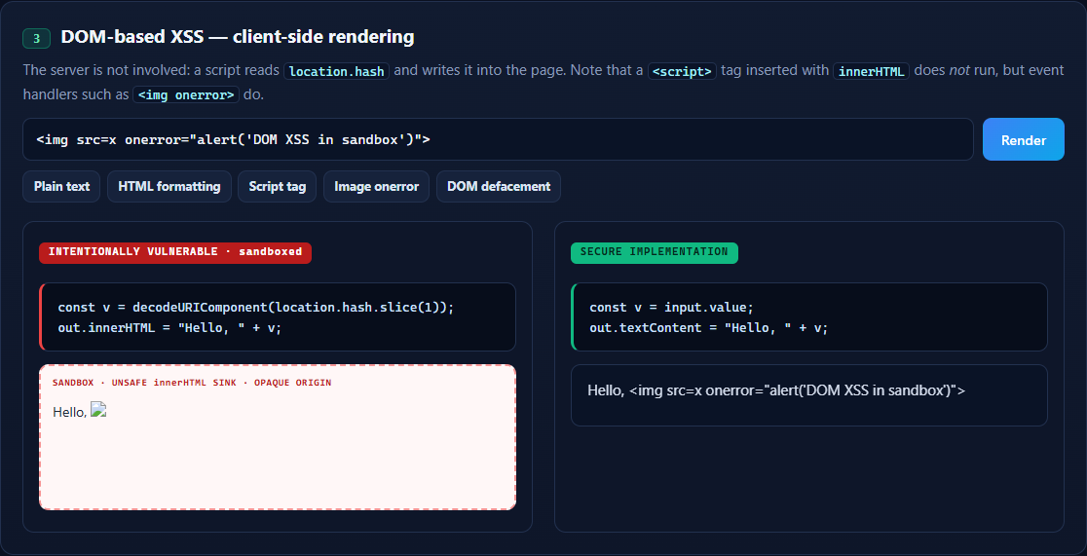
Figure 11 – DOM-based XSS: the innerHTML sink runs the onerror handler in the sandbox; the textContent output shows the payload as text

8. Security Comparison, Activity Logs and Documentation (Modules E–G)
Security comparison (Module E) explains what each layer is responsible for and traces a request in six steps: browser → CSRF and validation → parameterised SQL → constraints → output encoding → safe DOM. It also maps each control to the attack it stops:
Control | Layer | SQL Injection | XSS
Parameterised queries | Server / database | Primary defence | –
Output encoding | Server | – | Primary defence
Safe DOM APIs (textContent) | Client | – | Primary defence (DOM-based)
Server-side validation | Server | Supporting | Supporting
Content-Security-Policy | Client (sent by server) | – | Defence in depth
HttpOnly cookies | Server | – | Limits impact
Least privilege | Database | Limits impact | –
Client-side validation | Client | Usability only | Usability only

Activity logs (Module F) record the demonstration type, the date and time, the implementation (vulnerable or secure), the outcome and a short explanation. The outcome is one of EXPLOITED, BLOCKED, DETECTED, NORMAL or INFO, and the log can be filtered by outcome. Only a classification is stored. Passwords, session tokens and raw payloads are never logged (test SQLI-12).
Documentation (Module G) covers each vulnerability under these headings: definition, how it works, where it happens, why it is dangerous, a practical demonstration, prevention techniques and conceptual real-world examples.
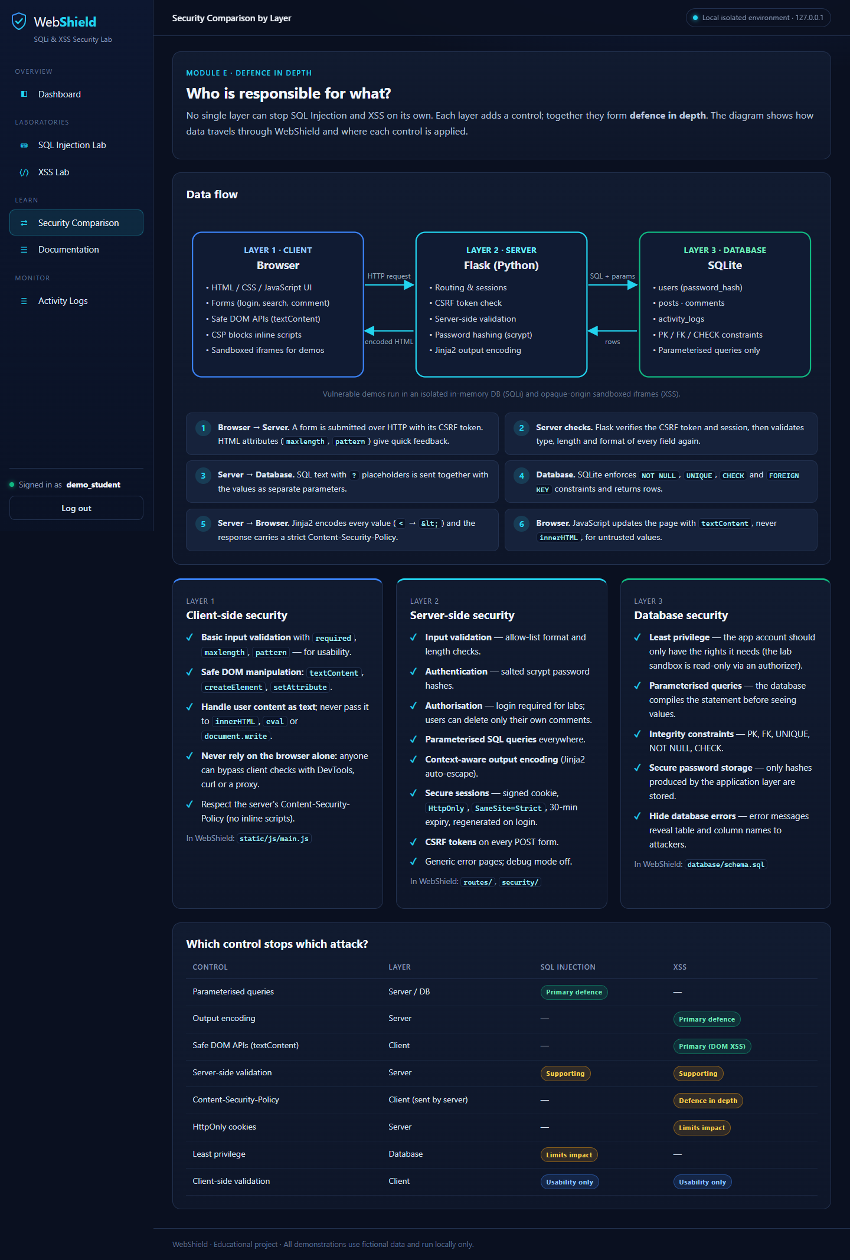
Figure 12 – Security comparison page with the data-flow diagram, the three layers and the control matrix
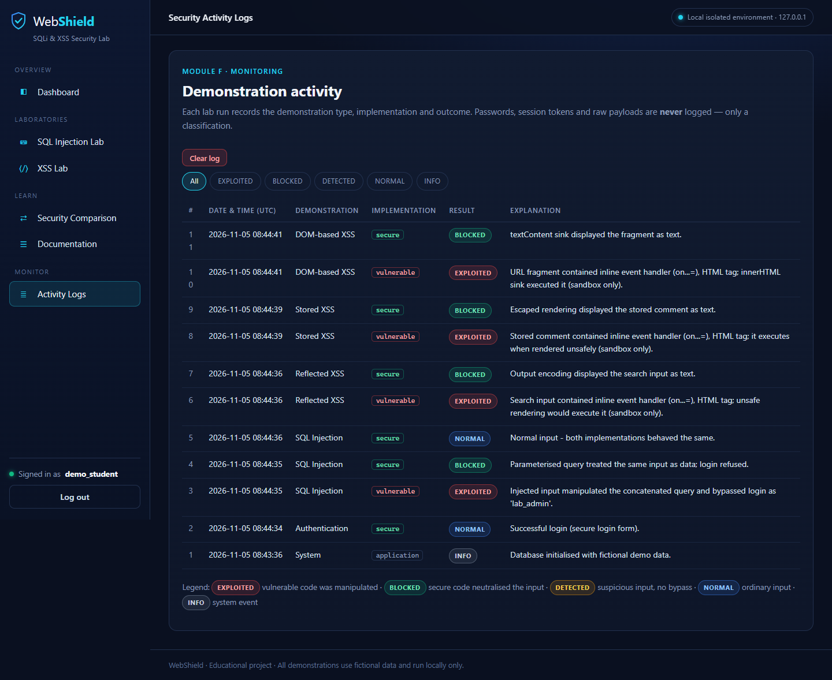
Figure 13 – Activity logs showing EXPLOITED and BLOCKED entries recorded during the lab demonstrations
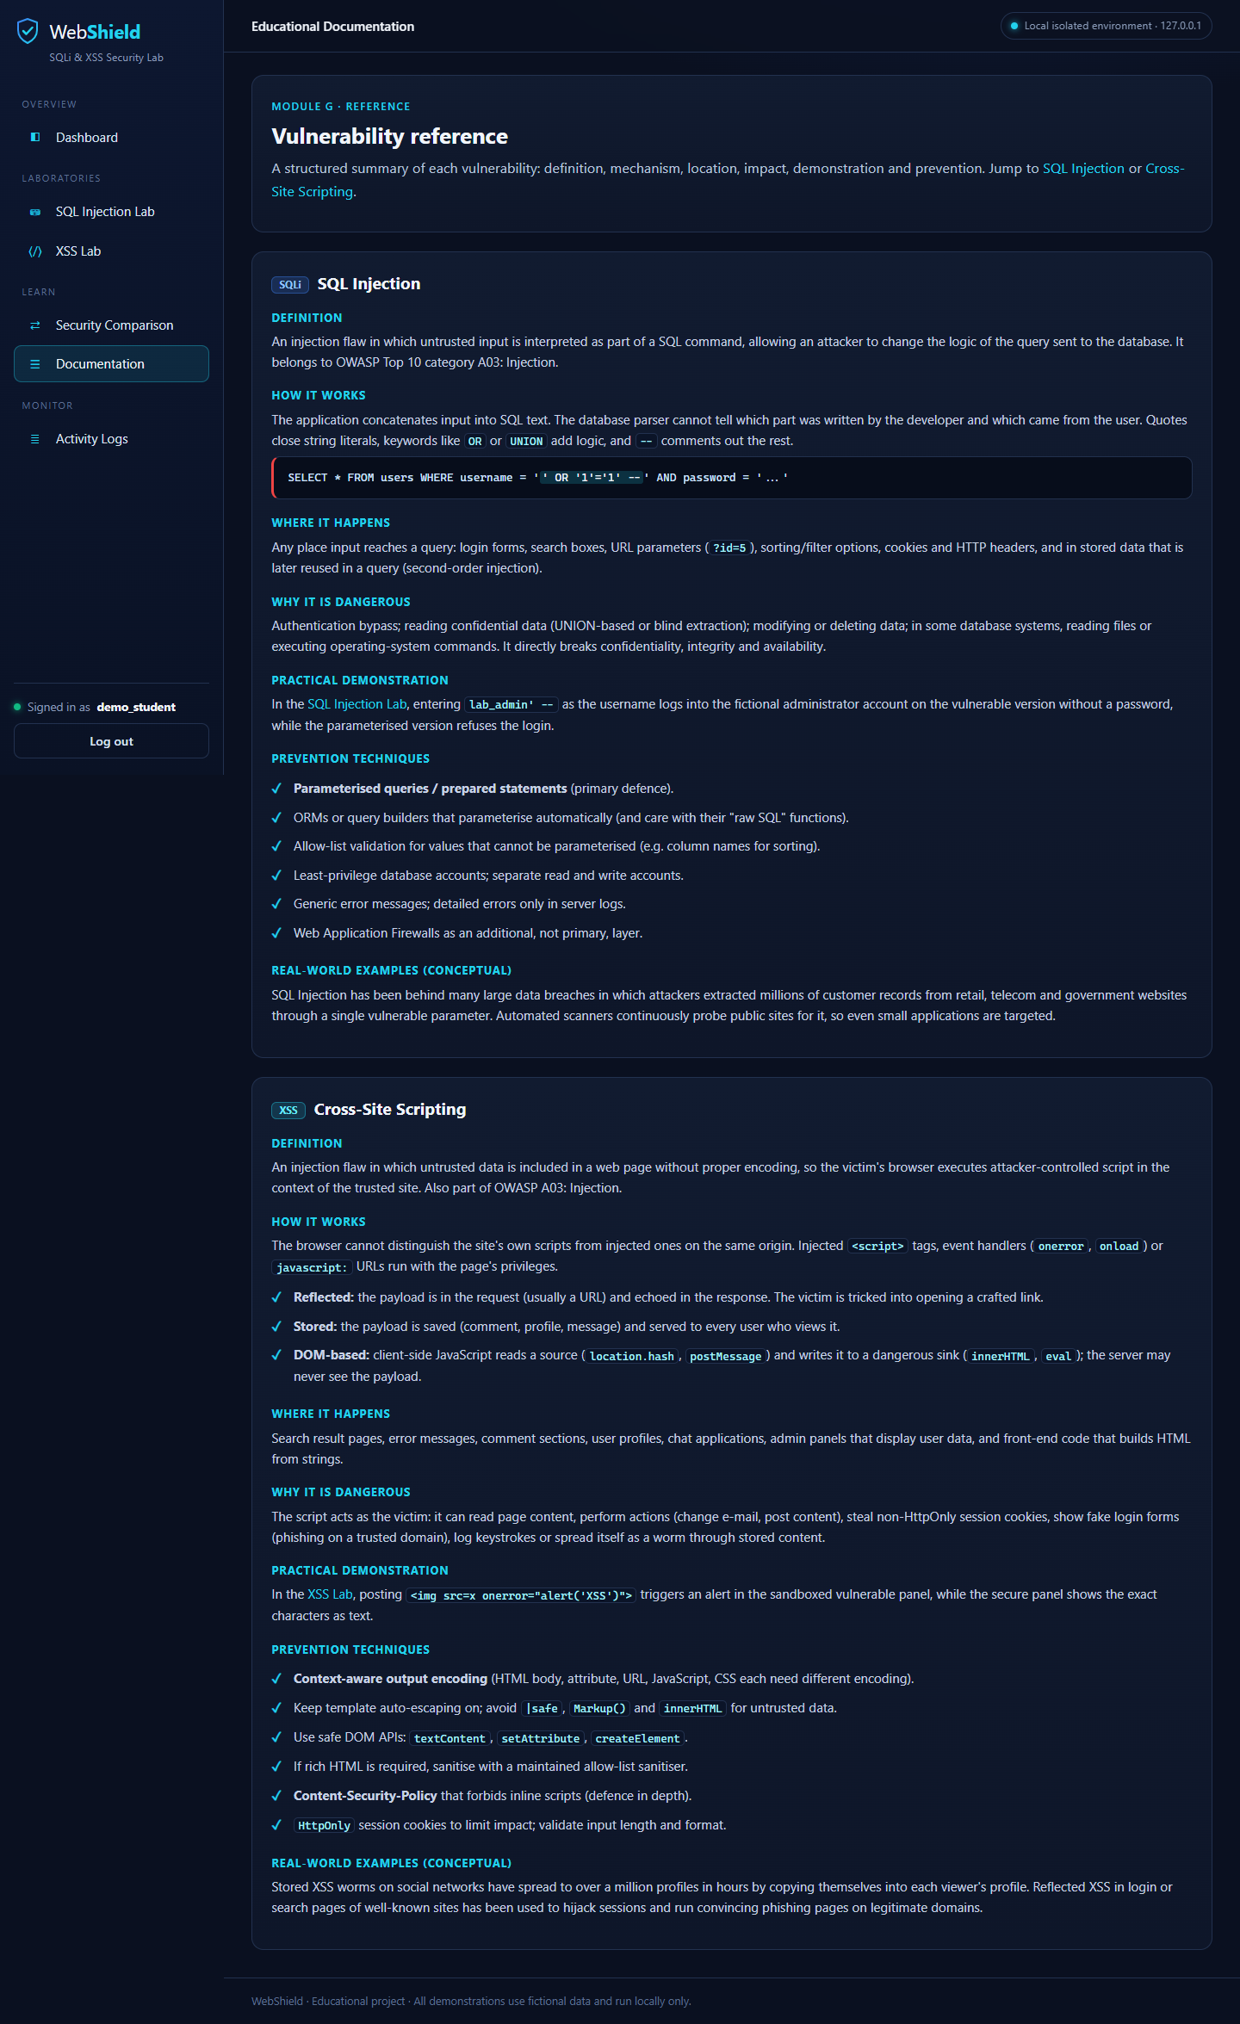
Figure 14 – Documentation page (Module G)
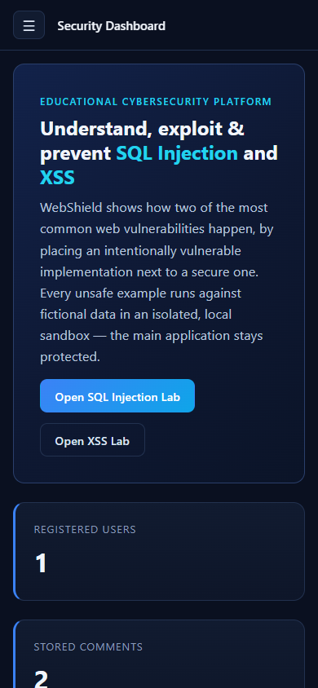
Figure 15 – Responsive mobile layout of the dashboard at 390 px width

9. Security Controls Protecting the Main Application
The main application meets all 14 mandatory security requirements, even though it contains vulnerable demonstrations.
# | Requirement | How WebShield meets it
1 | Separate vulnerable demos | Code only in vulnerable/ and templates/vulnerable/; in-memory SQLi database; XSS served only from /xss/sandbox/*
2 | Fictional data | Lab accounts alice, bob and lab_admin; seeded demo_student account
3 | Not exposed publicly | Server binds to 127.0.0.1 only
4 | No real passwords or personal data | Only fictional values in seeds and labs
5 | Parameterised queries | Every normal operation uses ? placeholders
6 | Password hashing | Werkzeug salted scrypt
7 | Server-side validation | security/validation.py checks username, password, comment and search length
8 | Context-aware output encoding | Jinja2 auto-escaping; |safe used only in sandbox templates
9 | Safe DOM manipulation | main.js uses only textContent and .value (test XSS-09)
10 | Session security | HttpOnly, SameSite=Strict, 30-minute expiry, session recreated at login
11 | CSRF protection | Synchroniser token on every POST (test AUTH-08)
12 | No debug information shown | Debug mode off; generic 400/404/500 pages; generic SQL error messages
13 | No injected scripts in the main app | Main CSP is script-src 'self', with no inline scripts; demo frames sandboxed with an opaque origin and connect-src 'none'
14 | Vulnerable code clearly marked | Red INTENTIONALLY VULNERABLE labels in the UI and warning banners in the source

Other protections: an open-redirect check on the login next parameter, a 64 KB limit on request size, X-Content-Type-Options: nosniff, and Referrer-Policy: no-referrer.

10. Testing and Results
All 39 automated test cases passed: 12 for authentication, 14 for SQL Injection and 13 for XSS. Each test uses a fresh temporary database. A pytest hook writes docs/TEST_REPORT.md from the actual outcomes, so no test can be reported as passed without having run. Command: python -m pytest -v.
Test ID | Input | Expected result | Actual result | Status
AUTH-01 | Register alice_test / Secret123, then log in | Redirect, session created | 302, user_id in session | PASS
AUTH-02 | Register bob_test / Secret123 | Salted hash stored, no plaintext | Stored value starts scrypt:, no plaintext | PASS
AUTH-03 | demo_student / WrongPass1 | 401, generic message | 401, generic message | PASS
AUTH-04 | nobody_here / Whatever1 | Same generic message (no user enumeration) | 401, generic message | PASS
AUTH-05 | ' OR '1'='1' -- on the real login | Login refused | 401, no session | PASS
AUTH-06 | a<b> / short | 400, server validation rejects | 400 | PASS
AUTH-07 | Register demo_student again | 400 "already taken" | 400 "already taken" | PASS
AUTH-08 | POST /login without CSRF token | 400 | 400 | PASS
AUTH-09 | Log out, then GET /sqli/ | Redirect to /login | 302 → /login?next=/sqli/ | PASS
AUTH-10 | Successful login | Cookie HttpOnly + SameSite=Strict | Both present | PASS
AUTH-11 | GET /does-not-exist | Generic 404, strict CSP | 404, no traceback, no unsafe-inline | PASS
AUTH-12 | POST /login?next=//evil.example | Redirect stays on site | Location = / | PASS
SQLI-01 | alice / Wonderland1 | Both log in | Both = alice | PASS
SQLI-02 | alice / wrongpass | Both refuse | Both refused | PASS
SQLI-03 | O'Brien | Vulnerable: syntax error; secure: handled | As expected | PASS
SQLI-04 | ' OR '1'='1' -- | Vulnerable bypass; secure refuses | Vulnerable = alice; secure refused | PASS
SQLI-05 | lab_admin' -- | Vulnerable bypass; secure refuses | Vulnerable = lab_admin; secure refused | PASS
SQLI-06 | ' OR 1=1 LIMIT 1 OFFSET 2 -- | Vulnerable bypass; secure refuses | Vulnerable = lab_admin; secure refused | PASS
SQLI-07 | x' UNION SELECT 1, sqlite_version(), 'injected' -- | Attacker row vs. nothing | role = injected; secure 0 rows | PASS
SQLI-08 | x'; DROP TABLE lab_users; -- | Rejected; table intact | Stacked query rejected; alice still logs in | PASS
SQLI-09 | Recursive CTE payload | Sandbox authorizer refuses | Refused | PASS
SQLI-10 | ' OR '1'='1' -- (secure) | SQL text identical for any input | Same text, payload not in SQL | PASS
SQLI-11 | POST lab with lab_admin' -- | Bypass + block shown; logs EXPLOITED and BLOCKED | As expected | PASS
SQLI-12 | POST lab alice / Wonderland1 | Password never in logs | Not present | PASS
SQLI-13 | UNION SELECT … FROM users -- | Main users table not reachable | Query failed, no login | PASS
SQLI-14 | 201-character username | 400 | 400 | PASS
XSS-01 | Hello WebShield | Stored and shown unchanged | As expected | PASS
XSS-02 | <b>bold</b> | Shown as encoded text | Encoded, no raw tag | PASS
XSS-03 | <script>alert('XSS')</script> (stored) | Encoded in main page; raw only in sandbox | As expected | PASS
XSS-04 | <img src=x onerror="alert(1)"> (stored) | Encoded; logs EXPLOITED and BLOCKED | As expected | PASS
XSS-05 | Script in search query | Encoded in main page; raw only in sandbox | As expected | PASS
XSS-06 | Search "firewall" | Displayed, logged NORMAL | As expected | PASS
XSS-07 | GET sandbox page | CSP sandbox, connect-src 'none' | Present, no allow-same-origin | PASS
XSS-08 | GET /xss/ | Strict CSP; both iframes sandboxed | unsafe-inline absent; 2/2 sandboxed | PASS
XSS-09 | Inspect main.js | textContent only, no innerHTML | As expected | PASS
XSS-10 | DOM payload sent to /xss/dom-log | 204; EXPLOITED and BLOCKED logged | As expected | PASS
XSS-11 | Empty and 501-character comments | Both rejected | Comment count unchanged | PASS
XSS-12 | Delete another user's comment | 403 | 403 | PASS
XSS-13 | <a href="x" onclick='y'>&</a> | All five special characters encoded | All encoded | PASS

A browser-level check (docs/take_screenshots.py, Microsoft Edge) also passed. The DOM-based payload raised an alert inside the sandbox only. The secure panel showed the payload as text, the main page was unchanged, and document.cookie was empty because the cookie is HttpOnly.
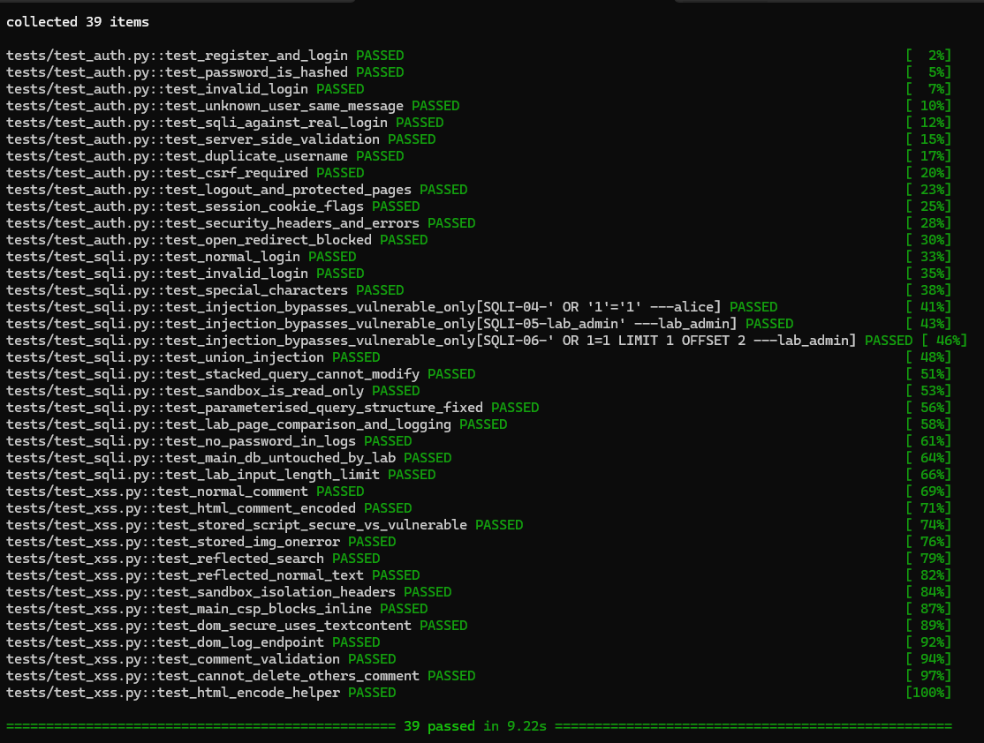

11. Conclusion, Limitations and Future Work
WebShield meets every acceptance criterion. It launches locally, users can register and log in, and the database stores and retrieves data correctly. Both labs show the difference between unsafe and safe handling, and the main application stays protected. All tests pass.
The central lesson is that SQL Injection and XSS share one root cause: code and data are mixed. The fixes are the framework's own safe defaults – parameterised queries and output encoding – kept switched on. Blacklist detection and client-side validation help with labelling and usability, but they are not defences.

Limitations
- The secret key is regenerated at every restart unless WEBSHIELD_SECRET_KEY is set, so restarting the app logs everyone out.
- SESSION_COOKIE_SECURE is off because the local server uses HTTP.
- SQLite has no database users, so least privilege is shown with the sandbox authorizer rather than database roles.
- There is no rate limiting on login attempts.

Future work
Login rate limiting, an HTTPS deployment profile, a blind (time-based) SQL Injection demonstration, an attribute-context and URL-context XSS demonstration, and Trusted Types for DOM sinks.

Appendix: Installation and Running
Requires Python 3.10 or later. From the WebShield folder:
- python -m venv .venv, then activate it with .venv\Scripts\activate (Windows) or source .venv/bin/activate (macOS and Linux).
- pip install -r requirements.txt
- python -m database.init_db creates or resets the database.
- python app.py, then open http://127.0.0.1:5000. The fictional demo account is demo_student / DemoPass123.
- python -m pytest -v runs the automated tests.
- Optional: pip install -r requirements-dev.txt, then python docs/take_screenshots.py regenerates the screenshots and reruns the browser check.

