DESIGN YOUR OWN SYSTEM

QR-Code Smart
Attendance System
A practical four-layer architecture for university classes

SUBMISSION DETAILS
Student name | Salman Mugharbel
Student ID | 268199
Course / module | Development of Databases

University mini-project

1. Project Title
Design of a QR-Code Smart Attendance System for University Classes.

2. Introduction and Problem Statement
Manual attendance takes class time and may lead to missing or incorrectly recorded entries. This project proposes a small system in which a lecturer opens a time-limited class session and displays its QR code. A student scans the code or enters its short fallback code. The application checks that the session is active and that the student is enrolled, records valid attendance, and returns a result.
The prototype demonstrates a typical information-system workflow, not identity verification. Its sample student profiles are selectable demo data; therefore, the prototype should not be treated as a secure production attendance service.

3. System Objectives
- Allow a lecturer to start a class attendance session and display its QR code.
- Allow a student to submit attendance through a mobile or web interface.
- Validate the session and course enrollment before saving a record.
- Store and retrieve attendance records for lecturers to review.
- Show session status, attendance counts, and recent records in a dashboard.

4. Selected System and Components
The Smart Attendance System is selected because its users and workflow are familiar, its four layers are easy to demonstrate, and it avoids the specialized machine-learning or high-stakes decision requirements of crop diagnosis and hospital triage.
OPTION | ASSESSMENT FOR THIS MINI-PROJECT
Smart Attendance System — selected | Clear lecturer/student workflow; achievable prototype; demonstrates interface, processing, storage, and devices.
Crop Disease Detection System | Could demonstrate image capture and AI, but reliable diagnosis needs labeled image data and model evaluation, adding substantial complexity.
Hospital Triage System | Has a clear workflow but supports high-stakes medical prioritization; safe, credible design requires domain expertise and stronger safeguards.

Main components: lecturer web dashboard; student mobile/web interface; request API (the interface used by the client to send backend requests); session and enrollment validation logic; SQLite database for students, courses, enrollments, sessions, and attendance; classroom screen; student phone/camera; and campus network or local hosted server.

5. Four-Layer Architecture Diagram
The diagram below shows four system layers. The student phone scans the classroom QR code. Requests move from the user interface to application processing; the application reads and writes records in the data layer, then returns a result to the interface.
1 PRESENTATION LAYER
Lecturer web dashboard | Student mobile/web interface | Admin attendance/report view
Input: lecturer actions, scan/code, report request → Output: session status, confirmation/error, attendance view
↓ HTTP requests / responses
2 APPLICATION / PROCESSING LAYER
Request API | Session and enrollment validation | Attendance and report logic
Input: interface requests and QR/session code → Output: validated record, result, or report data
↓ validation reads / writes
3 DATA LAYER
Student/course/enrollment records | Class session records | Attendance records and report queries
Input: application queries and updates → Output: stored records and retrieved results
↕ QR / device / network interaction
4 INFRASTRUCTURE / DEVICE LAYER
Classroom display showing QR | Student phone camera | Campus Wi-Fi/internet and hosted server
Input: lecturer display and student device activity → Output: scannable QR and network/computing resources
End-to-end flow: classroom screen displays the session QR → student phone scans it → student interface sends the code → application checks the active session and enrollment against stored data → attendance is saved → confirmation is returned to the student; the lecturer can retrieve the updated attendance list.

6. Explanation of Each Layer
LAYER | PURPOSE AND COMPONENTS | MAIN INPUT → OUTPUT
Presentation | The user-facing screens: lecturer dashboard, student mobile/web interface, and admin report view. | Lecturer actions, scan/code, or report request → session status, attendance result, and lists.
Application / Processing | Receives requests and applies rules: request API, active-session check, enrollment check, attendance recording, and report logic. | User requests and session data → validated attendance, confirmation/error, or report.
Data | Stores and retrieves the system records: students, courses, enrollments, class sessions, and attendance. | Application queries/updates → stored information or retrieved records.
Infrastructure / Device | Physical and computing resources: classroom display, student phone/camera, network, and hosted server. | QR display and device/network activity → scannable input and connectivity/computing resources.

Screenshots below document the running prototype. They show the dashboard and its four-layer-facing user interactions, session QR display, successful student submission, and stored attendance records. They are interface evidence, not performance measurements.
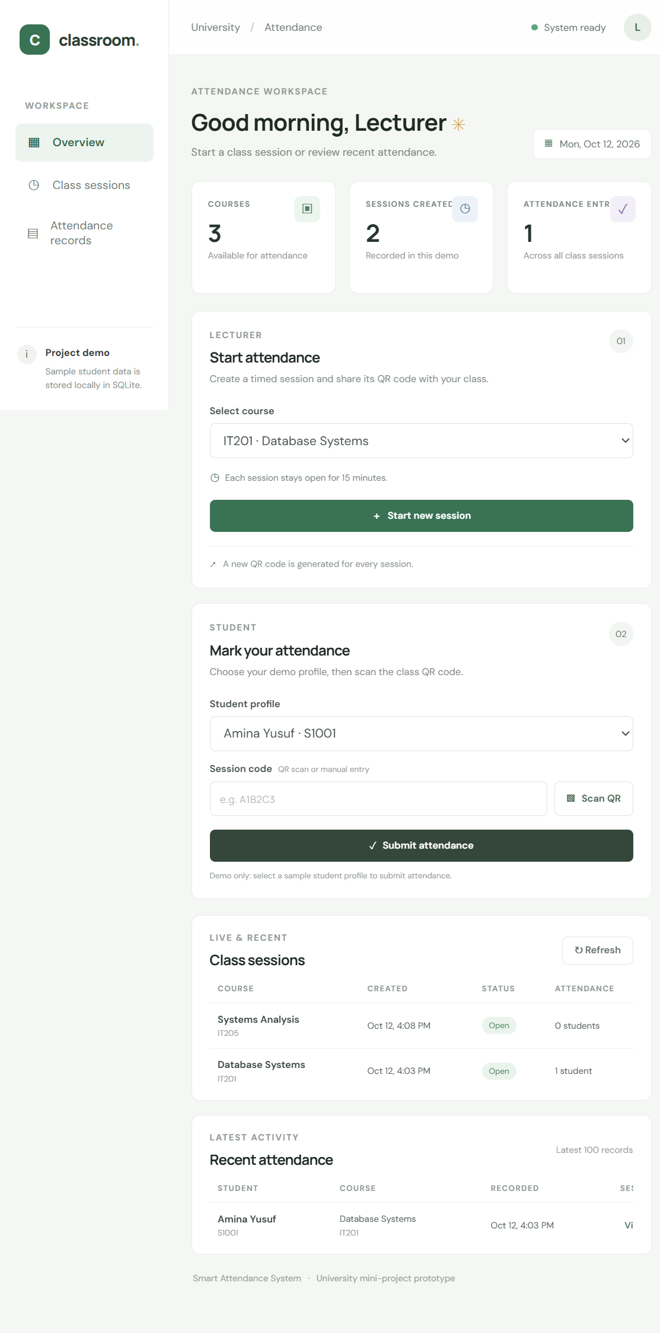
Figure 1. Dashboard with lecturer session controls, student submission form, sessions, and attendance overview.
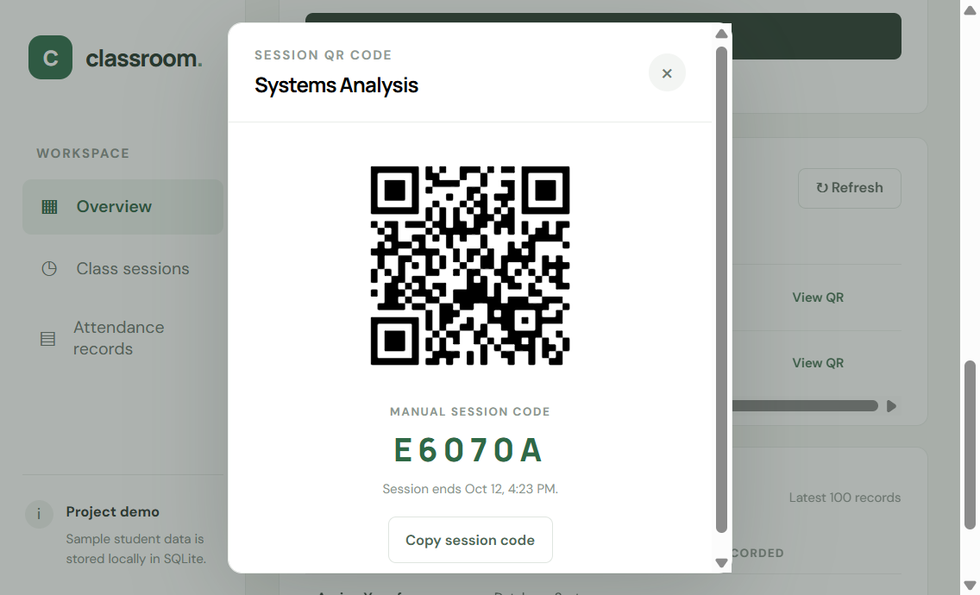
Figure 2. Active class session QR code and manual code fallback.
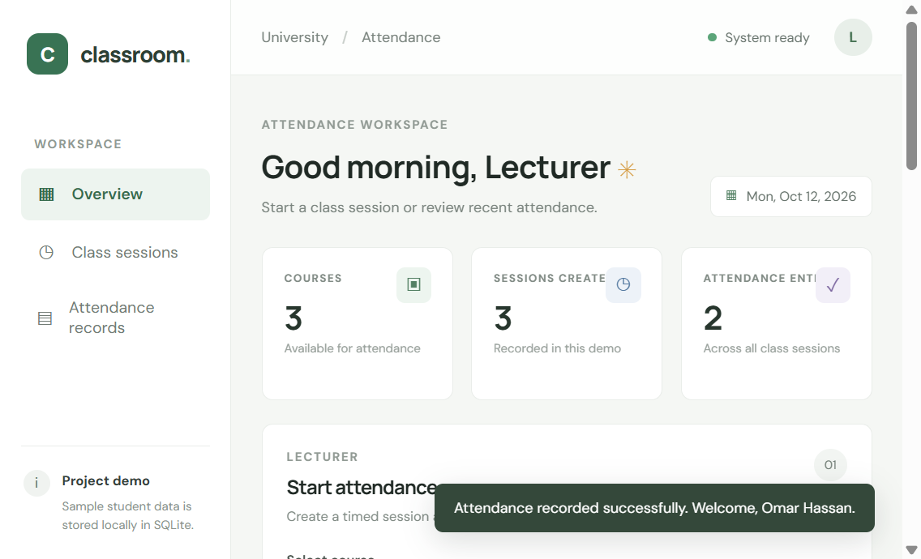
Figure 3. Successful attendance submission confirmation in the student workflow.
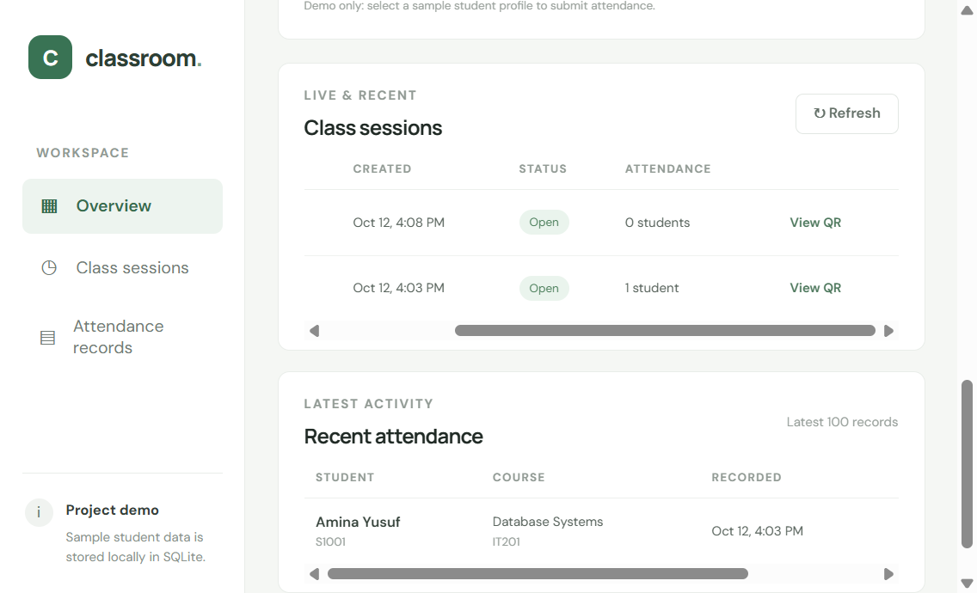
Figure 4. Recent class sessions and a saved attendance entry in the records view.

7. Processing Model: Batch, Real-Time, and Edge
APPROACH AND MEANING | SUITABILITY AND EXAMPLE | RISK IF CHOSEN INCORRECTLY
Real-time: handle a request as it arrives and return a prompt result. | Suitable for attendance submission: check the code and enrollment, save the record, and confirm the result immediately. | If submission is deferred to a later batch, students may not know whether attendance was recorded and may retry.
Batch: collect work and process it together later. | Suitable for non-urgent work such as a daily summary or export of records. | If scans are handled only in a batch, immediate confirmation is lost; if every report must be real-time, resources may be used needlessly.
Edge computing: process data on or near the device that produced it. | Not needed in the initial system. The phone can scan the QR, while the central application performs the authoritative session/enrollment checks. | Unneeded edge logic adds complexity and can make rules harder to keep consistent. Central processing requires network connectivity; offline support would need a separate design.

Recommended combination: real-time processing for student submissions and confirmations; batch processing for future reports/exports if they are large; no dedicated edge computing in this prototype.

8. Latency Requirements
Latency is the time between making a request and receiving its response. The figures below are illustrative design targets under normal network and system load. They are not measured performance results; a deployed implementation would need testing to determine actual response times.
OPERATION | ILLUSTRATIVE TARGET | REASON / URGENCY
Open dashboard/student interface | ≤ 2 seconds | Lets users start without a noticeable wait.
Submit attendance and receive confirmation/error | ≤ 2 seconds | Needs prompt feedback; this is the immediate operation.
Load class attendance list | ≤ 3 seconds | Lecturer review should feel responsive.
Generate class/daily report | ≤ 10 seconds | Useful but less time-critical; larger exports may run in the background.

Immediate path: session validity check, enrollment check, attendance write, and submission result. Background/non-urgent path: end-of-day summaries and larger report exports. The stated targets describe desired behavior only, not observed or experimentally verified results.

9. Conclusion
The QR-code Smart Attendance System is a practical project for demonstrating a four-layer architecture. A student submission flows from the interface through business-rule validation to stored data, and the result returns to the user. Real-time handling is appropriate for check-ins, batch work can serve non-urgent reports, and edge computing is unnecessary for the initial design. The prototype screenshots show workflow evidence; the latency figures remain design targets until measured.

Appendix A. 60–90 Second Presentation Script
My project is a QR-code Smart Attendance System for university classes. I chose it because the problem is familiar and the design is practical to demonstrate. The system has four layers. The Presentation Layer contains the lecturer dashboard and student interface. The Application Layer receives requests and checks whether a session is active and whether a student is enrolled. The Data Layer stores students, courses, sessions, and attendance records. The Infrastructure and Device Layer includes the classroom display, student phones, network, and server. A lecturer starts a session and displays a QR code. A student scans it or enters the fallback code. The application validates the request, saves valid attendance, and returns a result. Attendance submissions use real-time processing, while larger reports can be generated later in batches. Dedicated edge computing is not necessary. The response-time values in my report are design targets, not measured results.

Appendix B. Likely Teacher Questions
QUESTION | SHORT ANSWER
Why choose QR codes instead of facial recognition? | QR codes are simpler for this prototype and avoid face-data collection and the additional privacy concerns it would introduce.
Why is attendance real-time? | Students need prompt confirmation that a scan succeeded; otherwise they may be uncertain or submit again.
What information is stored? | Student/course/enrollment records, class sessions, and attendance records.
Why not use edge computing? | A phone can scan the QR, but central processing can perform the authoritative enrollment and session checks. Edge processing is not needed for this scope.
Are the latency values proven results? | No. They are illustrative design targets; actual performance must be measured after implementation.

Appendix C. Assignment Requirement Checklist
REQUIREMENT | REPORT LOCATION
Evaluate three candidate systems and select/justify one | Section 4
Four labeled layers, with relevant components, arrows, inputs and outputs | Section 5
Simple explanation of each layer and information movement | Sections 5–6
Batch, real-time, and edge definitions, fit, example, and consequences | Section 7
Latency definition, operation targets, urgency, and target/measurement distinction | Section 8
Introduction, problem, objectives, components, conclusion | Sections 2–4 and 9
Screenshots from the working prototype | Section 6, Figures 1–4
60–90 second presentation and five short teacher answers | Appendices A–B

