git-> version control system-> 1)version changes

2)project save

we are deploying this projects in remote(not at our location) server

version control systems are like git

repository means project folder

remote repository ->storing of repository on any internet server like bit bucket,gitlab,github,

github is one of remote repository hosting(storing) service

1)remote repository

2)local repository

3)staging area

4)working directory -> working in a file (untracked files)

syntax

git init -> initializing this project as git repo then it will create .git file

git status->it will tell about commits and untracked files

git add ->it will move from wdir to staging area

staging area means area where the changes are yet to be commited

git commit -m “commiting codeand example (here -m for message) from sa to local repo

for moving local repo to remote repo we have to create remote repo like github

the main target is save in remote repository so first save in local repository we have main place is staging area

ex:-

working directory staging area local repository remote repository

code.py

example .txt we want only code.py push for move files in

remote repository

but not example.txt

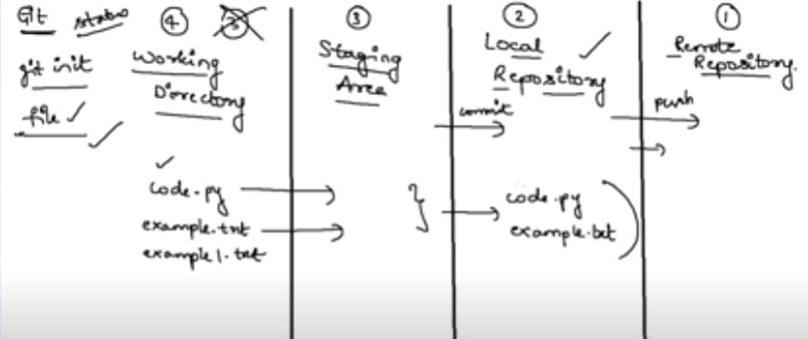

From working dir to staging we send one by one files after this we send by batches

From wdir to sa is git add

Checkout is to jumping between branches

Git checkout -b “copy1”(-b for creating branch)