**Section 1: Metadata**

*to be filled by the student*

**1.1. Project Information** to be filled by the student

|  |  |
| --- | --- |
| Title: Enrollment Management System | |
| Section: L5 | Instructor: Sir Umer Tariq |

**1.2. Student(s) Information**

|  |  |
| --- | --- |
| Name: Muhmmad Shayan Wasif | ID: 08071 |
| Section: L5 | Batch: 2026 |

|  |  |
| --- | --- |
| Name: Salman Adnan | ID: 07885 |
| Section: L5 | Batch: 2026 |

|  |  |
| --- | --- |
| Name: Hussain Umer Farooqui | ID: 08040 |
| Section: L5 | Batch: 2026 |

**Submission guideline:** Save your project proposal as a pdf file and rename as Project Proposal_L1_ProposedTitle where L1 is to be replaced with your section

**Section 2: The Project**

*to be filled by the student*

**2.1. Project Description:** *Please provide a brief introduction of the project including its scope.*

Our project centers on an enrollment system, enabling students to construct their timetables from a provided list of courses. Additionally, students have the flexibility to make adjustments, including adding, dropping, or swapping courses up-to a specific date. The system will incorporate safeguards to prevent any scheduling conflicts. Each student will be provided with unique credentials for secure access to the system.

**2.2 Functional Requirements**

*This section describes each function/feature provided by your system. These functions are logically grouped into modules based on their purposes. The users in your system must be categorized such as client, customer or administrator etc. These users will be accessing the database with the level of access that they are authorized with.*

Sample functional Requirements:

**Module 1: Login**

**• Function 1: Login:** Allows students to securely access the system using their unique student IDs, ensuring personalized and confidential interaction with their timetables.

**Module 2: Timetable**

**• Function 2: Create and Edit Timetable:** Empowers students to select from a list of available courses and construct a personalized timetable tailored to their preferences and academic requirements.

**• Function 3: View and Filter Timetable:** Provides students with the ability to easily review their chosen timetable, with options to refine the view based on specific days or weeks, optimizing accessibility and convenience.

**• Function 4: Course List:** Offers students a comprehensive list of available courses, enabling them to efficiently make selections and populate their timetables.

**• Function 5: Activity Log:** Maintains a detailed record of all student activities within the system, such as course swaps, add/drop actions, providing transparency and accountability.

**• Function 6: Export Timetable:** Enables students to generate and download their timetable in an Excel format, facilitating easy access and sharing of their schedules.

**• Function 7: Conflict Resolution:** Check if there is a clash in time and day.

**2.3. Planned Schedule:** *Kindly list the start/end dates and the timeline for the achievement of any intermediate milestones and the expected contribution to be made by the participant(s).*

Start date: 25th September: start making the ERD and overall schema of the database. End date: Project Deadline. Equal contribution by all three partners and progress will depend on the pace of the class as we will be employing the knowledge we learn in class as we go along.

**2.4. Technology Stack:** *If you are utilizing any language or database besides PyQt and SQL Server, please complete this section; otherwise, leave it blank. Specify the programming language and database management system intended for constructing this application, as well as the application type (Desktop, Web, or Mobile).*

SQLAlchemy or MySQL

PyQt6

**2.5. Screens:** *Provide images of all application screens, showcasing clear input and corresponding outputs. Ensure each image includes a concise caption explaining user action and expected/observed output. You can create these screens using Qt Designer.*

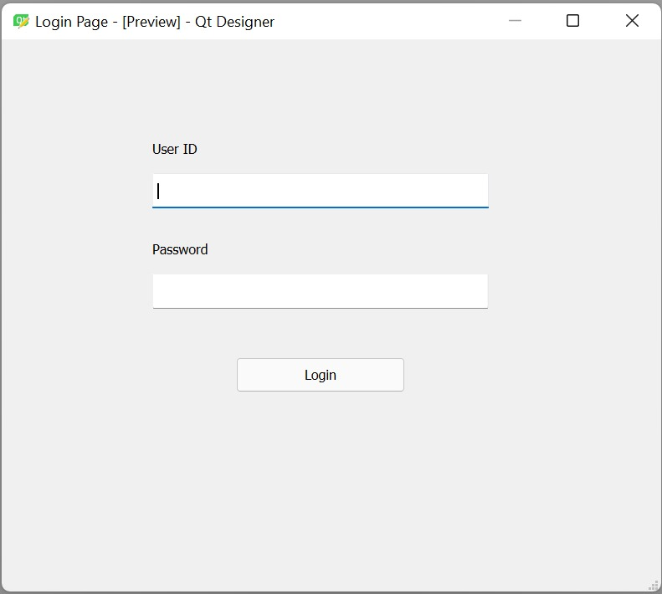Login Window: Students will log in using their unique credentials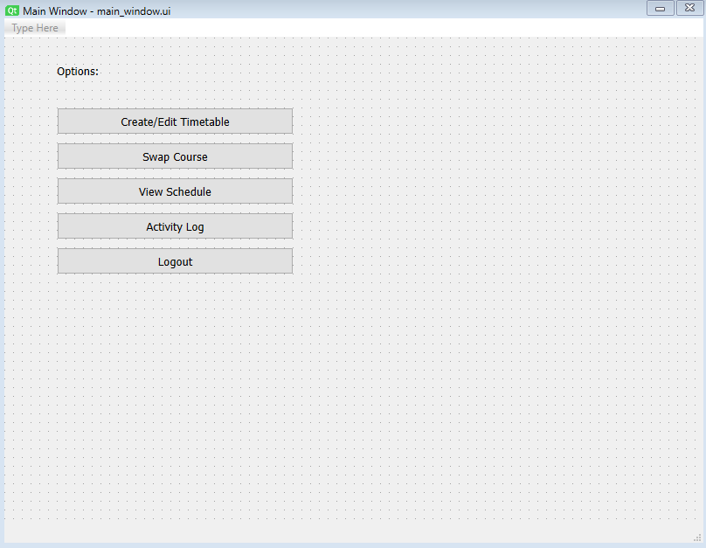Main Window: All the options students have are mentioned here. 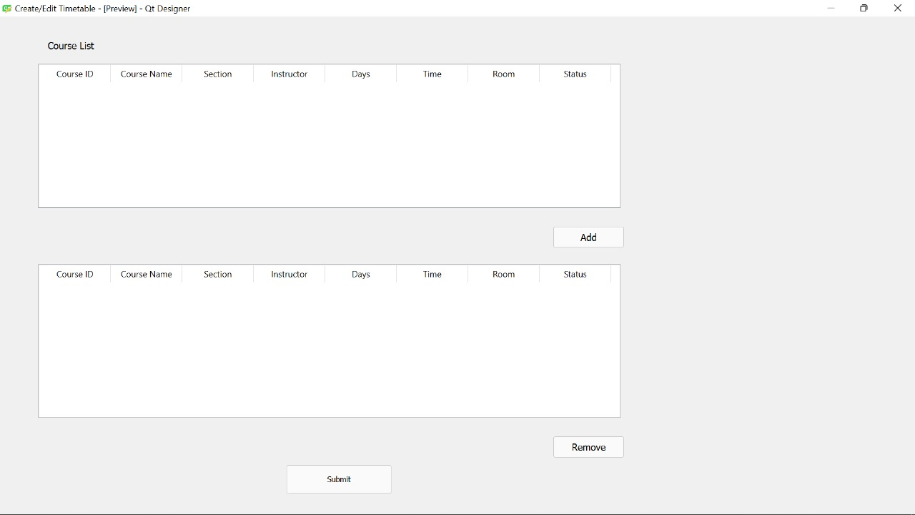Create/Edit Timetable: Shows course list from which students can add/remove courses.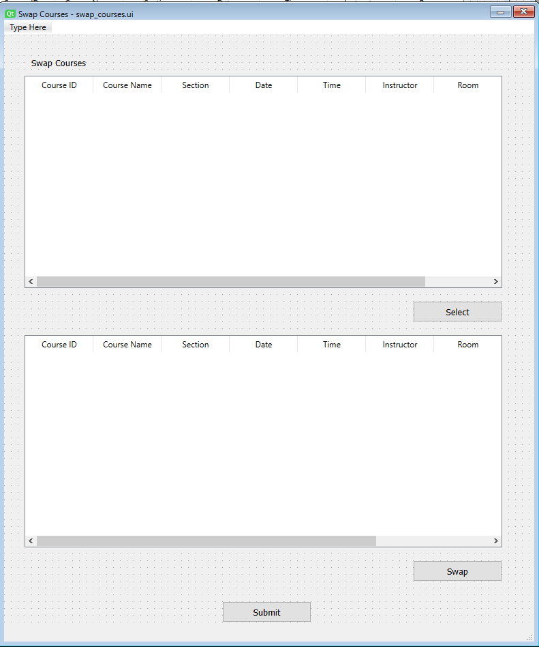Swap Courses: Students can swap their courses.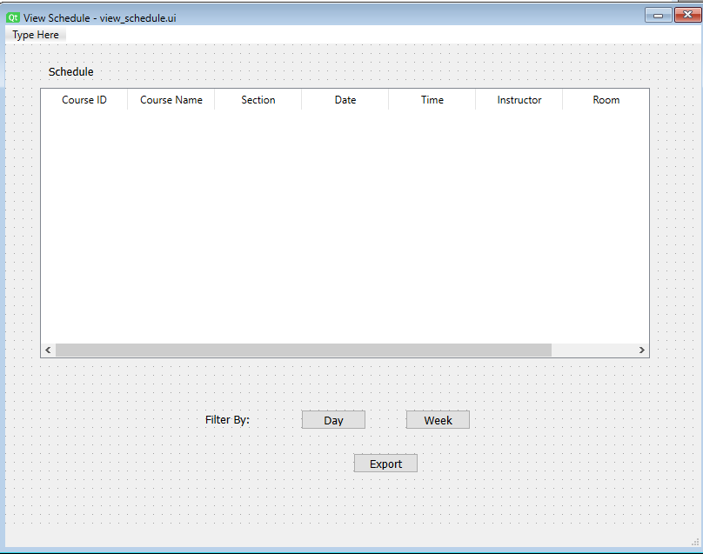View Schedule: Their daily/weekly schedule is mentioned here. 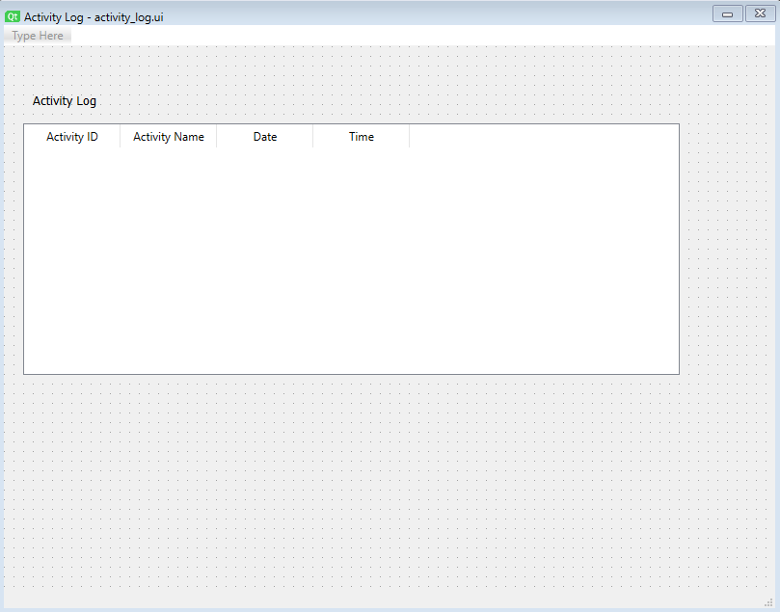Activity Log: Any changes they have e.g. create timetable or swap course

**2.5. ERD:** *Please incorporate an initial ERD for your project, ensuring clear highlighting of primary keys and accurate depiction of table relationships. Avoid manual ERD creation; utilize tools like DBdesigner for this purpose.*

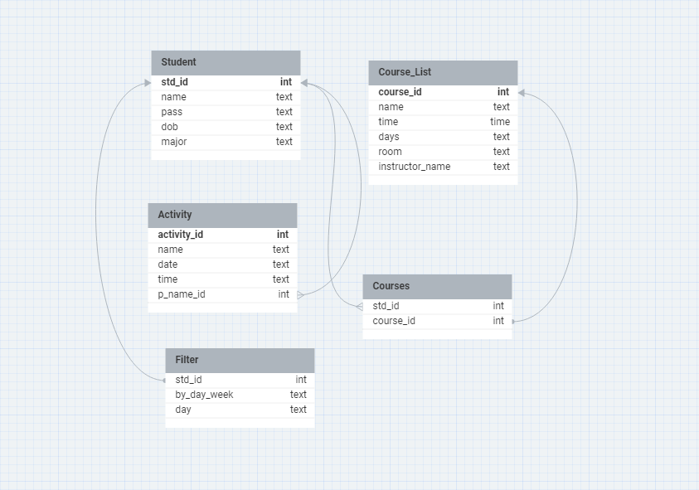

ER Diagram: Showing relationships and tables for the database.