B2B CRM SYSTEM
ERD & SYSTEM ARCHITECTURE
Software Engineering Project Documentation — Version 1.0

1. Entity Relationship Diagram (ERD)
The ERD defines the core CRM data model, including users and permissions, companies, contacts, leads, deals, pipeline stages, activities, tasks, notes, automation, notifications, reports, and audit logs.
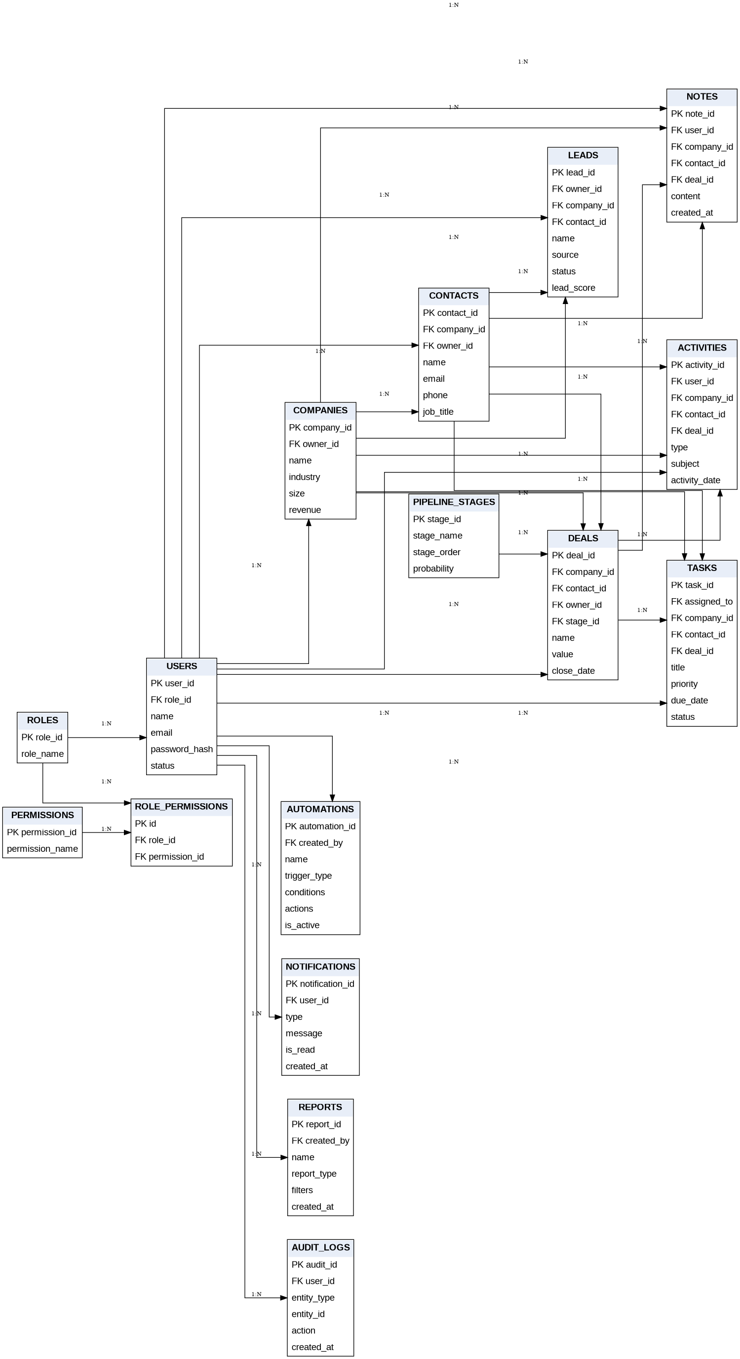

2. System Architecture Diagram
The proposed architecture separates the web UI, API, business logic, relational database, optional background services, integrations, monitoring, and deployment infrastructure.
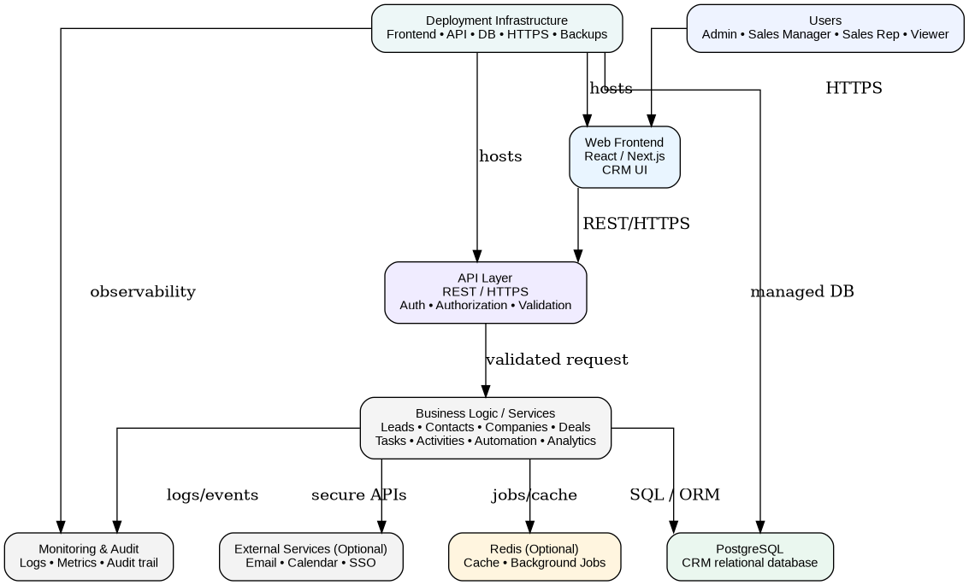

3. Recommended Technology Stack
- Frontend — React / Next.js
- Backend — FastAPI / Python
- Database — PostgreSQL
- Authentication — JWT / OAuth 2.0
- API — REST / JSON
- Charts — Recharts / Chart.js
- Cache & Jobs — Redis (optional)
- Version Control — Git / GitHub

4. Development Sequence
Finalize requirements → finalize ERD and architecture → create database schema → implement authentication and authorization → build CRM APIs → connect the UI → implement automation and analytics → test → deploy.

