# EDUCATION

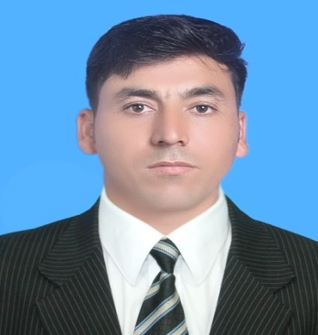

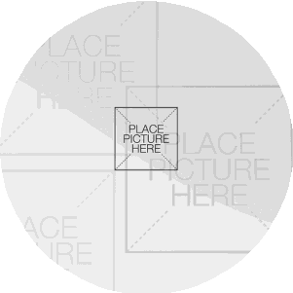

2016-2020 BACHELORS IN SOFTWARE

ENGINEERING.

Sarhad University of Science and InformationTechnology,Peshawar,Pakistan[www.suit.edu.pk](http://www.suit.edu.pk/)

2014-2016 HIGHER SECONDARY SCHOOL

CERTIFICATE.

MuhammadFarooq

Govt Degree College Kohat

2012-2014 SECONDARY SCHOOL CERTIFICATE.

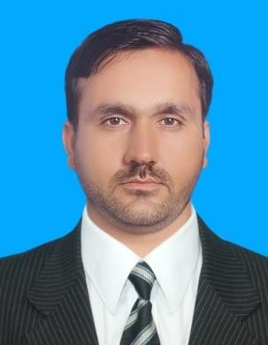

Govt High School Khermatoo Kohat

# WORKEXPERIENCE

**ABOUT ME**

## The Nerdcamp IT company

2020-2022

I am aperson who is positive about

aspectoflife.There are many is things

I like do, to see, and to experience. I to read,dream;Iliketotalk,Iliketolisten.

Iliketoflowing onmyface,

## WEB DEVELOPER

* PHP,Laravel Developer

**CONTACT ME**

## Web Designing

Address District Mohmand Tehsil Halimzai Village Ghazibag

03442900411

Farooqhalimzai24@gmail.com

* Html,Js,Css,Bootstrap,ajax

**COMMUNICATION**

* + English( Read, Write, Speak)
  + Pashto(Mother Tongue)

**INTERESTS**

* + Urdu(Proficient Read,Write,Speak)

Football/Cricket

Badminton/Games/GuitarBasketball

# SKILLS ME

ProgramingSofware javascript

CEO The Nerdcamp

Sir Luqman Khan

REFERENCE

Bootstrap

laravel framework



web-designing



php

java

