**EFFICIENT SYNDICATED DEAL CREDIT RISK MANAGEMENT USING MACHINE LEARNING ON BLOCKCHAIN**

**BACKGROUND:**

Financial innovations like syndicated deals have arguably helped make financial intermediaries better diversified and improved credit decisions.

One such innovation of Syndication allow banks to diversify , expanding their lending to broader geographic areas and industries. In addition , the structure allows banks that are constrained by their capital-asset ratios to participate in deals to large borrowers.

But credit risk sharing results in asymmetric information problems between informed lenders and outside investors. One asymmetric information problem comes from hidden information via adverse selection. An informed lender has an incentive to offload loans that it privately knows are poor quality but that it may have nonetheless decided to originate. Reasons the lender may have originated such loans include private benefits and other incentives coming from cross-selling opportunities with the borrower, for example. A second asymmetric information problem comes from hidden action via moral hazard in effort. Typically investors will delegate task to carry out due diligence and monitoring of borrower performance to lead/arranger bank. Lead/Arranger banks with a lower portion of a deal will have a weaker incentive to carry out due diligence and monitor deal and borrower over time.

Further currently in syndicated market ,deals can take up to 20 days to go through the clearing and settlement process considering contractual obligation, regulatory needs and number of investors and lenders involved.

Additionally each participant in current syndicated business network needs to maintain its own ledger which needs to be reported to regulatory on adhoc/periodic basis. Further regulatory also needs to maintain its own ledger to be able to reconcile participant ledger report. This approach is inefficient , error prone and take long for agreement and much more longer time in case of disagreements.

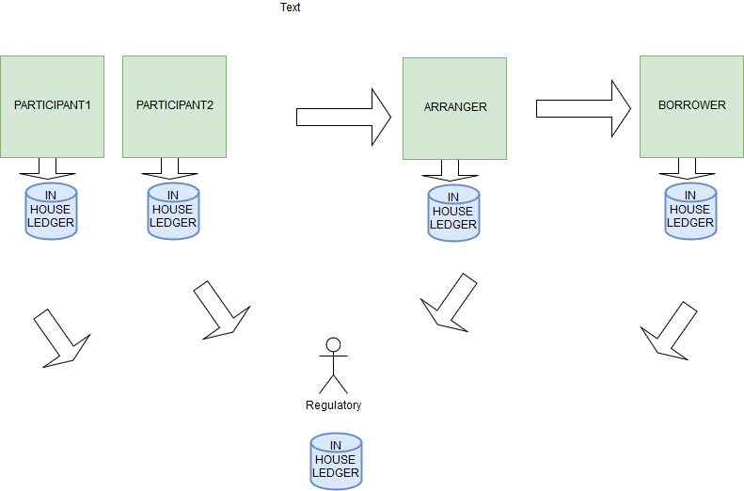

**RESEARCH : MACHINE LEARNING FOR AUTOMATIC BORROWER PERFORMACE OVER DISTRIBUTED LEDGER TECHNOLOGY FOR SYNDICATION/PARTICIPATION:**

Research work will be focused on using Smart contracts instead of legal contracts to do real time clearing and settlement of syndicated deals. Additionally leveraging Machine Learning algorithms for evaluating probability of default and publish it over blockchain to all participants.

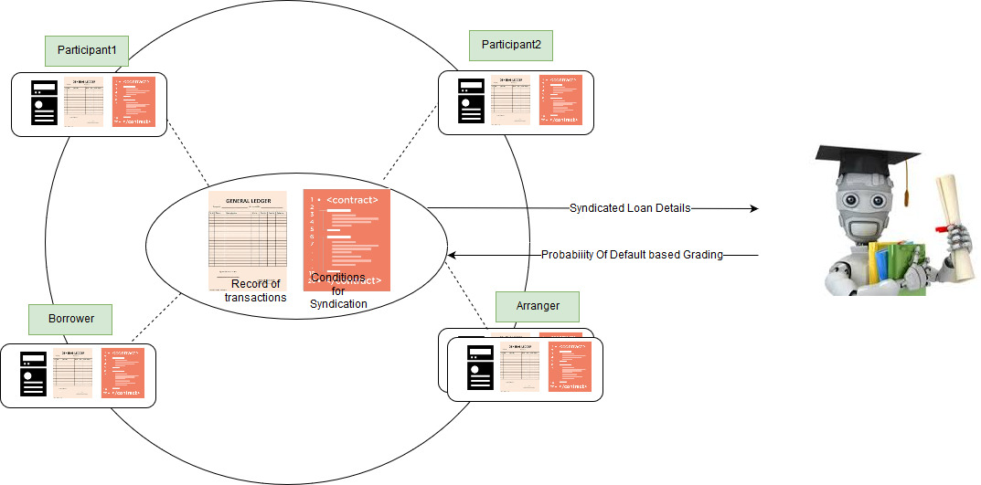

Following will be the major benefits for the research work:

1. Reduction in clearing and settlement process time drastically by providing secure/immutable database to all participants across a distributed private network
2. Looking at a single source of information would help reduce disagreements and make it easier to comply with legal requirements , speeding up the process at every stage and drastically reducing cost of preparing/executing legal contracts
3. Single ledger with regulator as participant together with borrower , investors and lenders on blockchain will completely avoid reconciliation problems due to multiple ledgers
4. Automatic grading of deals using machine learning algorithms and publishing over block-chain will avoid adverse selection problem since leading bank will not be able to hide performance of borrower as grades will be available/visible real time for all the participants
5. Publishing of machine learned grades on immutable blockchain will completely remove moral hazard problem as there will be no need to offload due diligence and monitoring task to lead bank as all investors and lenders will be able to check real time performance of borrower on blockchain irrespective of portion of loan funded by each one of them.
6. Research work can be extended to use of crypto-currencies as collateral for syndication/participation to reduce risk exposure of deal.