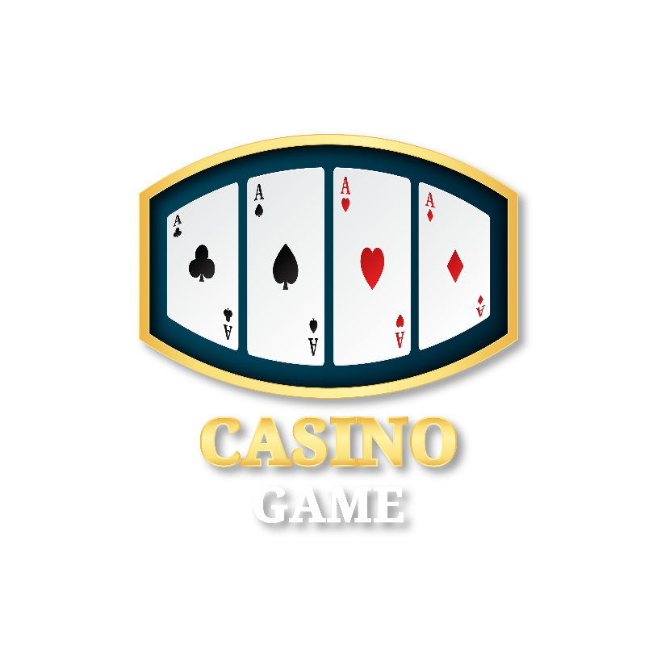

This project report titled “Concentration Card Game using Tkinter in Python Language Programming” was made to give a written statement to the readers. The basic objective behind doing this project report is to get knowledge about python programming language and data structure and algorithms implemented into a Concentration card game.

Introduction

This is a simple flip card game also known as Concentration Game. This module provides a flip card game as a drupal block that can be enabled on any page. Each block of flip card game has its own set of settings such as loading game images, success images, command text, downside images to be displayed on the flip.

Software Design

The software is designed in this manner.

Each player takes a turn by turning two cards over. If the cards match, then the player picks up the cards and keeps

them. If they don't match, the player turns the cards back over. If the player gets a match, they get to go again,

until they fail to get a match. A match is when two cards have the same rank and color. For example, a match would

be two Jacks that were both red, one was the Jack of Diamonds and the other the Jack of Hearts. The game is over

when all of the cards have been matched and picked up.

**Scope**

This is a desktop application, this application will work perfectly for major operating systems. The scope of this project can be spread,i.e. the project can be modified to operate online and could add many features.

**Development Tools**

The software is developed using python, the libraries are following below.

* Tkinter
* Pygame
* Pillow
* random