**Simulating IoT data into Timestream**

In 2022 the number of connected IoT devise grew to [14.4 billion](https://iot-analytics.com/number-connected-iot-devices/). This number is expected to grow exponentially alongside the jobs in this field. In 2022 global consulting firm McKinsey & Company found the biggest barrier to IoT adoption was skill shortages in the workforce. The number of jobs openings is outpacing the supply of IoT engineers. One of the main barriers to learning about IoT is the cost associated with purchasing IoT hardware.

This blog shows how you can simulate IoT devices and capture/filter that data for your own visualization tools. In 30 minutes you will

* Use a [**CloudFormation**](https://docs.aws.amazon.com/cloudformation/index.html) template to create simulator
* Capture time series data from the simulator into [**AWS IoT Core**](https://docs.aws.amazon.com/iot/index.html)
* You will send that data into [**Amazon Timestream**](https://docs.aws.amazon.com/timestream/index.html) for your visualization

**Prerequisites**

* An AWS Account
* An understanding of the associated costs of this demo: [Here](https://docs.aws.amazon.com/solutions/latest/iot-device-simulator/cost.html)

**Instructions**

1. Click the link below and download the [CloudFormation template](https://aws.amazon.com/cloudformation/resources/templates/)
2. [Link](https://s3.amazonaws.com/solutions-reference/iot-device-simulator/latest/iot-device-simulator.template)
3. Open your AWS console (click [here](https://us-east-1.console.aws.amazon.com/console/home?region=us-east-1))
4. At the top right make sure the **N. Virginia** region (us-east-1) is selected

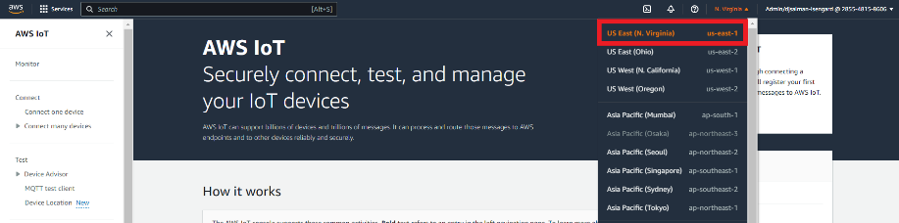

1. At the top left of the console search for and click on Cloud Formation (or click [here](https://us-east-1.console.aws.amazon.com/cloudformation/home?region=us-east-1#/stacks?filteringText=&filteringStatus=active&viewNested=true))
2. On the top right click the orange **Create Stack** button.
3. In the section titled **Prerequisite – Prepare Template** select the **Template is ready** button
4. In the section below titled **Specify Template** select **Upload a template file**
5. Upload the file you downloaded earlier click **Next.**

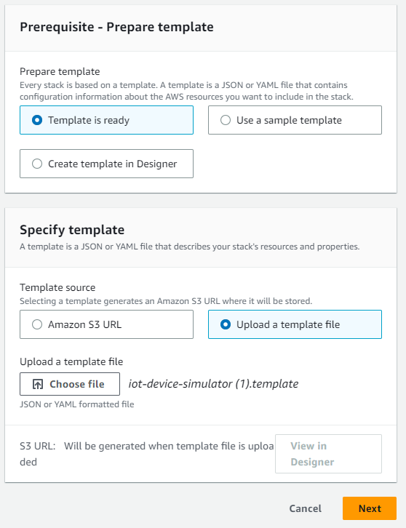

1. On the next page, under the section title **Stack name** enter **iot-device-simulator** (exclude the <>)
2. Under the section title **Parameters** enter your personal email address and hit **Next**

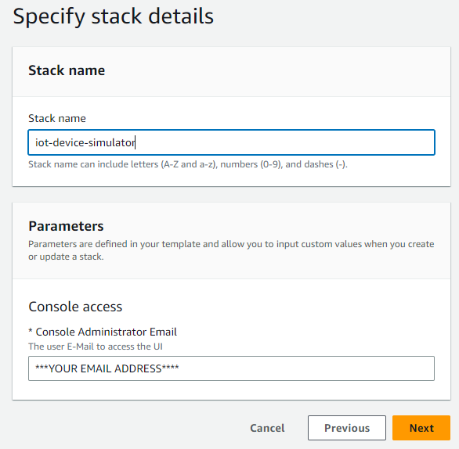

1. Hit **Next** then **Next** again
2. Check the box at the bottom of the page next to **I acknowledge that AWS CloudFormation might create IAM resources** and hit **Submit**
3. Wait about 5 minutes. You will receive an email from [no-reply@verificationemail.com](mailto:no-reply@verificationemail.com) with login information.
4. Click the link and sign in using the credentials provided to you

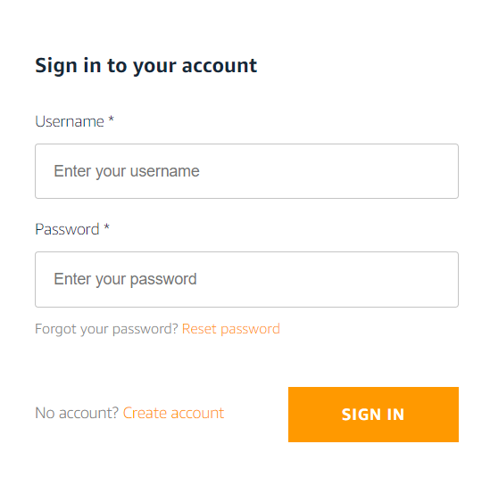

1. At the top of the site click the **Device Types** button
2. Click the **+ Add Device Type** button

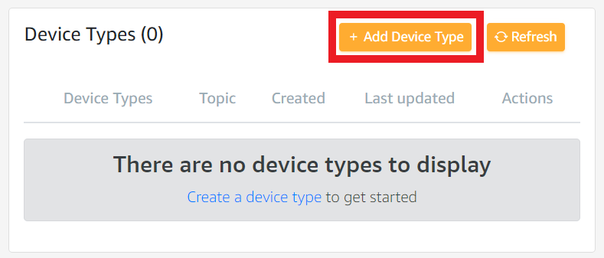

1. Under Device type name enter **Device type name**
2. Under **Topic** enter **TurbineMQQT**
3. Under the section title **Message payload** click the **+ Add attribute** button
4. Add an attribute by clicking the **+ Add attribute** button
5. Enter the following values

Attribute name: **id**

Attribute data type: **ID**

ID character set (optional): (leave blank)

ID length (optional): (leave blank)

Static: **False**

1. Add another attribute by clicking the **+ Add attribute** button

Attribute name: **rpm**

Attribute data type: **Integer**

Minimum Value: **20**

Maximum Value: **400**

Default Value: (leave blank)

1. Add one more attribute by clicking the **+ Add attribute** button

Attribute name: **voltage**

Attribute data type: **Integer**

Minimum Value: **600**

Maximum Value: **3000**

Default Value: (leave blank)

1. ***(Optional)*** Add one attribute of your choice (Feel free to copy the example below or make your own)

Attribute name: **humidity**

Attribute data type: **Integer**

Minimum Value: **23**

Maximum Value: **97**

Default Value: (leave blank)

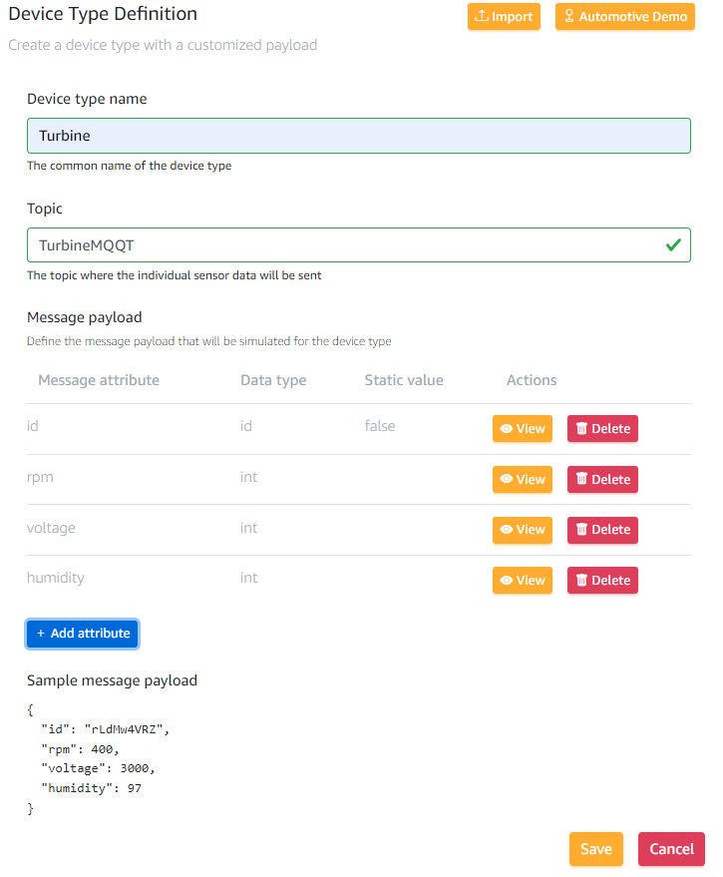

1. Hit the **Save** button at the bottom of the page
2. At the top of the page click the **Simulations** button



1. Click the **+ Add Simulation** button
2. Under **Simulation name** enter **turbine-west**
3. Under Simulation type choose the **User created** option
4. Under **Select a device type** select **Turbine**
5. Under **Number of devices** enter your desired number. Remember [the associated costs](https://docs.aws.amazon.com/solutions/latest/iot-device-simulator/cost.html)
6. Under **Data transmission interval** enter **1**
7. Under **Data transmission duration** enter your desired duration in seconds. I recommend **600-1200** but use your discretion based on the [associated costs](https://docs.aws.amazon.com/solutions/latest/iot-device-simulator/cost.html)
8. Click **Save**

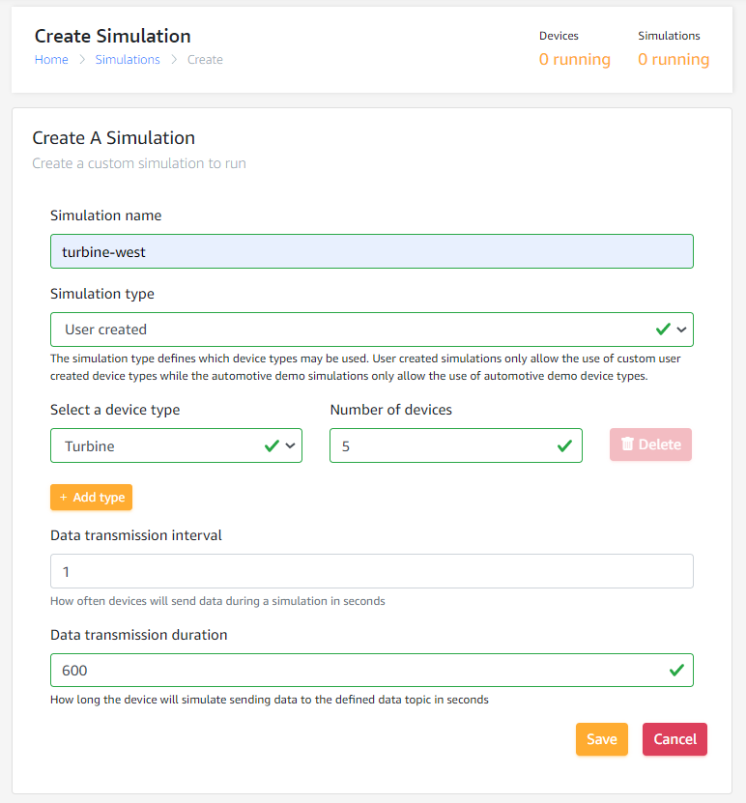

1. Go back to your AWS console and search for Amazon Timestream(or click [here](https://us-east-1.console.aws.amazon.com/timestream/home?region=us-east-1&hashArgs=%23#dashboard))
2. In the left navigation bar click **Databases**

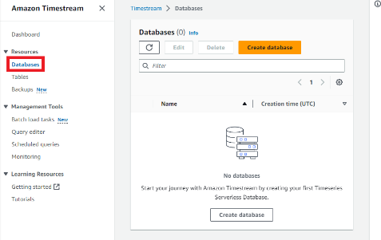

1. Click the orange **Create database** button
2. Under Choose a configuration select **Standard database**
3. Under Name enter **TurbineDB**
4. At the bottom click the **Create Database** button
5. In the left navigation bar click **Tables**

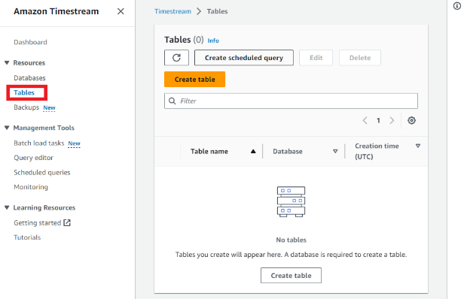

1. Click the **Create table** button
2. Under **Database name** select **TurbineDB**
3. Under **Table name** enter **TurbineTable**
4. At the bottom click **Create table**
5. In your AWS console and search for IOT Core (or click [here](https://us-east-1.console.aws.amazon.com/iot/home?region=us-east-1#/home))
6. On the left navigation bar select **Message Routing** then select **Rules**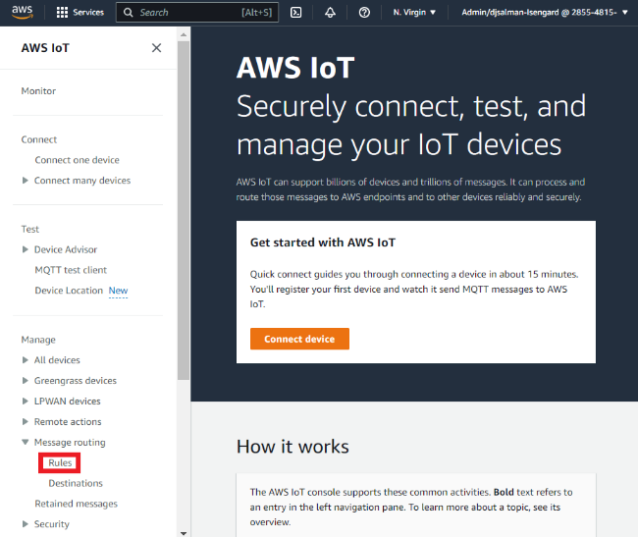
7. Click the orange **Create Rule** button
8. Under Rule name enter **allTurbineTelemetryToTimestream**
9. Add a description if you’d like and click **Next**
10. Under **SQL Statement** delete the existing text and enter **SELECT assetId AS id, rpm, voltage FROM 'TurbineMQQT'**
11. (Optional) if you added a custom attribute on step 25 you can include it after **voltage** (don’t forget the comma). If you are unsure or unfamiliar with SQL just skip this step.
12. At the bottom click **Next**
13. Under **Action 1** search for and click on **Timestream table**
14. Under Database name select **TurbineDB**
15. Under **Table name** select **TurbineTable**
16. Under **Dimensions Name** enter **TelemetryAssetType**
17. Under **Dimension value** enter **Telemetry**
18. Click **Add new dimension**
19. Under the second **Dimensions name** enter **TelemetryAssetId**
20. Under the second **Dimension value** enter **${topic(1)}**
21. Under **Timestamp value – optional** enter **${timestamp()}**
22. Under **Timestamp unit** select **MILLISECONDS**
23. Under **IAM role** click **Create new role**
24. Enter **CoreToTimestream** and click **Create new role**
25. Click **Next** and then **Create**
26. Go back to the Iot Device Simulator URL you received via email
27. At the top of the page click the **Simulations** button



1. Click the check box next to **turbine-west** and click the yellow **Start Simulation(s)** button

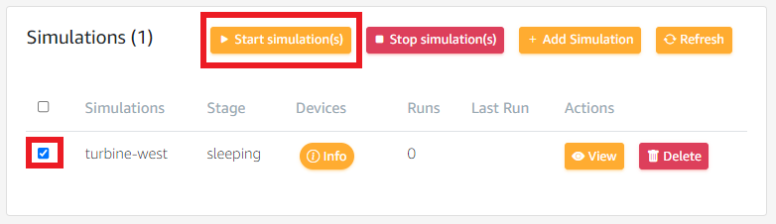

1. Return to the AWS IoT in the AWS console([here](https://us-east-1.console.aws.amazon.com/iot/home?region=us-east-1#/test)).
2. In the left navigation bar click **MQQT test client**

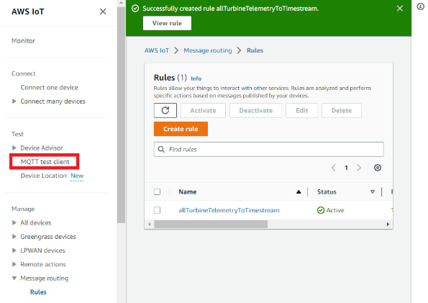

1. Under **Subscribe to a topic** enter **TurbineMQQT**

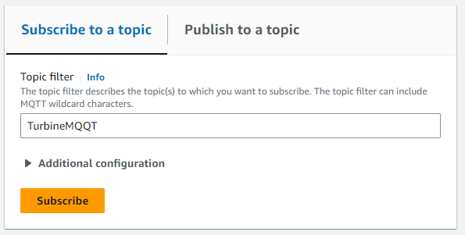

1. You should see your IoT data populating under **Subscriptions.** If you don’t see data populating then something was spelled incorrectly. Retrace your steps.
2. Congratulations you are in the home stretch all that is left is to find your data in Amazon Timestream
3. At the top of the AWS Console search for and click on Amazon Timestream
4. On the left navigation click on Query editor

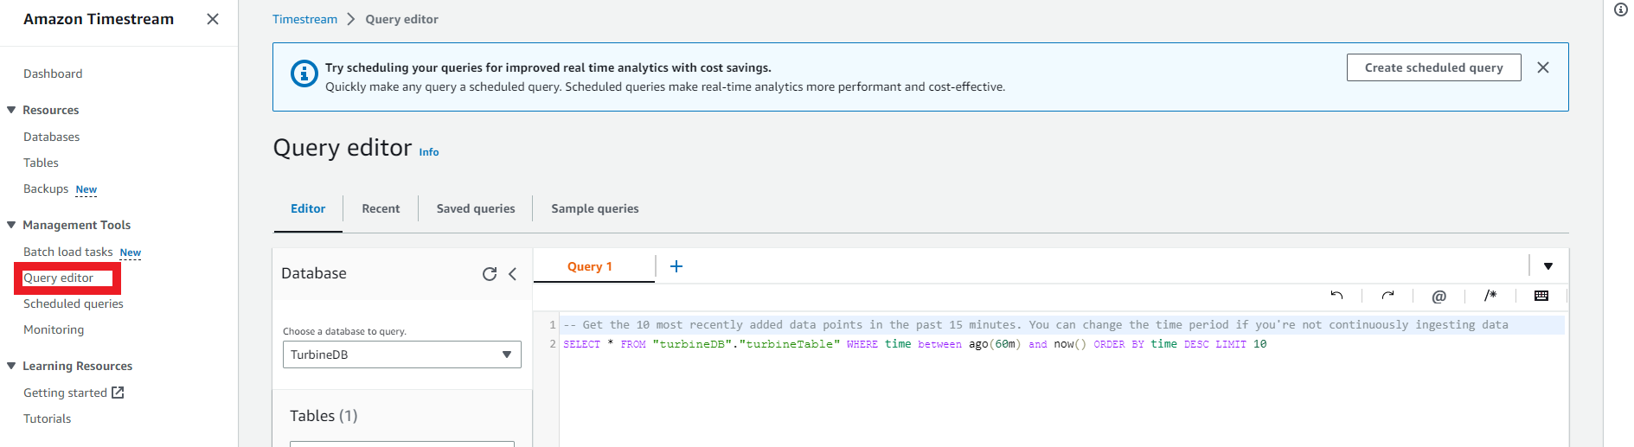

1. In the text box under **Query 1** enter **SELECT * FROM "TurbineDB"."TurbineTable" WHERE time between ago(60m) and now() ORDER BY time DESC LIMIT 10**
2. You should see data populating below.
3. Congratulations. You have completed this workshop.
   * You have simulated MQQT data
   * Sent that data into Iot Core
   * Queried that data into Timestream
4. All that is left is connecting this to a visualization tool like Quicksight or Grafana. That out of scope for this workshop but you can learn about that [**here**](https://docs.aws.amazon.com/general/latest/gr/timestream.html).