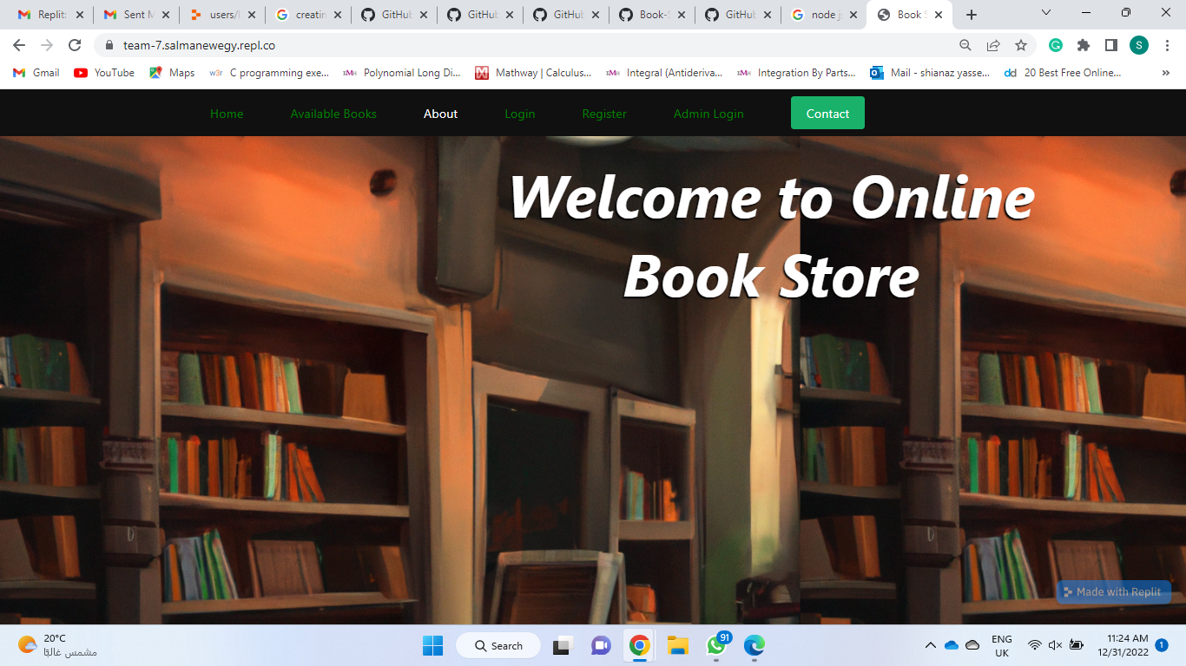

ONLINE BOOK STORE

__ __

WEB PROGRAMMING - GN231

* + **GROUP ID 7**
  + Salma Fawzy Newegy 19109938
  + Shahinaz Yasser Mahmoud 19103366

**TABLE OF CONTENTS**

1. **INTRODUCTION..................................................... 3**
2. **OBJECTIVES………….………………………………………… 3**
3. **FILE STRUCTURE .….…………………….…………………. 5**
4. **REQUIREMENTS……………………………………………… 6**
5. **SEQUENCE DIAGRAM………………………………………. 7**
6. **INTRODUCTION**

In this project, we designed and built a website that allows users to browse and purchase books online. The website features a catalog of books, with details such as the title, author, and price displayed for each book. Users will be able to search for books by keyword, filter the catalog by various criteria, such as genre or price range, and add books to their shopping cart.

We used a variety of web programming technologies and techniques to build the website, including HTML, CSS, and JavaScript for the front end and Node.js Express to handle the back-end functionality. We also make use of MySQL databases to store information about the books and users and implement security measures such as user authentication to ensure the safety of sensitive data.

Throughout the project, we worked to create a user-friendly and visually appealing website that offers a smooth and seamless shopping experience for our customers. We hope you enjoy following along as we bring this online bookstore to life!

1. **OBJECTIVES**

Implementing an online bookstore has several objectives, including increasing sales and revenue, expanding the customer base, and providing a convenient shopping experience for customers.

One of the primary objectives of implementing an online bookstore is to increase sales and revenue. An online store allows the business to reach a wider audience and sell to customers who may not have access to a physical store. It also allows the business to sell products 24/7, increasing the potential for sales. An online store can also offer additional payment options, such as online banking and credit card payments, which can make it easier for customers to make purchases.

Another objective of implementing an online bookstore is to expand the customer base. An online store allows the business to reach a global audience, rather than just those within a certain geographical location. It also allows the business to target specific customer segments, such as those who prefer to shop online or those who are interested in a particular genre of books.

Finally, an online bookstore provides a convenient shopping experience for customers. Customers can shop from the comfort of their own homes and do not have to worry about transportation or store hours. An online store also allows customers to easily compare prices and read reviews from other customers before making a purchase.

In summary, implementing an online bookstore can help a business increase sales and revenue, expand the customer base, and provide a convenient shopping experience for customers. It is a valuable tool for businesses looking to reach a wider audience and sell products online.

1. **FILE STRUCTURE**

## A- Client Side

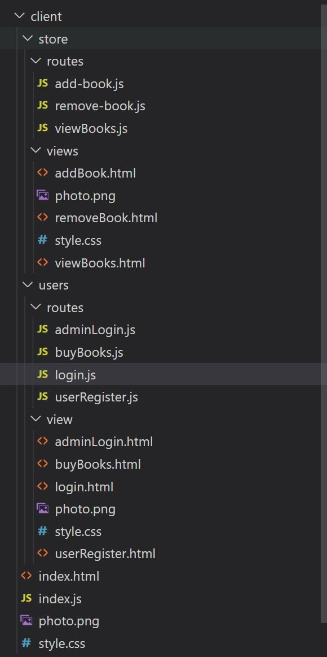

## B- Server Side

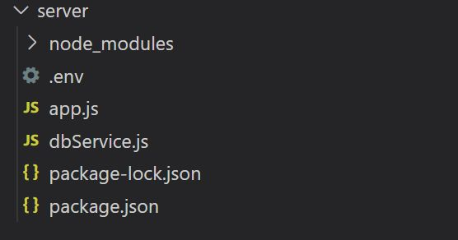

1. **REQUIREMENTS**

## A- Functional Requirements

1. Users are able to view the details of a book, including its description, price, and availability.
2. Users are able to add books to their shopping cart and place an order.
3. The website allows users to create an account and log in to access their account information.
4. The website allows administrators to add and delete books from the inventory.

## B- Non-Functional Requirements

1. The website has a responsive design and is optimized for mobile devices.
2. The website has fast loading times and is easy to navigate.
3. The website should have error handling and recovery mechanisms in place to prevent crashes and ensure uptime.
4. The website has a user-friendly interface with clear and concise instructions for users.
5. **SEQUENCE DIAGRAM**