# First assignment:
# Task 1
**Skipping Question 1, was already using Jupyter Notebook**

Question 2: Write a program which will find all such numbers which are divisible by 7 but are not a multiple of 5, between 2000 and 3200 (both included). The numbers obtained should be printed in a comma-separated sequence on a single line.
Solution:
a = list(range(2000,3201))
b = []
for i in a:
if i%7==0 and i%5!=0:

(b.append(i))
print(b)
screenshot of the Output:

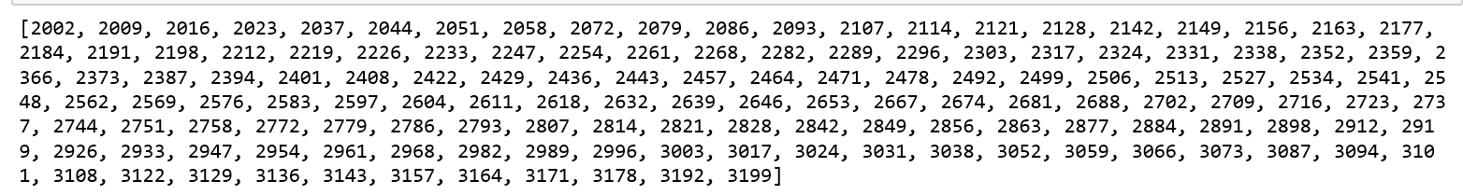

Question 3: Write a Python program to accept the user's first and last name and then getting them printed in the reverse order with a space between first name and last name.

Solution:
a = input("Please enter your first name: ")
b = input("Please enter your last name: ")
d = a[::-1]
e = b[::-1]

print("{} {}".format(d,e))

Screenshot of the Output:
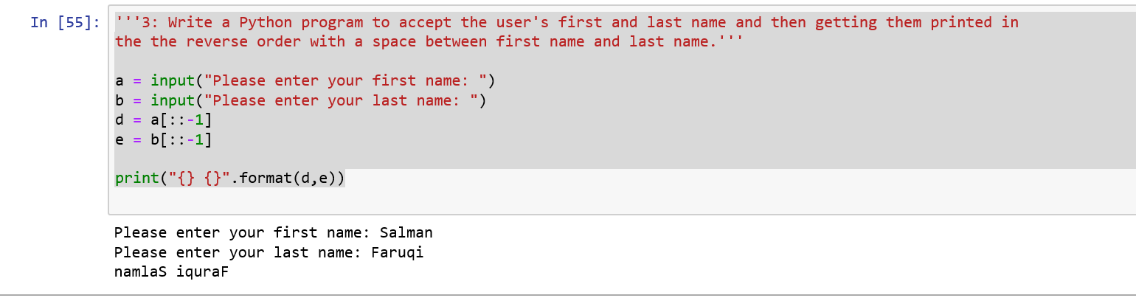

Question 4: Write a Python program to find the volume of a sphere with diameter 12 cm.
Solution:
sphere = 4/3*3.14159*6*6*6
sphere ‘’’ Output = 904.7779199999999’’’
# Task 2:
''' 1: Write a program which accepts a sequence of comma-separated numbers from console and
generate a list.
'''
a = input("Please enter the numbers: ")
list = a.split(',')
list
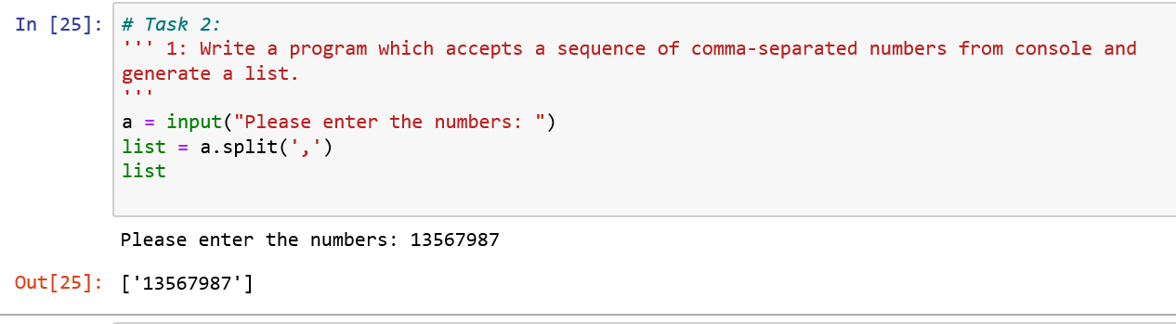

# 2: Create the below pattern using nested for loop in Python.
n = 5
for i in range(n):
for j in range(i):
print('*', end = ' ')
print('\n')
for i in range(n,0,-1):
for j in range(i):
print('*', end = ' ')
print('\n')
Screenshot :
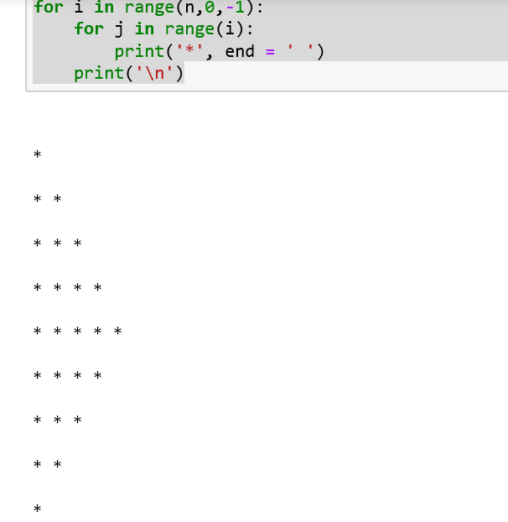
# 3: Write a Python program to reverse a word after accepting the input from the user.

word = input("Please enter the word you want to reverse: ")
word = word[::-1]
word
Screenshot :

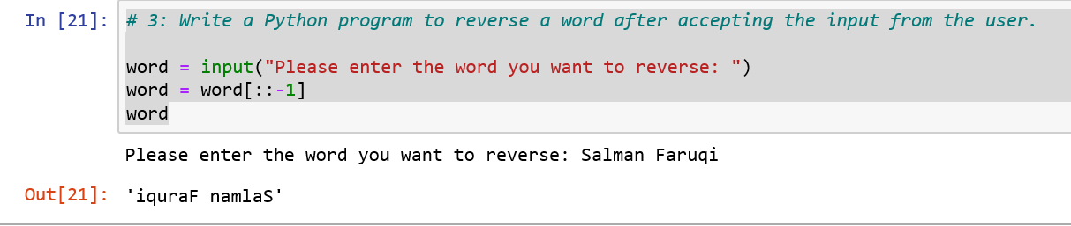

# 3: Write a Python program to reverse a word after accepting the input from the user.

string = "WE, THE PEOPLE OF INDIA, {} having solemnly resolved to constitute India into a SOVEREIGN, {} SOCIALIST, SECULAR, DEMOCRATIC REPUBLIC {} and to secure to all its citizens{}".format('\n\t', '!\n\t\t', '\n\t\t',':')
print(string)

Screenshot:

