User Story 1:

As a user, I want to access and see all the buttons easily.

Priority: low

Estimate: 2 hours

Test: Conduct tests with various people to check whether all the buttons are clear enough.

User Story 2:

As a user, I want to be able to create a city to be simulated.

Priority: high

Estimate: 5 hours

Test: Enter city editing mode to create a city with set of road shapes and traffic lights.

User Story 3:

As a user, I want the program to be simple yet understandable.

Priority: medium

Estimate: 7 hours

Test: Running the program and ask users whether they understand the user interface and the words on the screen.

User Story 4:

As a user, I want to be able to see that vehicles go through traffic lights conveniently when green and stop when red.

Priority: high

Estimate: 3 hours

Test: Continue to move vehicle when green light and stop when red light.

User Story 5:

As a user, I want the program to be free of bugs.

Priority: low

Estimate: 7 hours

Test: Running the program and try every feature.

User Story 6:

As the user, I want to able to stop the simulation.

Priority: high

Estimate: 8 hours

Test: Run the simulation and stop the simulation.

User:

1. Start / stop simulator.
2. Create a new city.
3. Enter Simulation / city editing mode.

System:

1. Vehicle types are only car, bus and motorbike.
2. Roads has two lanes. (Left and Right)
3. Have 3 road intersection shapes; straight, 4 ways, 3 ways.
4. The simulation only simulates the roads, vehicles, and traffic lights
5. The length of the car resolves the length of other vehicles
6. Vehicles randomly choose to turn or not on the crossroad or T-shaped road
7. Vehicles do not move repeatedly over a lane
8. Vehicles vanish after they come to the end of the road
9. Traffic lights are green, yellow and red.
10. Road is twice the length of the bus.

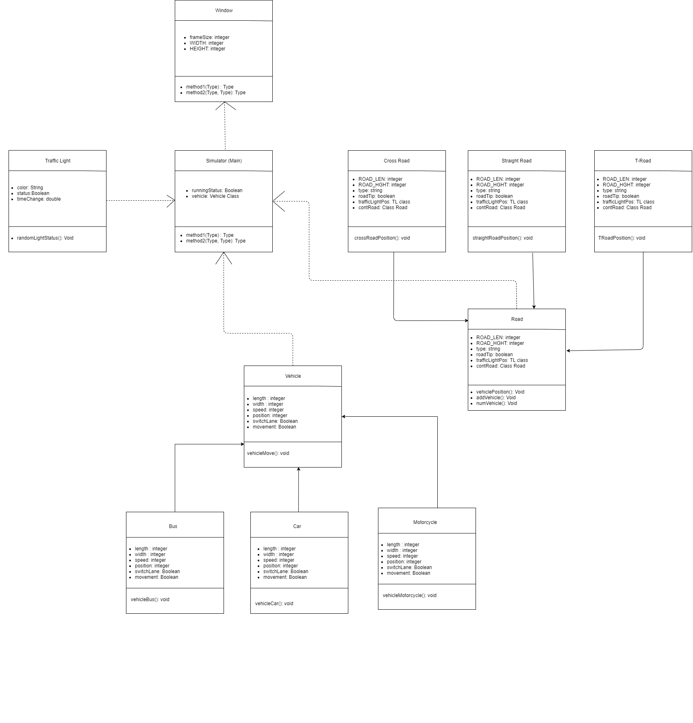UML:

UML

<https://github.com/salmankarsa/CP2406-Assg>

<https://github.com/salmankarsa/CP2406-Assg>