Lab 6: NLP Fundamentals
Tokenization, Embeddings & Text Chunking
Artificial Intelligence Lab
SALMAN ZAHOOR
037
Task 1 (Beginner): Tokenization and a FAQ Chatbot

Part 1: Tokenization (task1_tokens.py)
Objective: compare whitespace splitting with a Unicode word-like regex (\b\w+\b) on six inputs: punctuation, a contraction, an email, an identifier (CS4944), an empty string and Urdu text. The model sub-word tokenizer is attempted for the first two English examples.

Code
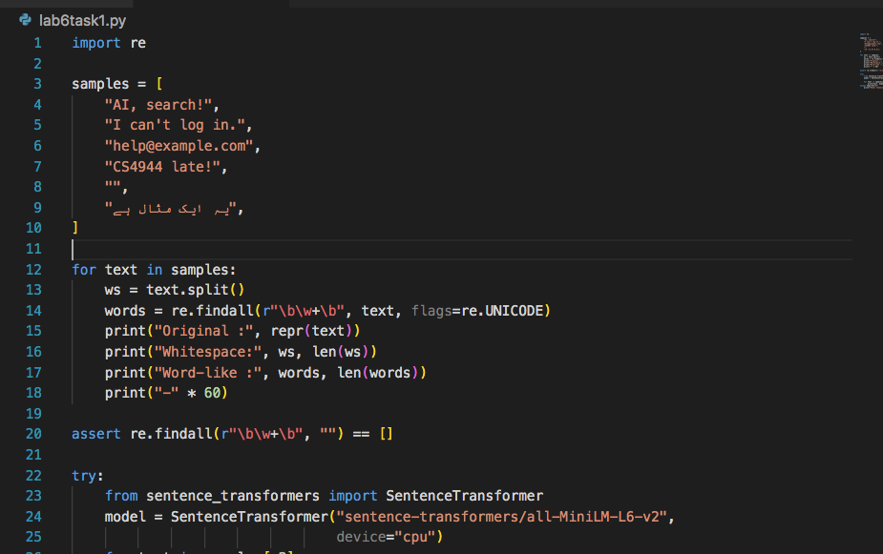

Output
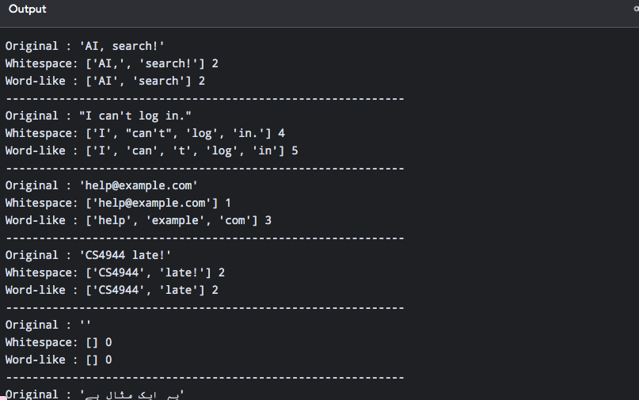

Comparison table (from the output above)
Input | Whitespace tokens | Count | Word-like (regex) tokens | Count
AI, search! | AI, | search! | 2 | AI | search | 2
I can't log in. | I | can't | log | in. | 4 | I | can | t | log | in | 5
help@example.com | help@example.com | 1 | help | example | com | 3
CS4944 late! | CS4944 | late! | 2 | CS4944 | late | 2
(empty string) | (none) | 0 | (none) | 0
Urdu sentence | 4 words | 4 | 4 words | 4

Explanation
- Difference 1 - punctuation and contractions: whitespace splitting keeps punctuation attached ('late!', 'in.') and keeps "can't" as one token (4 tokens for "I can't log in."). The regex removes punctuation but splits the contraction into 'can' and 't' (5 tokens).
- Difference 2 - email addresses: whitespace splitting keeps help@example.com as one unit, while the regex breaks it into 'help', 'example' and 'com', so the address can no longer be searched as one identifier.
- Normalization risk: removing punctuation or lowercasing blindly can damage meaning and identifiers. Splitting "can't" into 'can' + 't' leaves a positive-looking word 'can' and loses the negation, and splitting emails or codes such as CS4944 destroys exact-match information. The original text should therefore be kept for reporting, and any normalized copy should be stored separately.
- Urdu: for this one sentence both methods gave 4 tokens because Urdu words are separated by spaces. This does not prove the regex is a complete multilingual tokenizer; it was only tested on one short sample.
- Model tokenizer: skipped, because sentence-transformers is not installed in this environment (the script prints this message instead of failing). Model sub-word counts are therefore not reported.

Part 2: FAQ Chatbot (guided_chatbot.py, TF-IDF backend)
Objective: run the FAQ chatbot with TF-IDF, add two FAQs (each with a source), and capture one exact answer, one suggestion response and one empty/unsupported input. The two added FAQs are faq:wifi (source it_help.txt) and faq:library (source library_rules.txt). The chatbot depends on the shared helper lab6_search.py, which is also part of the project.

Code
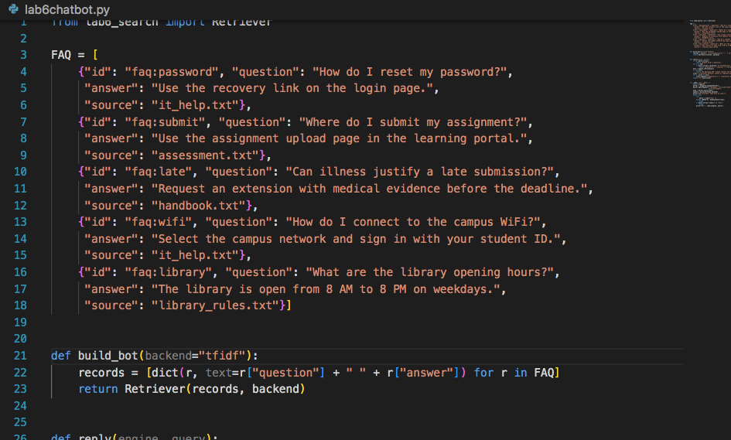

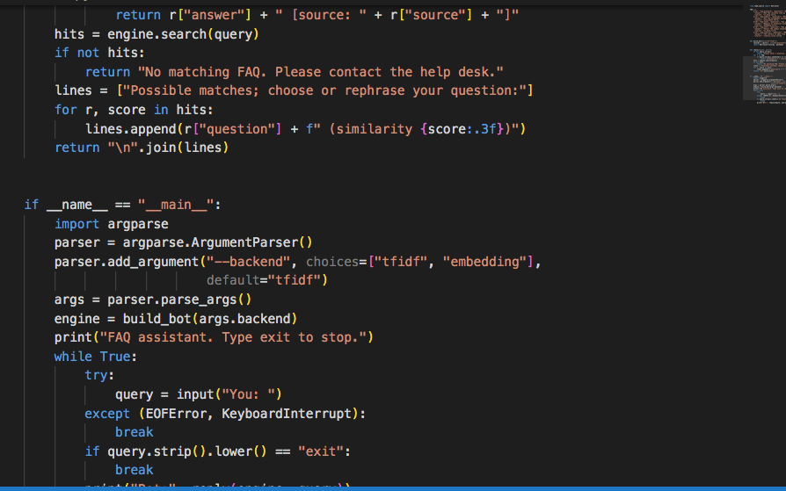

Output 2: chatbot transcript
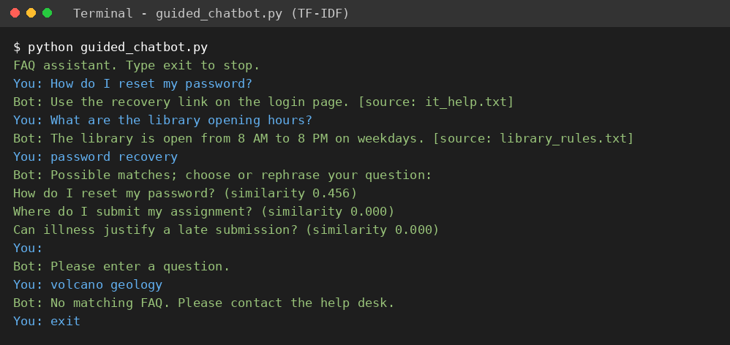
Transcript: exact answers, a paraphrase suggestion, an empty input and an unsupported input
Note: the transcript was produced by sending these inputs, one by one, to the same reply() function that guided_chatbot.py uses (demo_task1_transcript.py), so the typed inputs appear next to the bot's responses. Running 'python guided_chatbot.py' interactively gives the same responses.

Explanation
- Exact answer: the canonical questions 'How do I reset my password?' and 'What are the library opening hours?' return the stored answer together with its source file.
- Suggestion response: 'password recovery' is not an exact FAQ question, so the bot lists candidate questions with similarity scores (0.456 for the password FAQ, 0.000 for the others) instead of asserting an answer.
- Empty / unsupported input: an empty line gives 'Please enter a question.' and 'volcano geology' gives the help-desk fallback, because TF-IDF finds no shared vocabulary and returns no matches.
- Why confirmation is needed: a similarity score only measures overlap between texts. It does not prove that the retrieved FAQ answers the user's question, that it is current, or that it is complete. Asking the user to confirm or rephrase avoids presenting a wrong answer as fact.

Task 2 (Intermediate): Chunking and Semantic Suggestions

A: Chunking with source offsets
Three synthetic documents were written (task2_docs.py): handbook (201 words), it_help (191 words) and remote_work (182 words). Each contains a rule with an exception and one sentence longer than the 40-word budget (48, 54 and 57 words). Three strategies were implemented in task2_chunks.py: 40-word windows with overlap 0, 40-word windows with overlap 10, and sentence-aware packing with a 40-word budget. Every chunk stores its document ID, chunk ID and character start/end offsets, and the code asserts that text == source[start:end]. Size and overlap are measured in whitespace-separated words.

Output: python task2_analysis.py
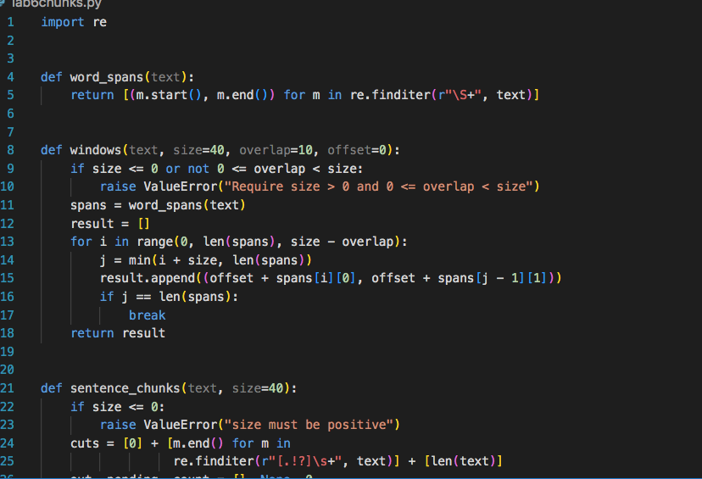

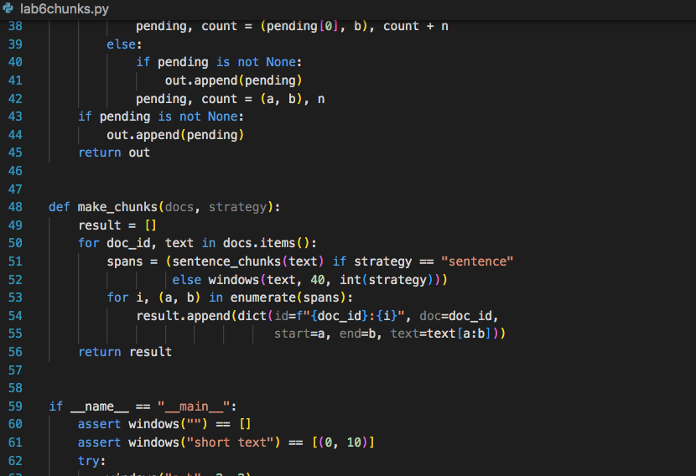

Results table (from the output above)
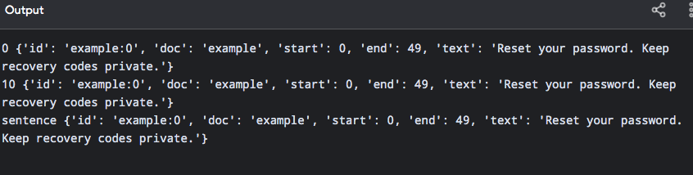
Strategy | Chunks | Min words | Max words | Avg words | Duplicate words | Rule+exception in one chunk?
Window, overlap 0 | 16 | 1 | 40 | 35.9 | 0 | Yes (3 of 3)
Window, overlap 10 | 20 | 11 | 40 | 37.2 | 170 | Yes (3 of 3)
Sentence-aware (40) | 20 | 8 | 40 | 28.7 | 0 | Yes (3 of 3)
Duplicate words = total words in all chunks minus the 574 original words.

Boundary tests
Test | Observed result
Empty text | windows('') and sentence_chunks('') both return []
Document shorter than the budget | One chunk covering the whole text: [(0, 20)] for both strategies
Invalid overlap (size 2, overlap 2) | ValueError: Require size > 0 and 0 <= overlap < size
Sentence longer than the budget (95 words) | Split by the fallback into 3 chunks of 40, 40 and 15 words

Discussion
- Evidence survival: in this small corpus the labeled rule and its exception stayed inside a single chunk under all three strategies, so no strategy lost evidence here. This depends on where the text happens to fall relative to the 40-word boundary and should not be generalized to other documents.
- Overlap cost: overlap 10 produced 4 extra chunks and 170 duplicated words (about 30% more text) compared with overlap 0, with no gain in labeled-evidence survival on this corpus.
- Window with overlap 0: the minimum chunk size is 1 word, i.e. a tiny leftover fragment at the end of a document. Sentence-aware chunks are smaller on average (28.7 words) but always start at a sentence boundary.
- Long sentences: the fallback splits them inside the sentence. For example the 48-word handbook sentence became handbook:5 (40 words) and handbook:6 (8 words), so the end of that sentence is separated from its beginning.
- Where sentence splitting fails: the teaching splitter cuts after any '.', '!' or '?' followed by whitespace. In the test 'Dr. Khan approved the request. See Fig. 2 for details.' it wrongly treated 'Dr. ' and 'See Fig. ' as complete sentences (the short 3-word budget was used only to make the effect visible). Abbreviations, decimal-like numbering and other languages need a better splitter.

B: Semantic suggestions - TF-IDF vs embeddings
Records were built from the 20 sentence-aware chunks. Three paraphrased queries with little keyword overlap were used. Retrieval was run with both backends of lab6_search.py (task2_semantic.py). Chunk IDs, scores, character offsets and the beginning of each retrieved text are displayed.

TF-IDF results against the labeled evidence
Query | Top-3 chunk IDs (score) | Labeled evidence chunk | Rank of evidence
How can I regain access to my account? | it_help:5 (0.172), it_help:2 (0.142), remote_work:1 (0.127) | it_help:0 | 9 - not in top 3
Am I allowed to hand in coursework after the due date if sick? | remote_work:1 (0.172), it_help:1 (0.161), it_help:3 (0.148) | handbook:2 | 6 - not in top 3
Can a freelancer work from home? | remote_work:0 (0.253), remote_work:1 (0.215), remote_work:5 (0.168) | remote_work:1 | 2 - in top 3

Interpretation
- Failures: for queries 1 and 2 TF-IDF did not return the correct chunk in the top three. The retrieved chunks shared only generic words (for example 'account', 'after', 'work'), while the relevant chunks use different wording ('forgotten password'/'recovery link', 'illness'/'medical evidence').
- Partial success: query 3 found the contractor rule at rank 2 only because the word 'work' overlaps; 'freelancer' does not appear in the documents.
- Why this motivates embeddings: a sentence encoder maps paraphrases to nearby vectors even without shared keywords, so it may rank the intended chunks higher. This was not tested here and no embedding scores are claimed.
The embedding run (guided_embeddings.py, guided_suggestions.py with backend='embedding', and the embedding half of task2_semantic.py) could not be executed because sentence-transformers is not installed here. To complete it on your own machine: run 'python -m pip install numpy scikit-learn sentence-transformers' in the lab6_nlp folder, then 'python task2_semantic.py', and paste the screenshot of that output below.

Summary
- Task 1 Part 1: whitespace and regex tokenization compared on six inputs; differences and a normalization risk explained.
- Task 1 Part 2: FAQ chatbot extended with two sourced FAQs; exact answer, suggestion, empty and unsupported inputs captured.
- Task 2 Part A: three chunking strategies with source offsets, comparison table and boundary tests completed.

