ARTIFICIAL INTELLIGENCE LAB
LAB 3 — TASK 1: BFS AND DFS MANUAL TRACE
Student Name | Salman Zahoor | Roll Number | 037
Course | Artificial Intelligence Lab | Course Code | CAI601400

1. Objective
Trace BFS and DFS manually on the original A–G graph in the Lab 3 manual. Start at A, search for G, show each frontier and processed node, follow the supplied successor order, and stop when G is processed.

2. Graph and Search Setup
Successors: A → [B, C]; B → [D, E]; C → [F]; D → []; E → [G]; F → []; G → [].
Initial state: A. Goal state: G. Depth is counted in edges, so A has depth 0. BFS uses a FIFO queue. DFS uses a LIFO stack and pushes successors in reverse order so the first listed neighbour is processed first.

3. BFS Manual Trace
The leftmost queue item is the next node to be removed.
Step | Queue before | Processed node | Queue after expansion | Path
1 | [A] | A | [B, C] | A
2 | [B, C] | B | [C, D, E] | A → B
3 | [C, D, E] | C | [D, E, F] | A → C
4 | [D, E, F] | D | [E, F] | A → B → D
5 | [E, F] | E | [F, G] | A → B → E
6 | [F, G] | F | [G] | A → C → F
7 | [G] | G (goal) | [] | A → B → E → G

BFS visit order: A, B, C, D, E, F, G. Final path: A → B → E → G (3 edges).

4. DFS Manual Trace
The rightmost stack item is the next node to be popped.
Step | Stack before (top right) | Processed node | Stack after expansion | Path
1 | [A] | A | [C, B] | A
2 | [C, B] | B | [C, E, D] | A → B
3 | [C, E, D] | D | [C, E] | A → B → D
4 | [C, E] | E | [C, G] | A → B → E
5 | [C, G] | G (goal) | [C] | A → B → E → G

DFS visit order: A, B, D, E, G. Final path: A → B → E → G (3 edges).

5. Python Implementation
This program implements the BFS and DFS procedures and prints the returned paths and actual node-processing orders.

Code Screenshot 1
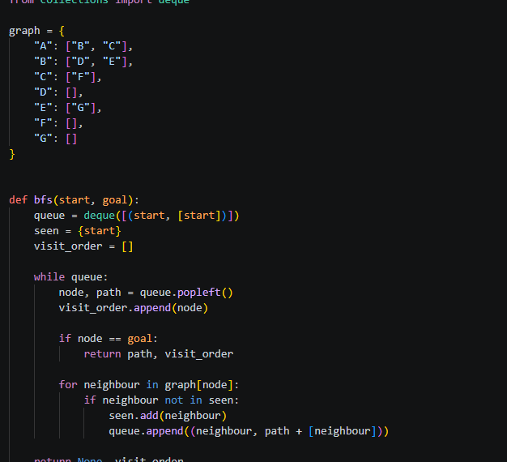

Code Screenshot 2
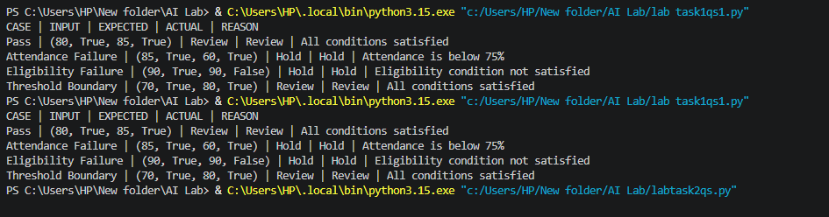

6. Actual Program Output

7. Comparison and Interpretation
Algorithm | Visit order | Returned path | Behaviour
BFS | A, B, C, D, E, F, G | A → B → E → G | Explores level by level using a queue.
DFS | A, B, D, E, G | A → B → E → G | Follows one branch deeply using a stack.

Both algorithms return the same path in this graph because the route to G is A → B → E → G. Their visit orders differ. BFS processes shallower alternatives first, while DFS follows the B branch through D and E before reaching G. The visit order and frontier trace are therefore important evidence in addition to the final path.

8. Conclusion
The manual traces agree with the Python results. BFS visits A, B, C, D, E, F, G, while DFS visits A, B, D, E, G. Both find A → B → E → G. The queue and stack cause different exploration orders even though the final path is identical.

ARTIFICIAL INTELLIGENCE LAB
LAB 3 — TASK 2: DLS AND IDDFS
Student Name | Salman Zahoor | Roll Number | 037
Course | Artificial Intelligence Lab | Course Code | CAI601400

1. Objective
Implement Depth-Limited Search (DLS) and Iterative Deepening Depth-First Search (IDDFS) on the original A–G graph. Test DLS at depth limits 1, 2, 3 and 4, and run IDDFS with maximum depths 1, 2, 3 and 4. The root A is at depth 0.

2. Graph and Search Setup
Successors: A → [B, C]; B → [D, E]; C → [F]; D → []; E → [G]; F → []; G → [].
Start state: A. Goal state: G. The solution path is A → B → E → G, which has 3 edges.
DLS performs depth-first exploration but does not expand beyond its depth limit. IDDFS repeats DLS with increasing limits, starting at depth 0. A path-local cycle check prevents revisiting a node already on the current route without incorrectly blocking that node on a different route.

3. DLS Implementation and Results
The program returns FOUND when it reaches G, CUTOFF when the depth boundary prevents exploring a deeper continuation, and FAILURE when the explored search space is exhausted without a cutoff or solution.
Depth limit | Status | Returned path
1 | CUTOFF | None
2 | CUTOFF | None
3 | FOUND | A → B → E → G
4 | FOUND | A → B → E → G

Interpretation: Limits 1 and 2 cannot reach G because the goal is at depth 3. At limit 3, DLS reaches G and returns FOUND. Limit 4 also finds the same path; the search stops as soon as the goal is found.

4. IDDFS Implementation and Results
Maximum depth | Status | Path | Limits attempted
1 | CUTOFF | None | [0, 1]
2 | CUTOFF | None | [0, 1, 2]
3 | FOUND | A → B → E → G | [0, 1, 2, 3]
4 | FOUND | A → B → E → G | [0, 1, 2, 3]

Interpretation: IDDFS starts at depth 0 and increases the limit one level at a time. Maximum depths 1 and 2 end with CUTOFF. Maximum depth 3 finds the goal at limit 3. With maximum depth 4, it also finds the goal at limit 3, so limit 4 is not run.

5. Python Code Screenshots
The following screenshots show the Python source code used for the experiment.
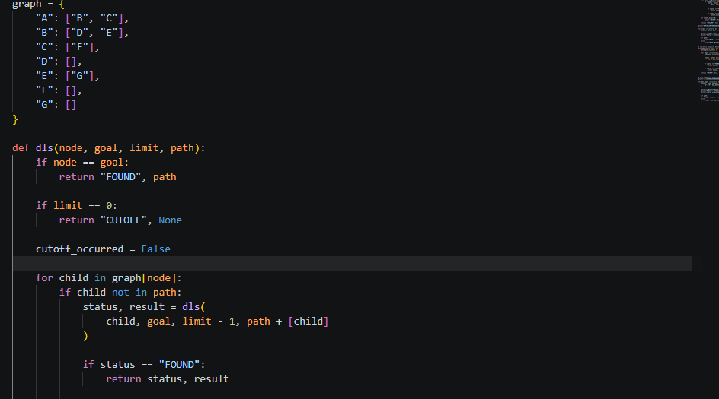

6. Actual Program Output
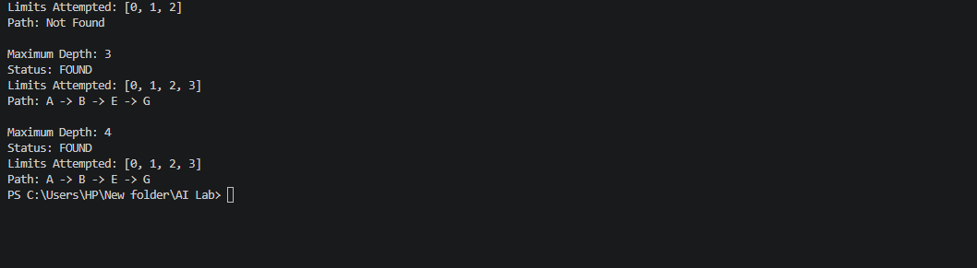

7. Why IDDFS Repeats Work
IDDFS reruns the search from A at each new depth limit. Nodes near the root are therefore visited more than once across iterations. This repeated shallow work is intentional: it lets IDDFS obtain the shallow-solution behaviour of breadth-first search while using the low memory associated with depth-first search.

8. Conclusion
The experiment confirms that the goal G is at depth 3. DLS returns CUTOFF at limits 1 and 2 and FOUND at limits 3 and 4. IDDFS progressively increases its depth limit and finds A → B → E → G when it reaches limit 3. The implementation uses a path-local cycle check and keeps FOUND, CUTOFF and FAILURE distinct.

ARTIFICIAL INTELLIGENCE LAB
LAB 3 — TASK 3: WEIGHTED GRAPH AND UNIFORM COST SEARCH (UCS)
Student Name | Salman Zahoor | Roll Number | 037
Course | Artificial Intelligence Lab | Course Code | CAI601400

1. Objective
Create a weighted version of the emergency-exit graph, implement Uniform Cost Search (UCS), and compare its result with Breadth-First Search (BFS) on the same graph.

2. Graph and Edge Weights
A is the starting point and G is the exit. The original corridors are retained and the additional corridor C → G is added for the weighted experiment, as required by Section 3.7 of the lab manual.
From | To | Travel cost
A | B | 1
A | C | 6
B | D | 2
B | E | 1
C | F | 2
E | G | 1
C | G | 6

All edge costs are nonnegative. These numerical weights are stated assumptions for this implementation and are selected to demonstrate the manual's comparison: BFS can choose the 2-edge route costing 12, while UCS finds the 3-edge route costing 3.

3. Python Code
The following is the complete source code used to generate the output.
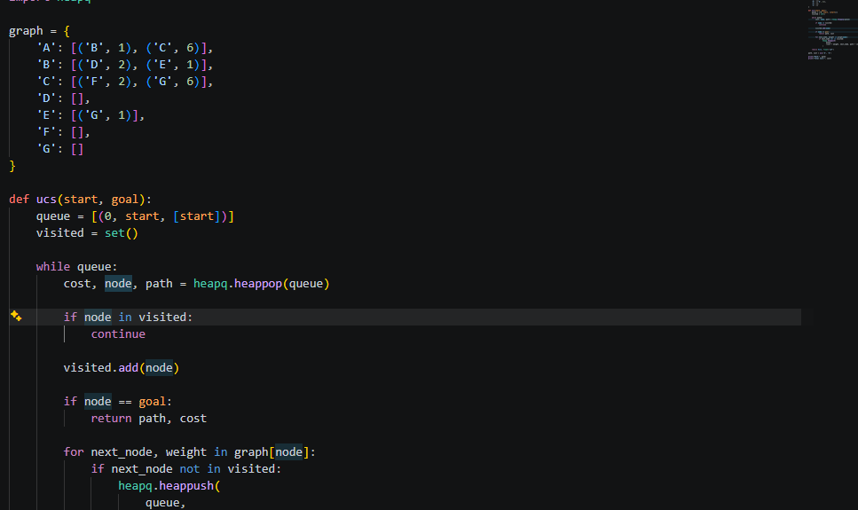

4. Actual Program Output Screenshot
The screenshot below was captured from the actual execution of lab3_ucs.py.
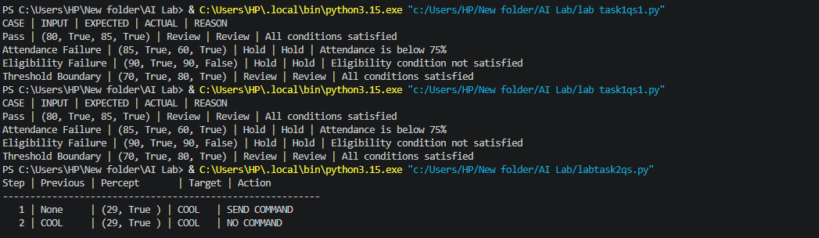

5. Results and Cost Verification
BFS returns A → C → G because it uses the fewest edges. Its travel cost is 6 + 6 = 12.
UCS returns A → B → E → G. Its travel cost is 1 + 1 + 1 = 3. The program independently sums the edge weights and confirms the same total cost of 3.
UCS processing order (including the goal): A → B → E → D → G. The priority queue expands the available node with the smallest accumulated path cost.

6. Conclusion
BFS is suitable when the objective is to find a route with the fewest edges and all steps have equal cost. In a weighted graph, the route with fewer edges may be more expensive. UCS considers accumulated travel cost and therefore selects A → B → E → G with total cost 3, which is less than the BFS route cost of 12.

