ARTIFICIAL INTELLIGENCE LAB
Lab 5 – Task 1: Minimax Trace
Name: Salman Zahoor | Roll No.: 037

1. Objective
Trace the supplied game tree using the Minimax algorithm and calculate the optimal value at the root.

2. Given Leaf Values
The supplied scores are [3, 5, 2, 9, 0, 7]. The manual pads the list with zeros to make a complete binary tree: [3, 5, 2, 9, 0, 7, 0, 0].
The root is a MAX node. The next level contains MIN nodes, followed by MAX nodes above the terminal leaf values.

3. Minimax Calculation
Bottom level (MAX): max(3,5)=5; max(2,9)=9; max(0,7)=7; max(0,0)=0.
Middle level (MIN): min(5,9)=5; min(7,0)=0.
Root level (MAX): max(5,0)=5. Therefore, the optimal Minimax value is 5.

4. Python Code
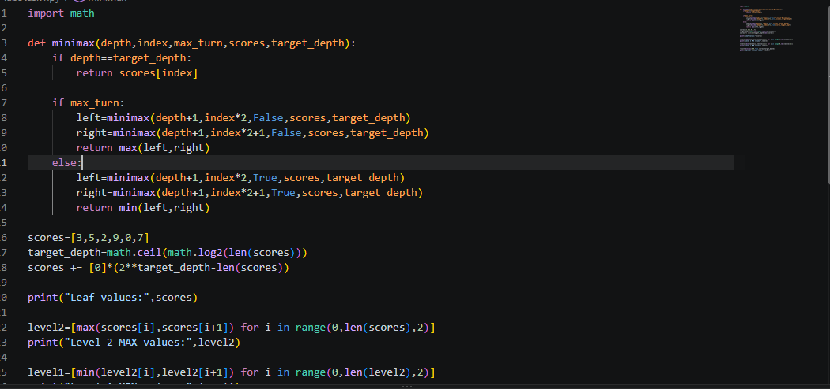

5. Program Output Screenshot
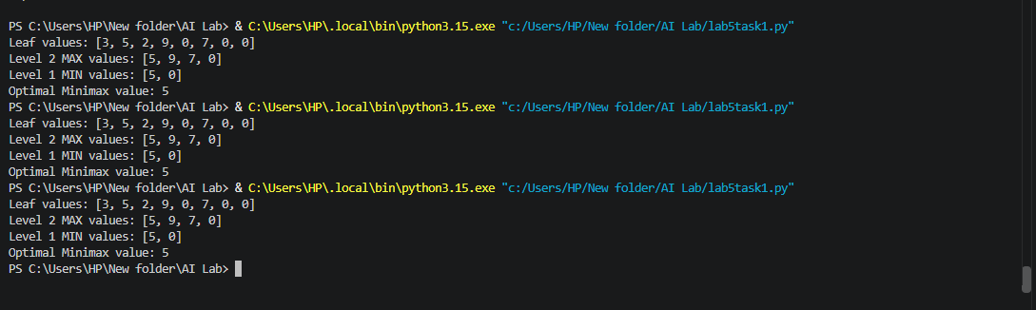

6. Result
The Minimax algorithm returns 5 as the optimal root value. MAX chooses the higher value, while MIN chooses the lower value at its turn. The result is calculated from the leaves upward.

ARTIFICIAL INTELLIGENCE LAB
Lab 5 – Task 2: Leaf-Evaluation Counter
Name: Salman Zahoor | Roll No.: 037

1. Objective
Add a leaf-evaluation counter to both Minimax and Alpha-Beta Pruning, then compare the number of terminal leaves evaluated by each algorithm.

2. Given Game Tree
Leaf scores: [3, 5, 2, 9, 3, 5, 2, 9]. The tree is a complete binary tree with MAX at the root, alternating MIN and MAX levels, and the listed values at terminal leaves.

3. Python Code
The counter increases only when an algorithm reaches a terminal leaf. Both algorithms use the same leaf values and left-to-right branch order.
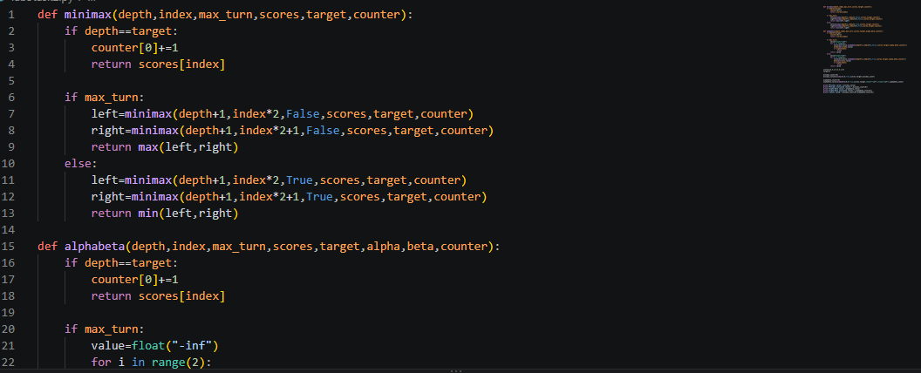

4. Program Output Screenshot
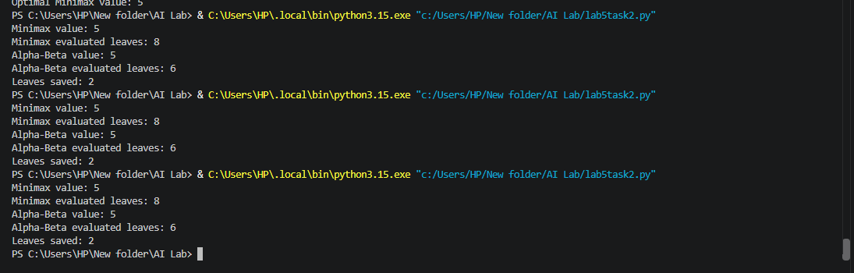

5. Results and Comparison
Algorithm | Root Value | Evaluated Leaves
Minimax | 5 | 8
Alpha-Beta Pruning | 5 | 6

Both algorithms return the same root value (5). Minimax evaluates all 8 terminal leaves, while Alpha-Beta evaluates 6 leaves and prunes the remaining 2.

6. Conclusion
The leaf counter shows that Alpha-Beta Pruning can reduce the number of evaluated leaves without changing the Minimax decision. For this tree and branch order, it evaluates 2 fewer leaves than plain Minimax.

ARTIFICIAL INTELLIGENCE LAB
Lab 5 – Task 3: Branch Ordering and Alpha-Beta Pruning
Name: Salman Zahoor | Roll No.: 037

1. Objective
Reorder the branches of the supplied game tree and observe how the number of leaves evaluated by Alpha-Beta Pruning changes while the Minimax value remains the same.

2. Experiment
The original leaf order is [3, 5, 2, 9, 3, 5, 2, 9]. The reordered version reverses the order within the tree as [9, 2, 5, 3, 9, 2, 5, 3]. The same algorithms, MAX/MIN structure, and evaluation counter are used for both runs.

3. Python Code
The counter increases when a terminal leaf is evaluated. Both Minimax and Alpha-Beta are run for each leaf order.
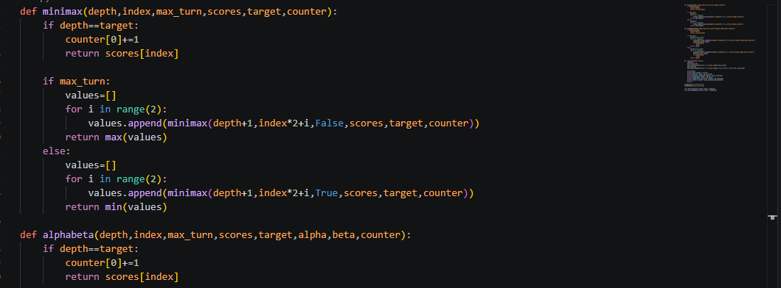

4. Program Output Screenshot
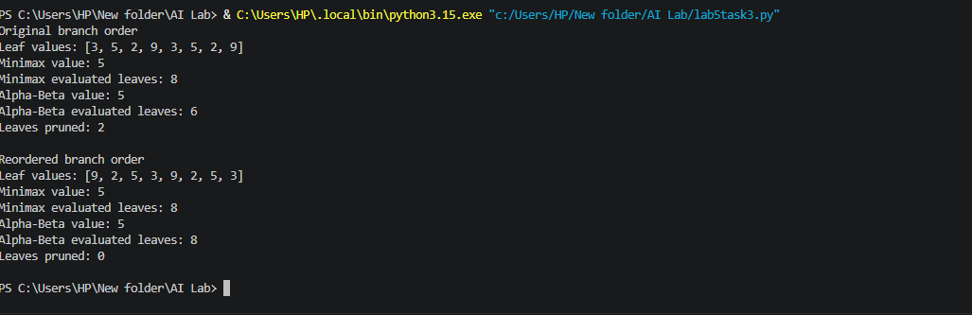

5. Results and Comparison
Branch Order | Minimax Value | Alpha-Beta Value | Alpha-Beta Leaves
Original | 5 | 5 | 6
Reordered | 5 | 5 | 8

Both branch orders produce the same Minimax value of 5. In this experiment, Alpha-Beta evaluates 6 leaves with the original order and 8 leaves after reordering. The change in ordering affects pruning efficiency, not the optimal Minimax result.

6. Conclusion
Branch ordering affects how many leaves Alpha-Beta Pruning evaluates. A favorable ordering can increase pruning, while an unfavorable ordering can reduce pruning. The Minimax value remains unchanged because the game tree's outcomes have not changed.

