1. Using containers as portable command lines

Create an image with AWS cli installed.

The image should be able to receive 2 environment variables: AWS SECRET ID, AWS SECRET ACCESS KEY.

Create a user in AWS IAM and attach a policy that allows the user to upload files to s3 bucket.

Create a file in your folder (host folder - not inside the container) and upload the file using the container

Bonus: Create a bash aliash to run the command.

Solution:

a) Dockerfile:

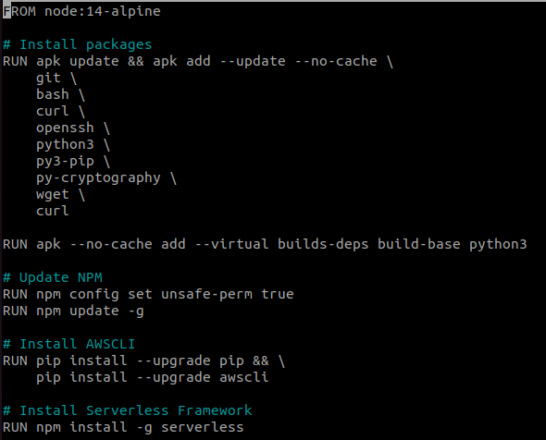

b) sudo docker build .

c) sudo docker run… :



d)file is uploaded to s3:



2. The following image using the command:

docker pull tomcat:9.0-jdk8-temurin-jammy

What is the CMD set in this container? How did you find out?

Solution:

a) sudo docker pull tomcat:9.0-jdk8-temurin-jammy

b) sudo docker image inspect tomcat:9.0-jdk8-temurin-jammy

c) I see that the CMD set in this container is running catalina.sh in c shell:

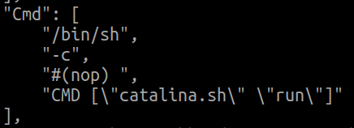

3. Remember you created a web site in EC2 using Wordpress?

You assignment is to create the same thing just with containers.

Run a wordpress container with a mariadb container in EC2 and make the web site accessible.

Remember the web site needs to be resistent to reboot (when we reboot the server - no data is supposed to be lost)

\* Can do nextcloud opensource instead

Solution:

a) mariadb container:

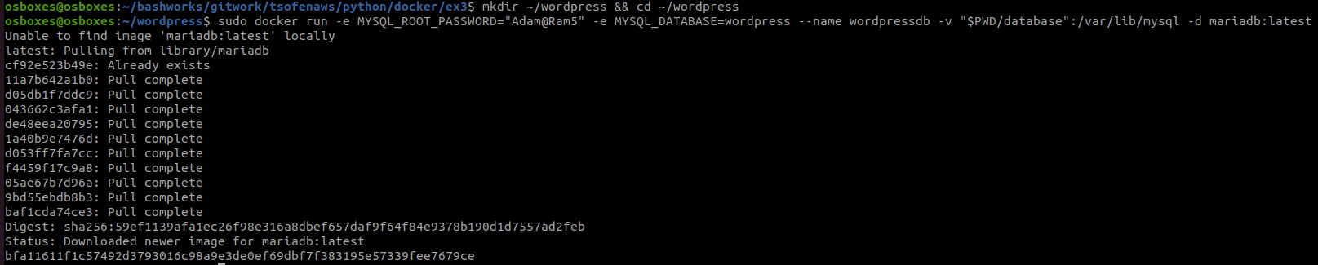



b) wordpress container:

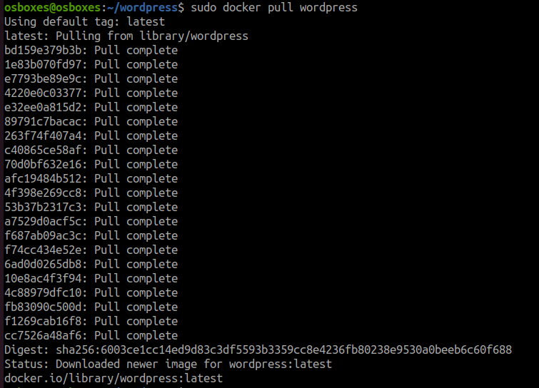



c) Working:

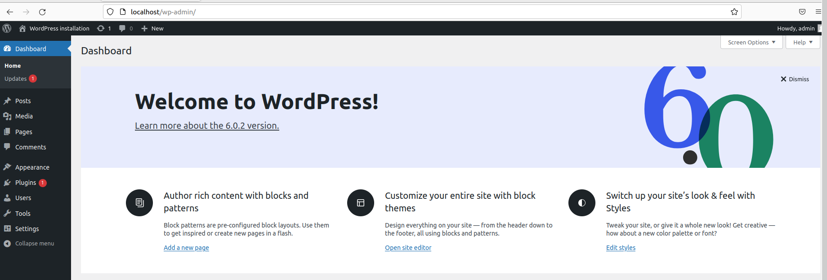

4. Create a Dockerfile with your favorite python script running.

The dockerfile needs to include all the requirements to run the script.

The python script needs to be downloaded from Github evemorytime you rebuilt the image.

Bonus: Try and change the python script in Github, and rebuilt the image. Did the image get updated?

What do you need to do to make this happen?

Solution:

a) Dockerfile:

b) sudo docker build --no-cache .

c) sudo docker run 56f7f4147c91

5. You need to migrate you newly created image using dockerfile from your laptop to the EC2 instance.

How would you do that?

Bonus: Find another way to do this.

Solution:

a) upload to docker hub and then download from docker hub to EC2.

b) use secure copy scp

6. What is a multistage build? And how can you use it?

Please created a demonstration of the benefits.

Solution:

When we use multiple from statements in docker file, the second from will use the dependencies of first from and the unused will be removed. This will decrease the image size.

7. What happens when you delete a file in a RUN phase during the dockerfile build?

Solution: depends

It is really deleted?

Solution: it can be deleted only if it is done in same layer

Bonus: How can you check file storage efficiency?

Solution: using dive socker