**High-Level Design (HLD)**

**Stores Sales Prediction**

|  |  |
| --- | --- |
| Written By | Mohammad Salman |
| Document Version | 1.0 |
| Last Revised Date | 26-11-2022 |

**Document Change Control Record**

|  |  |  |  |
| --- | --- | --- | --- |
| **Version** | **Date** | **Author** | **Comments** |
|  |  |  |  |
|  |  |  |  |
|  |  |  |  |
|  |  |  |  |
|  |  |  |  |
|  |  |  |  |
|  |  |  |  |
|  |  |  |  |
|  |  |  |  |
|  |  |  |  |
|  |  |  |  |
|  |  |  |  |
|  |  |  |  |
|  |  |  |  |
|  |  |  |  |

Review

|  |  |  |  |
| --- | --- | --- | --- |
| **Version** | **Date** | **Reviewer** | **Comments** |
|  |  |  |  |

**Approval**

|  |  |  |  |  |
| --- | --- | --- | --- | --- |
| **Version** | **Review date** | **Reviewed By** | **Approved By** | **Comments** |
|  |  |  |  |  |

# Abstract

Currently Rental bikes are introduced in many urban cities for the enhancement of mobility comfort. It is important to make the rental bike available and accessible to the public at the right time as it lessens the waiting time. Eventually, providing the city with a stable supply of rental bikes becomes a major concern. The crucial part is the prediction of bike count required at each hour for the stable supply of rental bikes.

# 1. Introduction

**1.1 Why these High-Level Design Documents?**

The purpose of this High-Level Design(HLD) Documents is to add necessary details to the current project description to represent a suitable for coding. This document is also intended to help detect contradictions before coding. And can be used as a reference manual for how the modules interact at a high level.

The HLD will be :

* Present all of the design aspects and define them in detail.
* Describe the user interface being implemented.
* Describe the needed Python libraries for the coding.
* Describe the performance requirements.
* Include design features and the architecture of the project.
* List and describe the non-functional attributes like:
  + Security o Reliability o Maintainability o Portability o Reusability
  + Application Compatibility o Resource Utilization o Serviceability

## 1.2 Scope

The HLD documentation presents the structure of the system, such as the database architecture, application architecture(layers), application flow (Navigation), and technology architecture, The HLD uses non-technical and mildly-technical terms which should be understandable to the administrators of the system

## 1.3 Definition

|  |  |
| --- | --- |
| **TERM** | **DESCRIPTION** |
| **DB** | Database, the cloud platform where the data will be stored. Can be considered cloud storage. |
| **ML** | Machine Learning |
| **API OR APIS** | Application Programming Interface can be considered a website link from there can extract information. |

# 2. General Description

## 2.1 Product Perspective

The Rental bike count Prediction is an ML-based Web Application that Is able to predict future rented bike count by analyzing past records. It will give the number that will be the measure of product sales.

## 2.2 Problem Statement

## Bike sharing systems are a new generation of traditional bike rentals where the whole

## process from membership, rental and return back has become automatic. Through

## these systems, users are able to easily rent a bike from a particular position and return

## back at another position. Currently, there are about over 500 bike-sharing programs

## around the world which is composed of over 500 thousand bicycles. Today, there exists

## great interest in these systems due to their important role in traffic, environmental and

## health issues. Apart from interesting real-world applications of bike sharing systems, the

## characteristics of data being generated by these systems make them attractive for the

## research.

## The goal here is to build an end-to-end regression task. Here the user will provide the

## data and the result will be given by the best performing hyper tuned Machine Learning

## model. The user will also get privileges to choose the deployment options.

## 2.3 Proposed Solution

We will use performe EDA to find the important relation between different attributes and will use a machine-learning algorithm to predict the future sales demand. The client will be filled the required feature as input and will get results through the web application. The system will get features and it will be passed into the backend where the features will be validated and preprocessed and then it will be passed to a hyperparameter tuned machine learning model to predict the final outcome.

## 2.4 Tool Used

The programming language is Python that is used here, also we will use some other pythonbased libraries like, for ml, we will use Scikit-Learn library, for data manipulation we will use pandas, for numerical computation Numpy, for custom APIs creation Flask web frameworks. Visual Studio Code is used as python IDE for all modular coding and custom APIs creation. And storing all code files for publically available we will use GitHub.

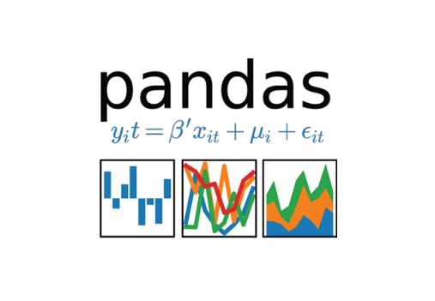

## 2.6 Constraints

The System should be user-friendly, the user should get all proper messages while using the web app. He/she also should get a proper error message if he/she has done something wrong On the web-app page. All the errors and results should be delivered in the easiest possible way and all the buttons are going to insert on the webpage should be labeled properly, so the user did not get confused to use the system.

## 2.7 Assumptions

The main objective is to implement a system that will produce approximate future demand for a bike rented.

# 3. Design Details

## 3.1 Process Flow

We will be using following process flow for this project. The process will be based on modular coding i.e. use of oops concepts to build the entire project from start to end.

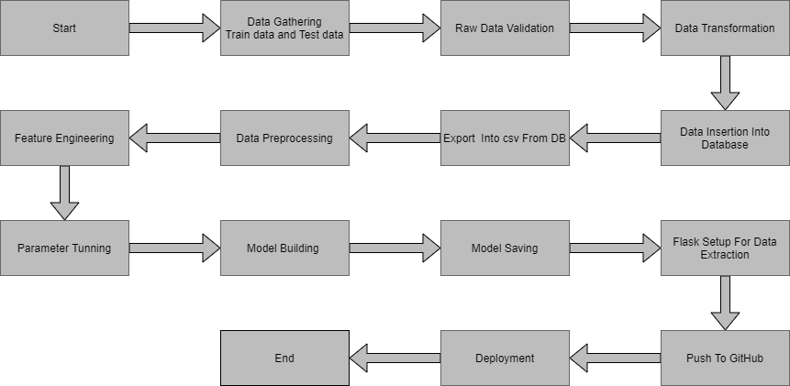

## 3.2 Deployment Process

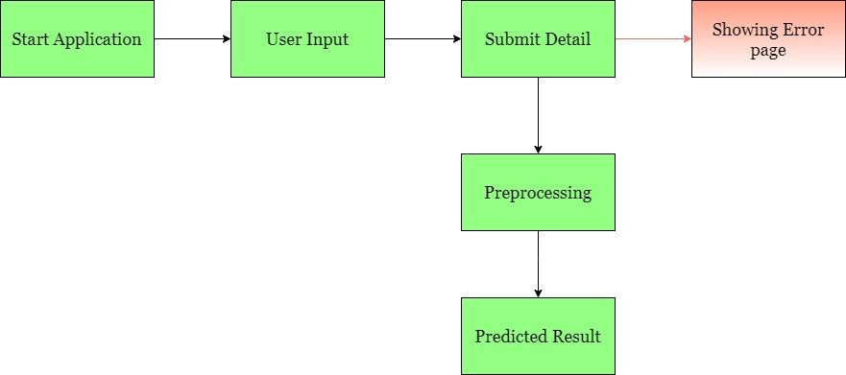

## 3.3 Error Handling

If any error occurred in the processing way then the error message should be shown to the user in a completely non-technical way that can be understandable by any person. And Meaningful error message should be shown, so the user can spot his mistake and rerun the process with improvement. All the errors that are will occur should be handled properly. And we have to log every error for our application and have to manage the same.

## 4. Performance

The Rental bike Prediction is dependent on machine-learning algorithms. We will train various ml algorithms and will find the best fitting algorithm for predicting the target. Our system performance will be based on the data we are going to feed to the algorithms. And the performance will depend on the finalized model. and the web application and the deployment server. With all of these components, our program should run properly.

### 4.1 Reusability

The code and the module are created during the time of building the project should maintain all coding guidelines and full project code is written in a Modular fashion. Our system should have the flexibility to work properly from any location. And it should handle any improper input value from the user and should give a meaningful error message so the user can correct his/her mistake and enter valid input to get the result. And the system should be reusable in every manner with different types of inputs values that are all are it has been trained.

### 4.2 Application Compatibility

The different libraries and python programming languages are used to build the system. Every library has its own functionality and it should work properly with our fluctuate system. Flask will be used for making the web APIs and HTML/CSS will be used to make the web application. All the components of the application should work properly and it should produce a result without any interpretation.

### 4.3 Resource Utilization

Our application should utilize the given resource properly and it should use a minimal amount of internet to work and call the APIs on the Web page. Our system should not use much amount of computational resources hence it will make the application slow. Our application will be deployed cloud platform and it should utilize the resource given on the cloud and work properly.

## 5. Deployment

For the deployment process, we will using Heroku cloud platforms for hosting our application. The cloud platform will run the system and it will give the flexibility to use our application globally.



## 6. Conclusion

The Rental bike Prediction is about to help business owners and manufacturing companies can predict of there product demand in the future. It can help them to grow the business also it will help the supply chain for products. We have a past record about products, product sales records along with store information. We will analyze the past data and will build an ml model that can identify the internal pattern and be able to predict the target value or the bike rented demand in the future.

## 7. Reference

Google image for collection the logos and images.

Sketch diagram for drawing the diagrams.