**YOUNG-OS**



**Supervisor**

SIR WAQAS

**Submitted by**

Muhammad Salman  
{2021_SE_04}

Noman Ahmad  
{2021_SE_24}

Farjad Waseem  
{2021_SE_56}

**Department of Computer Science,**

University of Engineering and Technology, Lahore, New-Campus.

# INTRODUCTION:

Lorem ipsum dolor sit amet, consectetur adipiscing elit, sed do eiusmod tempor incididunt ut labore et dolore magna aliqua. Ut enim ad minim veniam, quis nostrud exercitation ullamco laboris nisi ut aliquip ex ea commodo consequat. Duis aute irure dolor in reprehenderit in voluptate velit esse cillum dolore eu fugiat nulla pariatur. Excepteur sint occaecat cupidatat non proident, sunt in culpa qui officia deserunt mollit anim id est laborum.

# Working Diagram (you can change the name as well):

# Tasks:

1. Notepad
2. Calculator
3. Time
4. Creating a File
5. Move file
6. Copy file
7. Delete File
8. Check File Info
9. Image Viewer
10. Text Editor
11. Game
12. Task Manager
13. File Encryption Tool
14. File Decryption Tool
15. Text Encryption Tool
16. Text Decryption Tool

# Notepad:

## Description :

Notepad is a simple file-text editor with autosave feature which enable user to locate its file and then open inside notepad. Notepad provide a Text Editing Area where user can edit the text of file with autosave feature. That Autosave features triggers whenever the text is changed in text editing area.

## Features :

1. Open File to edit its text
2. “Q File Dialog” to locate file
3. Auto Save feature

## UI-Screenshot:

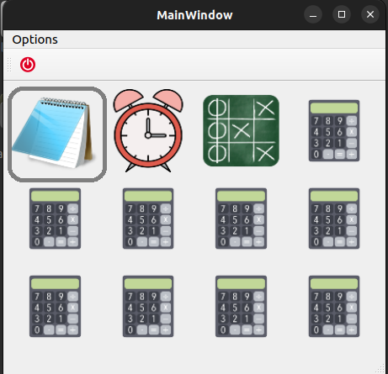

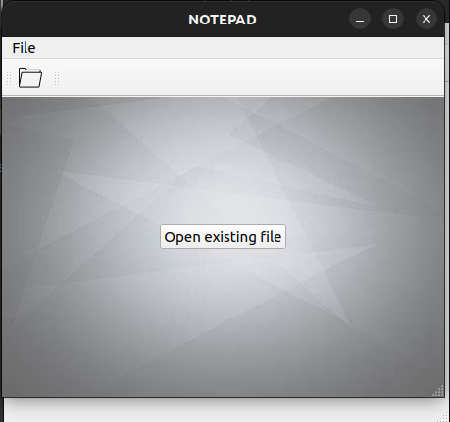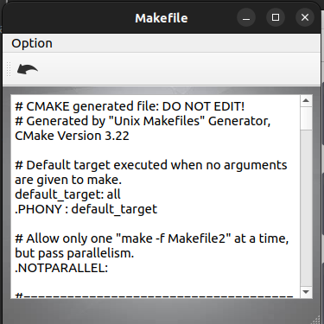

## Steps using Notepad:

1. Click on Notepad Icon
2. Click on Open File
3. Select File You want to open in notepad
4. Press Open
5. Now edit text, notepad will automatically save it in file
6. Close file

## Shortcut-Keys :

|  |  |  |
| --- | --- | --- |
| **No.** | **Actions** | **Shortcut Keys** |
| **1.** | Open Notepad from Desktop Window | Ctrl+1 |
| **2.** | Close Running Notepad from Desktop | Ctrl+Alt+1 |
| **3.** | Open File inside Notepad | Ctrl+O |
| **4.** | Close Open File | Esc |
| **5.** | Close Notepad While file is opened | Ctrl+Esc |
| **6.** | Close Notepad while file is not opened | Esc |

# Calculator:

## Description :

Lorem ipsum dolor sit amet, consectetur adipiscing elit, sed do eiusmod tempor incididunt ut labore et dolore magna aliqua. Ut enim ad minim veniam, quis nostrud exercitation ullamco laboris nisi ut aliquip ex ea commodo consequat

## Features :

1. Feature 1

## UI-Screenshot:

## Steps using Notepad:

1. Step 1
2. Step 2

## Shortcut-Keys :

|  |  |  |
| --- | --- | --- |
| **No.** | **Actions** | **Shortcut Keys** |
| **1.** |  |  |

# Time:

## Description :

Lorem ipsum dolor sit amet, consectetur adipiscing elit, sed do eiusmod tempor incididunt ut labore et dolore magna aliqua. Ut enim ad minim veniam, quis nostrud exercitation ullamco laboris nisi ut aliquip ex ea commodo consequat

## Features :

1. Feature 1

## UI-Screenshot:

## Steps using Notepad:

1. Step 1
2. Step 2

## Shortcut-Keys :

|  |  |  |
| --- | --- | --- |
| **No.** | **Actions** | **Shortcut Keys** |
| **1.** |  |  |

# Creating a File :

## Description :

Lorem ipsum dolor sit amet, consectetur adipiscing elit, sed do eiusmod tempor incididunt ut labore et dolore magna aliqua. Ut enim ad minim veniam, quis nostrud exercitation ullamco laboris nisi ut aliquip ex ea commodo consequat

## Features :

1. Feature 1
2. Feature 2

## UI-Screenshot:

## Steps using Notepad:

1. Step 1
2. Step 2

## Shortcut-Keys :

|  |  |  |
| --- | --- | --- |
| **No.** | **Actions** | **Shortcut Keys** |
| **1.** |  |  |

# Move file :

## Description :

Lorem ipsum dolor sit amet, consectetur adipiscing elit, sed do eiusmod tempor incididunt ut labore et dolore magna aliqua. Ut enim ad minim veniam, quis nostrud exercitation ullamco laboris nisi ut aliquip ex ea commodo consequat

## Features :

1. Feature 1
2. Featuer 2

## UI-Screenshot:

## Steps using Notepad:

1. Step 1
2. Step 2

## Shortcut-Keys :

|  |  |  |
| --- | --- | --- |
| **No.** | **Actions** | **Shortcut Keys** |
| **1.** |  |  |

# Copy file :

## Description :

Lorem ipsum dolor sit amet, consectetur adipiscing elit, sed do eiusmod tempor incididunt ut labore et dolore magna aliqua. Ut enim ad minim veniam, quis nostrud exercitation ullamco laboris nisi ut aliquip ex ea commodo consequat

## Features :

1. Feature 1

## UI-Screenshot:

## Steps using Notepad:

1. Step 1
2. Step 2

## Shortcut-Keys :

|  |  |  |
| --- | --- | --- |
| **No.** | **Actions** | **Shortcut Keys** |
| **1.** |  |  |

# Delete File :

## Description :

Lorem ipsum dolor sit amet, consectetur adipiscing elit, sed do eiusmod tempor incididunt ut labore et dolore magna aliqua. Ut enim ad minim veniam, quis nostrud exercitation ullamco laboris nisi ut aliquip ex ea commodo consequat

## Features :

1. Feature 1

## UI-Screenshot:

## Steps using Notepad:

1. Step 1
2. Step 2

## Shortcut-Keys :

|  |  |  |
| --- | --- | --- |
| **No.** | **Actions** | **Shortcut Keys** |
| **1.** |  |  |

# Check File Info :

## Description :

Lorem ipsum dolor sit amet, consectetur adipiscing elit, sed do eiusmod tempor incididunt ut labore et dolore magna aliqua. Ut enim ad minim veniam, quis nostrud exercitation ullamco laboris nisi ut aliquip ex ea commodo consequat

## Features :

1. Feature 1

## UI-Screenshot:

## Steps using Notepad:

1. Step 1
2. Step 2

## Shortcut-Keys :

|  |  |  |
| --- | --- | --- |
| **No.** | **Actions** | **Shortcut Keys** |
| **1.** |  |  |

# Image Viewer :

## Description :

Lorem ipsum dolor sit amet, consectetur adipiscing elit, sed do eiusmod tempor incididunt ut labore et dolore magna aliqua. Ut enim ad minim veniam, quis nostrud exercitation ullamco laboris nisi ut aliquip ex ea commodo consequat

## Features :

1. Feature 1

## UI-Screenshot:

## Steps using Notepad:

1. Step 1
2. Step 2

## Shortcut-Keys :

|  |  |  |
| --- | --- | --- |
| **No.** | **Actions** | **Shortcut Keys** |
| **1.** |  |  |

# Text Editor :

## Description :

Lorem ipsum dolor sit amet, consectetur adipiscing elit, sed do eiusmod tempor incididunt ut labore et dolore magna aliqua. Ut enim ad minim veniam, quis nostrud exercitation ullamco laboris nisi ut aliquip ex ea commodo consequat

## Features :

1. Feature 1

## UI-Screenshot:

## Steps using Notepad:

1. Step 1
2. Step 2

## Shortcut-Keys :

|  |  |  |
| --- | --- | --- |
| **No.** | **Actions** | **Shortcut Keys** |
| **1.** |  |  |

# Game :

## Description :

Lorem ipsum dolor sit amet, consectetur adipiscing elit, sed do eiusmod tempor incididunt ut labore et dolore magna aliqua. Ut enim ad minim veniam, quis nostrud exercitation ullamco laboris nisi ut aliquip ex ea commodo consequat

## Features :

1. Feature 1

## UI-Screenshot:

## Steps using Notepad:

1. Step 1
2. Step 2

## Shortcut-Keys :

|  |  |  |
| --- | --- | --- |
| **No.** | **Actions** | **Shortcut Keys** |
| **1.** |  |  |

# File Encryption Tool :

## Description :

Lorem ipsum dolor sit amet, consectetur adipiscing elit, sed do eiusmod tempor incididunt ut labore et dolore magna aliqua. Ut enim ad minim veniam, quis nostrud exercitation ullamco laboris nisi ut aliquip ex ea commodo consequat

## Features :

1. Feature 1

## UI-Screenshot:

## Steps using Notepad:

1. Step 1
2. Step 2

## Shortcut-Keys :

|  |  |  |
| --- | --- | --- |
| **No.** | **Actions** | **Shortcut Keys** |
| **1.** |  |  |

# File Decryption Tool :

## Description :

Lorem ipsum dolor sit amet, consectetur adipiscing elit, sed do eiusmod tempor incididunt ut labore et dolore magna aliqua. Ut enim ad minim veniam, quis nostrud exercitation ullamco laboris nisi ut aliquip ex ea commodo consequat

## Features :

1. Feature 1

## UI-Screenshot:

## Steps using Notepad:

1. Step 1
2. Step 2

## Shortcut-Keys :

|  |  |  |
| --- | --- | --- |
| **No.** | **Actions** | **Shortcut Keys** |
| **1.** |  |  |

# Text Encryption Tool :

## Description :

Lorem ipsum dolor sit amet, consectetur adipiscing elit, sed do eiusmod tempor incididunt ut labore et dolore magna aliqua. Ut enim ad minim veniam, quis nostrud exercitation ullamco laboris nisi ut aliquip ex ea commodo consequat

## Features :

1. Feature 1

## UI-Screenshot:

## Steps using Notepad:

1. Step 1
2. Step 2

## Shortcut-Keys :

|  |  |  |
| --- | --- | --- |
| **No.** | **Actions** | **Shortcut Keys** |
| **1.** |  |  |

# Text Decryption Tool :

## Description :

Lorem ipsum dolor sit amet, consectetur adipiscing elit, sed do eiusmod tempor incididunt ut labore et dolore magna aliqua. Ut enim ad minim veniam, quis nostrud exercitation ullamco laboris nisi ut aliquip ex ea commodo consequat

## Features :

1. Feature 1

## UI-Screenshot:

## Steps using Notepad:

1. Step 1
2. Step 2

## Shortcut-Keys :

|  |  |  |
| --- | --- | --- |
| **No.** | **Actions** | **Shortcut Keys** |
| **1.** |  |  |

# Task Manager :

## Description :

Lorem ipsum dolor sit amet, consectetur adipiscing elit, sed do eiusmod tempor incididunt ut labore et dolore magna aliqua. Ut enim ad minim veniam, quis nostrud exercitation ullamco laboris nisi ut aliquip ex ea commodo consequat

## Features :

1. Feature 1

## UI-Screenshot:

## Steps using Notepad:

1. Step 1
2. Step 2

## Shortcut-Keys :

|  |  |  |
| --- | --- | --- |
| **No.** | **Actions** | **Shortcut Keys** |
| **1.** |  |  |