Instructions To Run The Project

1. Extract the Zip File.

1. Open the Backend and Frontend folders in Visual Studio Code in separate windows.

1. Open the terminal for both windows

1. For the Backend terminal, write and enter “npm install” to install node modules for the backend

1. After that, write “npm audit fix” to fix some issues

1. Write and enter “npm run dev” to run both the backend and frontend

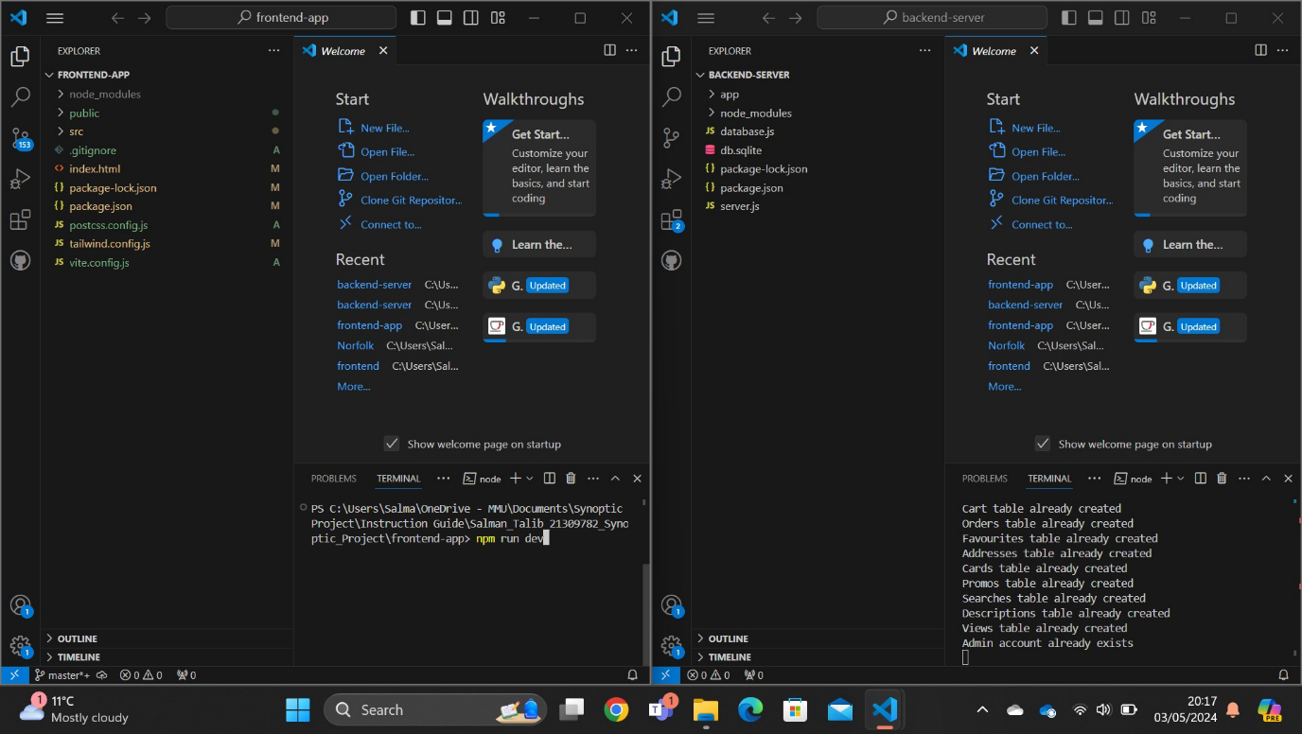

1. Use the link from the frontend terminal to open the website.

