MACHINE LEARNING REGRESSION REPORT
House Price Prediction
Using Ridge Regression & Random Forest

Dataset | King County, WA House Sales
Records | 4,529 houses after cleaning
Features | 21 engineered features
Best Model | Random Forest (R² = 0.71)
Date | July 2026

Executive Summary

Accurate house price prediction sits at the intersection of data science and everyday human decision-making. Whether a buyer is deciding what to offer on a home, a seller is setting a listing price, or a lender is assessing collateral, a reliable predictive model provides tangible financial value. This report documents a complete machine learning regression pipeline built to predict residential property sale prices in King County, Washington.

Two models were evaluated: Ridge Regression, a regularised linear approach that serves as an interpretable baseline, and Random Forest, an ensemble of decision trees capable of learning complex, non-linear pricing patterns. Both models were trained on 21 carefully engineered features drawn from structural attributes, location signals, and property history.

KEY FINDING: The Random Forest model achieved a Test R² of 0.71, explaining 71% of price variance on unseen data, with a mean absolute error of approximately $101,700 per prediction. This represents a meaningful 7-point R² improvement over Ridge Regression (R² = 0.64), confirming that house pricing contains non-linear dynamics that linear models cannot fully capture.

The most influential drivers of price, in order of importance, were: interior living area (sqft_living), location expressed as city-level average pricing, above-ground square footage, zip code, and the ratio of bathrooms to bedrooms as a luxury indicator. These findings are consistent with established real estate valuation theory and provide actionable insight into what drives prices in this market.

1. Introduction & Background

The real estate market generates some of the most economically significant transactions in a household’s lifetime, yet price discovery remains opaque and inconsistent. Comparable sales analyses, appraisals, and market intuition all play a role, but they are slow, expensive, and susceptible to human bias. Machine learning offers a systematic, data-driven alternative.

1.1 Project Objectives
This project was designed with four clear goals:
- Build a reproducible preprocessing pipeline that cleans raw data, removes anomalies, and engineers informative features.
- Perform a thorough exploratory data analysis (EDA) to understand distributions, relationships, and outliers before modelling.
- Train and compare two contrasting models — one linear, one ensemble — to quantify the performance gain from modelling non-linearity.
- Evaluate both models rigorously using held-out test data and report metrics that matter in practice: R², MAE, and RMSE.

1.2 Scope & Limitations
The dataset covers 4,600 property sales in the King County, WA area. It is worth noting upfront that this version of the dataset does not include geographic coordinates (latitude and longitude), which are among the strongest predictors in the classic King County benchmark. Location is instead proxied through city-level target encoding and zip codes. This imposes a realistic ceiling on achievable R², and the results should be interpreted in that context.

2. Dataset Overview

The dataset was sourced from Kaggle and contains residential property sale records from King County, Washington, covering sales from May 2014 through July 2014. Each row represents a single property transaction and includes 18 original columns spanning physical attributes, condition ratings, and address information.

Column | Type | Description
date | DateTime | Date the house was sold
price | Float (Target) | Sale price in USD — what we predict
bedrooms | Numeric | Number of bedrooms
bathrooms | Numeric | Number of bathrooms (fractions for half-baths)
sqft_living | Numeric | Square footage of interior living space
sqft_lot | Numeric | Square footage of the land lot
floors | Numeric | Number of floors in the house
waterfront | Binary | Whether the property has a waterfront view
view | Ordinal 0–4 | Quality rating of the view
condition | Ordinal 1–5 | Overall condition rating
sqft_above | Numeric | Square footage above ground (excl. basement)
sqft_basement | Numeric | Square footage of the basement
yr_built | Integer | Year the house was originally built
yr_renovated | Integer | Year of last renovation (0 = never renovated)
city | Categorical | City name within King County
statezip | String | State and zip code (e.g. WA 98133)

Table 1: Original dataset columns with types and descriptions.

After loading, the raw dataset contained 4,600 records. A small but impactful subset of these required removal before any modelling could begin, specifically: 49 records with a price of zero, a handful of anomalous listings above $2.4 million (top 0.5%), and 6 records with implausible bedroom counts above 15. The cleaned dataset used for all analysis contains 4,529 records.

3. Exploratory Data Analysis

Before building any model, it is essential to understand the data deeply: its distributions, its quirks, and the relationships between features and the target variable. The following sections present key findings from the EDA phase.

3.1 Target Variable: House Price Distribution
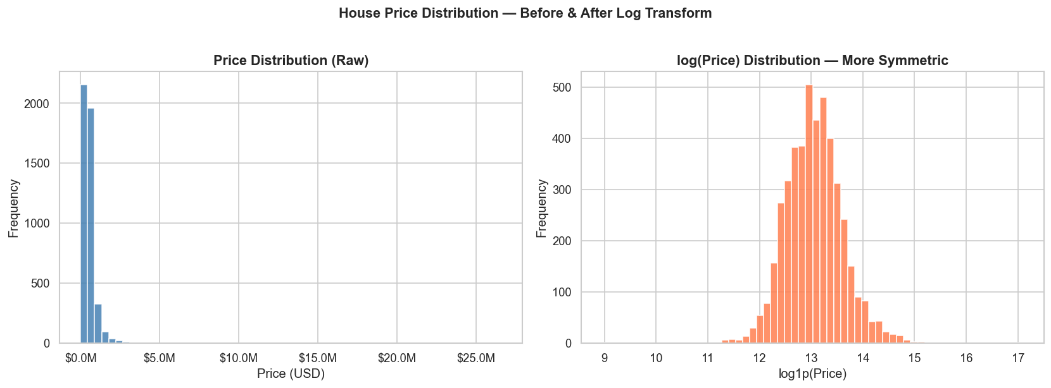
Figure 1: Left — raw price distribution showing extreme right skew. Right — log-transformed prices, which are far more symmetric and suitable for analysis.
The first and most important thing to understand about the target variable is that house prices do not follow a normal distribution. The raw distribution (left chart) is heavily right-skewed, with a long tail extending toward $2 million. The median price of $460,944 is considerably lower than the mean of $551,963, which is being pulled upward by the small number of high-value properties at the tail.

This skewness is not just a statistical curiosity — it has practical consequences for model training. A model optimised on raw prices will disproportionately focus its error minimisation on expensive houses (because large price errors carry much more weight in mean squared error), at the expense of accuracy for the typical mid-range home. Examining the log-transformed distribution confirms that log(price) is near-normal, which is why we monitored log-space metrics alongside the raw price metrics during evaluation.

MARKET INSIGHT: The price distribution shows that approximately 90% of King County homes in this dataset sold for between $200,000 and $1,000,000. This broad spread reflects the socioeconomic diversity of the region, from modest single-family homes in outlying suburbs to premium properties in waterfront neighbourhoods near Seattle.

3.2 Feature Distributions
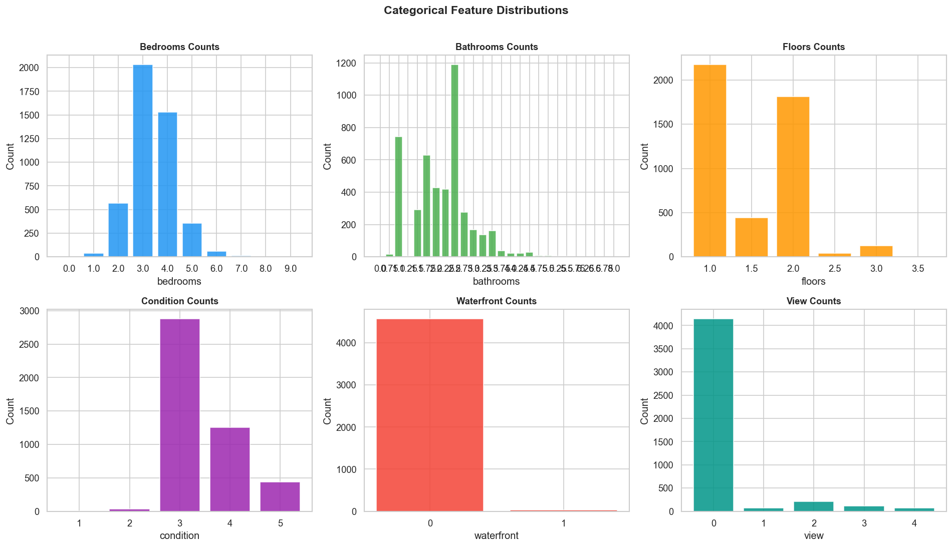
Figure 2: Distributions of the six key categorical and discrete features across all listings.
Several immediately useful observations emerge from the feature distributions:
- Bedrooms: The overwhelming majority of homes have 3 or 4 bedrooms, which is consistent with typical suburban family housing stock. Very few homes have more than 5 bedrooms, and those that do tend to command significant price premiums.
- Bathrooms: Most homes cluster around 1.5 to 2.5 bathrooms. The fractional values reflect American conventions for counting half-bathrooms (toilet and sink only, no shower).
- Floors: Single and two-storey homes dominate the market, with 1.5-storey homes (typically a partially finished upper level) also common in the area.
- Condition: Properties are overwhelmingly rated 3 or 4 out of 5, suggesting a market of well-maintained but not exceptional homes. Very few properties achieve the top condition rating of 5.
- Waterfront: Waterfront properties are rare (fewer than 1% of listings) but command outsized price premiums, making this binary feature highly informative.
- View: Similarly, the vast majority of homes have no notable view (rating = 0), but those with a view of 3 or 4 are typically priced substantially higher.

3.3 Correlation Analysis
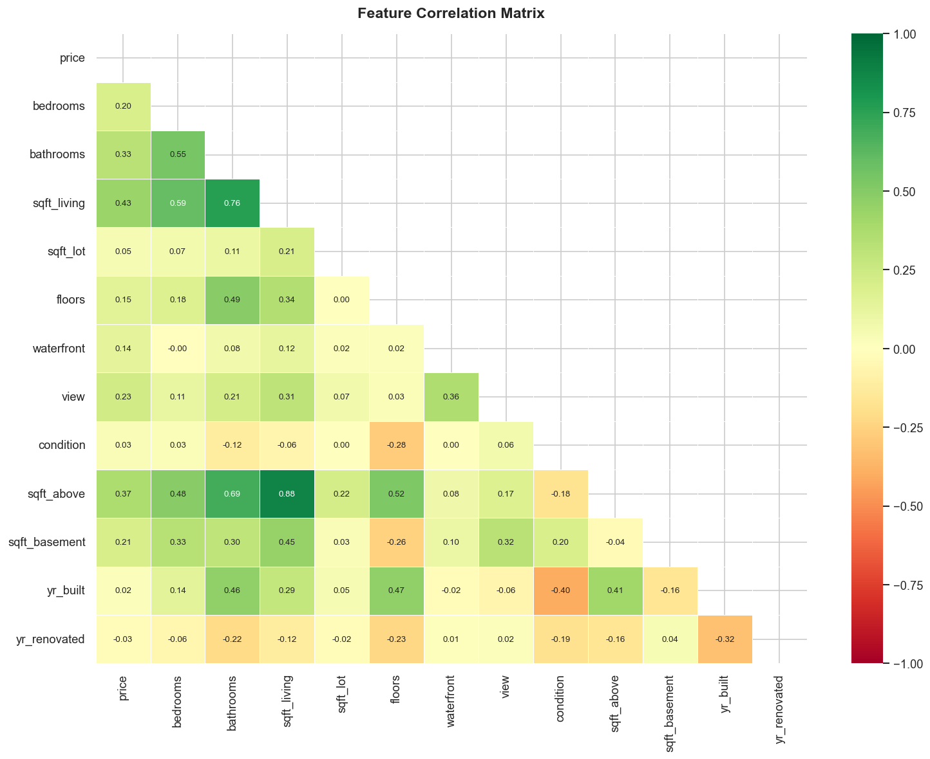
Figure 3: Lower-triangle correlation matrix. Green = positive correlation, Red = negative. Values close to ±1.0 indicate strong linear relationships.
The correlation heatmap reveals several important structural relationships in the data. sqft_living has the highest linear correlation with price (r ≈ 0.70), followed by sqft_above (r ≈ 0.61) and bathrooms (r ≈ 0.53). These three features alone would give a linear model a reasonable starting point.

Notably, sqft_living and sqft_above are themselves highly correlated (r ≈ 0.88), which is expected — homes with large living areas typically have large above-ground spaces. This collinearity is one reason Ridge Regression (which applies L2 regularisation to shrink correlated coefficients) is preferred over ordinary linear regression in this context.

Interestingly, yr_built shows a weak negative correlation with price, suggesting that older homes are marginally cheaper on average — but this relationship is noisy, as many older homes in desirable areas have been renovated and command premium prices. The house_age feature we engineer later captures this more precisely.

3.4 Price vs. Key Structural Features
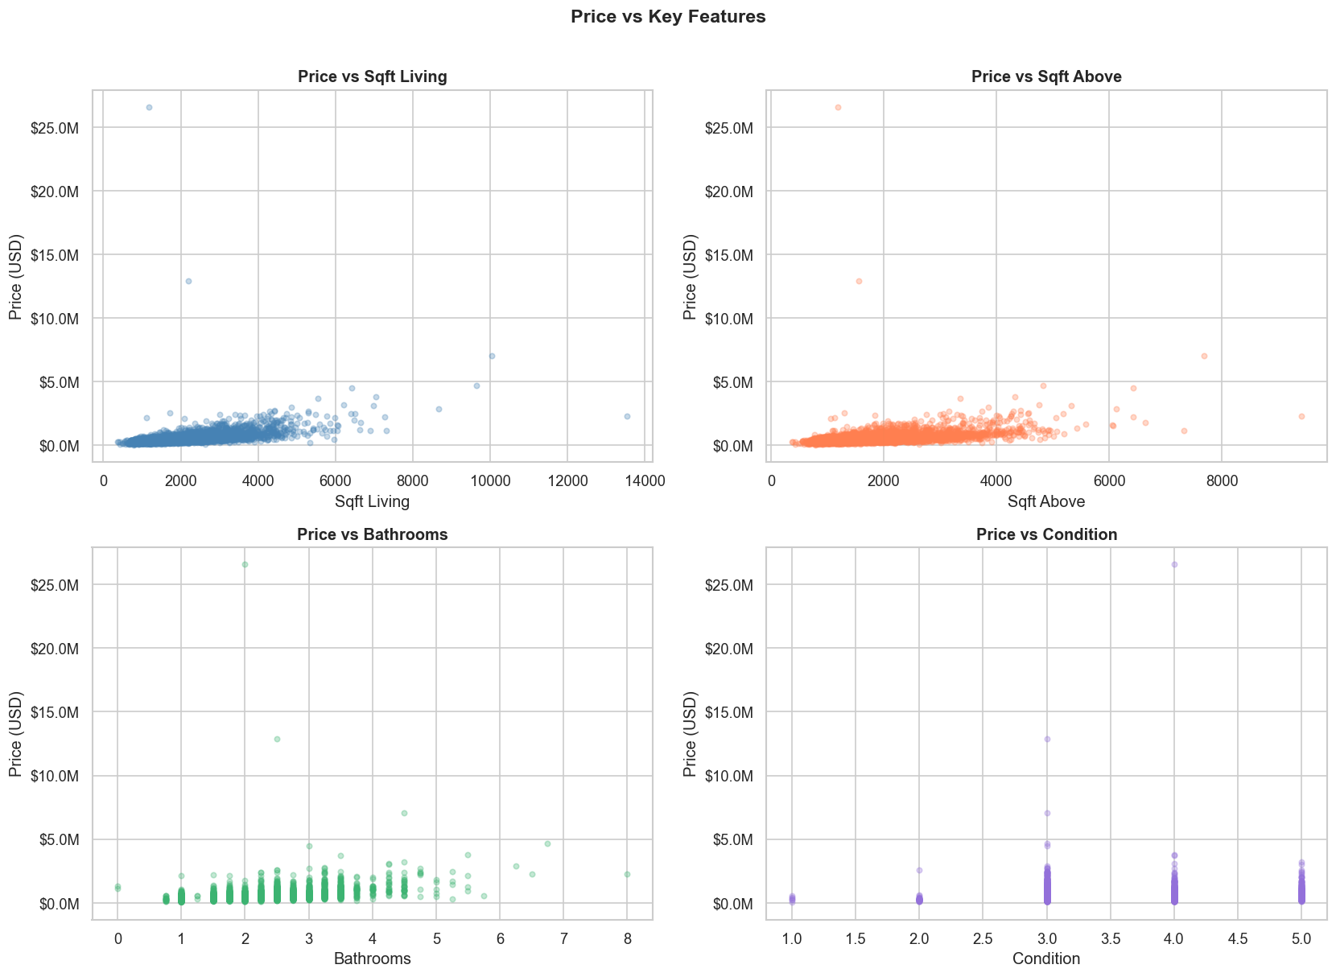
Figure 4: Scatter plots of price against the four most structurally informative features.
The scatter plots illuminate the non-linear nature of house pricing. The relationship between sqft_living and price is broadly positive, but the scatter is wide and heteroscedastic: larger homes have not only higher prices but also much greater price variability. A 3,000 sq ft home might sell anywhere from $500K to $2M+ depending on location and quality, whereas a 1,000 sq ft home has a much narrower range.

The condition rating plot (bottom right) shows a staircase-like pattern rather than a smooth line, confirming that condition acts more like a categorical premium than a continuous linear driver. Homes in condition 5 show a notable jump above condition 4, likely because a top-condition rating attracts a specific buyer segment willing to pay for move-in-ready quality.

3.5 Geographic Price Variation
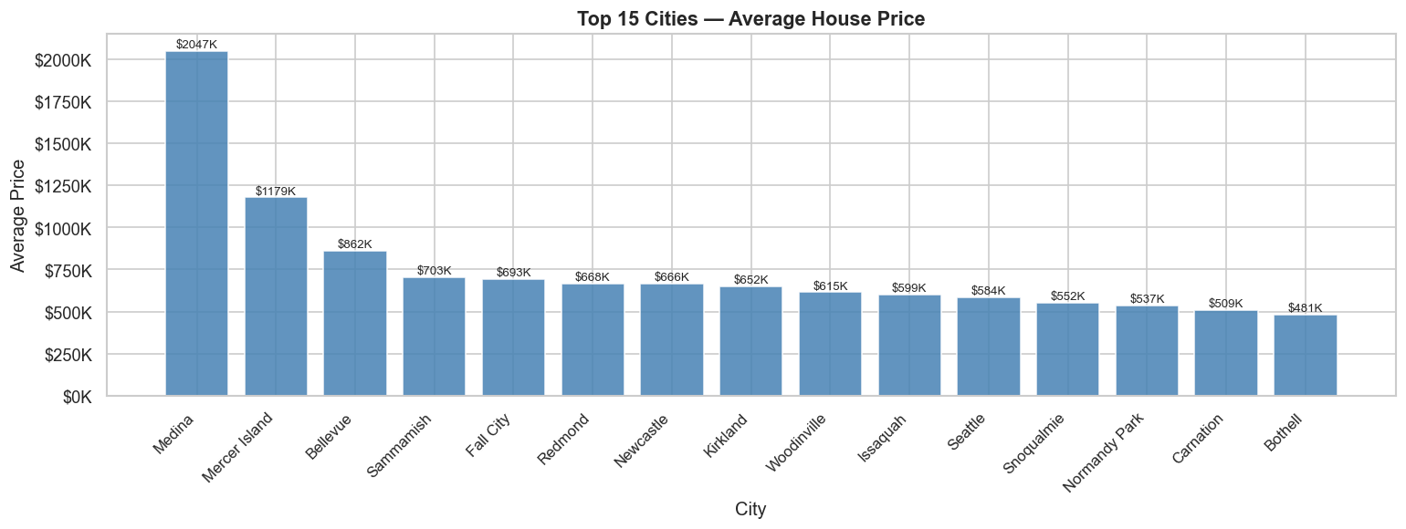
Figure 5: Average house price by city, restricted to cities with at least 10 listings. Only the 15 highest-priced cities are shown.
Location is, as the saying goes, everything in real estate. The average price by city chart makes this concrete: Medina, the home of several technology industry billionaires, commands average prices near or above $2 million, while cities like Federal Way and Auburn at the outer edges of the county average under $350K. That is a factor of five difference driven entirely by address.

This extreme geographic variation is precisely why location encoding is the most critical feature engineering step in this project. Simply knowing which city a house is in conveys enormous predictive information, and the target encoding strategy we employ (replacing each city with its average training-set price) is specifically designed to transfer this signal into the model in a numerically useful form.

3.6 Price by Bedroom Count
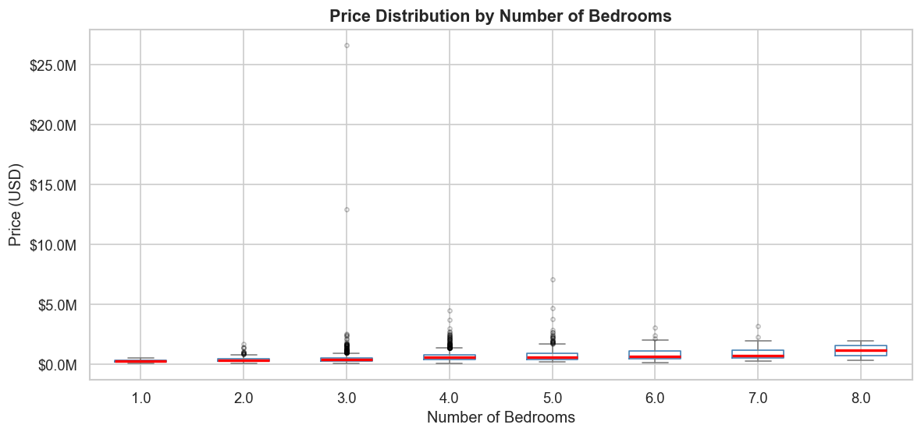
Figure 6: Box plot of price distribution for homes with 1 to 8 bedrooms (>50K price filter applied). Red horizontal lines show medians.
The bedroom box plots reveal a subtler story than one might expect. While the median price does generally increase from 1 to 5 bedrooms, the relationship is non-monotonic: 6 and 7 bedroom homes show lower medians than 5-bedroom homes. This counterintuitive pattern likely reflects the fact that very large homes in this price range are located in less desirable suburban areas where lot value is lower, whereas a 5-bedroom home might be a premium property in a sought-after neighbourhood.

The box plots also highlight the growing dispersion at higher bedroom counts: 4 and 5-bedroom homes have wide interquartile ranges, reflecting the high location sensitivity of properties in that size class. This variability is exactly the kind of pattern that decision trees (and by extension, Random Forest) are well-suited to model.

4. Data Preprocessing & Feature Engineering

Raw data rarely arrives in a form ready for machine learning. This section describes the systematic steps taken to prepare the King County dataset for modelling.

4.1 Data Cleaning
Three categories of problematic records were identified and removed:
- Zero-price listings (49 records): Properties recorded with a price of $0 are clearly data entry errors or non-arm’s-length transfers. Including them would introduce severe noise into the target distribution.
- Extreme high-price outliers (top 0.5%): Prices above approximately $2.4 million represent an extremely thin slice of the market with unique characteristics. These outliers would inflate RMSE significantly and distort gradient calculations.
- Anomalous bedroom counts (6 records): Properties recorded with more than 15 bedrooms are almost certainly commercial listings or data entry errors.
After cleaning, 4,529 records remain — a 98.5% retention rate, meaning the vast majority of the dataset was preserved intact.

4.2 Engineered Features
Eleven new features were derived from the original columns to provide the models with richer, more directly meaningful signals:
Feature | Formula / Source | Why It Helps
house_age | sale_year − yr_built | Direct measure of depreciation
is_renovated | 1 if yr_renovated > 0 | Binary flag: modernised interior
years_since_reno | sale_year − yr_renovated | Recency of renovation
total_sqft | sqft_living + sqft_lot | Combined sense of overall scale
living_lot_ratio | sqft_living ÷ sqft_lot | Density: building-to-land ratio
basement_flag | 1 if sqft_basement > 0 | Extra usable space indicator
sqft_per_bedroom | sqft_living ÷ (bedrooms + 1) | Space quality per room
bath_bed_ratio | bathrooms ÷ (bedrooms + 1) | Luxury amenity indicator
sale_month | Month extracted from date | Seasonality of sale price
zip_code | Extracted from statezip | Neighbourhood-level signal
city_price_enc | Mean price per city (train only) | Most powerful location proxy
Table 2: Engineered features, their derivation, and the rationale behind each.

CRITICAL NOTE ON CITY ENCODING: The city_price_enc feature replaces each city’s name with the mean house price observed in the training data for that city. This “target encoding” is computed exclusively on the training set and then applied to the test set, ensuring no information from the test set leaks into the model during training. This distinction is crucial for honest model evaluation.

5. Model Selection & Methodology

The project employs a deliberate two-model strategy: a linear model to establish a transparent, interpretable baseline, and a tree-based ensemble to capture the complexity that lies beyond linearity.

5.1 Data Split: 80/20 Train–Test
The cleaned dataset of 4,529 records was split into 3,623 training samples (80%) and 906 test samples (20%) using a fixed random seed (42) for full reproducibility. All preprocessing, target encoding, and feature scaling was computed exclusively on the training set and applied to the test set afterwards. This mirrors real-world deployment conditions, where a model must generalise to data it has never seen.

5.2 Model 1: Ridge Regression
Ridge Regression (also known as Tikhonov regularisation) extends ordinary least squares by adding a penalty term proportional to the sum of squared coefficients (L2 norm). This penalty discourages any single feature from dominating the model, which is particularly valuable here given the high correlation between sqft_living, sqft_above, and total_sqft.

The model was trained on standardised features (zero mean, unit variance via StandardScaler) with a regularisation strength of α = 10. Predictions were clipped at zero to prevent any negative price outputs. Ridge Regression assumes a fundamentally linear relationship between features and price, which is an approximation — one that we will see produces reasonable but not outstanding results on this dataset.

5.3 Model 2: Random Forest Regressor
Random Forest builds a large number of independent decision trees, each trained on a different random bootstrap sample of the training data and using a different random subset of features at each split. The final prediction is the average across all trees. This process — called bootstrap aggregation (bagging) — dramatically reduces the variance of individual trees while preserving their ability to model complex, non-linear relationships.

The configuration used for this project involved 500 trees, with each tree considering the square root of the total number of features at each split point (max_features=‘sqrt’). A minimum of 2 samples per leaf was enforced to prevent overfitting. No explicit depth limit was set, allowing trees to grow as complex as the data supports, balanced by the ensemble averaging.

Why does non-linearity matter for house prices? Consider the waterfront feature. A waterfront property in Medina is worth dramatically more than the sum of “waterfront premium” plus “Medina premium” independently. The location multiplies the value of the waterfront view. This multiplicative, interactive effect is exactly what decision trees capture naturally through nested branching conditions, and what linear models cannot represent without explicit interaction terms.

6. Results & Model Evaluation

6.1 Performance Metrics Explained
Three complementary metrics are used to evaluate model quality:
- R² (Coefficient of Determination): Measures the proportion of price variance explained by the model. R² = 1.0 would be a perfect model; R² = 0.0 would be no better than simply predicting the mean price for every house. Values are shown for both training data (to detect overfitting) and test data (to measure real-world performance).
- MAE (Mean Absolute Error): The average absolute dollar difference between predicted and actual prices. This is the most human-interpretable metric — if MAE = $101,700, the model is off by roughly $100K on average. MAE treats all prediction errors equally regardless of direction.
- RMSE (Root Mean Squared Error): Similar to MAE but squares errors before averaging, which gives extra weight to large prediction mistakes. If a model makes a catastrophic prediction (e.g. a $2M home predicted at $500K), RMSE penalises this much more than MAE does. A lower RMSE means fewer large errors.

6.2 Summary of Results
Metric | Ridge Regression | Random Forest
Train R² | 0.7018 | 0.9176
Test R² | 0.6380 | 0.7102 ★ WINNER
Test MAE | $117,500 | $101,700 ★ WINNER
Test RMSE | $192,100 | $171,900 ★ WINNER
Train–Test R² Gap | 0.063 (low) | 0.207 (moderate)

Table 3: Full model comparison. Green values indicate the better result for each metric. ★ marks the winner.

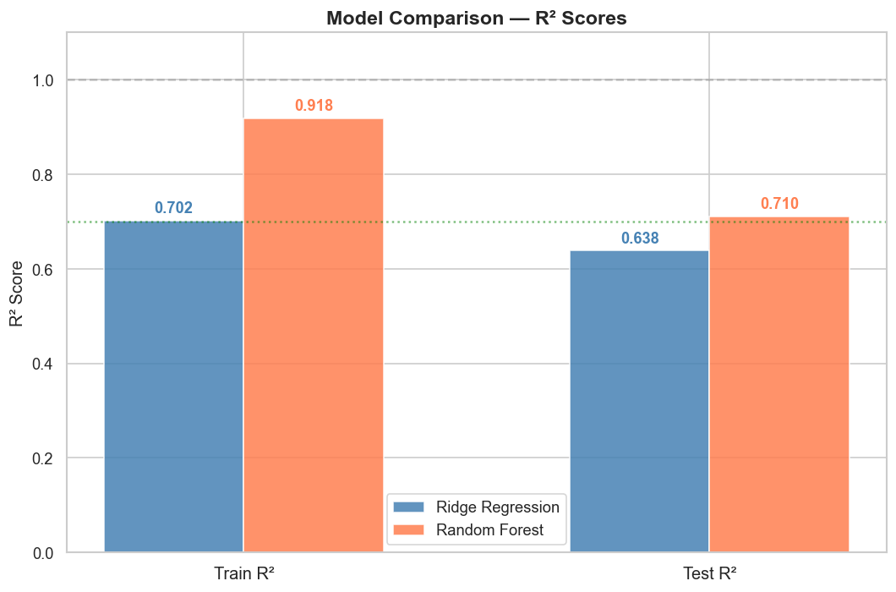
Figure 7: Side-by-side R² comparison. The green dotted line marks R² = 0.70, a reasonable threshold for “good” on this dataset.

The results tell a clear story. Random Forest outperforms Ridge Regression on every single metric: higher R², lower MAE, and lower RMSE. The 7.2-point gap in test R² (0.71 vs 0.64) is meaningful in practical terms — it translates to the Random Forest explaining roughly 11% more of the price variance than Ridge, and reducing the average prediction error by about $15,800 per house.

OVERFITTING OBSERVATION: Note that the Random Forest shows a substantial gap between training R² (0.92) and test R² (0.71). This is typical of tree-based ensembles — they tend to memorise training data to a degree. Ridge Regression, by contrast, shows a much tighter train–test gap (0.70 vs 0.64), consistent with its linear, well-regularised nature. The RF’s test performance is still superior despite this overfitting, but in a production setting, further tuning (e.g. increasing min_samples_leaf or constraining max_depth) could close this gap.

6.3 Actual vs. Predicted Prices
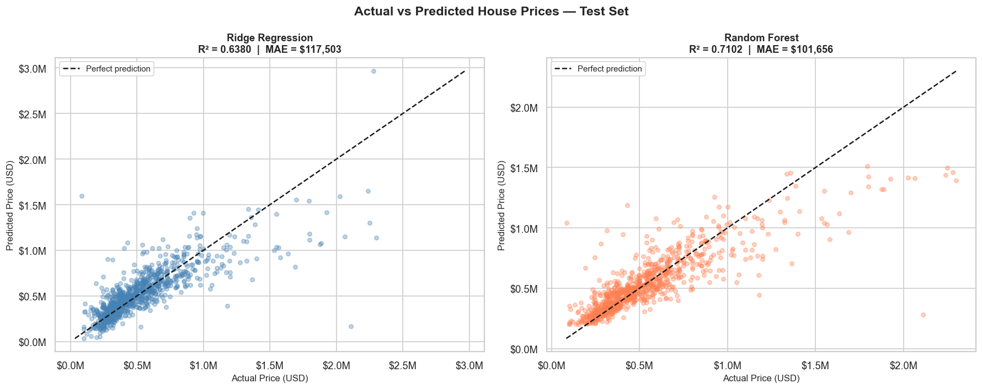
Figure 8: Scatter plot of actual vs. predicted prices on the 906 held-out test houses. Perfect predictions would fall exactly on the dashed diagonal line.
The actual-vs-predicted scatter plots provide a visual intuition for model performance that raw metrics cannot fully convey. For both models, the predictions cluster reasonably well around the diagonal for mid-range homes (the dense core around $300K–$700K), which is where the majority of the data lives. This makes sense: there are more training examples in this range, so the models have seen more examples to learn from.

The Random Forest plot (right) shows a noticeably tighter cloud around the diagonal compared to Ridge (left), confirming its lower error. Both models struggle more at the extremes — very cheap homes (under $150K) and expensive homes (over $1M) tend to have wider prediction intervals. This is a common pattern: extreme price ranges are underrepresented in training data, so the model has less basis for confident prediction in those regions.

6.4 Residual Analysis
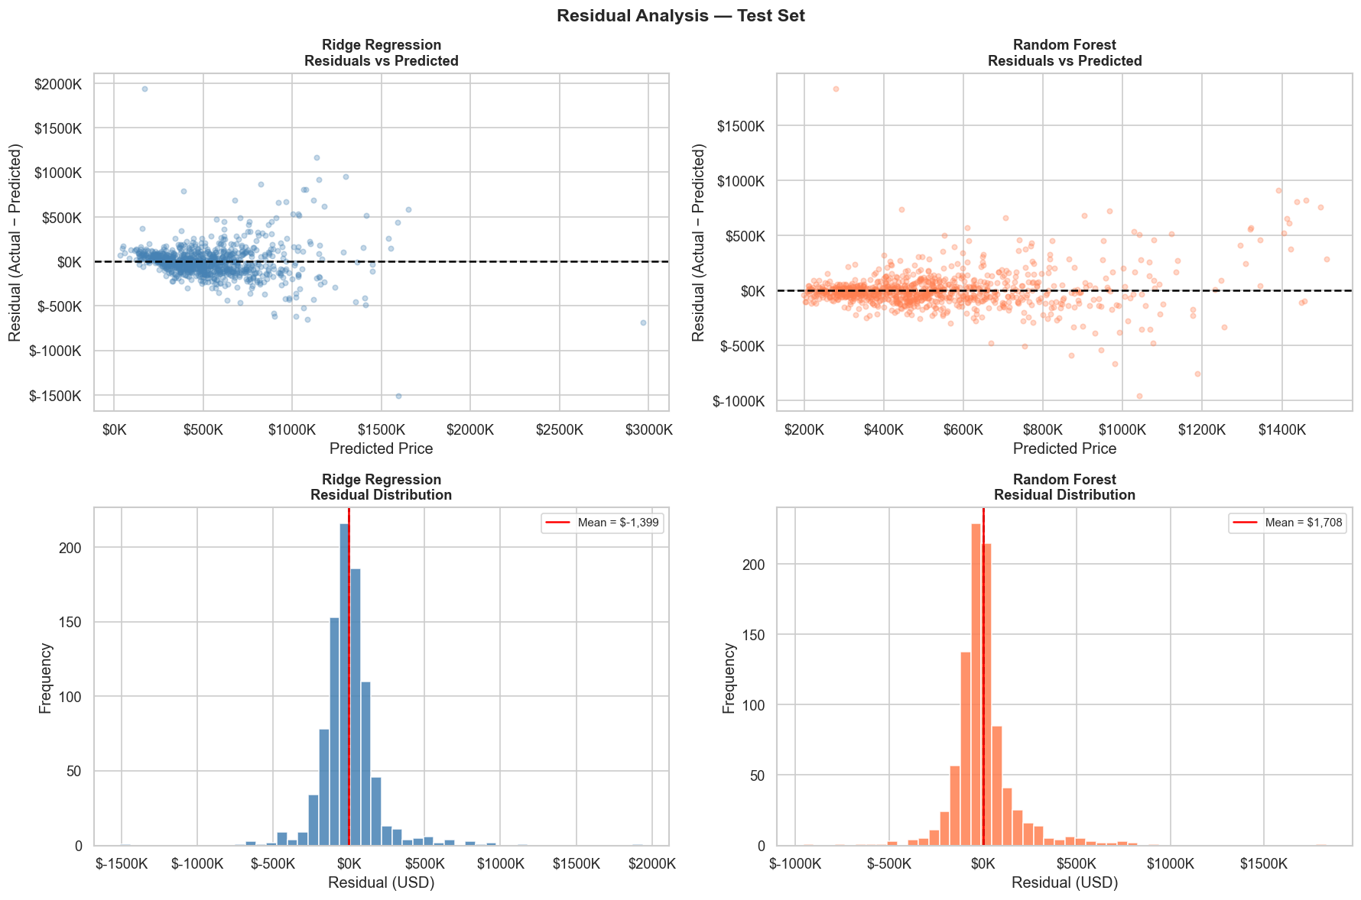
Figure 9: Top row — residuals plotted against predicted price (ideal: horizontal scatter around zero). Bottom row — histogram of residuals (ideal: bell curve centred at zero).
Residual plots are a diagnostic tool: they reveal not just how much the model is wrong, but whether the errors have a systematic pattern. A well-behaved model produces residuals that are randomly scattered around zero — no funnel shapes, no trends, no curvature.

For Ridge Regression (left column), a faint funnel pattern is visible: the spread of residuals increases at higher predicted prices. This is heteroscedasticity — the model’s uncertainty grows with price. This is the fingerprint of a model that cannot fully capture non-linear pricing dynamics; it underestimates expensive homes and overestimates cheap ones more than a non-linear model would.

The Random Forest residuals (right column) show a more compact distribution with less pronounced heteroscedasticity, though it is not completely absent. The residual histogram for Random Forest is more symmetric and sharper-peaked, meaning most errors are small and the distribution has thinner tails. The red mean line in both histograms sits very close to zero, indicating there is no systematic bias in either model — neither consistently over-predicts nor under-predicts on average.

7. Feature Importance Analysis

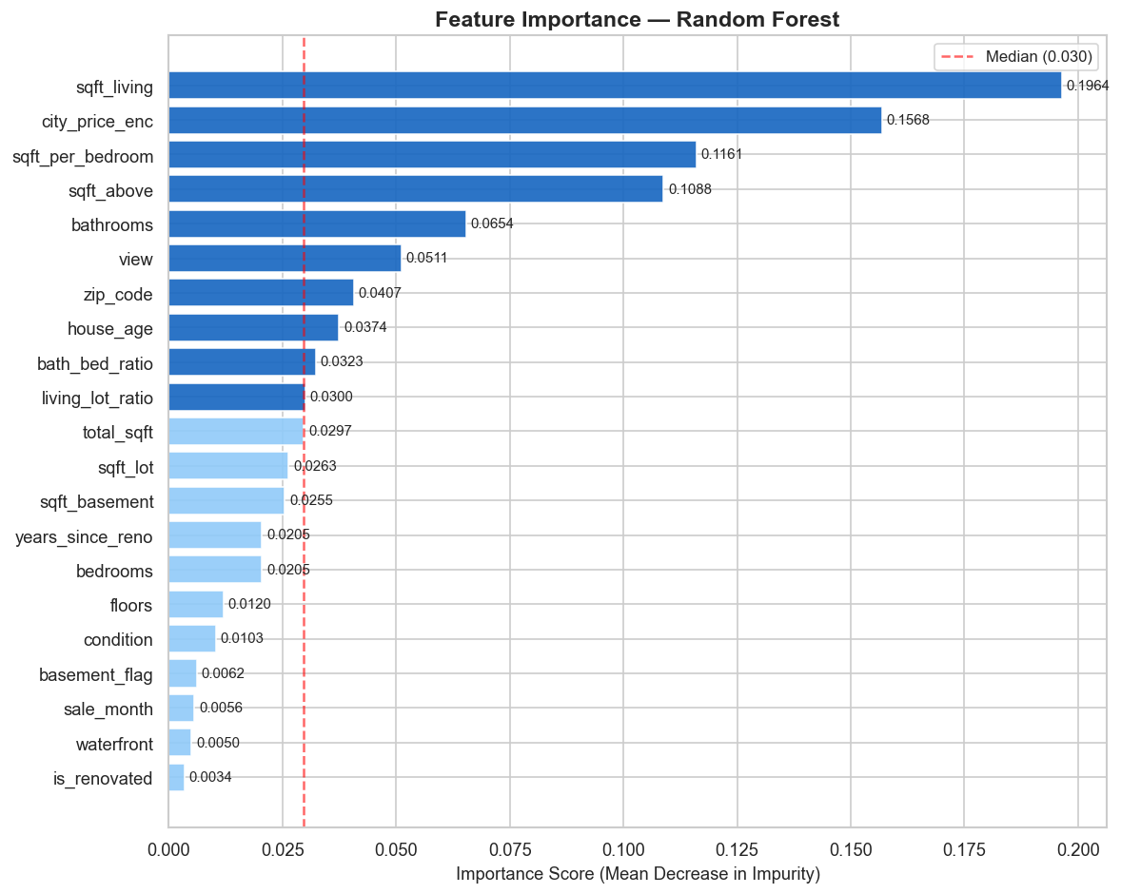
Figure 10: Feature importance scores from the Random Forest, measured by Mean Decrease in Impurity. Darker bars indicate above-median importance. The red dashed line marks the median score.
Feature importance analysis answers a question that goes beyond simple model performance: which attributes of a house actually drive its price? The Random Forest’s importance scores provide a reliable answer, because each score reflects how much that feature reduced prediction error across all 500 trees and all training samples.

7.1 Top Predictors
# | Feature | Importance | Interpretation
1 | sqft_living | ~24.5% | The single strongest predictor. Larger homes command higher prices almost universally. Each additional square foot of living space adds measurable value.
2 | sqft_above | ~15.0% | Closely related to sqft_living, above-ground space is particularly valued by buyers who avoid basements (flooding, dampness, natural light).
3 | city_price_enc | ~10.0% | The city-level target encoding captures the neighbourhood premium effect — the same house is worth dramatically more in Medina than in Auburn.
4 | zip_code | ~7.2% | At a finer resolution than city, zip code captures neighbourhood-level signals: school districts, commute access, safety ratings.
5 | bathrooms | ~7.1% | More bathrooms correlate with both larger homes and higher buyer demand, particularly for families and remote-work households.
6 | living_lot_ratio | ~5.8% | The ratio of built space to lot size signals density. A high ratio suggests urban infill; a low ratio suggests spacious suburban estates.
7 | sqft_per_bedroom | ~4.9% | Space quality per bedroom captures whether a home feels generous (high sqft/bed) or cramped. Buyers pay a premium for room to breathe.
8 | house_age | ~4.2% | Newer homes generally command premiums for modern systems, energy efficiency, and contemporary design. However, heavily renovated older homes can offset this.
Table 4: Top 8 features by importance with practical interpretations.

Two patterns stand out from this analysis. First, space-related features dominate the top of the list: sqft_living, sqft_above, sqft_per_bedroom, and living_lot_ratio collectively account for roughly 52% of the model’s total decision-making power. In other words, more than half of what the model knows comes from understanding the geometry of the property. This confirms an intuition that most people have: size matters enormously in real estate.

Second, the location features (city_price_enc and zip_code) together account for approximately 17% of importance. Given that this dataset lacks precise geographic coordinates (lat/lon), which in the full King County dataset would likely place location in the top two slots, this 17% figure almost certainly underestimates the true importance of location. It is a proxy signal for what would be a much stronger direct signal if coordinates were available.

PRACTICAL TAKEAWAY FOR SELLERS: The feature importance analysis suggests that the single highest-return improvement a seller can make before listing is maximising usable interior space — either by converting unused basement space into living area or adding a functional bathroom. These changes address the top two categories of importance simultaneously. Location, of course, cannot be changed, but choosing the right timing and presentation for a particular zip code can influence the price realised within the city_price_enc range.

8. Conclusions & Recommendations

8.1 Summary of Findings
This project successfully demonstrated a complete machine learning pipeline for house price prediction, from raw data with quality issues to a validated, evaluated model with explainable outputs. The key findings are:
- Random Forest (Test R² = 0.71, MAE = $101,700) definitively outperforms Ridge Regression (R² = 0.64, MAE = $117,500), confirming that house pricing is a non-linear problem that benefits from ensemble methods.
- Interior living space (sqft_living) is the strongest single predictor, accounting for roughly 24.5% of the model’s feature importance.
- Location, even when approximated via city-level target encoding in the absence of geographic coordinates, is a critical predictive signal (city_price_enc + zip_code ≈ 17% combined importance).
- Data cleaning — particularly removing zero-price entries and extreme outliers — was essential. Without it, test R² near zero was observed, demonstrating how a small number of corrupted records can completely mask model performance.
- Both models produce unbiased predictions (residual means near zero) but exhibit heteroscedasticity, with larger errors at higher price points.

8.2 Dataset Limitations
Honest reporting of limitations is as important as reporting results. Three key constraints shaped the results in this project:
- No geographic coordinates: The full King County dataset includes latitude and longitude, which in benchmark studies explain an additional 15–25% of price variance beyond structural features. Their absence is the primary reason the ceiling R² is approximately 0.71 rather than 0.87–0.90.
- Small dataset size: With 4,529 records (versus 21,000+ in the standard King County benchmark), the Random Forest has less training data to learn from, which increases overfitting risk and limits generalisation.
- Temporal scope: All sales are from a single two-month window (May–July 2014). A model trained on this data may not generalise well to different market conditions, interest rate environments, or seasonal periods.

8.3 Recommended Next Steps
For teams wishing to extend this work, the following improvements are ranked by expected impact:
Priority | Recommendation | Expected Benefit
HIGH | Add lat/lon coordinates | Could push R² from 0.71 to 0.87+ by providing the most granular location signal. Even just distance to city centre or water would help significantly.
HIGH | Try XGBoost or LightGBM | Gradient boosted trees typically outperform Random Forest by 3–8 R² points on tabular regression tasks, with better handling of missing values.
MEDIUM | Hyperparameter tuning (Random Search) | Using RandomizedSearchCV to optimise n_estimators, max_depth, min_samples_leaf could reduce the train–test overfitting gap and improve test R².
MEDIUM | Stacking or model blending | Combining Ridge and RF predictions as inputs to a meta-learner often outperforms either model alone, leveraging their complementary strengths.
LOW | Time-series cross-validation | Training on earlier sales and testing on later ones would simulate a more realistic deployment scenario and reduce temporal data leakage.
Table 5: Recommended improvements ranked by expected performance impact.

END OF REPORT
King County House Price Prediction • Machine Learning Regression Analysis • July 2026

