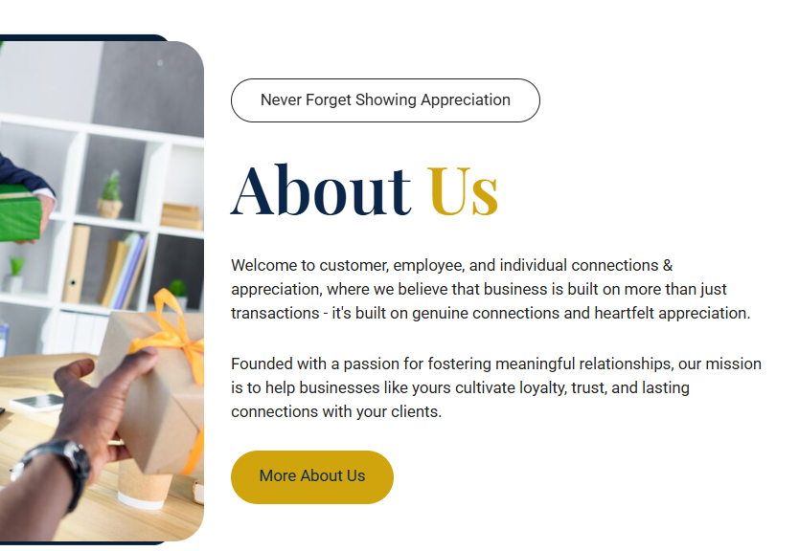



Gold color to be applied to all the tabs with neverforget name







Is ka kiaa krna hai

843 900 3876



ye number kahan lagana hai

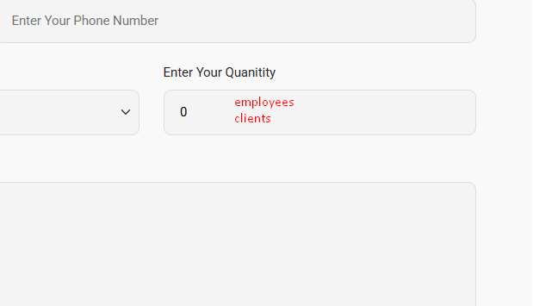

Is this for your client/ employees

Employee, clientele

Right now, because it’s a small, light button with white text on a light background, it doesn’t draw attention. Since this phrase is essentially your tagline/brand promise, it should pop visually on every page.

**Options to Improve It**

1. Bold Brand Colors  
   * Use one of your brand colors (gold, navy blue, or a bold accent) as the background.
   * Keep the text white or dark for contrast.
2. Typography & Weight  
   * Make the font slightly larger or bolded.
   * You can add a subtle shadow or outline for readability against lighter sections.
3. Button Styling  
   * Instead of a flat pill shape with a thin outline, fill the button with color.
   * Add hover effects (like darkening or glowing slightly) to give it interactivity.
4. Placement Consistency  
   * Since this appears on every screen, consistency is key — it should be noticeable but not overwhelming. A strong but clean color treatment works best.

👉 My recommendation: Use your gold brand color as the button background with white text. That ties directly to your “Choose Us” headline color and keeps the site cohesive while ensuring the tagline doesn’t get lost.

Please we do not offer free delivery should say standard rates for delivery will be applied something to that effect on the video that shows never forget is there a way of making it pause cause it will get annoying if I’m reading here through the items and cost hearing video call going could there be a way to stop it or pause it all or can we put the video at the top and then school the rest down this way they see the video and hear it. They can pause whatever they want instead of me trying to find out where that video is on here that’s making that

Where it says to enter quantity, nobody’s gonna know what that means so I would like that change to enter quantity into the amount of employees or clientele that you want me to cater to or you should have a tab that says for Employees and then job says enter amount of employees or clientele This makes it much easier and now down exactly what we could do for cost for them. And they shouldn’t be minus is always a plus so when I click the hour down the square minus which has into your quantity

Don’t say, Employee doesn’t say clientele your customer base Need a button for one that says Employees or one that says customer base if customer base is a lot higher than a certain amount they need to talk to us and then we could do the download for CRM for the customer base. Salmon employees have a certain number.

The one in blue it says monthly sending cap. I don’t want to limit them, so let’s leave that out. That would be discussed as they talk to representative or myself.

On standard plan takeoff up to 50 guests monthly included, please Integration service is for everybody for the CRM. This way we can keep track of everybody, including the basic plan.

Can I have a top in there for employment? Is somebody looking for a job and I can turn it on or off whenever I need so I’m looking for employees to sign on. I need a top for that so we discussed this before I don’t see on this website.