TELKOM UNIVERSITY
S2 Informatika • Prinsip Sains Data
Academic Year 2025/2026 • Week 15

FINAL REPORT
Analysis of Student Behavior for Exam Performance Prediction Using Machine Learning

Project Title | : | Analysis of Student Behavior for Exam Performance Prediction Using Machine Learning
Team / Group | : | Individual
Member 1 (NIM) | : | Salman Rachmadi (203012420009)
Supervisor / Lecturer | : | Dr. Warih Maharani
Submission Date | : | June 2026

ABSTRACT
This project analyzes the learning-behavior factors that influence student exam performance using machine learning on the Student Exam Performance dataset (10,000 students, 23 features). Two questions are examined: which behavioral factors correlate with performance (via Pearson correlation, t-test, and ANOVA), and whether classification models can predict pass/fail (Logistic Regression vs Random Forest with GridSearchCV tuning). Study hours correlate positively (r = 0.58, 95% CI [0.56, 0.59]) and social-media hours negatively (r = -0.25, 95% CI [-0.26, -0.23]) with exam scores. The two classifiers perform comparably, with Logistic Regression slightly ahead of Random Forest (87.05% vs 86.05% accuracy; corrected resampled t-test t(4) = -3.00, p = 0.040; ROC-AUC 0.946 vs 0.938), indicating that a more complex non-linear model offers no advantage here. An ablation study shows previous_gpa contributes ~13–14% of accuracy, yet behavior-only features still reach ~74–76%. The contribution is primarily methodological, separating actionable predictors (study_hours) from non-actionable ones (previous_gpa) via ablation. Because the dataset's provenance (Kaggle "ssssws") is unverified and possibly synthetic, the findings require validation before they can be generalized to a real student population. Demographic factors are not practically significant. The main recommendations, a structured study program and a social-media awareness campaign, are derived from the correlation findings.
Keywords:
Keywords: machine learning, classification, student performance, behavioral analysis, education analytics

Table of Contents
Table of Contents 3
1. Executive Summary 5
2. Dataset & Problem Definition 7
2.1 Dataset Description 7
2.2 Data Sample 7
2.3 Problem Formulation 8
3. Methodology 9
3.1 Data Collection & Preprocessing 9
3.1.1 Data Collection 9
3.1.2 Data Cleaning 9
3.1.3 Exploratory Data Analysis (EDA) 9
3.2 Feature Engineering 11
3.3 Model Development 11
3.3.1 Baseline Model 11
3.3.2 Candidate Models 11
3.3.3 Hyperparameter Tuning 12
3.3.4 Cross-Validation Strategy 12
4. Results 13
4.1 Model Comparison 13
4.2 Best Model Performance 13
4.3 Feature Importance 13
4.4 ROC-AUC Analysis 14
4.5 Ablation Study: Effect of previous_gpa 15
5. Discussion 16
5.1 Interpretation of Results 16
5.2 Error Analysis 17
5.3 Comparison with Existing Work / Baselines 17
5.4 Limitations 18
6. Conclusion & Recommendations 19
6.1 Conclusion 19
6.2 Future Work 19
7. References 20
Appendices 21
Appendix A: Code Repository 21
Appendix B: Additional Figures 21
Appendix C: Hypothesis Test Results Summary 21

1. Executive Summary
This section provides a high-level narrative of the project: motivation, approach, and impact. It should be written last, after all other sections are complete, and should be readable as a standalone summary.

1.1 Problem Statement
Business / Research Problem:
Student exam performance is influenced by behavioral factors beyond cognitive ability, yet educators often lack data-driven tools to identify at-risk students early. Without targeted intervention, students with poor study habits continue to fall behind.
Impact of the Problem:
Without a predictive system, schools lose the opportunity to intervene early with at-risk students, resulting in high failure rates and inefficient resource allocation.

1.2 Objectives
Main Objectives:
- Objective 1: Identify the learning-behavior factors most correlated with exam performance (RQ1 + H1)
- Objective 2: Build and compare ML classification models for predicting student pass/fail (RQ2 + H2)

Success Metrics (KPIs):
H1: study_hours_per_day is positively correlated (r > 0, p < 0.05) and social_media_hours is negatively correlated (r < 0, p < 0.05) → met
H2: Random Forest yields better performance than Logistic Regression → not met (LR is in fact slightly ahead; the significant difference favors LR, corrected resampled t-test p = 0.040)
Classification accuracy target ≥ 80% → met (LR 87.05%, RF 86.05%)

1.3 Summary of Findings
LR  Best Model  Logistic Regresion | 87%  Accuracy  test set | 0.86  F1-Score  macro avg | 0.94  AUC-ROC  if applicable

Key Insight:
study_hours_per_day is the strongest actionable behavioral predictor (r = 0.58), while previous_gpa dominates the model's prediction (importance = 0.42, ablation: ~-13–14% relative accuracy without GPA) but cannot be directly intervened upon. After GridSearchCV tuning, Logistic Regression (87.05%) is slightly ahead of Random Forest (86.05%), the hypothesis "RF > LR" is not supported (ROC-AUC LR 0.946, RF 0.938). A behavior-based model alone (without GPA) still reaches ~75%. Demographic factors are not significant.

2. Dataset & Problem Definition

2.1 Dataset Description
Dataset Name / Source | : | Student Exam Performance Dataset, Kaggle (user "ssssws"). Provenance unverified (real vs synthetic unknown), see Section 5.4 Limitations.
Number of Samples | : | 10,000 students
Number of Features | : | 23 original columns → 18 after dropping 5 score columns → 19 final features for modeling (8 numeric + 6 encoded + 5 engineered, after screen_time_ratio was removed as redundant; see Section 3.2)
Target Variable | : | pass_fail (binary)
Task Type | : | Classification
Class Balance | : | Pass/Fail: 48.6% / 51.4% (balanced, cutoff = 50 on final_exam_score). Grade: A=0.1%, B=0.9%, C=9.0%, D=38.3%, F=51.7% (highly imbalanced)
Missing Values | : | None
License / Terms of Use | : | Public / Kaggle

2.2 Data Sample
[ Insert a representative sample table (first 5 rows) or describe the key columns ]
Categorical Features (8 columns):
Feature | Values
gender | Male, Female
parental_education | High School, Bachelor, Master, PhD
family_income | Low, Medium, High
internet_access | Yes, No
study_environment | Quiet, Moderate, Noisy
tutoring | Yes, No
pass_fail | Pass, Fail
grade_category | A, B, C, D, F
Numerical Features (9 columns used):
Feature | Range
age | 15–18
study_hours_per_day | 0.50–7.24
attendance_rate | ~67–100
sleep_hours | ~4–10
social_media_hours | 0–~8
assignment_completion_rate | 0–100
online_courses_completed | 0–6
previous_gpa | 0–4.0
final_exam_score | ~4–98 (target)
5 internal score columns (math_score, reading_score, writing_score, science_score, participation_score) were removed to focus the analysis on behavioral factors.

2.3 Problem Formulation
RQ1 (Correlation): Given the behavioral features X = {study_hours_per_day, social_media_hours, attendance_rate, sleep_hours, assignment_completion_rate}, identify which features are significantly correlated with y = final_exam_score.
RQ2 (Classification): Given the features X (behavioral + demographic + engineered), predict the label y ∈ {Pass, Fail} using Logistic Regression and Random Forest Classifier.

3. Methodology
This section details every step of the data science pipeline, from raw data to final model.

3.1 Data Collection & Preprocessing

3.1.1 Data Collection
The dataset was obtained from Kaggle: the Student Exam Performance Dataset by user "ssssws". The dataset is in CSV format with 10,000 student records and 23 columns. No scraping or API process was required, the dataset is available for direct download. Provenance note: the dataset card does not document the collection methodology, so it is unknown whether the data is real or synthetic. The very high previous_gpa–final_exam_score correlation (r = 0.89), together with the absence of missing values/duplicates across 10,000 rows, is a pattern consistent with the possibility of synthetic data; the implications are discussed in Section 5.4.

3.1.2 Data Cleaning
Steps Applied:
- Missing value treatment: No missing values were found across all 23 columns
- Duplicate removal: No duplicate rows or duplicate student_id were found
- Outlier handling: Outliers were detected using the IQR method (1.5 × IQR) on several numeric columns (398 flags in total, e.g., final_exam_score 95, sleep_hours 63). Outliers were retained because they represent valid behavioral variation, not errors
- Label consistency: 30 rows were found in which grade_category and pass_fail were inconsistent: all of them exactly at final_exam_score = 50 (the cutoff point). They were retained because pass_fail (the modeling target) remains valid
- Data type corrections: All categorical columns were standardized (strip whitespace, title case)
- Score column removal: 5 internal score columns were dropped (math_score, reading_score, writing_score, science_score, participation_score)
- Target encoding: The pass_fail variable was derived from final_exam_score with cutoff = 50 (score < 50 → Fail, score ≥ 50 → Pass)
Metric | Before | After
Total rows | 10,000 | 10,000
Missing values | 0 | 0
Duplicate rows | 0 | 0
Feature count | 23 | 18

3.1.3 Exploratory Data Analysis (EDA)
Key EDA findings:
The pass/fail distribution is relatively balanced (Fail: 51.4%, Pass: 48.6%), but the grade distribution is highly imbalanced (A: 0.1%, F: 51.7%). previous_gpa has the highest correlation with final_exam_score (r = 0.89). Behavioral features show moderate correlations: study_hours_per_day (r = 0.58), social_media_hours (r = -0.25). Demographic factors show weak correlations with the target. Figure 1 (correlation heatmap) and Figure 2 (top correlations with final_exam_score) visualize these relationships.

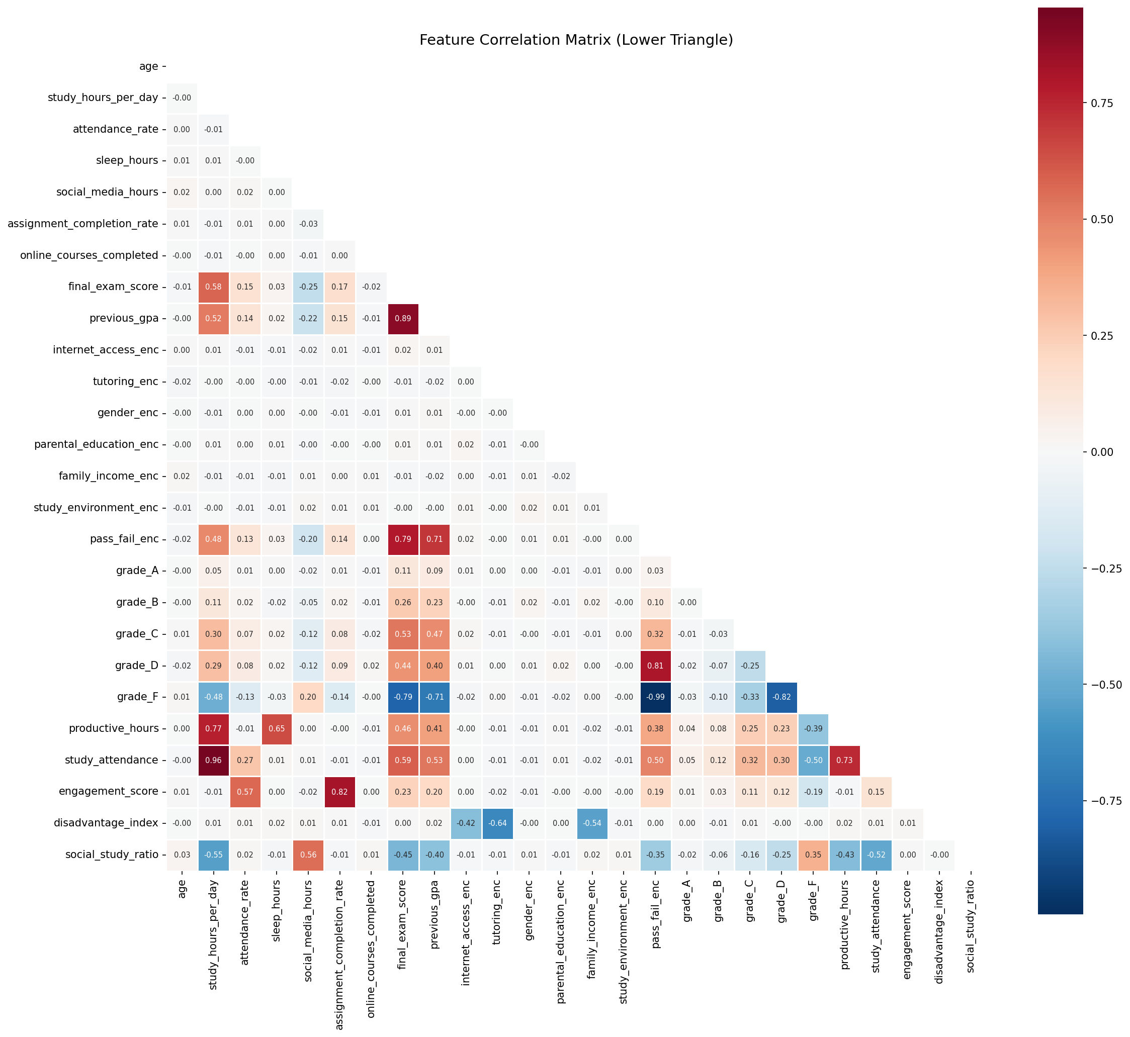
Figure 1. Correlation Heatmap of Features
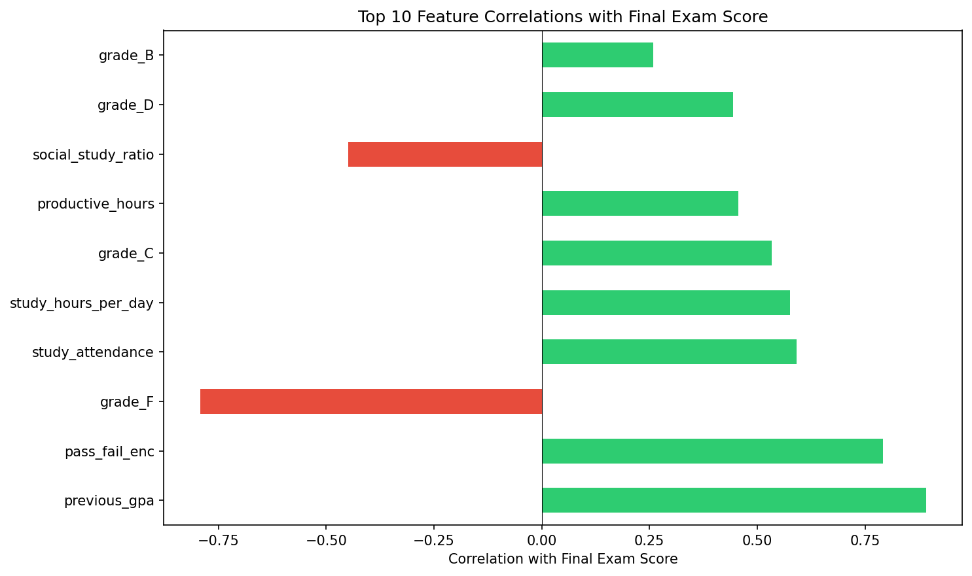
Figure 2. Top 10 Correlations with Final Exam Score

3.2 Feature Engineering
Features Created / Transformed:
New Feature | Formula | Rationale
productive_hours | study_hours + sleep_hours | Total daily study + rest time (note: combines two different constructs)
study_attendance | study_hours × attendance_rate | Interaction of studying and attendance
engagement_score | (assignment_rate + attendance_rate) / 2 | Average behavioral engagement
disadvantage_index | (no internet) + (no tutoring) + (low income) | Formative index of disadvantage (unweighted sum of 3 binary indicators)
social_study_ratio | social_media_hours / study_hours | Ratio of distraction vs study effort (with epsilon guard)

The screen_time_ratio feature (previously social_media_hours / 16) was removed because the constant denominator makes it a purely linear rescaling of social_media_hours: it adds no information beyond the original feature
Feature Selection Method:
Encoding:
Binary: internet_access, tutoring, gender (0/1)
Ordinal: parental_education (0–3), family_income (0–2), study_environment (0–2), pass_fail (0/1)
One-hot: grade_category → 5 columns

Final Feature Set:
19 features (after dropping identifiers, raw categoricals, target, and one-hot grade columns):
Numeric (8): age, study_hours_per_day, attendance_rate, sleep_hours, social_media_hours, assignment_completion_rate, online_courses_completed, previous_gpa.
Encoded (6): internet_access_enc, tutoring_enc, gender_enc, parental_education_enc, family_income_enc, study_environment_enc.
Engineered (5): productive_hours, study_attendance, engagement_score, disadvantage_index, social_study_ratio

3.3 Model Development

3.3.1 Baseline Model
Logistic Regression was chosen as the baseline because it is linear, interpretable, and a common standard for binary classification tasks [13]. The model uses StandardScaler on the numeric features.

3.3.2 Candidate Models
Model | Key Hyperparameters | Rationale
Logistic Regression | max_iter=1000, random_state=42 | Linear baseline, interpretable
Random Forest Classifier | n_estimators=100, random_state=42, n_jobs=-1 | Non-linear ensemble, robust to outliers

3.3.3 Hyperparameter Tuning
Tuning Strategy:
GridSearchCV was performed on both models using 5-fold Stratified CV on the training set:
Logistic Regression: C ∈ {0.01, 0.1, 1, 10, 100}, penalty ∈ {l1, l2}, solver = liblinear → Best: C=0.1, l2
Random Forest: n_estimators ∈ {50, 100, 200}, max_depth ∈ {None, 10, 20}, min_samples_split ∈ {2, 5}, min_samples_leaf ∈ {1, 2} → Best: max_depth=20, min_samples_leaf=2, min_samples_split=5, n_estimators=100

3.3.4 Cross-Validation Strategy
Train/test split: 80/20 (8,000 train, 2,000 test), random_state=42, stratified (`stratify=y`) so that the Pass/Fail proportions are identical in train & test.
5-fold Stratified Cross-Validation on the training set.
Model comparison uses the corrected resampled t-test (Nadeau-Bengio) to correct for the dependency between CV folds (rather than the ordinary paired t-test, which is optimistically biased).
Evaluation metrics: Accuracy, Precision, Recall, F1-Score, ROC-AUC, Confusion Matrix; effect size & 95% CI are reported.

4. Results

4.1 Model Comparison
Table 1 summarises the performance of all candidate models on the held-out test set.

Model | Accuracy | Precision | Recall | F1-Score | ROC-AUC
LR (default) | 0.8665 | 0.8762 | 0.8447 | 0.8601 | 0.9456
RF (default) | 0.8575 | 0.8604 | 0.8436 | 0.8519 | 0.9370
LR (tuned) | 0.8705 | 0.8780 | 0.8519 | 0.8648 | 0.9457
RF (tuned) | 0.8605 | 0.8651 | 0.8447 | 0.8548 | 0.9376
Model | Accuracy | Precision | Recall | F1-Score | ROC-AUC
LR (default) | 0.8665 | 0.8762 | 0.8447 | 0.8601 | 0.9456
Table 1. Model performance comparison: default vs GridSearchCV-tuned. Tuned models in bold. Logistic Regression leads across all metrics.

4.2 Best Model Performance
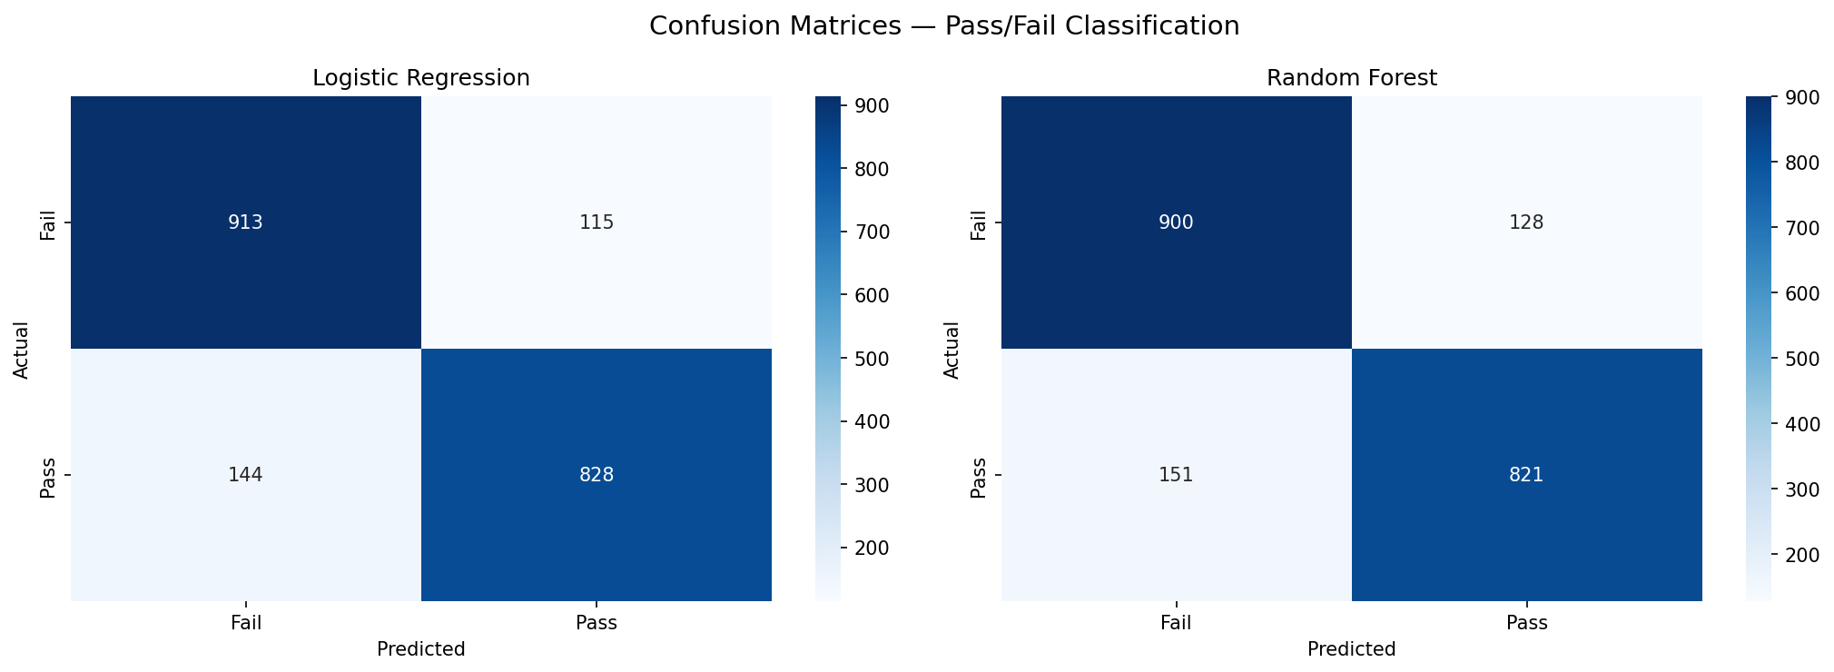
Figure 3. Confusion Matrix: Logistic Regression vs Random Forest
Figure 3 presents the confusion matrices for both models. After GridSearchCV tuning, Logistic Regression leads on all four test-set metrics (accuracy 0.8705 vs RF 0.8605; precision, recall, F1 are also higher) as well as on CV (LR 0.8610 vs RF 0.8562). The comparison using the corrected resampled t-test (Nadeau-Bengio) yields t(4) = -3.00, p = 0.040, significant and favoring LR. The hypothesis "RF is better than LR" (H2) is therefore not supported; if there is any difference, it is LR that is better. Both models yield high ROC-AUC (LR = 0.946, RF = 0.938). Because LR is equal/superior and more interpretable, LR is recommended as the primary model.

4.3 Feature Importance
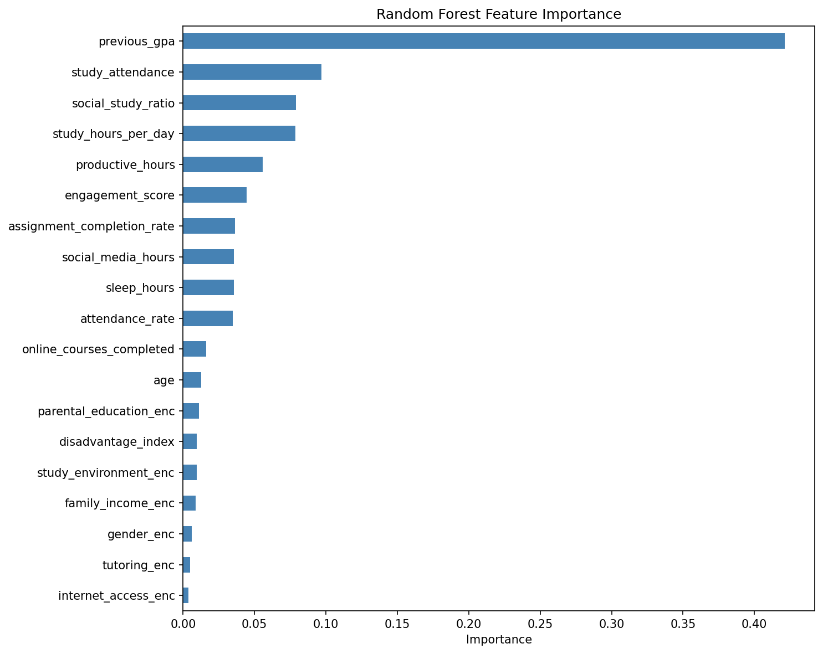
Figure 4. Random Forest Feature Importance
Figure 4 shows the Random Forest feature importances. The top-5 most influential features are:

Top-5 Most Influential Features:
- previous_gpa (importance = 0.42): A historical academic metric, the strongest predictor numerically but not directly actionable
- study_attendance (importance = 0.097, r = 0.59): A behavioral interaction feature (study × attendance), capturing the combination of high study hours and good attendance
- social_study_ratio (importance = 0.079): Ratio of distraction vs study effort, more informative than absolute social media hours
- study_hours_per_day (importance = 0.079, r = 0.58): The strongest single behavioral predictor, the primary target for intervention
- productive_hours (importance = 0.056, r = 0.46): Total daily time (study + sleep)

4.4 ROC-AUC Analysis

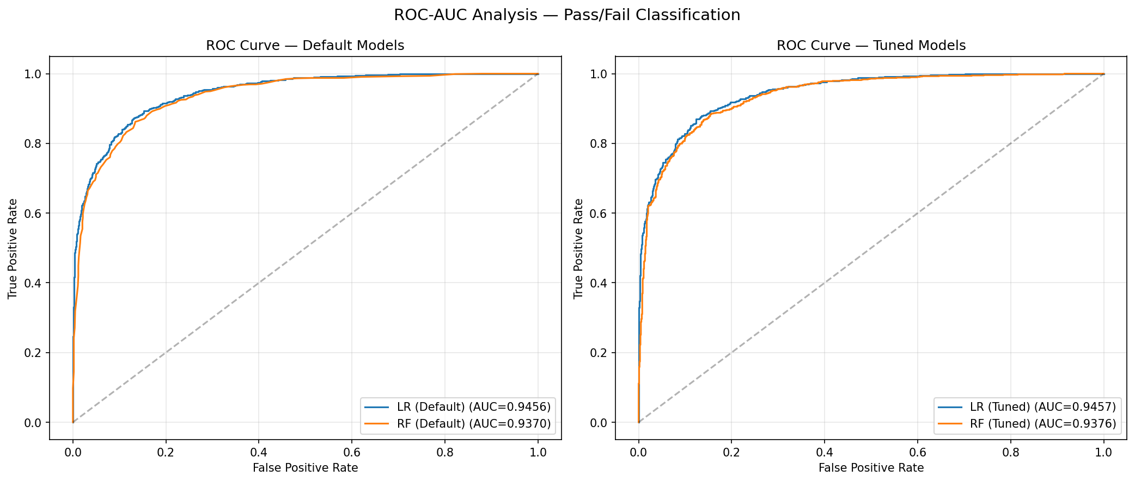
Figure 5. ROC curves: Default (left) vs Tuned (right) models. Both models achieve high discriminative ability (AUC > 0.93).
Figure 5 presents the ROC curves for the default and tuned models. ROC-AUC measures a model's ability to distinguish Pass vs Fail across all thresholds. Both models yield high AUC, LR (0.9457) is slightly higher than RF (0.9376), consistent with LR's superiority on the other metrics. This confirms that both models have excellent discriminative capability, not only at the default 0.5 threshold.

4.5 Ablation Study: Effect of previous_gpa
To quantify the contribution of behavioral features to prediction, an ablation study was conducted by removing previous_gpa from the feature set. Table 2 reports the results, and Figure 6 the corresponding feature importances without previous_gpa.

Table 2. Ablation study: removing previous_gpa lowers accuracy by ~11–12 percentage points (≈13–14% relative).
Model | Full Features | Without previous_gpa | Accuracy Drop (absolute) | Drop (relative)
Logistic Regression | 0.8705 | 0.7575 | -0.1130 (-11.3 points) | -13.0%
Random Forest | 0.8605 | 0.7410 | -0.1195 (-12.0 points) | -13.9%
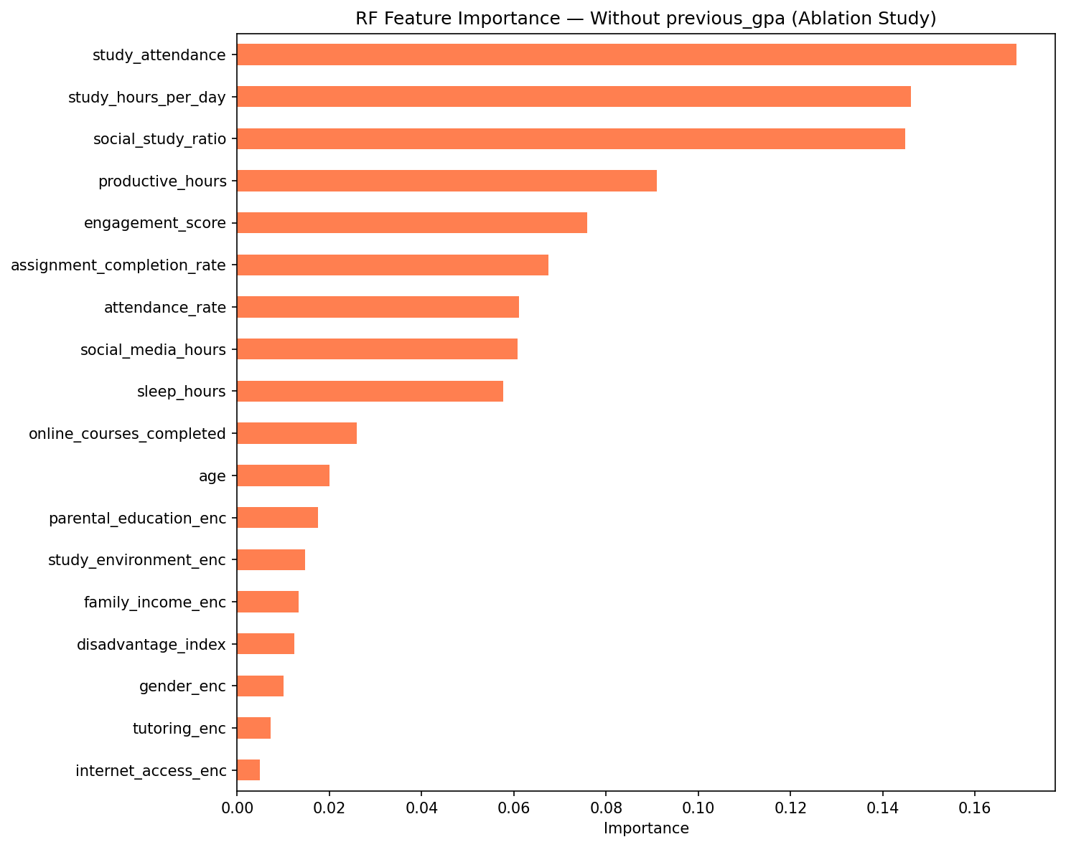
Figure 6. RF feature importance without previous_gpa: behavioral features become dominant.
Without previous_gpa, accuracy drops from ~87% to ~74–76%, confirming the dominance of previous_gpa (≈13–14% relative drop). However, a model based on behavioral features alone still reaches ~75% accuracy, well above the majority-class baseline (51.4%). The strongest behavioral features without GPA are study_attendance, study_hours_per_day, and social_study_ratio. A note of caution: some of the remaining "behavioral" features (attendance_rate, assignment_completion_rate) are proxies for academic outcomes, not purely actionable behavior, so ~75% is the upper bound of "actionable accuracy", not a pure behavioral contribution.

5. Discussion

5.1 Interpretation of Results
H1 (SUPPORTED): study_hours_per_day is significantly positively correlated (r = 0.58, 95% CI [0.56, 0.59], p < 0.001) and social_media_hours is significantly negatively correlated (r = -0.25, 95% CI [-0.26, -0.23], p < 0.001) with final_exam_score; both remain significant after Benjamini-Hochberg correction. The direction of the correlations is in line with general expectations: the negative effect of social media usage is consistent with [8], with the caveat that [8] measures social media addiction (a behavioral-clinical construct), not duration, so it constitutes directional support, not a direct replication. The positive relationship between study time and performance (r = 0.58) is intuitive and directly confirmed by the H1 results on this dataset; a quantitative comparison with specific time-on-task studies is beyond the scope of this report and is a direction for literature development (Section 6.3). The sleep_hours correlation itself is weak (r = 0.03); this contrasts with [10], which found that sleep duration predicts GPA in college students, possibly because of differences in population (students aged 15–18 vs college students) and context. Study habits across grade categories are shown in Figure B.1 (Appendix B).
H2 (NOT SUPPORTED): The hypothesis predicted that Random Forest would be superior to Logistic Regression. The result is the opposite: after GridSearchCV tuning, LR leads on all four test metrics (accuracy 0.8705 vs RF 0.8605) and on CV (LR 0.8610 vs RF 0.8562). The corrected resampled t-test (Nadeau-Bengio, which corrects for the dependency between folds) yields t(4) = -3.00, p = 0.040, significant in favor of LR. The claim "RF > LR" is therefore rejected; if there is any difference, it is LR that is better. This finding indicates that the feature-target relationship is relatively linear, so the non-linear ensemble model (RF) provides no advantage, and is even slightly inferior, possibly due to overfitting to noise. Because LR is equal/superior and also interpretable, LR is recommended as the primary model. The KPI accuracy target ≥ 80% is still met (both ~86–87%).
Additional findings (demographics): Demographic factors are not practically meaningful. parental_education ANOVA p = 0.387 (η² = 0.0003), tutoring t-test p = 0.414 (Cohen's d = -0.018), family_income chi-square p = 0.584. internet_access is statistically significant (p = 0.034; BH-adj p = 0.040) but the effect size is negligible (Cohen's d = 0.070, a mean difference of only 0.85 points), so it is practically meaningless. The demographic performance gaps are visualized in Figure B.2 (Appendix B). Overall, on this dataset individual behavioral factors are more relevant for intervention than socio-economic background, although this claim requires caution given the uncertainty of the data provenance (Section 5.4).

5.2 Error Analysis
Common Misclassification Patterns:
Both models produce an error rate of about 14–15%, with a relatively balanced distribution of errors between False Positives and False Negatives
False Negative (Pass students predicted Fail): ~150 cases per model: likely students with a behavioral profile resembling that of Fail students
False Positive (Fail students predicted Pass): ~140–149 cases per model: likely students with a behavioral profile resembling that of Pass students

5.3 Comparison with Existing Work / Baselines

Study | Method | Accuracy | Notes
Alkan et al. [1] | Random Forest | 74.3% | 613 students, 10-fold CV
This project | Logistic Regression (tuned) | 87.05% | ROC-AUC = 0.946 (best model)
This project | Random Forest (tuned) | 86.05% | ROC-AUC = 0.938, GridSearchCV
Rakitina & Qureshi [13] | LR vs RF | Variable | LR vs RF comparison
The accuracy of this project (86–87%) is higher than [1] (74.3%), possibly due to a larger dataset and richer behavioral features. However, this comparison is not apples-to-apples because the datasets and contexts differ, and, given the unverified data provenance (Section 5.4), high accuracy on data that may be synthetic could be an artifact and should not be read as methodological superiority.

5.4 Limitations
- Data limitation: The dataset is cross-sectional: it does not capture changes in behavior over time. Correlation does not prove causation.
- Model limitation: previous_gpa dominates prediction (importance = 0.42, ablation shows a ~13–14% relative accuracy drop without GPA), making the contribution of behavioral features difficult to isolate.
- Data source uncertainty: The dataset was uploaded by the Kaggle user "ssssws" and it is unknown whether the data is real or synthetic. The very high previous_gpa–final_exam_score correlation (r = 0.89) and the accuracy ~13 points above the comparison literature [1] are patterns consistent with the possibility of synthetic data. If synthetic, the correlations and patterns found may not reflect student reality. The results and findings cannot be generalized to a student population without validation on real data; the project's contribution is therefore framed as methodological/demonstrative (Section 1.4), not a substantive finding about students.
- Self-fulfilling prophecy & proxy discrimination: Because previous_gpa (a proxy for past performance) dominates prediction, an early-warning system built on it risks merely reproducing historical performance: students are flagged because of a low GPA, which can lower teacher expectations and worsen outcomes. GPA can also potentially become a proxy for socio-economic status, so a direct demographic bias audit alone is insufficient (see Section 6.2).
- Ethical consideration: The model must not be used to stigmatize students based on predictions. Prediction results should be used as an early warning for positive intervention, not for punishment.

6. Conclusion & Recommendations

6.1 Conclusion
The project achieves Objective 1 (H1 SUPPORTED) and Objective 2 with an important correction: the directional hypothesis "RF > LR" (H2) is not supported, LR is in fact slightly ahead (~87% vs ~86%, corrected resampled t-test p = 0.040) and at the same time more interpretable, so LR is recommended as the primary model; the KPI accuracy target ≥ 80% is still exceeded. The ablation confirms that previous_gpa contributes ~13–14% of accuracy (relative). The intervention recommendations are derived from the RQ1 correlation findings (rule-based): a structured study program (study_hours, r = 0.58) and a social-media awareness campaign (social_media_hours, r = -0.25).

Key Takeaways
- Finding 1: study_hours_per_day is the strongest actionable behavioral predictor (r = 0.58, H1 validated)
- Finding 2: social_media_hours significantly hinders performance (r = -0.25, H1 validated)
- Finding 3: previous_gpa dominates the model's prediction (importance = 0.42) but cannot be directly intervened upon
- Finding 4: The hypothesis "RF > LR" is not supported; LR is in fact slightly ahead and more interpretable (primary model)

6.2 Future Work
- Direction 1: A longitudinal dataset to capture changes in behavior over time and build a more accurate predictive model.
- Direction 2: Feature selection without previous_gpa to see the pure contribution of behavioral features, and exploration of interpretable models (SHAP, LIME).
- Direction 3: An ML-based recommendation system to replace the current rule-based approach, as well as deploying a prototype with Streamlit/FastAPI.

7. References
List all papers, books, datasets, and tools referenced in this report. Use APA 7th edition format.

[1] [1] Alkan, B. B., Kuzucuk, S., Alkan, N., & Sinan, A. (2025). Using machine learning to predict student outcomes for early intervention and formative assessment. Scientific Reports, 15, 39797. https://doi.org/10.1038/s41598-025-23409-w
[2] Chen, Y., & Zhai, L. (2023). Comparative study of student performance prediction using machine learning. Education and Information Technologies, 28, 12039–12057. https://doi.org/10.1007/s10639-023-11672-1
[3] Feraco, T., et al. (2023). An integrated model of school students' academic achievement and life satisfaction. European Journal of Psychology of Education, 38, 109–130. https://doi.org/10.1007/s10212-022-00601-4
[4] Harris, C. R., et al. (2020). Array programming with NumPy. Nature, 585(7825), 357–362. https://doi.org/10.1038/s41586-020-2649-2
[5] Hunter, J. D. (2007). Matplotlib: A 2D graphics environment. Computing in Science & Engineering, 9(3), 90–95. https://doi.org/10.1109/MCSE.2007.55
[6] Hussain, S., & Khan, M. Q. (2023). Student-Performulator: Predicting students' academic performance. Annals of Data Science, 10, 637–655. https://doi.org/10.1007/s40745-021-00341-0
[7] Khan, A., & Ghosh, S. K. (2021). Student performance analysis and prediction in classroom learning: A review. Education and Information Technologies, 26(1), 205–240. https://doi.org/10.1007/s10639-020-10230-3
[8] Malakeh, Z., et al. (2022). Correlation between psychological factors, academic performance, and social media addiction. Behavior and Information Technology, 41(8), 1583–1595. https://doi.org/10.1080/0144929X.2021.1891460
[9] McKinney, W. (2022). Python for data analysis (3rd ed.). O'Reilly Media.
[10] Okano, K., et al. (2023). Nightly sleep duration predicts GPA in first-year college students. Proceedings of the National Academy of Sciences, 120(12), e2209123120. https://doi.org/10.1073/pnas.2209123120
[11] Pedregosa, F., et al. (2011). Scikit-learn: Machine learning in Python. Journal of Machine Learning Research, 12, 2825–2830.
[12] Plak, S., et al. (2022). Early warning systems for more effective student counselling in higher education. Higher Education Quarterly, 76(1), 131–152. https://doi.org/10.1111/hequ.12298
[13] Rakitina, T., & Qureshi, R. (2023). Logistic Regression and Random Forest comparison in predicting students' qualification. IEEE Xplore. https://doi.org/10.1109/ITQM59423.2023.10262783
[14] Scikit-learn. (2024). Machine learning in Python. https://scikit-learn.org
[15] Student Exam Performance Dataset. (2026). Retrieved from https://www.kaggle.com/datasets/ssssws/student-exam-performance-dataset
[16] Virtanen, P., et al. (2020). SciPy 1.0: Fundamental algorithms for scientific computing in Python. Nature Methods, 17(3), 261–272. https://doi.org/10.1038/s41592-019-0686-2
[17] Waskom, M. L. (2021). seaborn: Statistical data visualization. Journal of Open Source Software, 6(60), 3021. https://doi.org/10.21105/joss.03021
[18] Yağcı, M. (2022). Educational data mining: Prediction of students' academic performance using machine learning. Smart Learning Environment, 9, 11. https://doi.org/10.1186/s40561-022-00192-z
[19] Student Exam Performance Dataset. (2026). Retrieved from https://www.kaggle.com/datasets/ssssws/student-exam-performance-dataset
[20] Scikit-learn. (2024). Machine learning in Python. https://scikit-learn.org

Appendices

Appendix A: Code Repository
GitHub / Google Colab Link:

Appendix B: Additional Figures
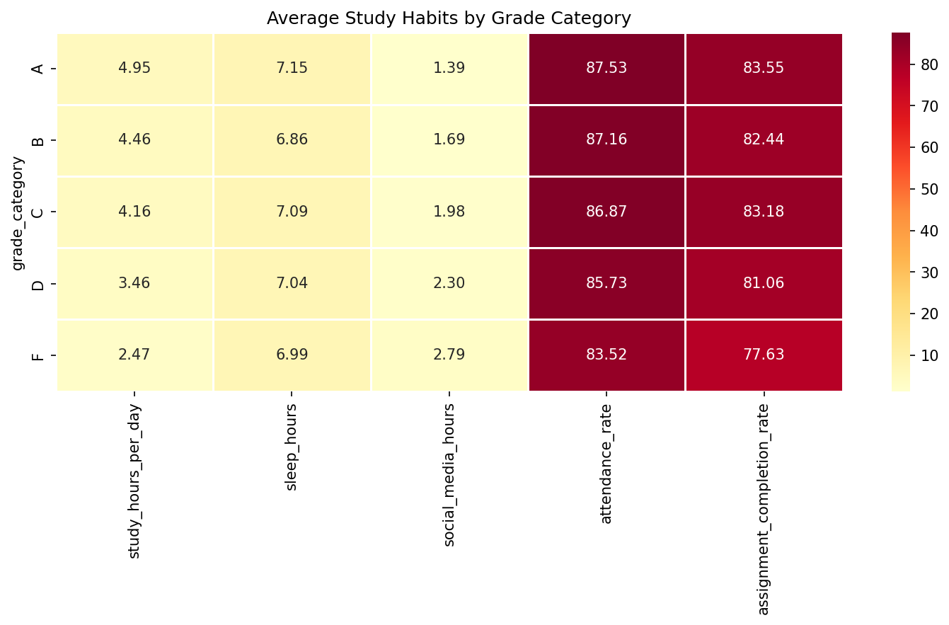
Figure B.1: Study habits by grade category: supports H1
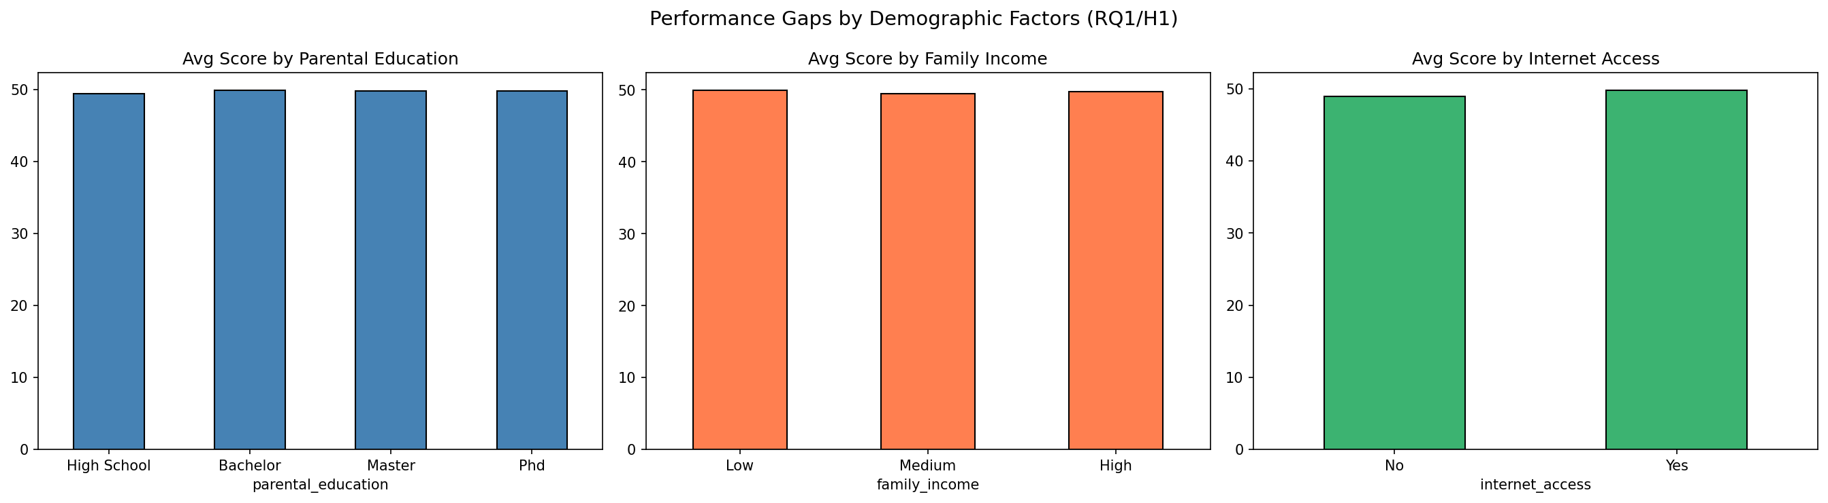
Figure B.2: Performance gaps by demographics: demographic factors not significant (The ROC-AUC and ablation feature importance figures are presented in the main body as Figure 5 and Figure 6.)

Appendix C: Hypothesis Test Results Summary
Hypothesis | Test | Statistic | Effect size | p-value | Conclusion
H1: study_hours (+) | Pearson | r = +0.576, 95% CI [.563, .589] | r (medium-large) | < .001 (BH-adj < .001) | SUPPORTED
H1: social_media (-) | Pearson | r = -0.246, 95% CI [-.265, -.228] | r (small-medium) | < .001 (BH-adj < .001) | SUPPORTED
H2: RF > LR | Corrected resampled t-test (5-fold CV, tuned) | t(4) = -3.00 | n/a | .040 | NOT SUPPORTED (LR > RF, significant)
Tutoring impact | t-test | t = -0.82 | d = -0.018 (negligible) | .414 | Not significant
Internet impact | t-test | t = 2.12 | d = 0.070 (negligible) | .034 (BH-adj .040) | Statistically significant, practically negligible
Parental education | ANOVA | F = 1.01 | η² = 0.0003 | .387 | Not significant
Grade × study_hours | ANOVA | F = 903.08 | η² = 0.266 (large) | < .001 | Significant
Grade × social_media | ANOVA | F = 113.54 | η² = 0.044 (small) | < .001 | Significant
Grade × attendance | ANOVA | F = 45.39 | η² = 0.018 (small) | < .001 | Significant

Declaration of Originality
We declare that this report is our own original work and that all sources have been properly cited.
Signature:
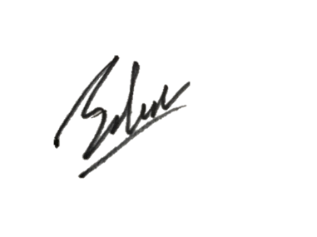
Salman Rachmadi / 2023012420009:

