GDM-8351 **GW INSTEK**

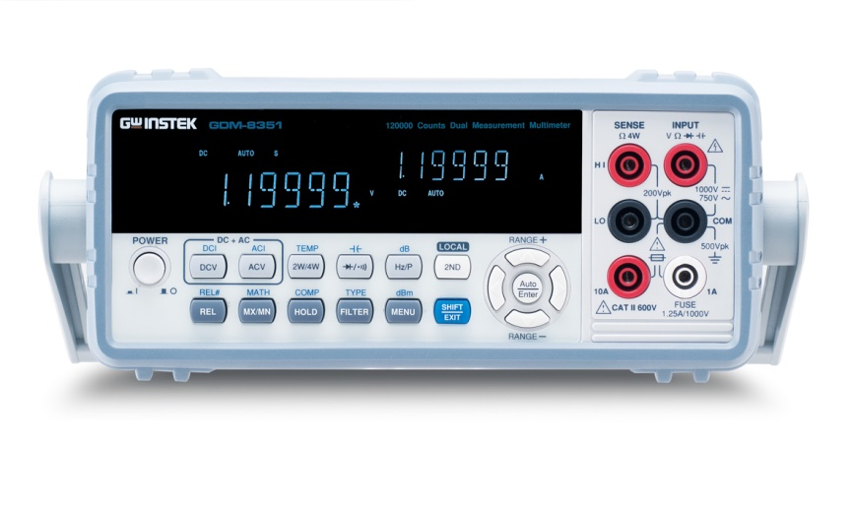

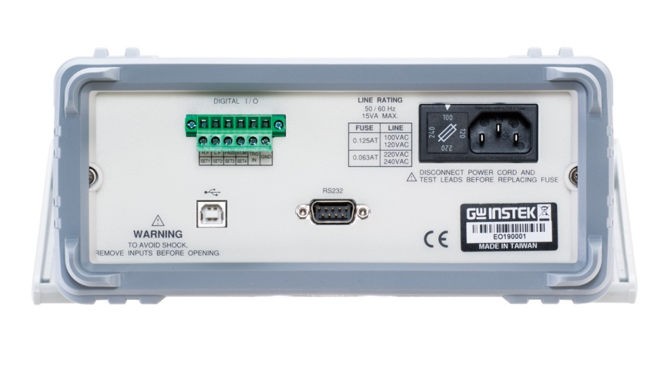

|  |  |
| --- | --- |
| Url | https://www.gwinstek.com/en-global/products/detail/GDM-8351/ |
| Video | https://www.youtube.com/watch?v=eQdVsnzjpGY |

Features

* 120,000 counts, VFD display
* Dual measurement/Dual display
* The basic precision of DC voltage: 0.012%
* Selectable measurement speeds, the maximum: 320 Readings/s
* True RMS (AC，AC+DC) measurements
* Auto/manual selection
* 12 different measurement functions: AC/DC voltage, AC/DC current, AC+DC voltage/current, 2W/4W resistance, continuity beeper, diode test, capacitance, frequency, temperature
* Many auxiliary functions: Max./Min., REL/REL#, Compare, Hold, dB, dBm, Math (MX+B, %, 1/X)
* Digital I/O provides dual mode (standard Compare and User definition modes)
* Standard RS-232C and USB device interface (support USBCDC and USBTMC modes)