**Purpose**

The purpose of this Software Requirements Specification (SRS) document is to define the software requirements for the **BuyTopia** platform. This is version **1.0** of the platform. This SRS outlines the functional and non-functional requirements for **BuyTopia**, which integrates the sale of car accessories, home appliances, and the hiring of technicians for repairs. This document covers the entire scope of the platform, detailing the features required to support both product sales and technician services, ensuring that all elements work together seamlessly. The platform aims to provide a user-friendly, comprehensive solution to the current market gap where separate e-commerce platforms exist for products and services.

**Product Scope**

The software being specified is an online e-commerce platform designed to offer a **comprehensive solution for purchasing car spare parts, home accessories, and hiring repair technicians**. The platform will feature:

* A marketplace for car accessories and spare parts, allowing users to browse, purchase, and manage automotive products.
* A section dedicated to home appliances such as irons, kettles, and washing machines, enabling users to purchase and maintain these household items.
* A service to hire technicians who can repair purchased items or similar products, providing a one-stop solution for product procurement and maintenance services.

The software will cater to a broad audience, including everyday users, car enthusiasts, and homeowners, offering a **seamless and integrated shopping experience**. It will distinguish itself from current market offerings by combining product sales and repair services within the same platform. The platform will include features like a **strong search and filter system** to enhance the user experience and simplify the search for products and services. The solution will align with the growing demand for convenience and integrated services, enabling users to meet their shopping and repair needs in one place.

**Title**

**BuyTopia** is an integrated e-commerce platform designed to provide users with a seamless experience for purchasing car spare parts, home appliances, and hiring professional technicians for repairs. The project aims to address the inconvenience of using multiple separate platforms for these different needs, offering a **single platform solution** that saves time and enhances user convenience.

**Objectives**

The primary objectives of this project are as follows:

* To build an intuitive and user-friendly e-commerce platform that allows customers to browse, purchase, and manage car accessories and home appliances, including spare parts.
* To provide a seamless service that allows users to hire technicians for repairing purchased products or similar items in their households.
* To integrate a robust search and filtering system that helps users easily locate the products and services they need, improving navigation and user experience.
* To create a platform that ensures secure and easy transactions, offering different payment methods to accommodate various user preferences.
* To establish partnerships with reliable product suppliers and service providers (technicians), ensuring consistent product availability and quality services.
* To ensure the platform is scalable and capable of supporting future growth, including the addition of more product categories and service providers.

**Problem Statement**

The problem this project addresses is the **fragmented and inefficient process** of using multiple platforms for purchasing car accessories, home appliances, and hiring technicians for repairs. Consumers face the challenge of switching between various e-commerce websites or service provider platforms to meet their needs, which results in **increased inconvenience, time consumption, and a disjointed user experience**. For example, a car owner may need to visit a dedicated e-commerce site for car parts, and then separately contact a technician from a different service platform for installation or repair.

A **successful solution** will be the development of an **integrated platform** that combines these various needs into one application. This will provide users with a centralized hub where they can purchase products and arrange for repairs without having to juggle multiple websites or services. The solution will help users **save time, reduce stress**, and enhance their overall experience by offering a **streamlined, convenient shopping and service process**.

**Feasibility**: The platform is highly feasible given the increasing reliance on digital marketplaces and the growing demand for integrated service offerings. The project will leverage existing e-commerce technologies and service provider networks, which will keep development costs and timelines manageable. Additionally, a market analysis will ensure the platform meets customer needs, while strategic partnerships with suppliers and technicians will help ensure the consistent availability of high-quality products and services.

**2. Overall Description**

### 2.1 Product Perspective

BuyTopia is a new, self-contained platform designed to address the fragmented experience users face when purchasing products and hiring services. Unlike existing systems, which cater to either e-commerce or repair services independently, BuyTopia integrates these functionalities into a unified solution.

This product does not build upon or replace any existing systems but introduces a novel platform that streamlines the process of product purchasing and repair service hiring. The platform operates as an independent solution while leveraging third-party integrations, such as payment gateways and supplier networks, to provide a comprehensive user experience.

The major components of BuyTopia include:

* **E-commerce Module**: Facilitates browsing, purchasing, and managing car accessories, home appliances, and spare parts.
* **Service Booking Module**: Enables users to hire professional technicians for repairs or installations.
* **Search and Filter System**: Provides an intuitive way for users to locate products and services quickly.
* **Payment Integration**: Supports multiple payment methods for secure and convenient transactions.
* **User Management Module**: Allows users to manage their accounts, order histories, and service bookings.

A high-level architecture diagram:

1. **Frontend Interface**: User-facing web and mobile applications.
2. **Backend Services**: Business logic and database management.
3. **Third-Party Integrations**: Payment gateways, product supplier APIs, and technician networks.
4. **Database**: Stores user data, product catalogs, service information, and transaction history.

### 2.2 Product Functions

The platform will provide the following major functions:

* **Product Catalog Management**:
  + Users can browse, search, and filter products by category, brand, or price range.
  + Detailed product pages with specifications, reviews, and ratings.
* **E-commerce Transactions**:
  + Add products to the cart, checkout, and manage orders.
  + Support for multiple payment methods (credit card, PayPal, etc.).
* **Service Management**:
  + Search and hire professional technicians for repair services.
  + Schedule appointments and manage service requests.
* **User Account Management**:
  + User registration and login functionality.
  + Manage personal information, order history, and service bookings.
* **Supplier and Technician Integration**:
  + Integration with suppliers to ensure product availability.
  + Collaboration with technicians for repair services.
* **Search and Filtering**:
  + Advanced search functionality for products and services.
  + Filters to refine search results based on specific user criteria.

These functions will ensure a seamless experience for users, combining e-commerce and service functionalities into a single, intuitive platform.

**List of Use Cases**

* Registration
* Buy Products
* Rate Products
* Hire Technician
* Rate Technician
* Cancel Order
* List Product
* Accept order
* Accept order cancellation request
* List a service
* Approve service request
* Approve Technician Seller

**Use Case Diagram**

BUYTOPIA

Registration

Buy Product

Rate Product

Cancel

Product

Hire

Technician

Rate

Technician

List a Product

Accept Order

Accept order

cancellation

request

List a service

Approve

Service

Request

Approve

Technician

Seller

Customer

Seller

Technician

Admin

**Fully Dressed Format**

**(1)**

**Use Case Name**: Registration

**Scope:** BuyTopia

**Level:** User-goal

**Primary Actor:** Customer, Seller, Technician

**Stakeholders and Interests:**

* **Customer**: Wants to sign up to purchase products/services.
* **Seller**: Wants to register to sell products on the platform.
* **Technician**: Wants to register to offer services.

**Preconditions:**

The platform is online and accessible.

**Postcondition:**

* The user’s account is created and can log in.
* The account may require admin verification (for sellers/technicians).

**Main Success Scenario:**

|  |  |
| --- | --- |
| **Actor Action** | **System Response** |
| 1. The User enters details | 2. System validates the data |
| 3. The user submits the registration form. | 4. System creates a new user profile and may mark it for admin verification (if seller or technician). |

**Extensions:**

**2a. Username already exists or** **missing information**:

* If required information (e.g., username, password) is missing or already present, the system prompts the user to correct the form and resubmit.

**(2)**

**Use Case Name:** Buy Products

**Scope:** BuyTopia

**Level:** User-goal

**Primary Actor:** Customer

**Stakeholders and Interests:**

* **Customer**: Wants to purchase products
* **Seller**: Wants its product to be sold.

**Preconditions:**

The customer is logged in.

**Postcondition:**

* The product is successfully purchased.
* The seller is notified to accept the order.

**Main Success Scenario:**

|  |  |
| --- | --- |
| **Actor Action** | **System Response** |
| 1. The customer selects a product and confirms the purchase. | 2. The system processes the purchase and sends a transaction to the seller for approval. |

**Extensions:**

* **2a. The user has not selected the product or the product is out of stock**
* If The user has not chosen the product or the product is out of stock the system displays the error message.

**(3)**

**Use Case Name:** Rate Products

**Scope:** BuyTopia

**Level:** User-goal

**Primary Actor:** Customer

**Stakeholders and Interests:**

* **Customer**: Wants to provide feedback on a product they've purchased.
* **Seller**: Wants positive ratings to boost product credibility and attract more buyers.

**Preconditions:**

The customer has purchased the product.

**Postcondition:**

The Product is rated successfully.

**Main Success Scenario**:

|  |  |
| --- | --- |
| **Actor Action** | **System Response** |
| 1. Customer selects the Product and rating. | 2. The system validates and saves the rating. |

**Extensions:**

* **2a. Customer Provides Incomplete Information**:
* If the customer tries to submit without selecting a rating (or entering the required details), the system prompts the user to complete the necessary fields before submitting.

**(4)**

**Use Case Name:** Cancel Order

**Scope:** BuyTopia

**Level:** User-goal

**Primary Actor:** Customer

**Stakeholders and Interests:**

* **Customer**: Wants to cancel an order for various reasons (e.g., change of mind).
* **Seller**: Wants to be notified promptly if an order is canceled to avoid unnecessary shipment or restocking issues.

**Preconditions:**

The customer has an active order.

**Postcondition:**

The seller is requested for the cancellation of the order.

**Main Success Scenario:**

|  |  |
| --- | --- |
| Actor Action | System Response |
| 1. Customer selects the order they wish to cancel and cancel the order. | 2. The System sends the cancellation request to the seller for approval and notify the customer. |

**Extensions:**

* **2a. Customer Provides Incomplete Information**:
* If the customer tries to submit without selecting an order the system prompts the user to complete the necessary fields before submitting.

**(5)**

**Use Case Name:** Hire Technician

**Scope:** BuyTopia

**Level:** User-goal

**Primary Actor:** Customer

**Stakeholders and Interests:**

* **Customer**: Wants to hire a qualified technician for specific repair or installation services.
* **Technician**: Wants to get hired.

**Precondition:**

The customer is logged into their account.

**Postcondition:**

The technician is notified of the hiring request.

**Main Success Scenario:**

|  |  |
| --- | --- |
| **Actor Action** | **System Response** |
| 1. Customer selects the technician and confirms the hiring. | 2. The system processes the hiring request and updates the technician’s job queue. |

**Extensions:**

* **2a. The user has not selected the technician**

If The user has not chosen the technician the system displays the error message.

**(6)**

**Use Case Name:** Rate Technician

**Scope:** BuyTopia

**Level:** User-goal

**Primary Actor:** Customer

**Stakeholders and Interests:**

* **Customer**: Wants to provide feedback on the technician's performance.
* **Technician**: Wants to receive constructive feedback to improve their services.

**Precondition:**

The customer has hired and completed a service with the technician.

**Postcondition:**

The system updates the technician's overall ratings.

**Main Success Scenario**:

|  |  |
| --- | --- |
| **Actor Action** | **System Response** |
| 1. Customer selects the technician. |  |
| 2. Customer selects the rating | 3. The system validates and saves the rating. |

**Extensions:**

* **3a. Customer Provides Incomplete Information**:
* If the customer tries to submit without selecting a rating (or entering the required details), the system prompts the user to complete the necessary fields before submitting.

**(7)**

**Use Case Name:** List a Product

**Scope:** BuyTopia

**Level:** User-goal

**Primary Actor:** Seller

**Stakeholders and Interests:**

* **Seller**: Wants to promote their products to attract customers and increase sales.
* **Customer**: Wants to find various products to purchase on the platform.

**Precondition:** The seller is logged into their account and is approved by the admin.

**Postcondition:** The product is successfully listed on the platform and available for customers to view.

**Main Success Scenario:**

|  |  |
| --- | --- |
| **Actor Action** | **System Response** |
| 1. The seller fills in the product details. | 2. The system validates the information entered in the form. |
| 3. The seller submits the product listing. | The system saves the product details and updates the product directory. |

**Extensions:**

* **2a. Missing Required Information**:

If any required fields are missing or incorrectly filled, the system prompts the seller to correct the errors before submitting.

**(8)**

**Use Case Name:** Accept Order

**Scope:** BuyTopia

**Level:** User-goal

**Primary Actor:** Seller

**Stakeholders and Interests:**

* **Seller**: Wants to approve customer orders to sell their product.
* **Customer**: Wants their order to be accepted in order to receive the product they ordered.

**Precondition:** The customer has ordered some products.

**Postcondition:** The order is successfully accepted by the seller.

**Main Success Scenario:**

|  |  |
| --- | --- |
| **Actor Action** | **System Response** |
| 1. The Seller selects the order to approve and confirm approval. | 2. The system validates and updates the order status. |

**Extensions:**

* **2a. Missing Required Information**:

If the seller has not selected the order, the system prompts the seller to select the order before submitting it.

**(9)**

**Use Case Name:** Accept order cancellation request

**Scope:** BuyTopia

**Level:** User-goal

**Primary Actor:** Seller

**Stakeholders and Interests:**

* **Seller**: Has to accept customer cancellation requests to provide flexibility, understanding, and a commitment to customer satisfaction.
* **Customer**: Wants their cancelation request to be accepted.

**Precondition:** The customer has submitted an order cancellation request. **Postcondition:** The customer cancellation request has been accepted.

**Main Success Scenario:**

|  |  |
| --- | --- |
| **Actor Action** | **System Response** |
| 1. The Seller selects the request to approve and confirm approval. | 2. The system validates and updates the order status. |

**Extensions:**

* **2a. Missing Required Information**:

If the seller has not selected the request, the system prompts the seller to select the request before submitting it.

**(10)**

**Use Case Name:** List Service

**Scope:** BuyTopia

**Level:** User-goal

**Primary Actor:** Technician

**Stakeholders and Interests:**

* **Technician**: Wants to promote their service to attract customers and increase sales.
* **Customer**: Wants to find various services to avail on the platform.

**Precondition:** The technician is logged into their account and is approved by the admin.

**Postcondition:** The service is successfully listed on the platform and available for customers to view.

**Main Success Scenario:**

|  |  |
| --- | --- |
| **Actor Action** | **System Response** |
| 1. The technician fills in the service details. | 2. The system validates the information entered in the form. |
| 3. The technician submits the service listing. | 4. The system saves the service details and updates the service directory. |

**Extensions:**

* **2a. Missing Required Information**:

If any required fields are missing or incorrectly filled, the system prompts the technician to correct the errors before submitting.

**(11)**

**Use Case Name:** Accept Service Request

**Scope:** BuyTopia

**Level:** User-goal

**Primary Actor:** Technician

**Stakeholders and Interests:**

* **Technician**: Wants to approve customer requests to sell their service.
* **Customer**: Wants their request to be accepted to receive the service they ordered.

**Precondition:** The customer has requested some service.

**Postcondition:** The request is successfully accepted by the technician.

**Main Success Scenario:**

|  |  |
| --- | --- |
| **Actor Action** | **System Response** |
| 1. The technician selects the request to approve and confirm approval. | 2. The system validates and updates the request status. |

**Extensions:**

* **2a. Missing Required Information**:

If the technician has not selected the request, the system prompts the technician to select the request before submitting it.

**(12)**

**Use Case Name:** Approve Technician/Seller

**Scope:** BuyTopia

**Level:** User-goal

**Primary Actor:** Admin

**Stakeholders and Interests:**

* **Admin**: Wants to ensure that only qualified technicians and sellers are approved to maintain service quality and platform integrity.
* **Technician/Seller**: Wants to get approved quickly to start offering their services or products to customers.

**Precondition:** There are pending approval requests from technicians or sellers. **Postcondition:** The technician or seller is approved.

**Main Success Scenario:**

|  |  |
| --- | --- |
| **Actor Action** | **System Response** |
| 1. The Admin selects the request to approve and confirm the approval. | 2. The system validates and updates the request status. |

**Extensions:**

* **2a. Missing Required Information**:

If the admin has not selected the request, the system prompts the admin to select the request before submitting it.

### 3.1 Performance Requirements

The performance of **BuyTopia** must ensure a smooth user experience across various circumstances. The platform should provide fast page load times for product listings, details, and technician services, ensuring quick access to content. The search and filter functionality should deliver relevant results promptly, even with a large database. Additionally, the platform should be able to handle a significant number of concurrent users without performance issues, ensuring it remains functional during peak traffic periods. The checkout and payment process should be efficient, with minimal delay. Furthermore, **BuyTopia** must maintain high uptime, with planned maintenance communicated to users in advance to ensure consistent availability.

### 3.2 Safety Requirements

**BuyTopia** must prioritize safety to prevent potential harm or damage during usage. The following safety requirements are specified:

* **Data Protection**: All user data (such as personal details, payment information, and transaction history) should be encrypted both during transmission and while at rest. This ensures that sensitive information is not exposed in the event of a data breach.
* **Payment Security**: In Pakistan, the platform must adhere to the **State Bank of Pakistan (SBP)** guidelines for secure online payments. The payment processing must comply with the **Payment Card Industry Data Security Standard (PCI-DSS)**, ensuring that customer financial data is protected.
* **Product Safety Information**: For all home appliances and car accessories listed on the platform, accurate and comprehensive **product safety instructions** should be provided. This includes details on safe handling, installation, and use to prevent accidents, particularly for electrical appliances.
* **User Accountability**: Ensure that any transactions or service bookings performed on the platform can be traced back to authenticated users to prevent unauthorized access and potential fraudulent activities.
* **Compliance**: The platform must adhere to relevant local and international safety regulations, such as **Consumer Product Safety Improvement Act (CPSIA)** for products and **General Data Protection Regulation (GDPR)** for user data.

### 3.3 Security Requirements

Security is critical for protecting both user data and the integrity of the platform. The security requirements for **BuyTopia** include:

* **Authentication**: All users must authenticate using secure methods. For registered users, this includes **username/password** and an optional two-factor authentication (2FA) for added security. Technicians providing repair services must be verified through identity checks and relevant certifications.
* **Data Encryption**: In Pakistan, all customer data, including personally identifiable information (PII) and financial details, must be encrypted using industry-standard encryption techniques, such as **AES-256 encryption** during storage and **SSL/TLS encryption** during transmission. This ensures that user information remains confidential and protected against unauthorized access. **Pakistan Telecommunication Authority (PTA)** require local e-commerce platforms to ensure that user data is handled securely and that compliance with data protection laws is maintained.
* **Role-Based Access Control**: The platform should implement **role-based access control (RBAC)** to restrict user access based on their role. For example, customers should only be able to access their account and product listings, while administrators can manage users, products, and services.
* **Secure API Access**: Any APIs used for payment processing, inventory management, or service bookings must have secure access protocols.
* **Compliance with Data Protection Laws**: The platform must comply with the **Personal Data Protection Bill** and other existing data protection guidelines issued by the **Pakistan Telecommunication Authority (PTA)** and **State Bank of Pakistan (SBP)**. The platform should also adhere to **Pakistan Electronic Crimes Act (PECA) 2016**.

**3.4 Software Quality Attributes**

The following quality attributes are essential for **BuyTopia** to meet customer expectations and developer goals:

* **Usability**: The platform must be intuitive and easy to navigate, with clear and concise labeling, helpful tooltips, and a responsive design. Users should be able to complete key tasks (e.g., searching for products, making a purchase, or booking a technician) within a few clicks.
* **Reliability**: The system should exhibit high reliability, ensuring that transactions, user registration, and service bookings are successfully processed without errors. The system should handle failures gracefully by providing clear error messages and allowing users to retry failed operations.
* **Scalability**: The platform should be scalable to handle increasing user traffic, product listings, and service providers. This includes the ability to add new product categories and geographic regions for technician services without compromising system performance.
* **Maintainability**: The codebase should be modular and well-documented, allowing for easy updates and feature additions. This will ensure that the platform can be maintained over time with minimal disruption to the user experience.
* **Availability**: The platform should be available 24/7 with minimal downtime for maintenance. The system should be capable of handling peak loads, especially during sales or promotional events.
* **Testability**: The platform should be built with testability in mind. Unit tests, integration tests, and load testing should be conducted to ensure the platform functions as expected under different conditions.

**3.5 Business Rules**

The following business rules apply to **BuyTopia**:

* **Role-Based Permissions**: Users must have specific roles (e.g., Customer, Technician, Administrator) with different levels of access:
  + **Customers** can browse products, make purchases, and book services.
  + **Technicians** can accept repair requests and manage their service schedules.
  + **Administrators** can add/remove products, manage user accounts, and monitor transactions.
* **Product Availability**: Products must only be listed for sale if they are in stock. The platform will integrate with the inventory management system to ensure real-time product availability is displayed to customers.
* **Technician Availability**: Technicians must mark their availability for services on their profile, and customers can only book services if technicians are available at the specified time.
* **Shipping & Returns**: Products must have clear shipping policies, including estimated delivery times. Customers can initiate returns or exchanges within **14 days** of purchase if the product is faulty or not as described.

**3.6 Operating Environment**

**BuyTopia** will operate in the following environment:

* **Hardware Platform**: The platform will be hosted on a cloud-based infrastructure such as **Amazon Web Services (AWS)** or **Microsoft Azure**, utilizing virtual machines, storage, and networking services to ensure scalability and reliability.
* **Operating System**: The platform will be compatible with the following:
  + **Server-side**: Linux-based operating systems (e.g., Ubuntu, CentOS).
  + **Client-side**: The platform will be accessible through modern browsers on **Windows, macOS, and Linux** systems, as well as mobile operating systems **iOS** and **Android** for app-based access.
* **Software Components**: The platform will use common web development technologies such as:
  + **Frontend**: **JavaFX** is used.
  + **Backend**: **Java** language or **MySQL** database is used
  + **Payment Integration**: In Pakistan, online payment systems are widely integrated with mobile wallets and local banking solutions. The platform will support the following local payment methods:
* **EasyPaisa**: A popular mobile wallet service in Pakistan, providing secure transactions and ease of use for both customers and merchants.
* **JazzCash**: Another widely used mobile wallet service in Pakistan, offering secure payment processing and integration with online platforms.
* **Bank Transfers**: Support for payments via direct bank transfers from major Pakistani banks, such as **UBL**, **Bank Alfalah**, and others.
* **Cash on Delivery**: For users who prefer not to use digital payments, the platform will also support cash on delivery (COD), a common payment method in Pakistan.

.

**3.7 User Interfaces**

The following logical characteristics define the user interfaces for **BuyTopia**:

* **Main Interface**: The platform will feature an intuitive home page with categories for products and services. Customers should be able to access the search bar, featured products, and promotions easily.
* **Product Pages**: Each product page will include product details (e.g., images, specifications, price), a quantity selector, and an "Add to Cart" button. The layout will follow best practices for e-commerce UI design, ensuring clarity and usability.
* **Service Booking**: The technician service page will allow customers to select a service category (e.g., car repair, home appliance repair), choose a technician based on availability, and schedule a time.
* **Standard Buttons & Functions**:
  + **Help Button**: A help button will be available on every screen, directing users to a knowledge base or customer support chat.
  + **Error Messages**: Clear and actionable error messages will appear for issues like failed payments or unavailability of a product.
  + **Responsive Design**: The UI will adapt to different screen sizes, including desktops, tablets, and mobile devices.
* **Keyboard Shortcuts**: Common actions, such as "Add to Cart" or "Go to Home Page," will have keyboard shortcuts to enhance usability.

These user interfaces are shown in the pictures below

**System Sequence Diagram**

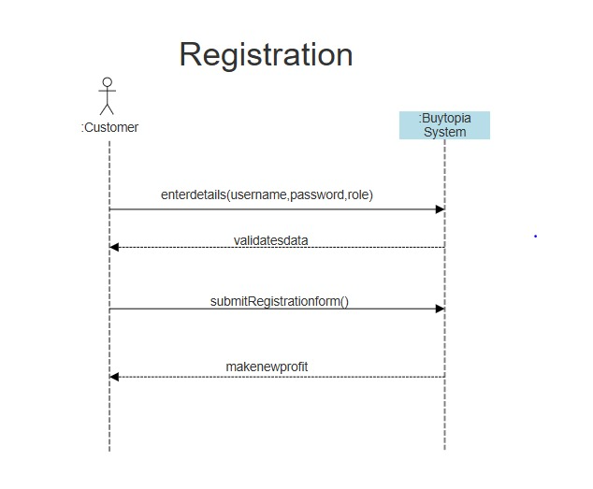

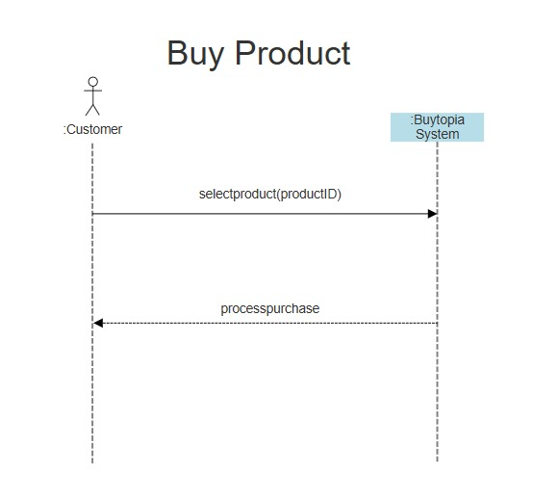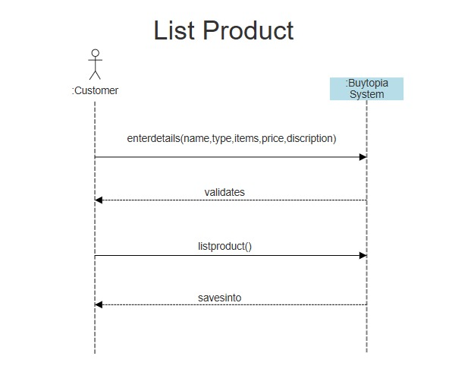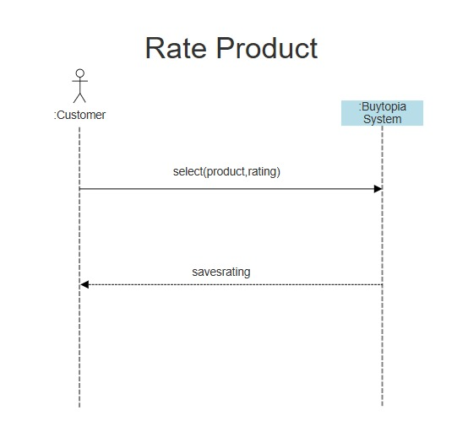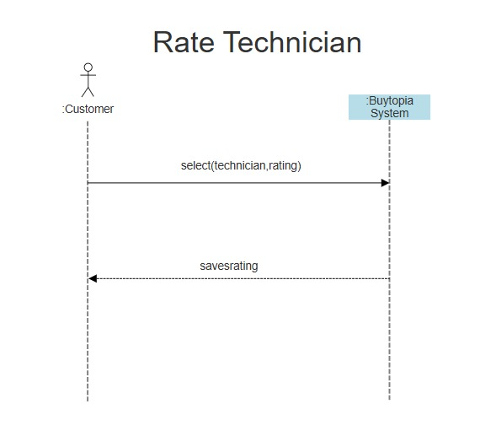

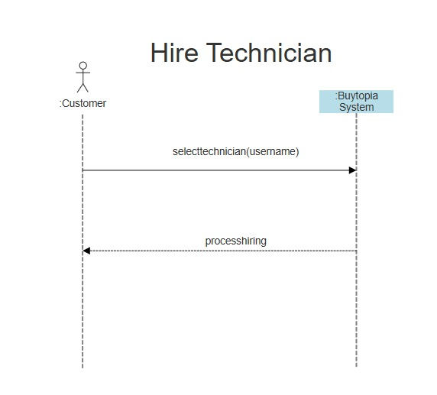

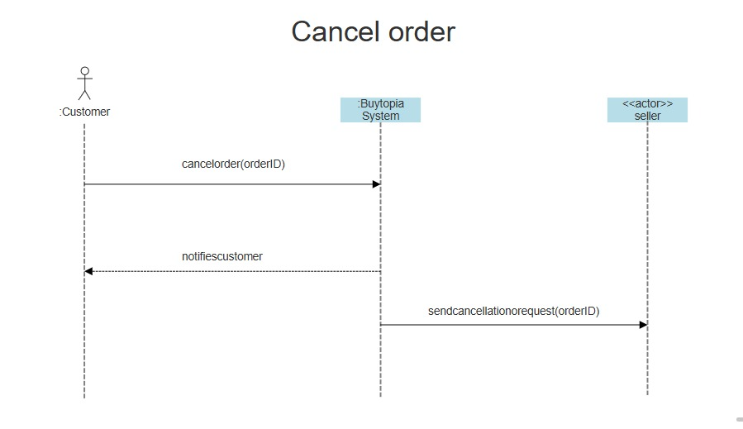

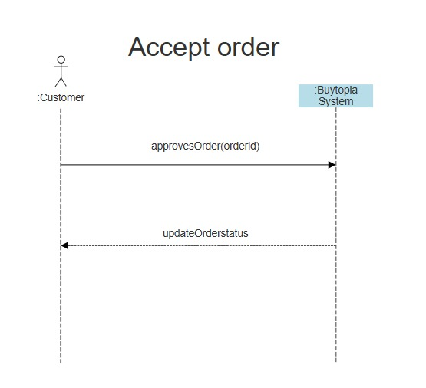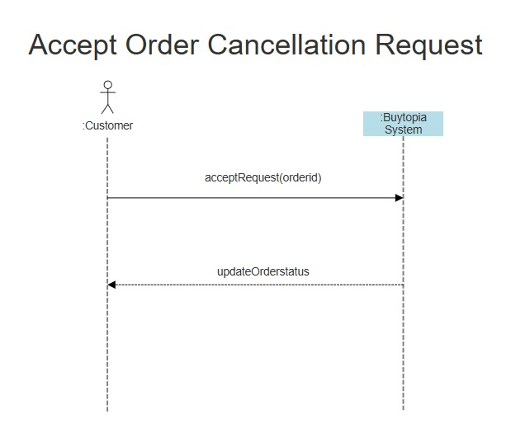

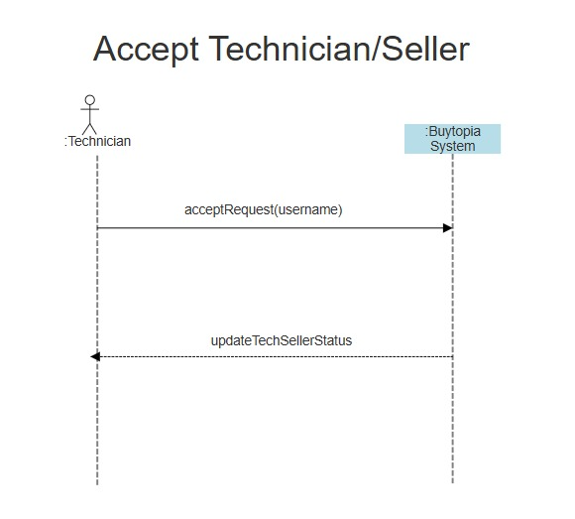

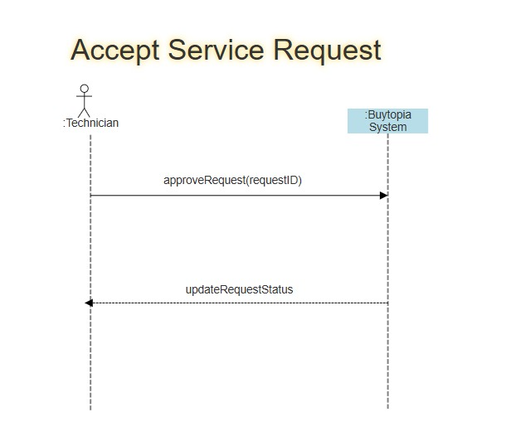

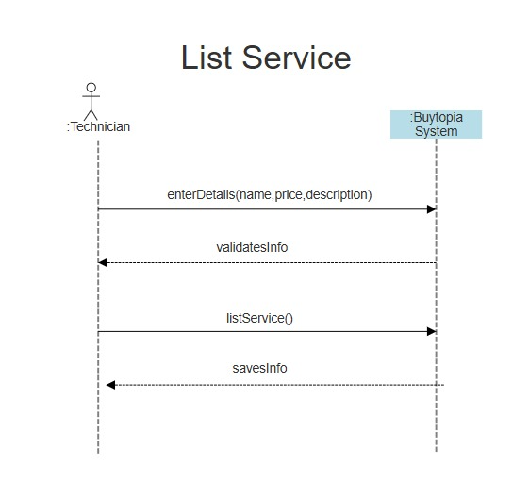

**Sequence Diagram**

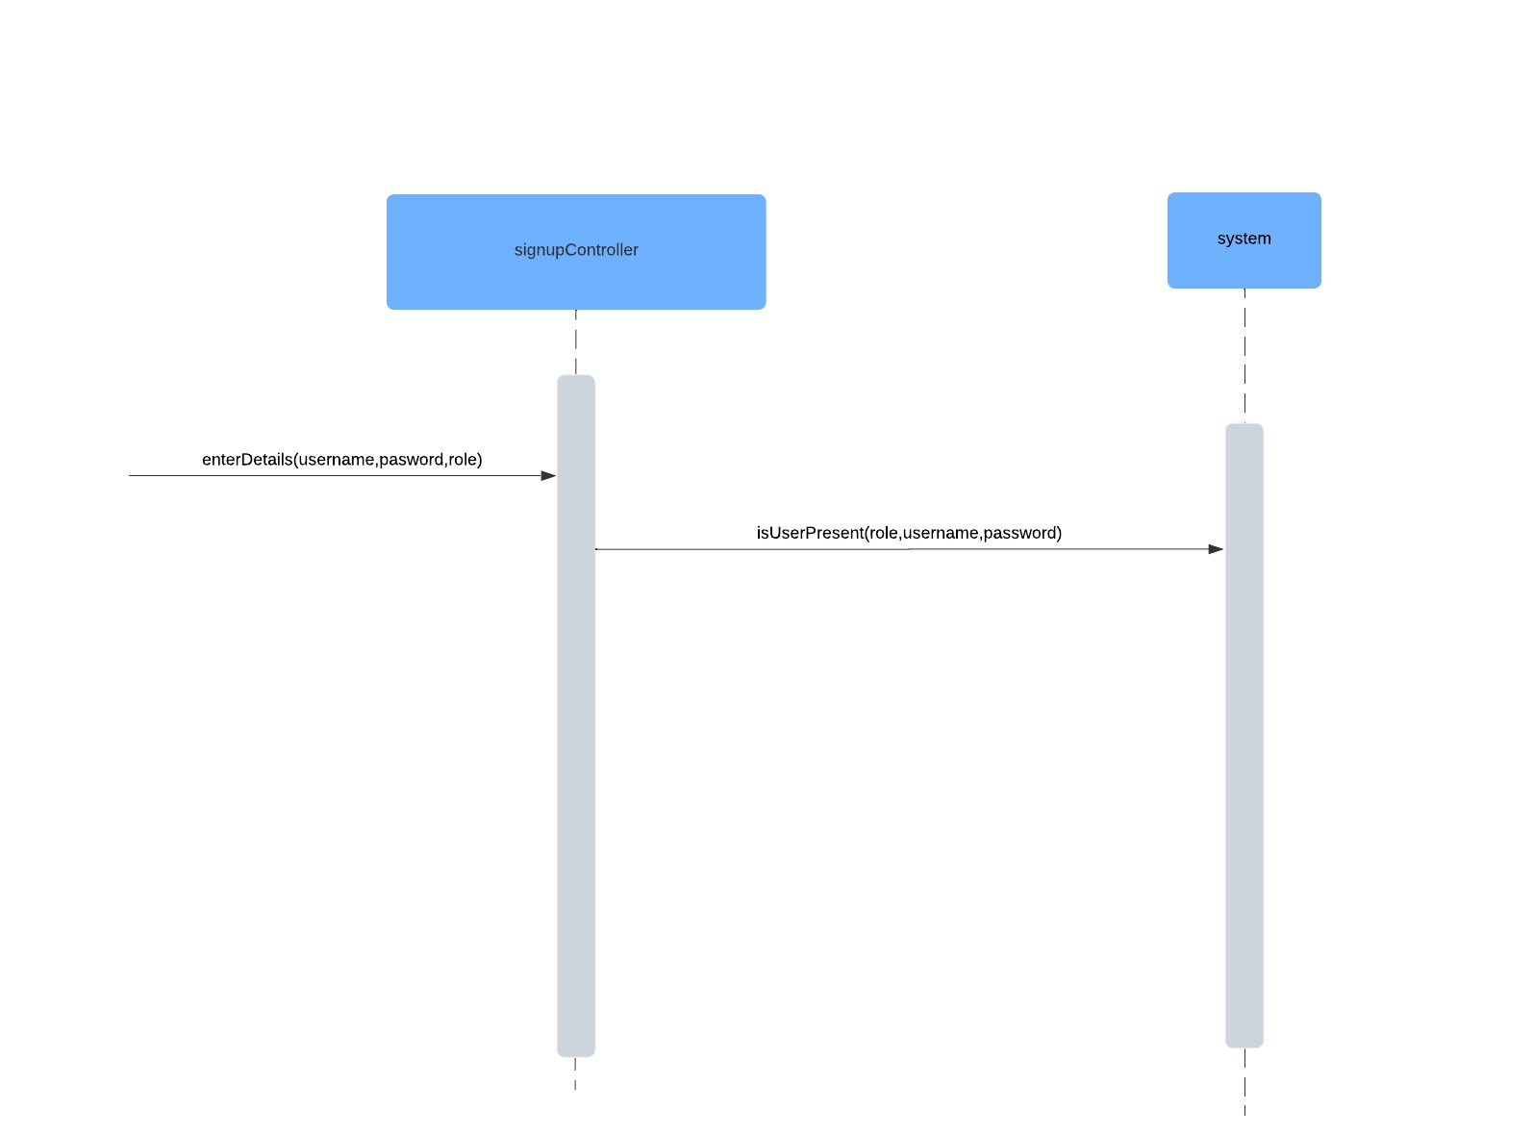

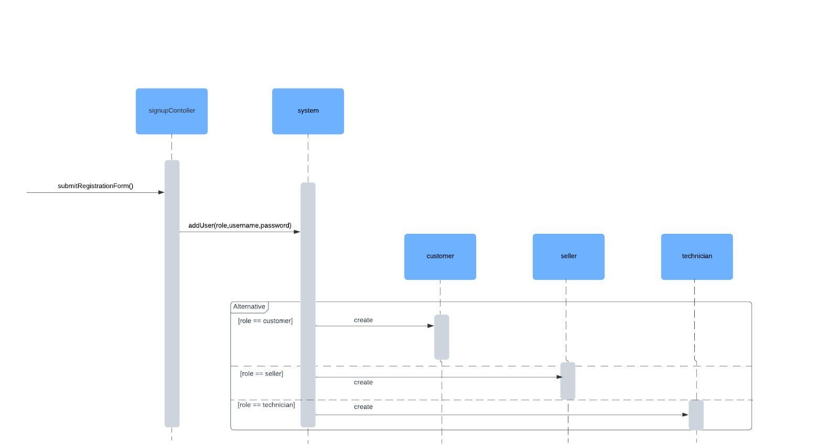

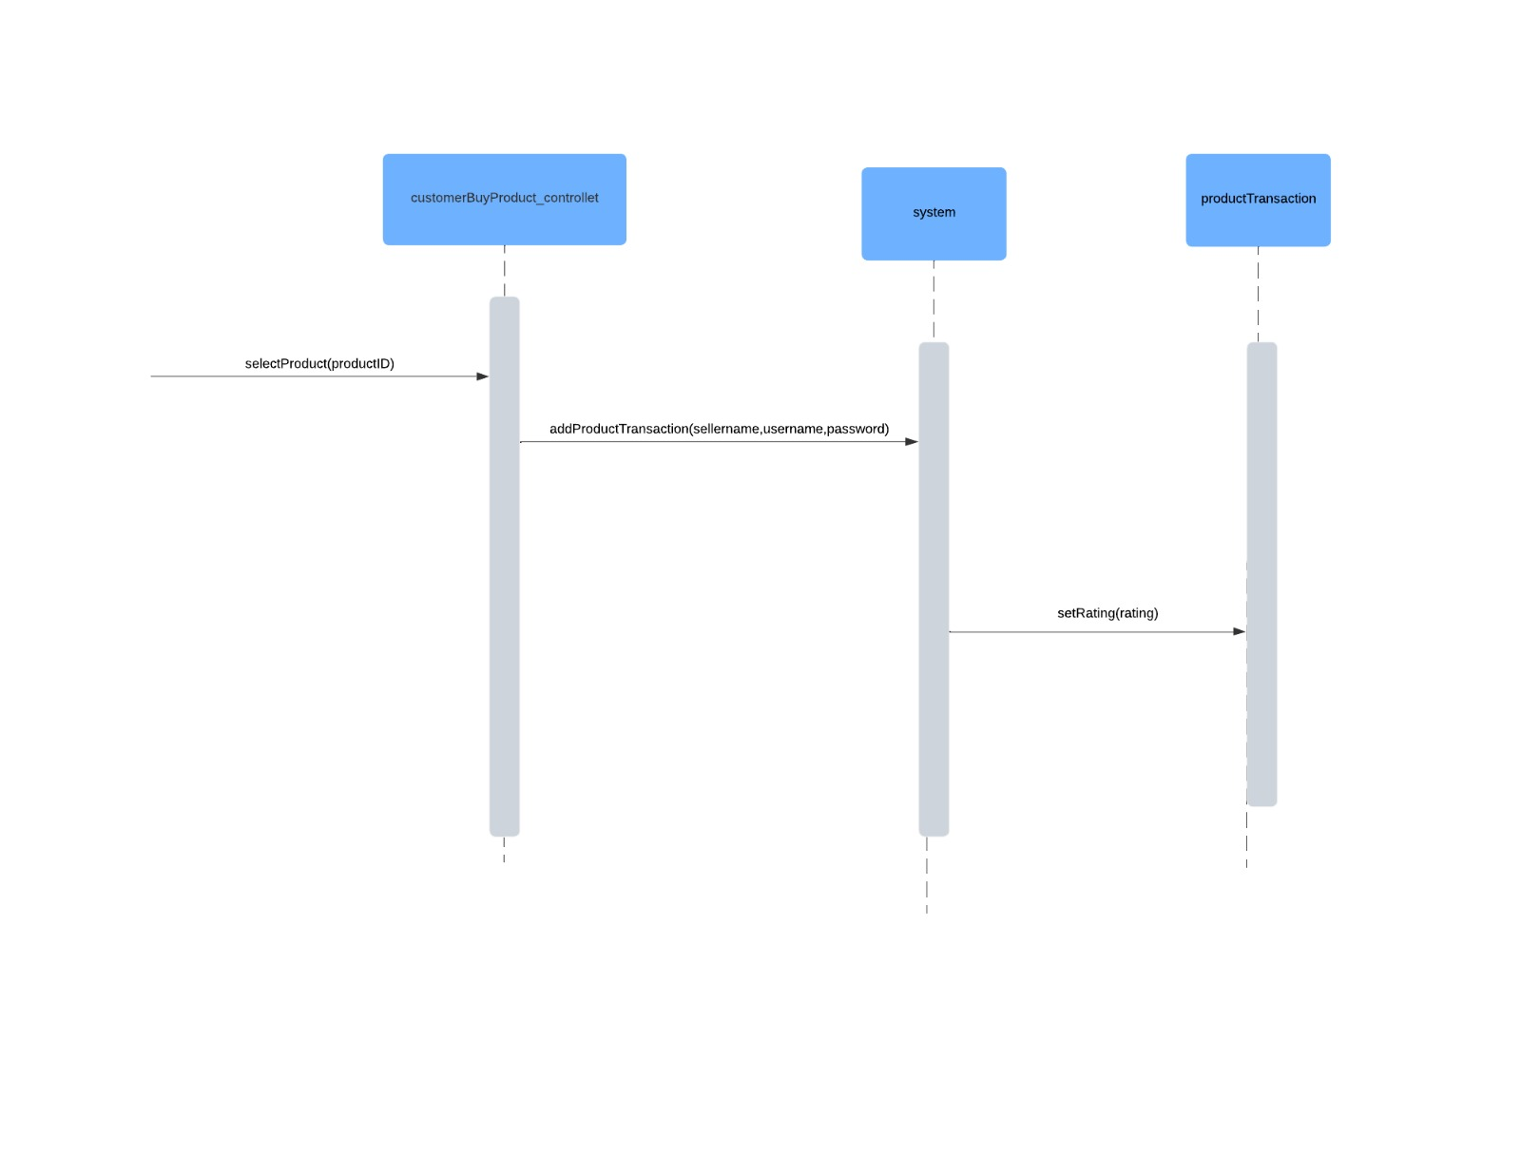

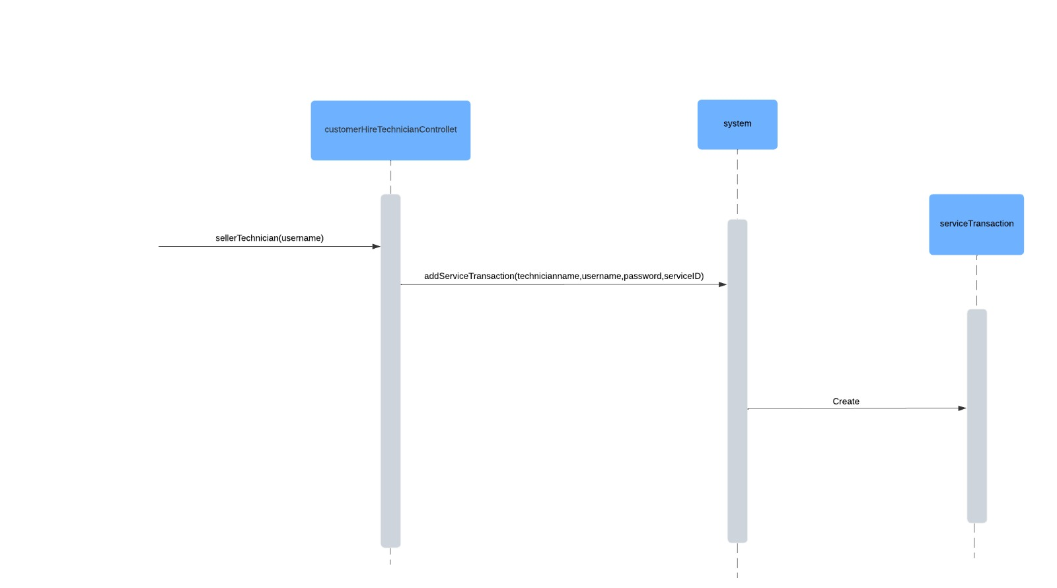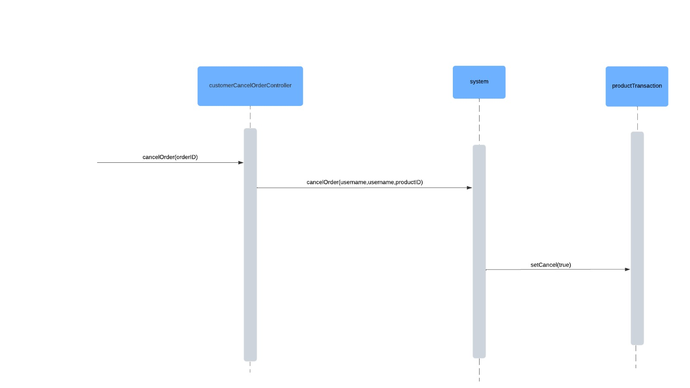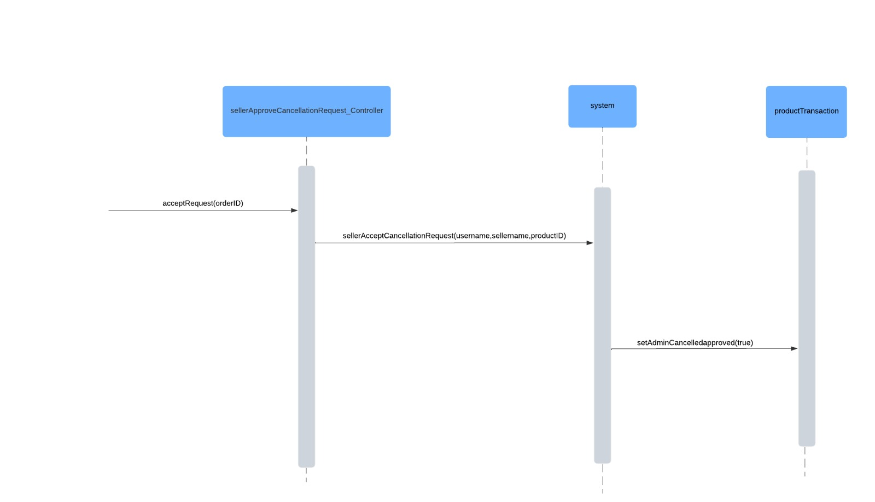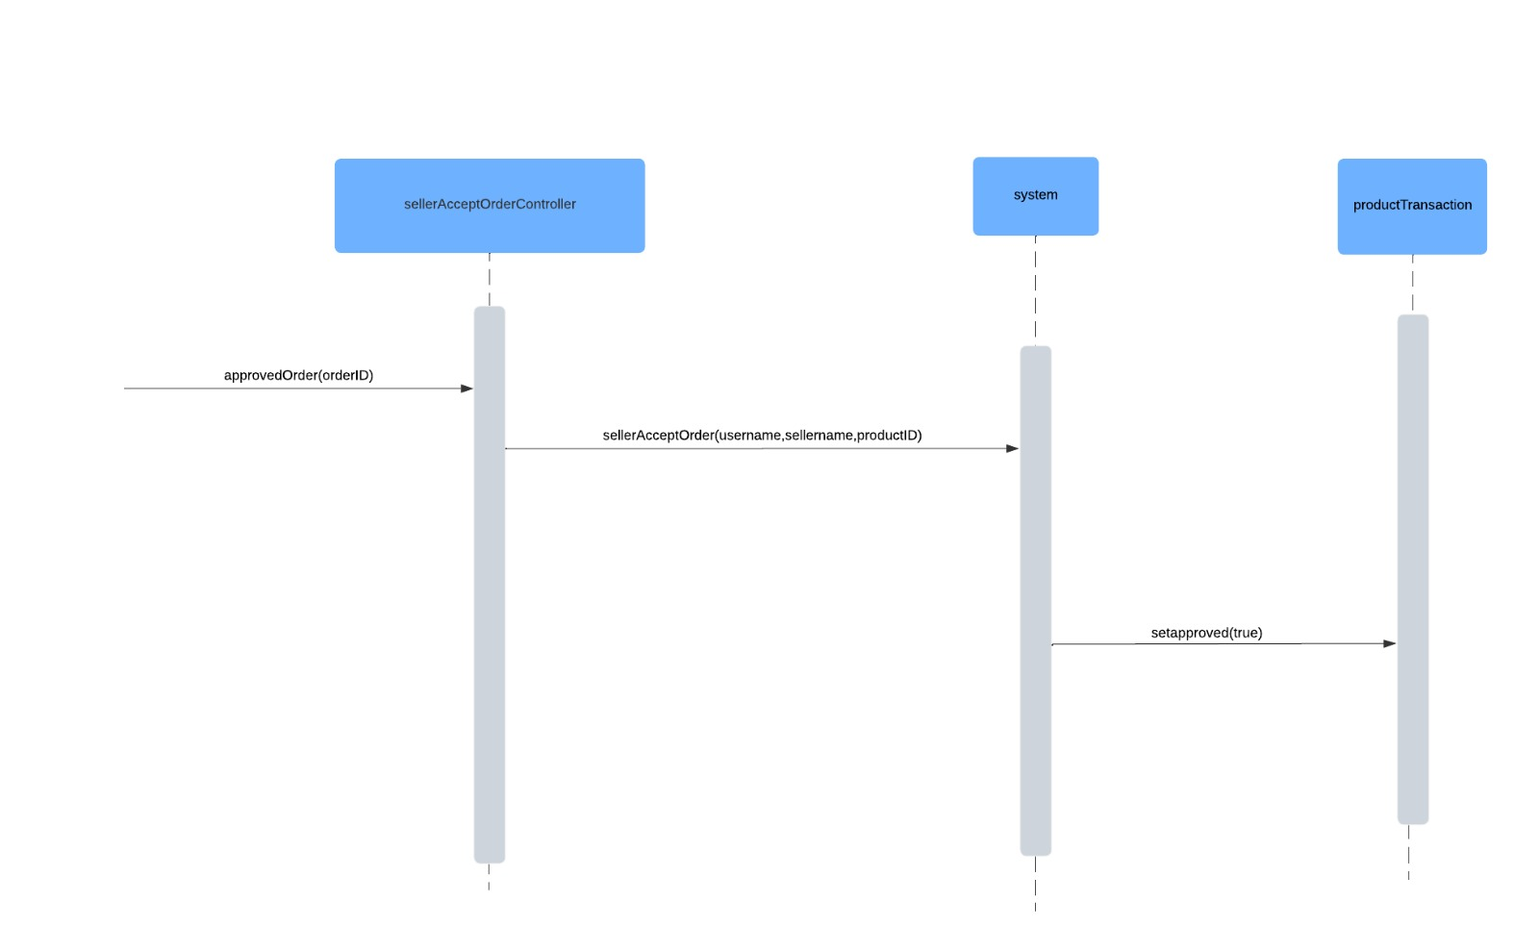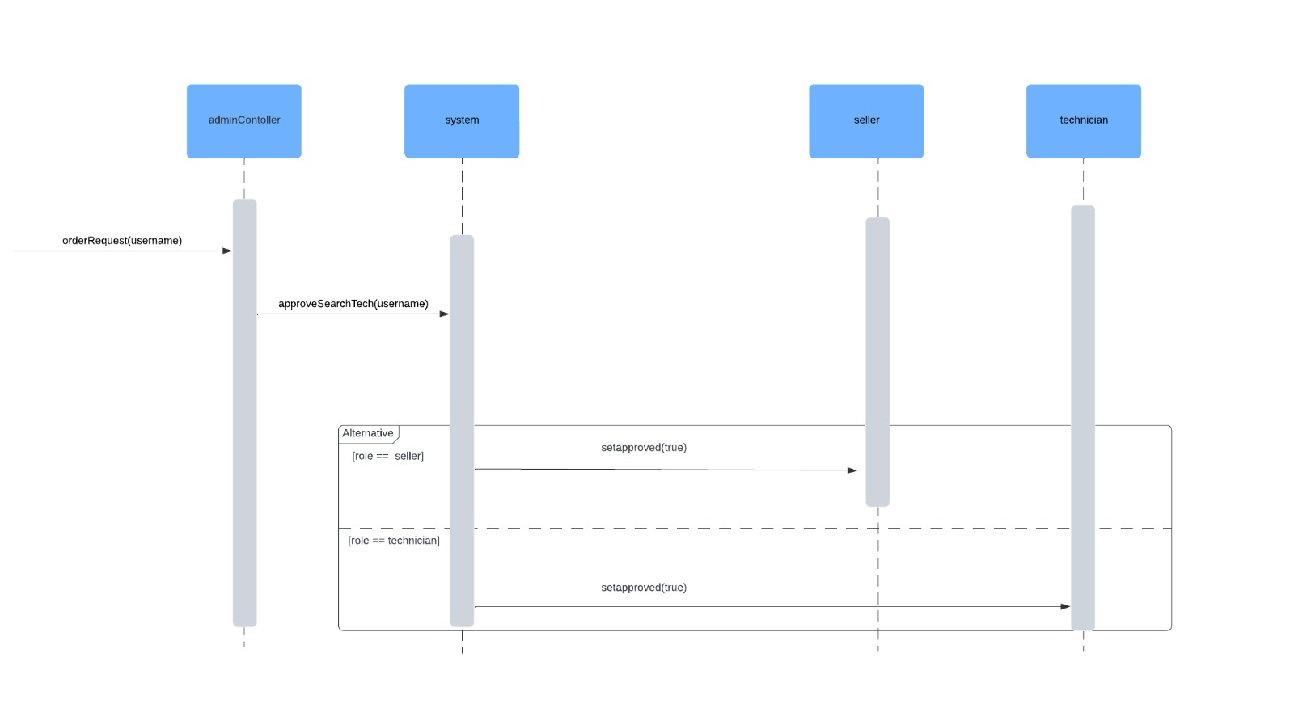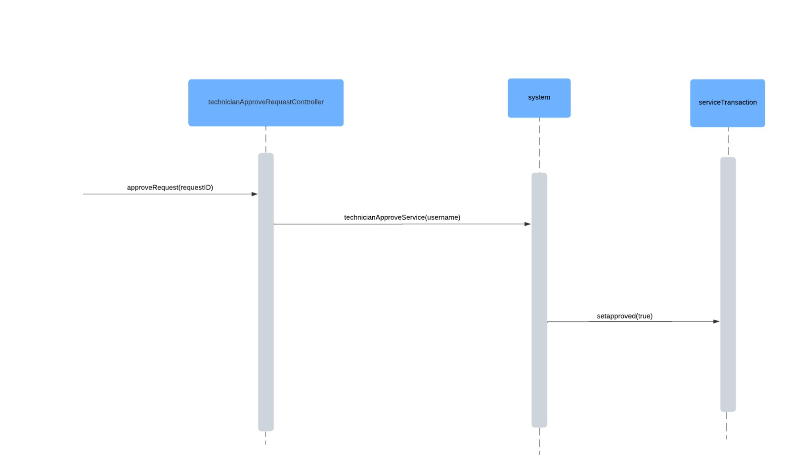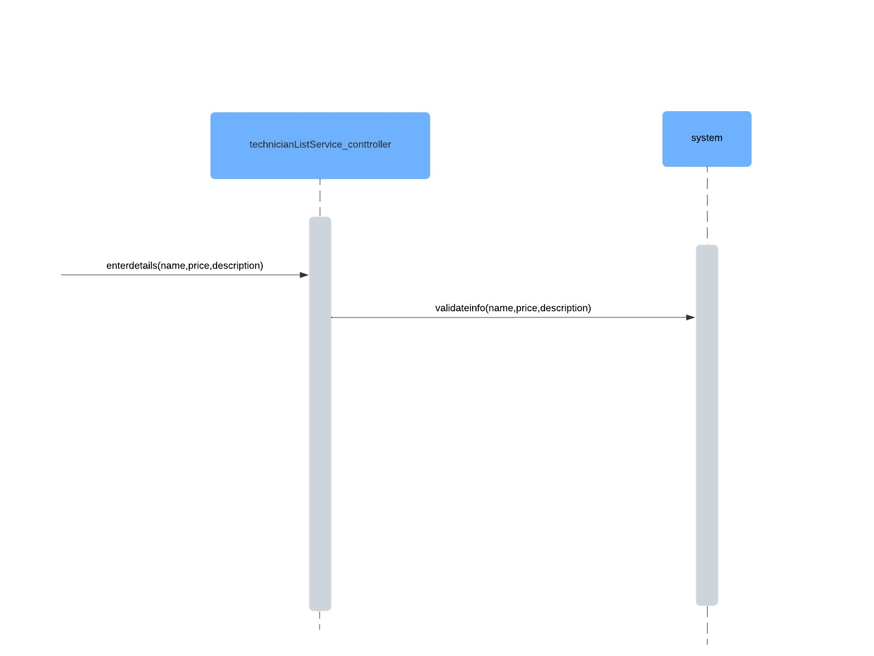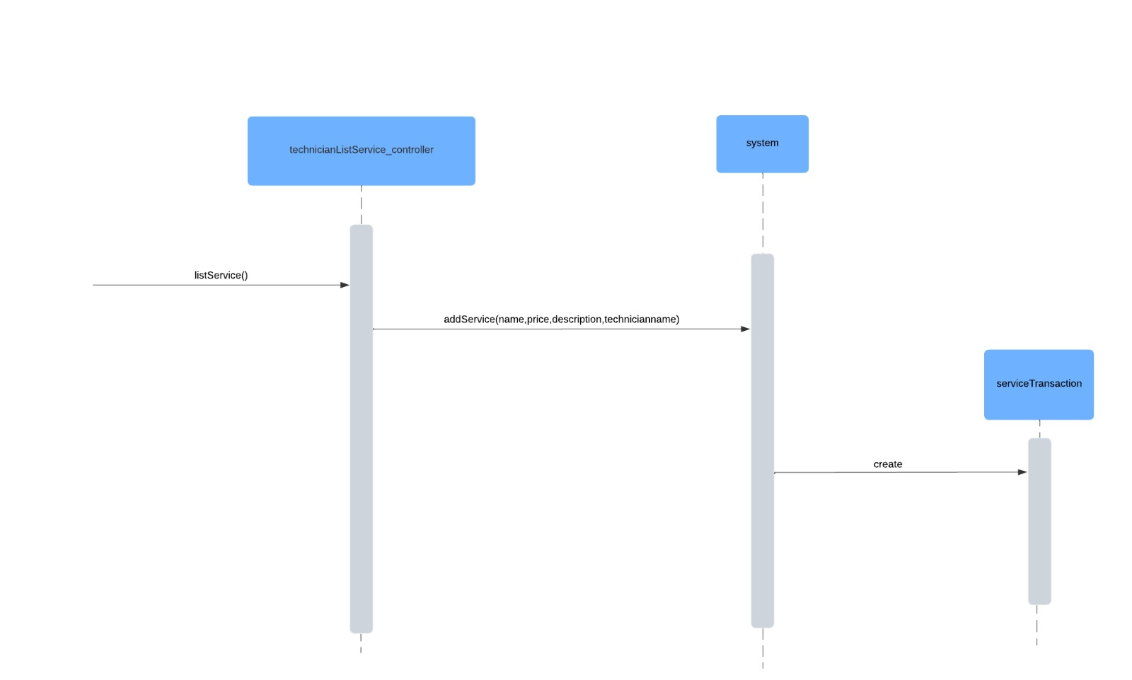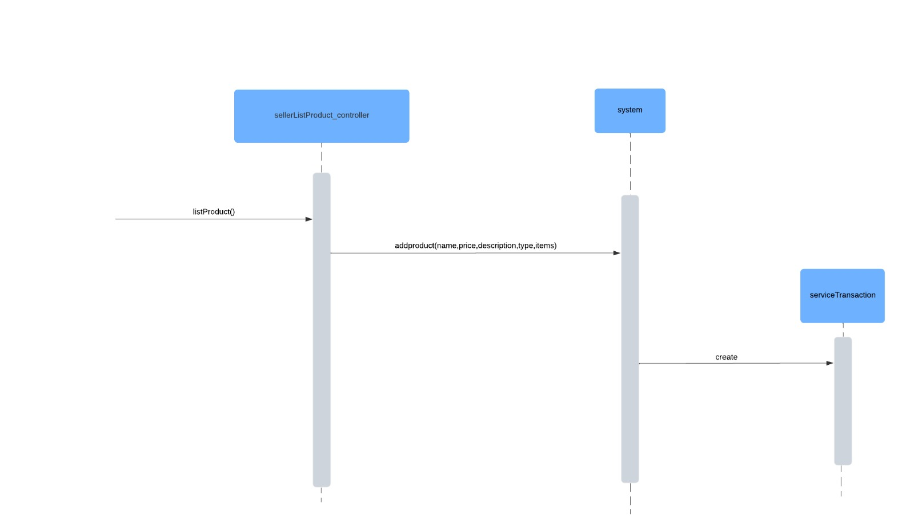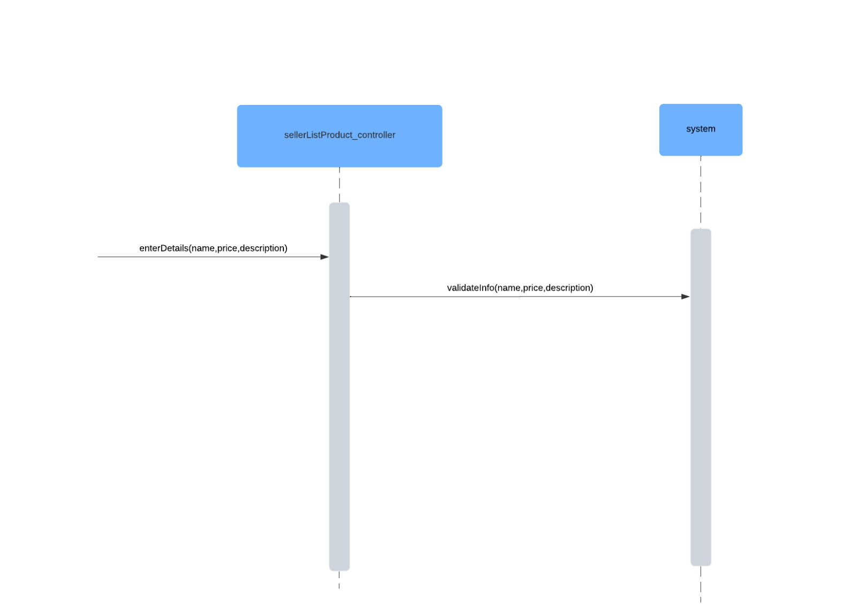

**Class Diagram   
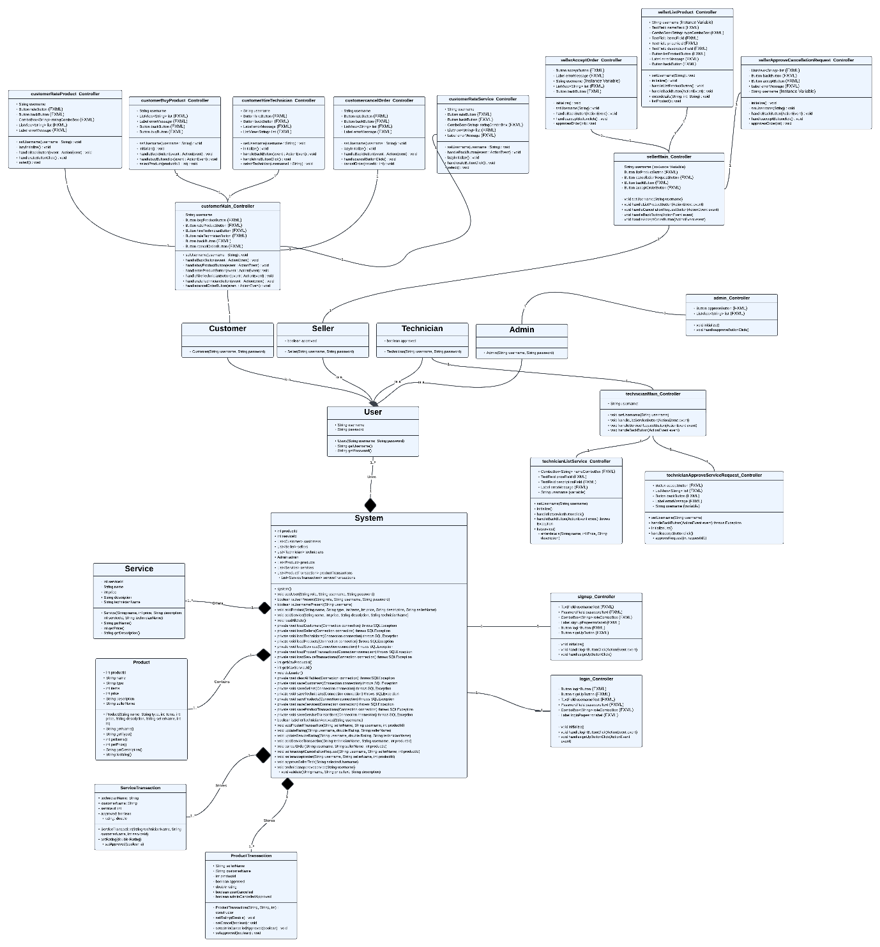**

**Domain Model**

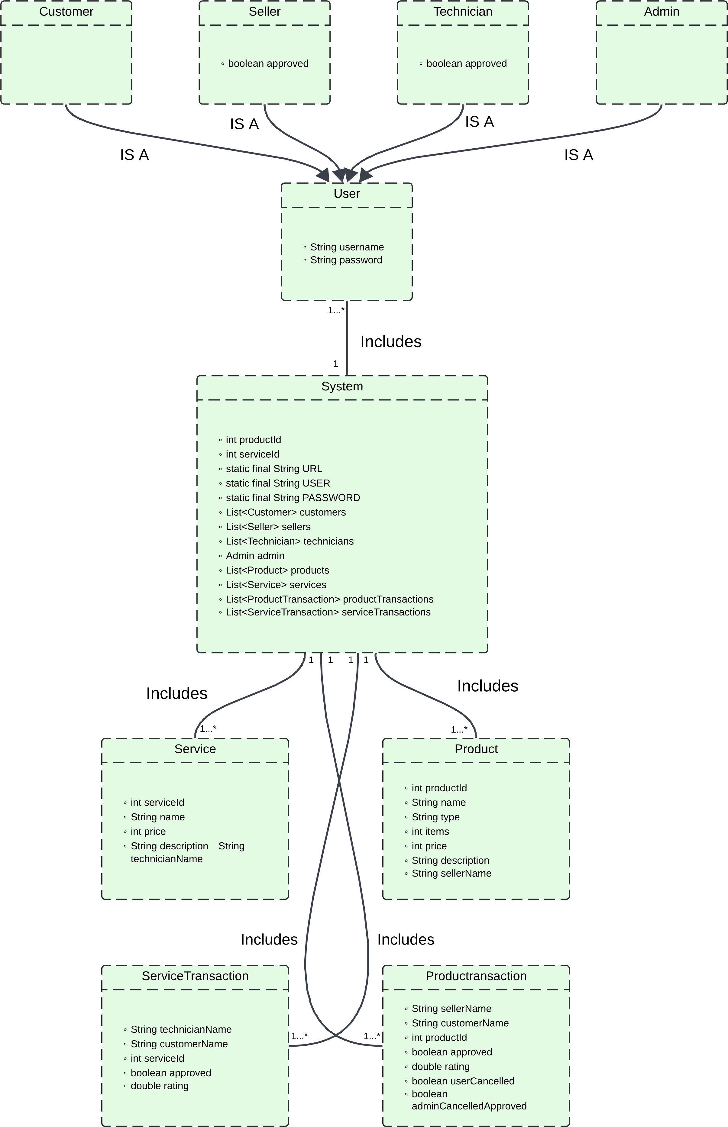

**Component Diagram**

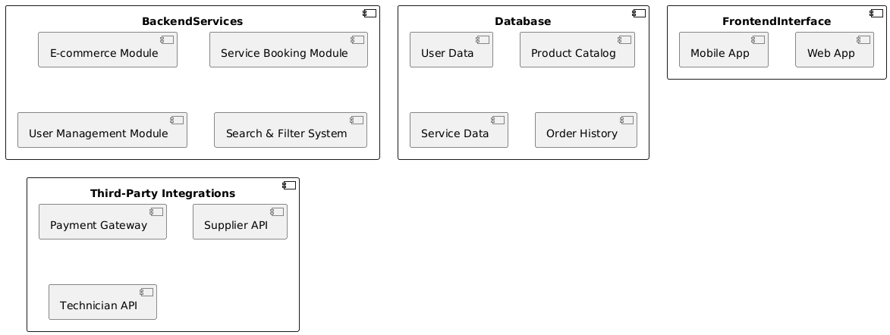

**Deployment Diagram**

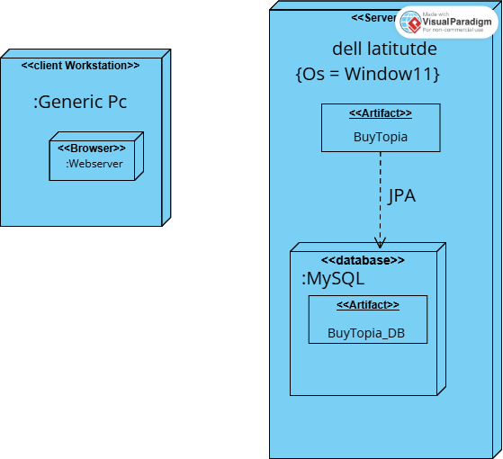

**Package Diagram**

