Shift Control Logic
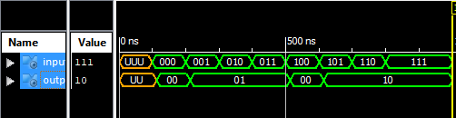
4 input mux
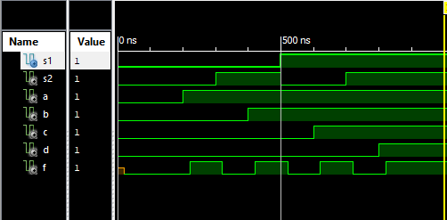

One bit logic slice
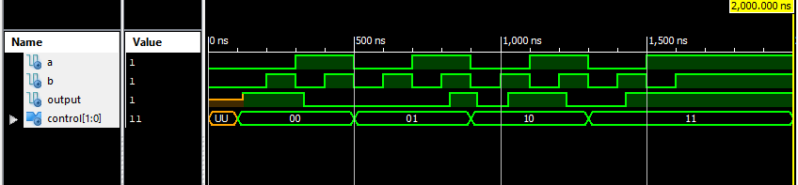
Nbit adder
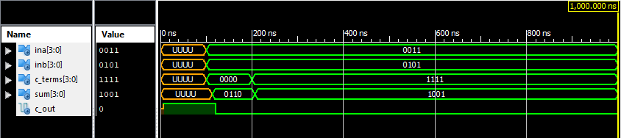

Fourbit lac adder
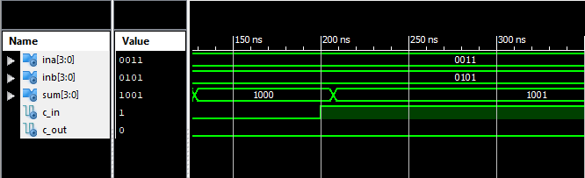

Nbit_two_input multiplexer
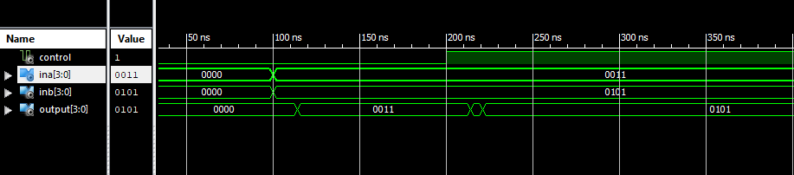
Nbit logic unit
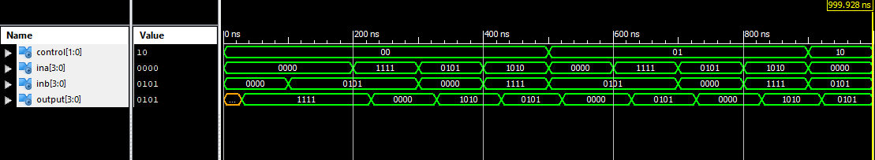
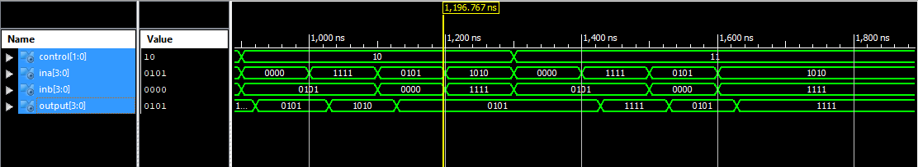
Shift rotate
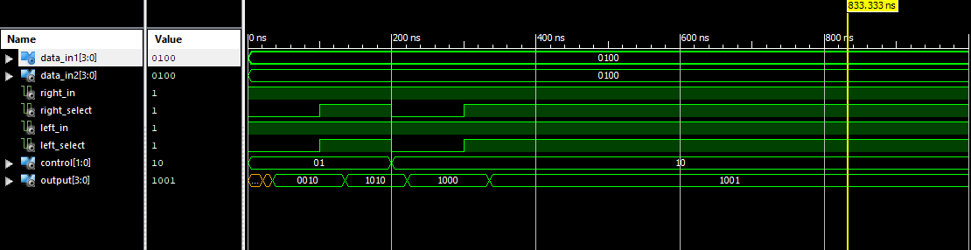

Four bit lac adder
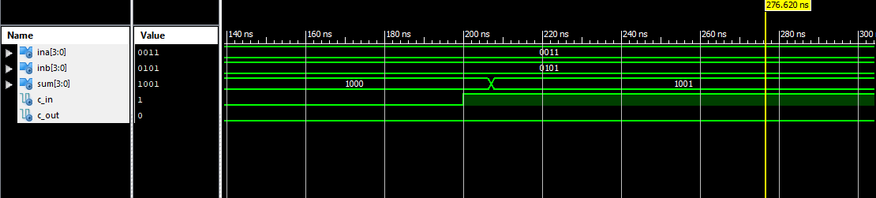

Four bit adder subtractor
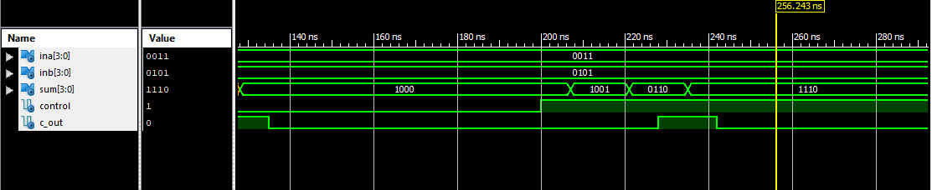
Four bit arithmetic unit
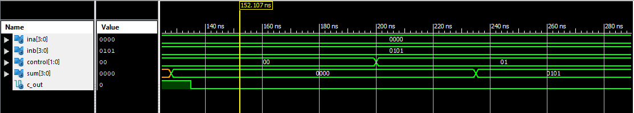
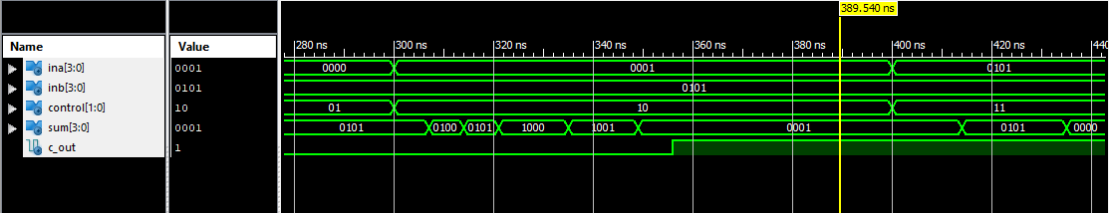
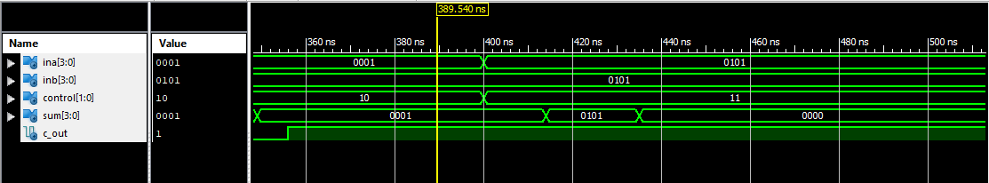

- 4-bit ALU (top-level device) (code provided)

- 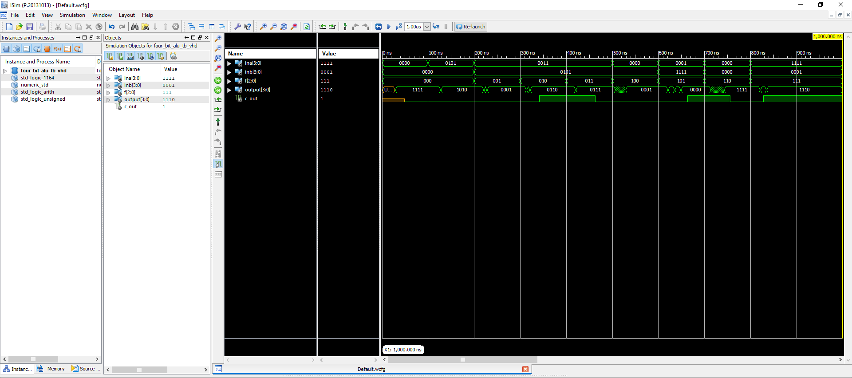
2. 4-bit Shifter (top-level device) (code provided)

