Lab 3 Simulations
Tri State buffer
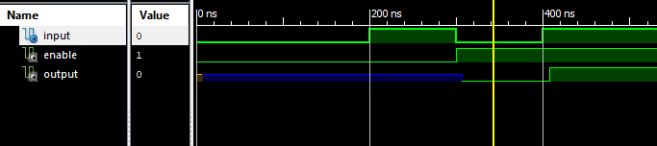
T-type flip-flop
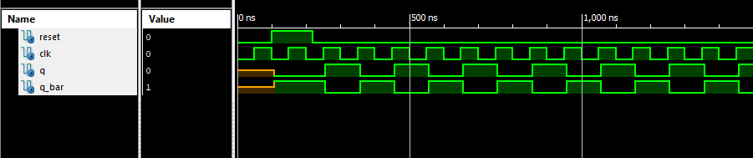
n-bit shift register
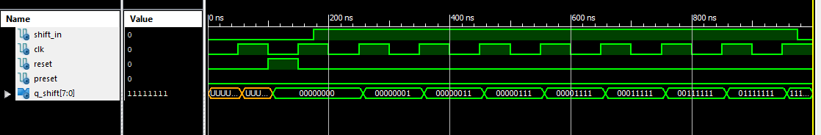
D flip-flop
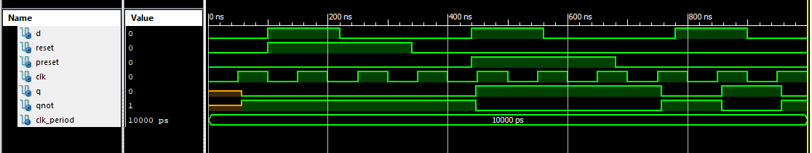
n-bit register
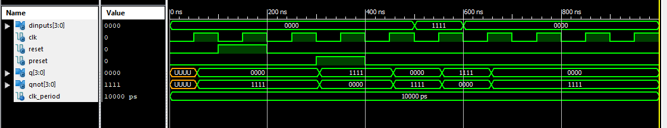

n-bit register with load/~hold control
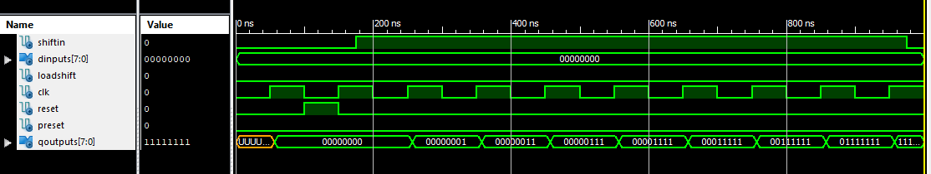
n-bit tri-state buffer
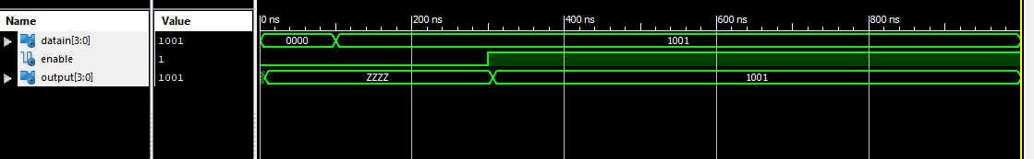
n-bit register load/~hold and tri-state output enable
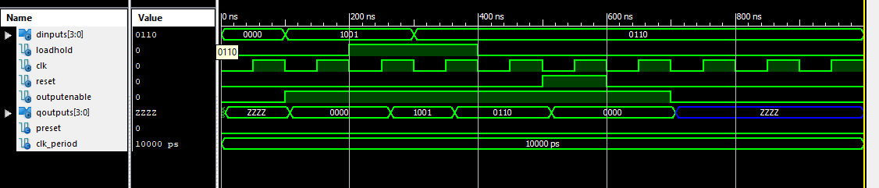
n-bit shift register with parallel load input
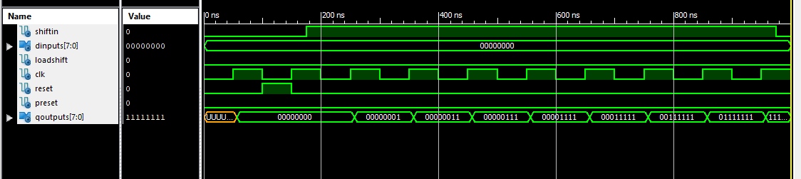
4-bit linear feedback shift register
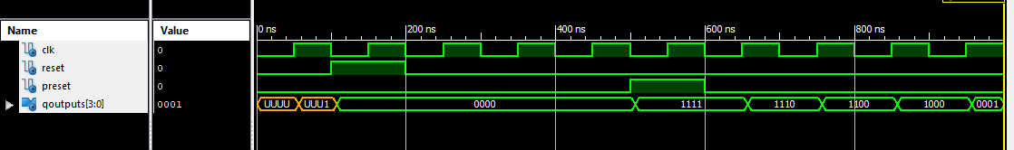
n-bit universal shift register
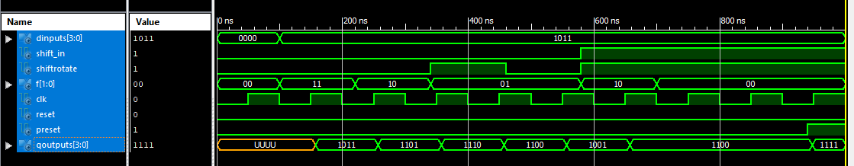
n-bit twisted ring counter
