**n-bit asynchronous (ripple) counter**

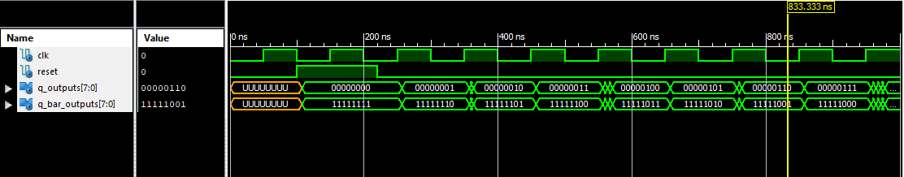

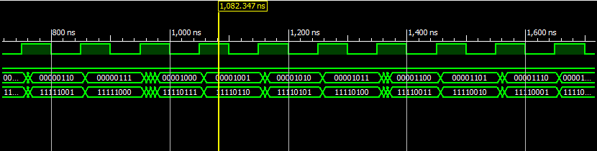

**4 bit synchronous counter (using combinational next state logic)**

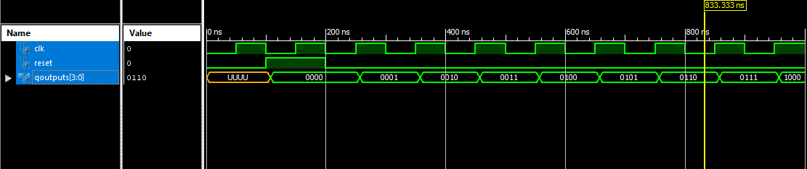

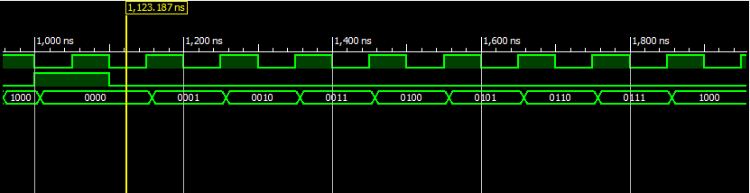

**N bit incrementer circuit**

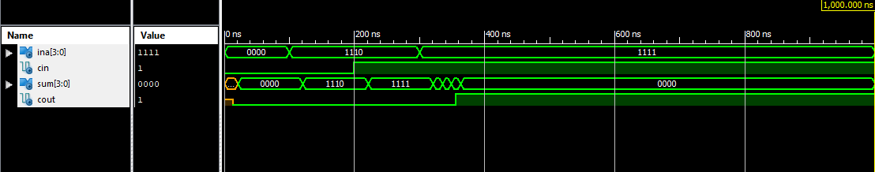

**n-bit synchronous counter with enable (code provided)**

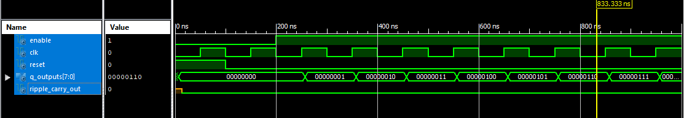

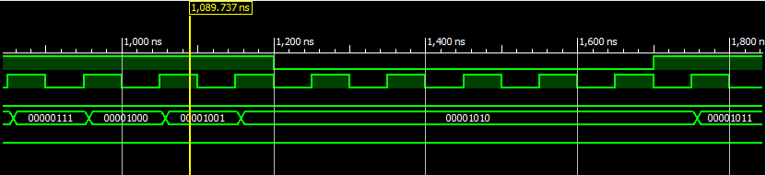

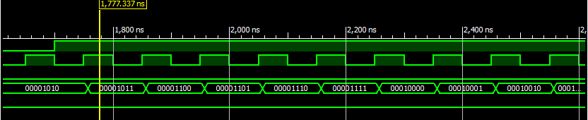

**n-bit synchronous counter with parallel load input**

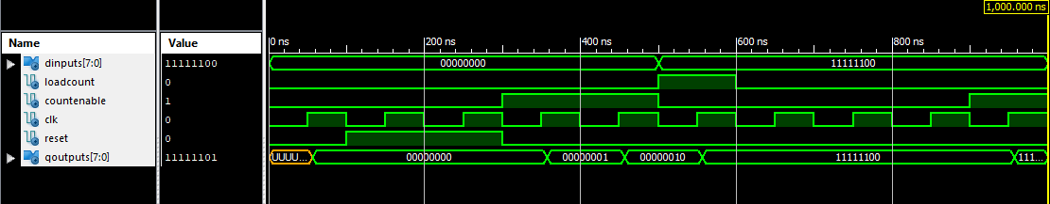

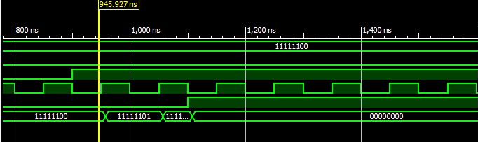

**4-bit synchronous up/down counter**

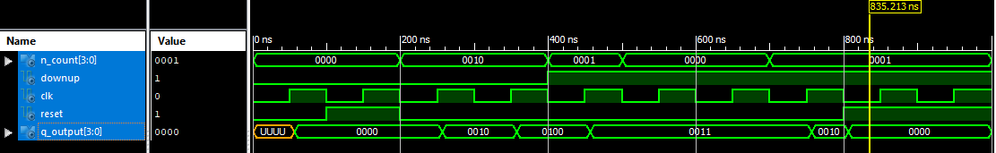

**8-bit Comparator**

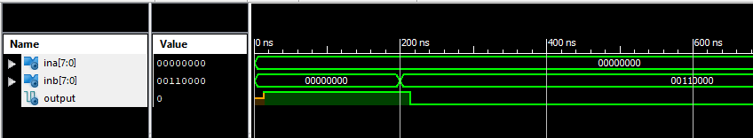

**8-bit modulo-m counter with asynchronous reset**

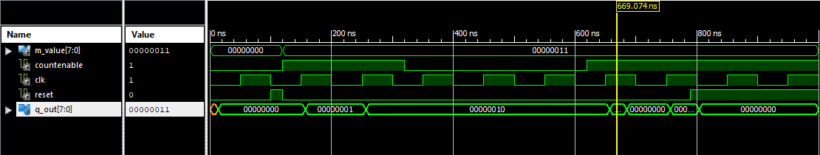

**8-bit modulo-m counter with synchronous reset**

