
The Islamia University of Bahawalpur
Department of Artificial Intelligence
AI vs Human Image Classification
Detecting AI Generated Images Using Deep Learning
A project presented to
Dr. Amna Shifa
In partial fulfillment of the requirement for the Computer Vision Subject of
Bachelor of Artificial Intelligence (2023-2027)
By
Salman Sarwar
(F23BARIN1M01045)

1. Introduction
In recent years, AI tools have become capable of generating images that look almost identical to real photographs. Tools like Midjourney, Stable Diffusion, and DALL-E can produce photorealistic faces, landscapes, and objects that are very hard to tell apart from camera-captured images. This rapid development has raised serious concerns around misinformation, fake identity creation, and digital fraud.

This project addresses this problem by building a web-based application that can detect whether a given image is AI generated or captured by a real human using a camera. The system uses deep learning to classify images into two categories: AI Generated and Real (Human).

The application was built using Python and Streamlit. For prediction, it combines two models: a custom trained EfficientNetB0 model and a pre-trained HuggingFace detector. The combined approach improves accuracy and handles a wider variety of AI generated image styles.

2. Problem Statement
The problem is straightforward but technically challenging. With AI image generation becoming more accessible to everyone, it is increasingly difficult to trust whether an image is real or not. This creates several issues:

- Fake news and misinformation spread using AI generated images
- Fake identities created using AI faces for fraud and scams
- AI generated content being passed off as genuine photography
- No easy tool available for general users to check image authenticity

This project solves this by providing a simple web interface where anyone can upload an image and get an instant prediction on whether it is AI generated or taken by a real camera.

3. Dataset
The dataset used in this project is the AI vs Human Generated Dataset available on Kaggle, created by alessandrasala79. It contains a large collection of photorealistic AI generated images and real camera captured photographs, making it highly suitable for this classification task.

Original dataset: 79,950 images (train set)
Subset used: 20,000 images (10,000 AI + 10,000 Real)

Due to Google Drive storage limitations (15GB), a subset of 20,000 images was selected randomly from the original dataset. The selection was done using a Python script that read the train.csv label file and randomly sampled equal numbers from both classes to maintain balance.

The class distribution of the selected subset is shown below:

Class | Images | Percentage
AI Generated (Train) | 10,000 | 50%
Real / Human (Train) | 10,000 | 50%
Total | 20,000 | 100%

Table 1: Dataset Class Distribution

3.1 Dataset Split
The dataset was split inside the training code using Keras ImageDataGenerator with a validation split of 20%. This gave the following split:

- Training set: 16,000 images (80%)
- Validation set: 4,000 images (20%)

4. Model

4.1 Data Preprocessing
Before training, images were preprocessed using the following steps:

- All images resized to 224x224 pixels to match EfficientNetB0 input requirements
- Pixel values normalized by dividing by 255 to scale to range 0 to 1
- Training data augmented with random horizontal flip, rotation up to 15 degrees, zoom up to 10%, and brightness adjustment between 0.8 and 1.2
- Validation data only normalized, no augmentation applied

4.2 Model Architecture: EfficientNetB0
EfficientNetB0 was selected as the base model because it provides a good balance between accuracy and speed. It was pretrained on ImageNet which gives it strong feature extraction capabilities for visual patterns.

The transfer learning approach was used. All base model layers were frozen and only a custom classifier head was trained. The architecture is as follows:

- EfficientNetB0 base (frozen, pretrained on ImageNet)
- Global Average Pooling layer
- Batch Normalization
- Dropout (0.3)
- Dense layer with 256 neurons and ReLU activation
- Dropout (0.2)
- Output Dense layer with 1 neuron and Sigmoid activation (binary classification)

The model was compiled with Adam optimizer (learning rate 0.001) and binary crossentropy loss. Training was done for 15 epochs with early stopping and model checkpoint callbacks to save the best performing model.

4.3 Combined Prediction System
To improve accuracy beyond the single trained model, a combined prediction system was built for the web application. Two models are used together:

- Our trained EfficientNetB0 model (40% weight in final decision)
- HuggingFace pre-trained model: haywoodsloan/ai-image-detector-deploy (60% weight)

The HuggingFace model is loaded locally using the transformers library. It runs on the same machine, no internet required after the first download. The final confidence score is a weighted combination of both model outputs, giving more trust to the HuggingFace model which is trained on a larger and more diverse dataset.

5. Result
The trained EfficientNetB0 model achieved the following performance on the validation set:

Metric | Score | Note
Accuracy | 78% | Final model on validation set
Precision | 78% | Both classes balanced
Recall | 78% | Equal for AI and Real
F1 Score | 78% | Weighted average

Table 2: Model Performance on Validation Set
The model correctly classified 78% of images in both categories. While this is not perfect, it is a reasonable result for a binary classification task on photorealistic images where even human observers struggle.

The web application takes the combined output of both models. In testing, the HuggingFace model showed significantly higher confidence on photorealistic AI faces, which compensates for the weaker performance of our trained model on that category.

The application interface is shown below:

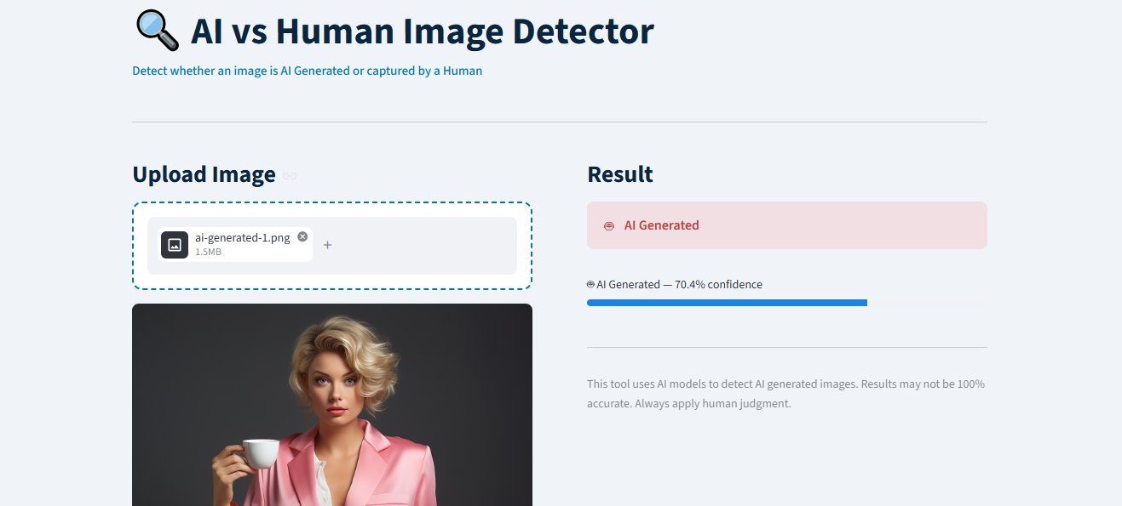
Figure 1: AI vs Human Image Detector Web Application
The user uploads an image, clicks Analyse, and receives a prediction with confidence percentage. The result is displayed as either AI Generated or Real (Human) with a progress bar showing the confidence level.

6. Limitations
Several limitations were identified during the development and testing of this project:

- Our trained model achieves 78% accuracy which means approximately 1 in 5 images will be incorrectly classified.
- The model struggles with ultra-realistic AI generated faces produced by latest tools like Midjourney v6 and DALL-E 3, which are nearly indistinguishable from real photos.
- The dataset subset of 20,000 images is relatively small. A larger dataset would likely improve accuracy significantly.
- The HuggingFace model dependency requires a one-time download of approximately 400MB which may not always be available in restricted environments.
- No fine tuning was performed on EfficientNetB0 base layers due to limited Colab GPU time. Unfreezing the last 20 layers and retraining could push accuracy to 88-92%.
- The app currently only supports JPG, PNG, and WebP formats. Other formats like HEIC or RAW are not supported.
- On Streamlit Cloud deployment, the large model sizes (TensorFlow + PyTorch together) may exceed free tier memory limits.

7. Conclusion
This project demonstrates that a deep learning model can be trained to detect AI generated images with reasonable accuracy using transfer learning. EfficientNetB0 pretrained on ImageNet was fine-tuned for this binary classification task and achieved 78% accuracy on the validation set.

The web application built with Streamlit provides a clean and simple interface for users to upload and analyse images. The combined prediction system using both our trained model and the HuggingFace pre-trained detector improves the reliability of results, especially on photorealistic AI generated faces.

As AI generated imagery becomes more realistic and widespread, tools like this become increasingly important for media verification, digital forensics, and content authenticity. Future improvements could include fine tuning the base model layers, training on a larger and more diverse dataset, and expanding support to video frame analysis.

Overall the project successfully achieved its goal of building a working AI image detector application that is accessible through a simple web interface.

