
The Islamia University of Bahawalpur
Department of Artificial Intelligence
Project Title
CardioPredict
Intelligent Heart Disease Risk Assessment
A project presented to
Ms. Marrium Aslam
In partial fulfillment of the requirement for the Data Mining Subject of
Bachelor of Artificial Intelligence (2023-2027)
Presented By
Salman Sarwar
(F23BARIN1M01045)
Muhammad Nadeem
(F23BARIN1M01025)

1. Introduction
Heart disease is one of the biggest causes of death around the world. Every year millions of people lose their lives because it either gets detected too late or not at all. The problem is even bigger in areas where there are not enough doctors or where medical tests are too expensive for most people.

This project, CardioPredict, is a web-based application that helps doctors quickly check whether a patient has a risk of heart disease or not. The doctor enters the patient test results into the system and the system gives an instant prediction. The idea is simple. Instead of waiting and guessing, doctors get a second opinion from a machine learning model trained on real patient data.

The application was built using Python and Streamlit, and the prediction model behind it is Random Forest, which was selected after comparing five different machine learning algorithms.

2. Problem Statement
There are two main problems that this project tries to solve.

- There are not enough cardiologists in many parts of the world. Patients have to wait a long time for a diagnosis, which can be dangerous when it comes to heart disease.
- Many existing tools for heart disease detection are built for hospitals or researchers, not for everyday clinical use. They are either too complex or not accessible enough.

CardioPredict addresses this by providing a simple, clean interface where a doctor can input a patient clinical values and get an immediate prediction. No technical knowledge is required. The system is designed to support the doctor decision, not replace it.

3. Dataset
The dataset used in this project comes from the UCI Machine Learning Repository, specifically the Cleveland Heart Disease dataset. It is one of the most widely used datasets for heart disease research.

Original dataset: 1,025 rows and 14 columns
After removing duplicates: 302 unique rows

When we checked the dataset, we found that 723 out of 1,025 rows were exact duplicates. This is a known issue with some versions of this dataset available online. We removed all duplicates and worked with the 302 real, unique patient records. This is a limitation of the dataset but it is academically acceptable. The original UCI Cleveland dataset itself has around 303 records.

The class balance after cleaning was 54.3% with heart disease and 45.7% without, which is nearly balanced. So no resampling was needed.

The dataset contains the following 13 input features and 1 target variable:

Feature | Description
Age | Patient age in years
Sex | Gender: Male or Female
Chest Pain Type (cp) | Typical angina, Atypical angina, Non-anginal pain, Asymptomatic
Resting BP (trestbps) | Resting blood pressure in mmHg (range: 40 to 300)
Cholesterol (chol) | Serum cholesterol in mg/dL (range: 20 to 1000)
Fasting Blood Sugar (fbs) | Whether fasting blood sugar is above 120 mg/dL
Resting ECG (restecg) | Normal, ST-T wave abnormality, Left ventricular hypertrophy
Max Heart Rate (thalach) | Maximum heart rate achieved (range: 50 to 250 bpm)
Exercise Angina (exang) | Whether exercise induced chest pain: Yes or No
ST Depression (oldpeak) | ST depression induced by exercise (range: 0.0 to 10.0)
Slope (slope) | Upsloping, Flat, Downsloping
Major Vessels (ca) | Number of major vessels coloured by fluoroscopy (0 to 3)
Thalassemia (thal) | Normal, Fixed defect, Reversible defect
Target | 0 = No heart disease, 1 = Heart disease present

4. Model

4.1 Data Preprocessing
Before training any model, the data was cleaned and prepared through the following steps.

- Duplicate rows were removed. 723 duplicates were found and dropped, leaving 302 unique records.
- Missing values were checked. None were found in the cleaned dataset.
- The dataset was split into 80% training (241 rows) and 20% testing (61 rows).
- Only the five continuous features were scaled using StandardScaler: age, trestbps, chol, thalach, and oldpeak. Categorical features were left as they are since they are already numeric codes.

4.2 Models Compared
Five machine learning models were trained and compared. To get a reliable comparison, we used 5-fold cross validation which tests each model five times on different splits of the data. This gives a more honest picture than a single train and test split.

The table below shows the cross validation recall and standard deviation for all five models, along with single split accuracy and F1 score.

Model | CV Recall | CV Std | Accuracy | F1 Score
Logistic Regression | 87.86% | 6.03% | 78.69% | 80.00%
Decision Tree | 82.99% | 7.27% | 73.77% | 71.43%
Random Forest | 88.45% | 4.81% | 80.33% | 81.25%
KNN | 85.98% | 6.22% | 73.77% | 75.00%
SVM | 86.57% | 3.69% | 83.61% | 84.38%

Table 1: Model Comparison Results

4.3 Model Selection: Random Forest
Random Forest was selected as the final model for the following reasons.

- Highest cross validation recall of 88.45%. This means it correctly identified the most actual heart disease cases across all five test splits.
- Lowest standard deviation of 4.81%. This shows the model gives consistent results and does not just get lucky on one split.
- Random Forest also provides feature importance scores. The top three features were chest pain type, maximum heart rate, and ST depression, which matches what doctors already know from clinical experience.

Although SVM had a higher single split recall of 93.10%, it dropped to 86.57% in cross validation. Random Forest was more reliable overall.

5. Result
The final Random Forest model achieved the following results on the test set.

- Accuracy: 80.33%
- Precision: 74.29%
- Recall: 89.66%
- F1 Score: 81.25%
- Cross Validation Recall: 88.45% with standard deviation of 4.81%

Recall is the most important metric here because missing a patient who actually has heart disease is far more dangerous than a false alarm. The model caught 89.66% of actual disease cases in testing, and 88.45% on average across cross validation.

The application was built using Streamlit and deployed locally. The interface has two roles. The Doctor role provides full access to all 13 input fields and the prediction result. The Patient role shows the form in view only mode with a message to consult a doctor.

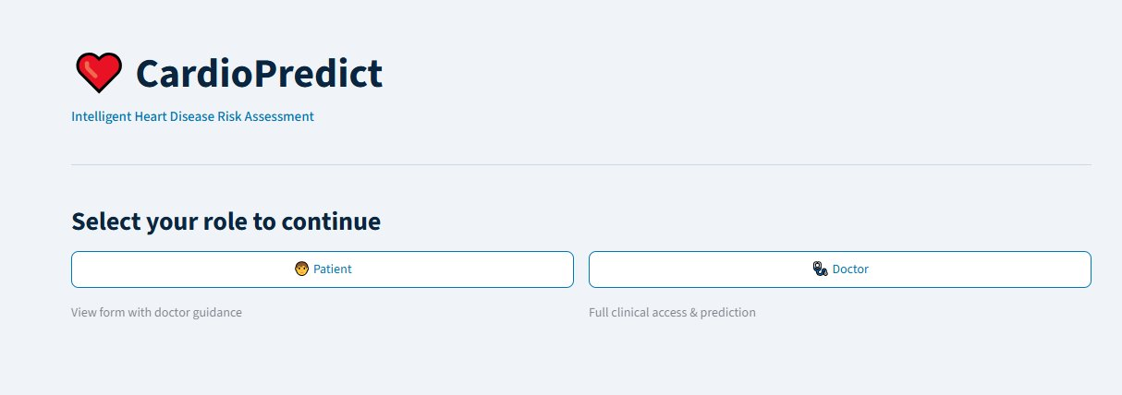
Figure 1: CardioPredict Home Page

When a doctor fills in all 13 fields and clicks Analyse, the system displays either No Heart Disease Detected in green, or Heart Disease Risk Detected in red. Both results include a note reminding the doctor that this is an AI assisted result and their clinical judgment should be applied before making any final decision.

6. Conclusion
This project shows that a simple machine learning model can be turned into a useful clinical tool without needing complex infrastructure. The CardioPredict web application makes heart disease risk assessment accessible. A doctor can use it directly in a consultation without any technical background.

The Random Forest model proved to be the most reliable choice after proper cross validation. It correctly identified the majority of heart disease cases, which is what matters most in a medical setting.

There are limitations to acknowledge. The dataset had only 302 unique records after cleaning, which is small for machine learning standards. The model performance could improve significantly with a larger and more diverse dataset. Future work could also explore integrating this tool with hospital information systems or expanding it to handle more complex input like ECG signals or imaging data.

Overall, the project demonstrates that even with limited data, a well built and properly validated machine learning pipeline can produce results that are useful for supporting medical decisions.

