LAB Logbook

Lab 1
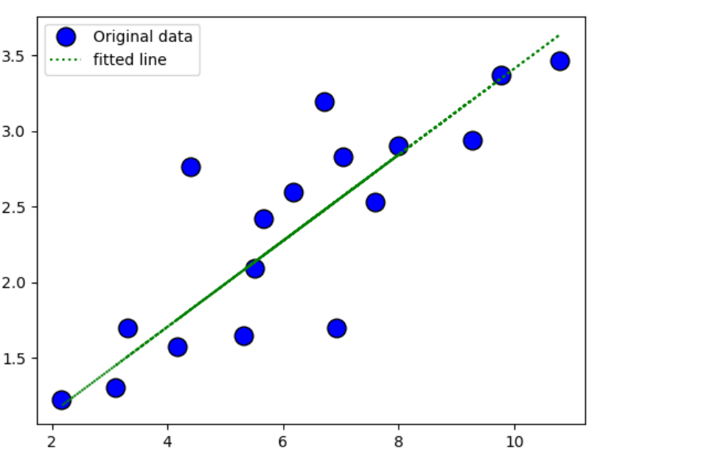

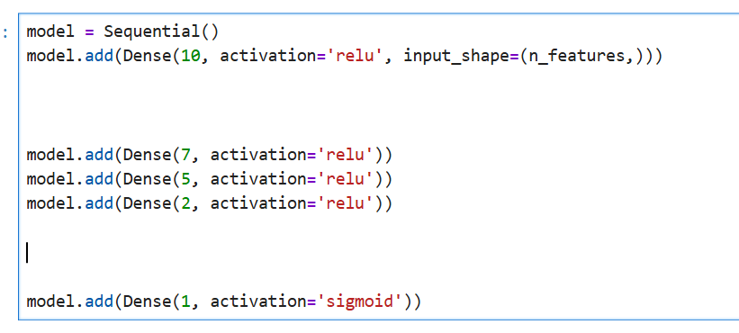
Lab 2

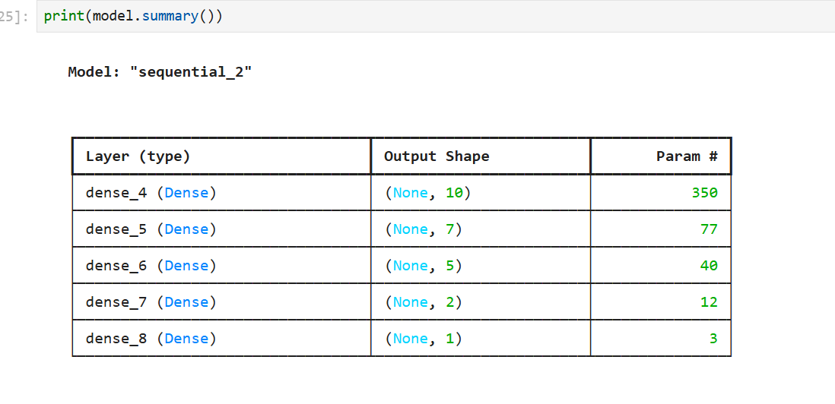

O1 = 0.828
O2 = 0.828

Lab 3
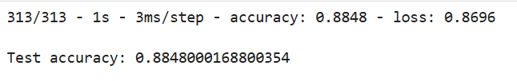
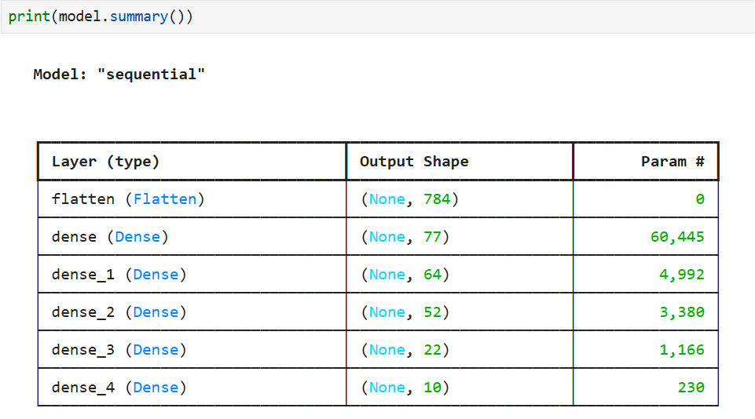
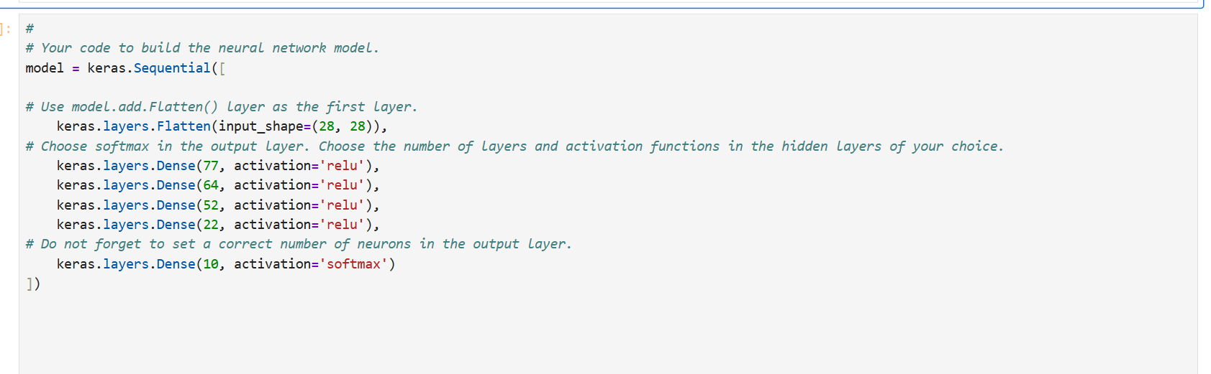

Lab 4

Lab 5

Lab 6

Lab 7

Lab 8

Lab 9

Lab 10

Lab 11

Lab 12

