LAB Logbook

Lab 1
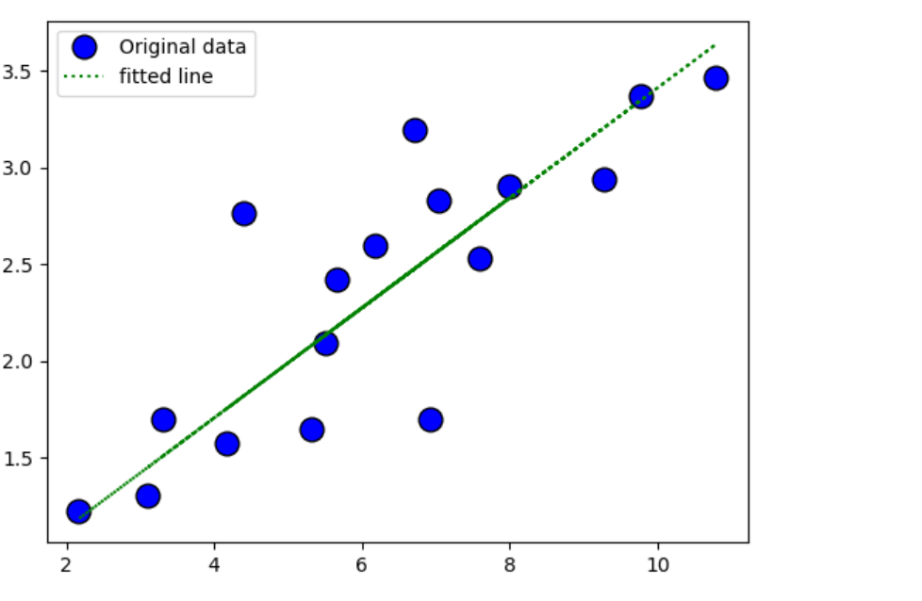

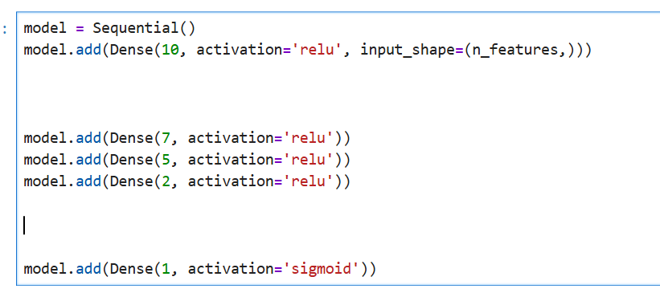
Lab 2

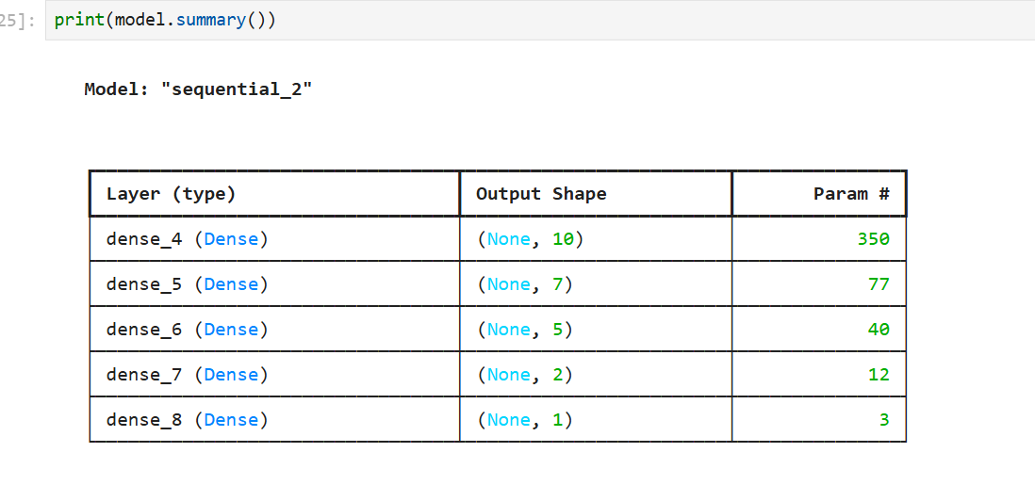

O1 = 0.828
O2 = 0.828

Lab 3
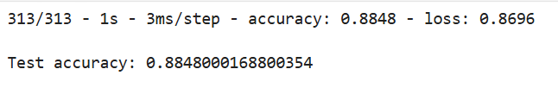
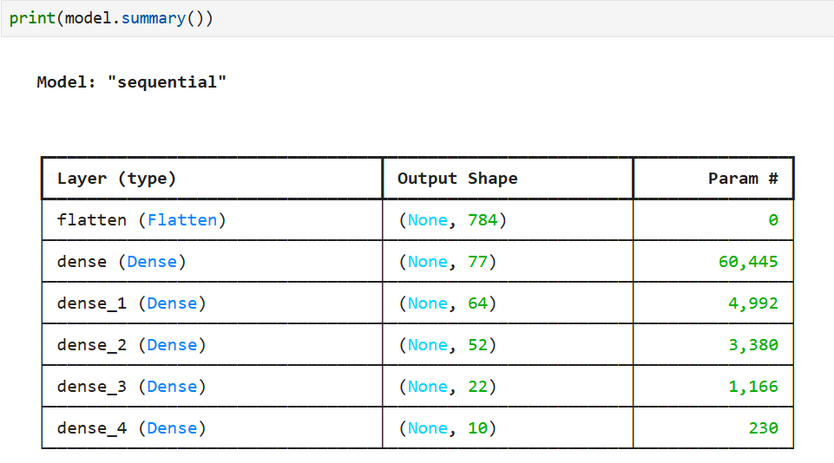
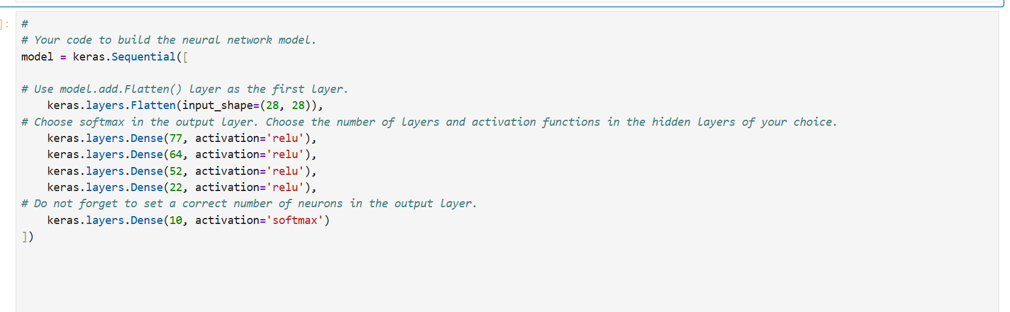

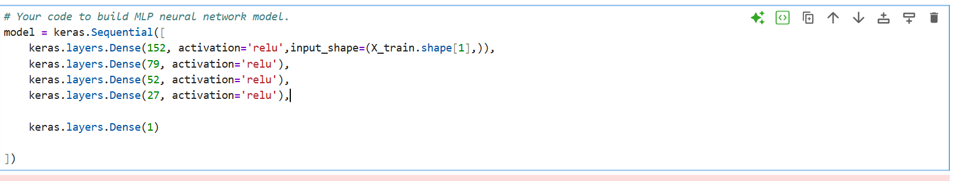
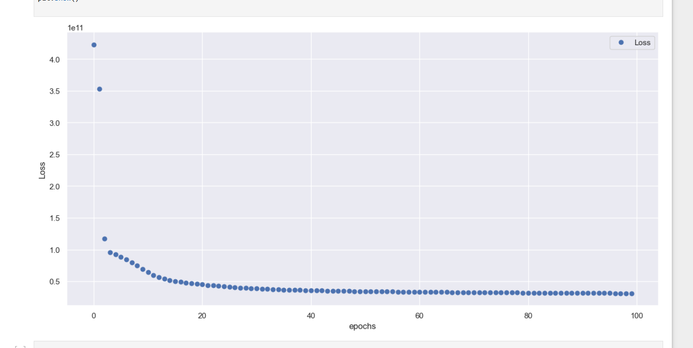
Lab 4
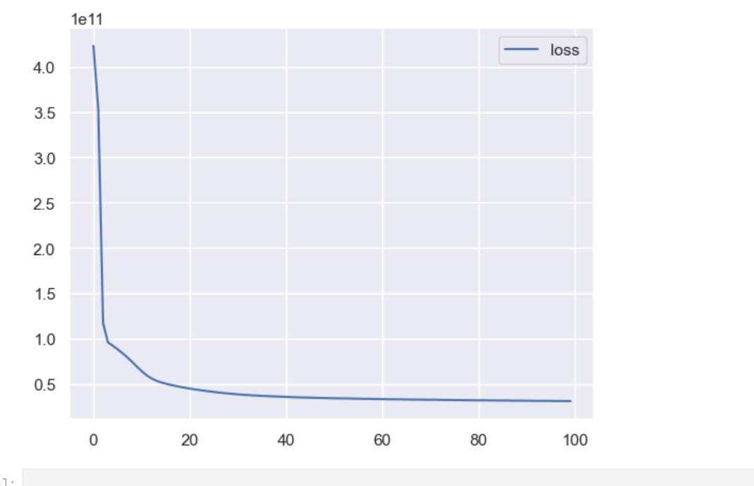
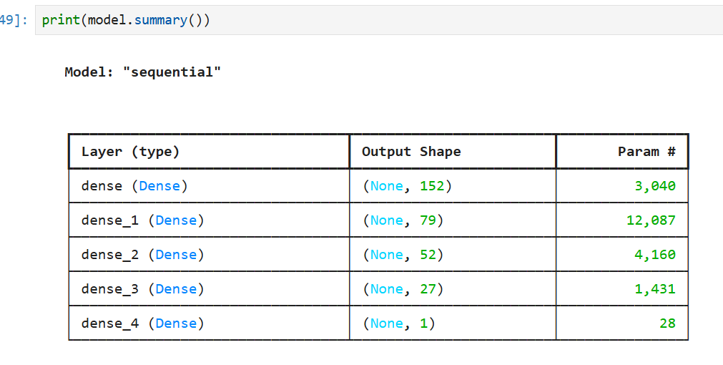
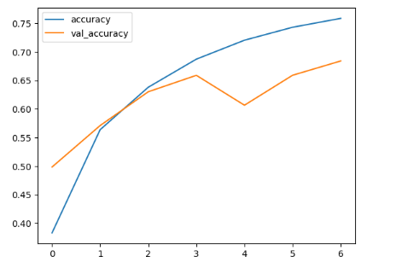
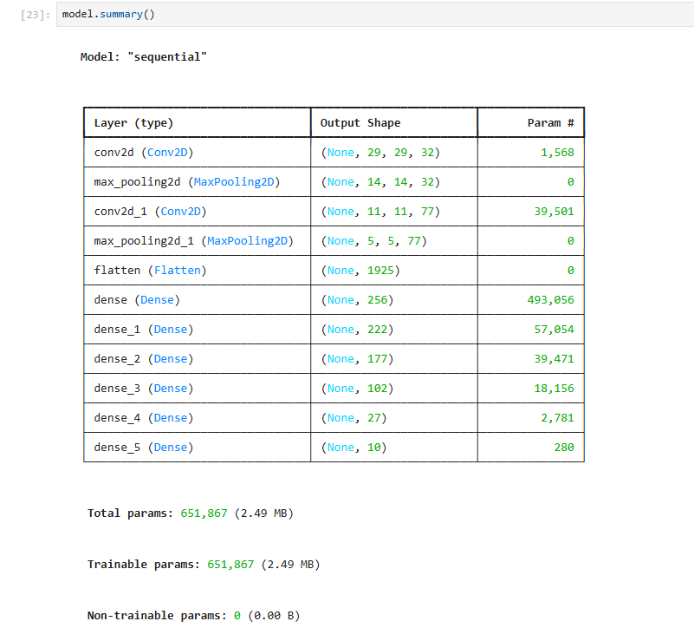
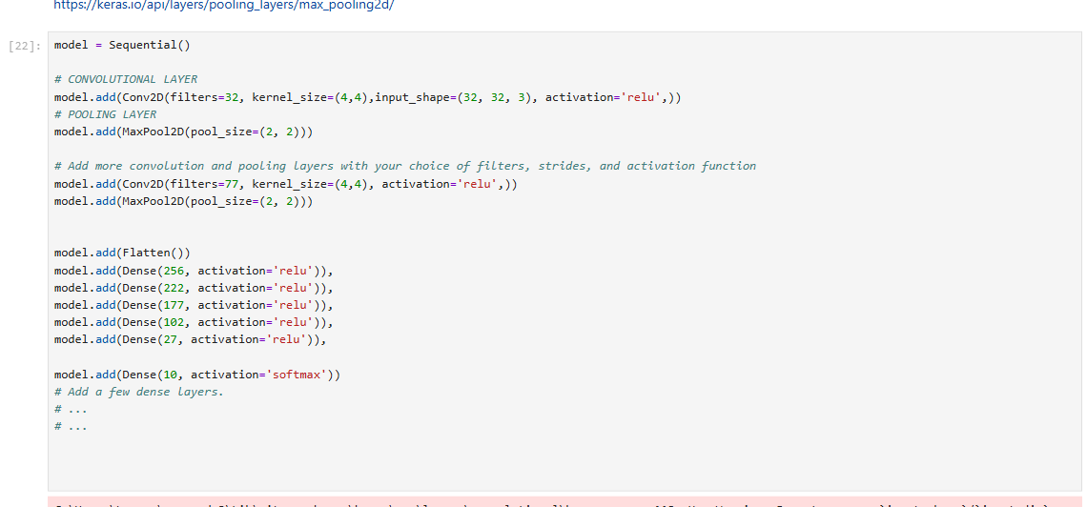
Lab 5
OVER FITTING IN GRAPH 01:
AT 3
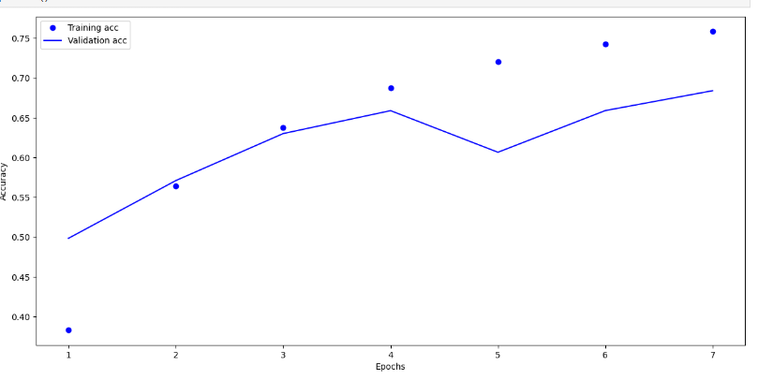
OVER FITTING IN GRAPH 02:
AT 4
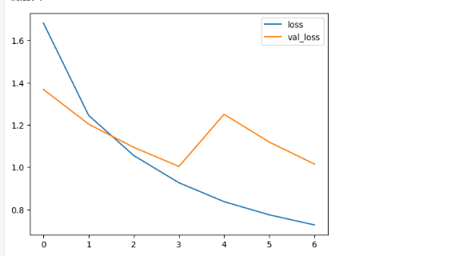

OVER FITTING IN GRAPH 03:
AT 3

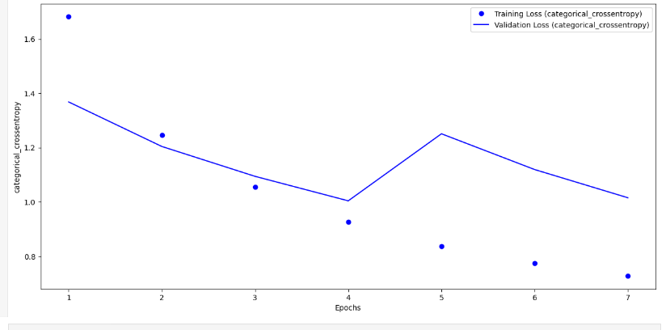
OVER FITTING IN GRAPH 04:
AT 4
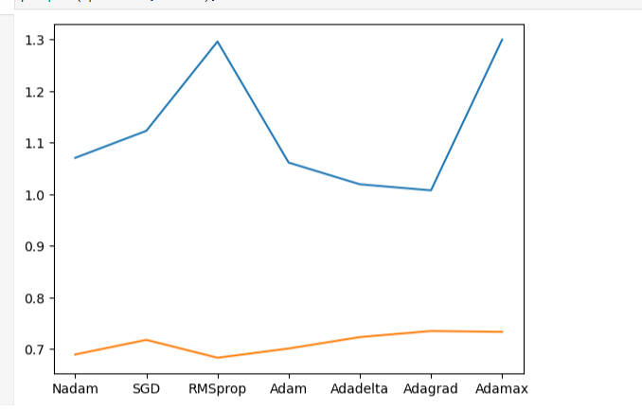
OVER FITTING IN GRAPH 05:
AT RMS prop and adamax

Lab 6

Lab 7

Lab 8

Lab 9

Lab 10

Lab 11

Lab 12

