**Business Requirement Document**

Document Date: 23 August, 2023

**Prepared by** Amjad Siddiqui

**Email:** amjsiddiqui@eand.com

Version Control:

|  |  |  |  |
| --- | --- | --- | --- |
| **Name** | **Date** | **Version** | **Notes** |
| BRD | 26 September 2023 | 1.0 | Rate Plan Report |
|  |  |  |  |
|  |  |  |  |
|  |  |  |  |
|  |  |  |  |
|  |  |  |  |

# Background/ Overview:

# To eliminate the manual interventions and decrease the time taken by manually waiting for the rate plan report, the process is designed to move from manual to automated with support of RPA

# Business Objectives:

We request to enable this implementation letter automation to enhance the productivity thus by removing the manual interventions and timely implementation letters shared with the regulatory team.

1. **Process Schedule Details:**

The process is to be executed when the user sends email***.***

# AS IS process description

**Step 1:**

Check the inbox if a mail is received from: ***Amjad Siddiqui*** [***amjsiddiqui@eand.com***](mailto:amjsiddiqui@eand.com)with a subject “***Report for Etisalat Device Care Plans***” and will have a comma separated list of codes which you will need to get. 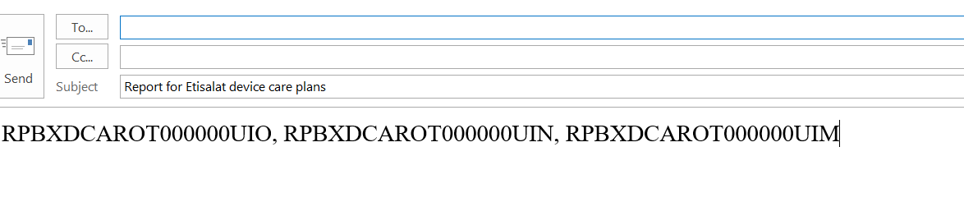

**Step 2:**

Now you need to run the query on the BCRM DB to get the report. The SQL query is attached here:  


Replace below line with actual **RATE_PLAN_CODE** mentioned in the email body and then run the query to share the results:

**WHERE p.ProductNumber IN ('MKTGS1001BIZULTIMATE')**

You will have to do it for each code and get the results for each as a separate excel Sheets. Name the Sheet with their codes and create a single excel file.

There is also a possibility that some Codes won’t fetch results. For those refer to step 3.

**Step 3:**

Finally reply all to the initial email with the file attached.   
Also mention the Rate plans in the email body for which the query fetched no results.