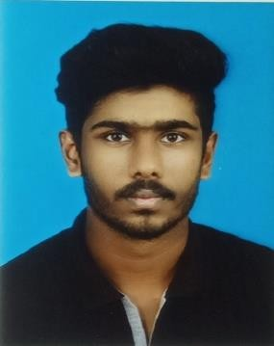Salman V S

Vadakkedam house Athirampuzha P.O Kottayam [salmanvs2001@gmail.com](mailto:salmanvs2001@gmail.com)

8129987291

[www.linkedin.com/in/salman-sameer](http://www.linkedin.com/in/salman-sameer)

# Objective

To succeed in an environment of growth and excellence and earn a job which provide me job satisfaction and self- development and help me achieve personal as well as organizational goals.

# Skills & Abilities

|  |  |  |  |
| --- | --- | --- | --- |
| **Qualification** | **Institution/University** | **Year of Passing** | **Mark in**  **Percentage** |
| BSc. Mathematics | **KURIAKOSE ELIAS COLLEGE, MANNANAM**  AT, Kottayam MG University | 2022 | 80 |
| Plus Two | **St.Aloysius H.S.S Athirampuzha** | 2019 | 80 |
| SSLC | **St.Aloysius H.S.S Athirampuzha** | 2017 | 95 |

Academic project and training

* Main Project : Online Stadium Seat Booking System in Java
* 3 month training on Java Full Stack Web Application Development at Spectrum Softtech Solutions, Mahakavi G Rd, Ernakulum South, Kochi, Kerala 682011.

# Additional skills

* Programming Languages known: Java, SQL, HTML5, CSS, MySQL and Ajax.
* Frameworks Known: Bootstrap, Angular, Hibernate, Spring
* Scripting Languages known: JavaScript, JSON, jQuery, XML.
* Operating Systems: Microsoft Windows, Ubuntu.
* Computer Proficiency: MS Office, LibreOffice.

# Skills

* Good learner
* Hard & smart working

# Declaration

I, Salman V S Sinclair, hereby declare that all the information given above are true and correct to the best of my knowledge and belief.

Date :

Place : Kottayam S alman V S