Descriptive Analysis 1

Project Description: 1

Project Title: 1

Objective: 1

Dataset: 1

Methodology: 1

Tools and Technologies: 2

Deliverables: 2

AWS Deployment and Service Models 2

AWS Cost Analysis 2

AWS Global infrastructure 3

AWS IAM 3

AWS VPC 3

AWS Lambda 3

AWS EBS 3

# Descriptive Analysis

*Please use the following template to explain your weekly activities 2,3,4 and add it to your portfolio*

Project Description: Descriptive Analysis of Customer Purchase Patterns

Project Title: Understanding Customer Purchase Patterns at XYZ Retail

Objective: The primary goal of this project is to conduct a descriptive analysis of customer purchase data at XYZ Retail. Through this analysis, we aim to summarize key characteristics of customer purchases, identify trends, and generate insights that can inform marketing strategies and inventory management.

Dataset: The dataset includes transactional data from XYZ Retail over the past year, containing the following key features:

* Transaction ID: Unique identifier for each purchase
* Customer ID: Identification number for each customer
* Purchase Date: Date and time of the transaction
* Product Category: Category of the purchased product (e.g., electronics, clothing, groceries)
* Quantity: Number of items purchased
* Price: Total price of the transaction
* Payment Method: Method used for payment (e.g., credit card, cash, digital payment)
* Location: Store location where the purchase was made

## Methodology:

1. Data Collection and Preparation:
   * Load the dataset using data analysis tools (e.g., Python, Excel).
   * Perform data cleaning to address missing values, correct data types, and remove duplicates.
2. Descriptive Statistics:
   * Calculate summary statistics for key variables, including:
     + Total sales and average transaction value
     + Number of transactions per month
     + Distribution of purchases by product category
     + Average quantity purchased per transaction
3. Data Visualization:
   * Create visual representations to illustrate findings:
     + Time series graphs showing sales trends over the year.
     + Bar charts displaying the most popular product categories.
     + Pie charts representing the share of different payment methods.
     + Heatmaps of sales by location and time of day.
4. Customer Segmentation:
   * Segment customers based on their purchasing behavior (e.g., high-frequency vs. low-frequency buyers).
   * Analyze the purchasing patterns of different segments.
5. Insights and Findings:
   * Summarize the insights derived from the analysis, highlighting:
     + Peak shopping periods (e.g., holidays, weekends)
     + Trends in product category sales over time
     + Preferences in payment methods across customer segments
6. Recommendations:
   * Provide actionable recommendations based on the findings to inform inventory management, targeted marketing campaigns, and promotional strategies.

## Tools and Technologies:

* Python (Pandas, Matplotlib, Seaborn) or Excel for data analysis
* Data visualization tools (Tableau or Power BI) for creating dashboards

## Deliverables:

* A detailed report summarizing the methods, findings, and recommendations.
* Visualizations and dashboards to present key insights clearly.
* A presentation for stakeholders to communicate important findings and suggestions for future action.

This descriptive analysis project aims to provide a comprehensive understanding of customer purchase behaviors, enabling XYZ Retail to optimize its operations and enhance customer satisfaction.

# Cloud Computing Concepts Overview

The present diagram illustrates the visual representation of main essence of the ideas, associated with the topic of cloud computing, in four primary areas, including the introduction to the world of cloud computing, its benefits, introduction of the Amazon Web Service, and Amazon Web Service Cloud Adoption Framework (CAF). Every section contains lists of the associated terms or topics, and the learners can grasp how simple principles of clouds can be the foundations of more complex AWS-specific strategies. The architecture emphasizes the rational sequence of cloud training, beginning with the basic concepts, and finishing with a tactic cloud transfers based on AWS (Weinman, 2012, p. 23).

# Case Study #1: Traditional vs Cloud Computing Models

This outline will look at a side by side comparison of two deployment models such as the traditional computing model and the cloud computing model. Conventionally, an organization is utilizing its own physical data centre, like the UCW Data Centre, in Vancouver, by which the complete infrastructure, location and environment setup is conducted manually and physically on-site. Conversely, cloud computing model involves using the global infrastructures of AWS. In this case, the infrastructure is based on launching a cloud account, choosing a geographical location (Virginia), and then installing the working environment of the registrar in this region. This points to the nature of cloud computing that hides physical constraints to effect scalable, location-independent deployment and greatly simplifies the management of infrastructures and facilitates accelerated innovation (Vaquero, Rodero-Merino, & Caceres, 2011, p. 52).

# Case Study #2: Cloud Deployment Models

This is used to compare the various deployment models of cloud and their approach to location, access and privacy of data. A Private Cloud has a storage location on-premise and full organizational possession of the datasets where privacy and internal access are highly limited. On the contrary, the Public Cloud stores the information on a provider such as AWS infrastructure, which has a broader access with moderate levels of privacy, governed by provider-level policies. Hybrid Cloud is a mix of these two strategies, which enables the organizations to separate on-prem and cloud by positioning that organizations can provide partial access and customizable levels of privacy according to the needs of workloads. Finally, the Multi Cloud model transfers information to several cloud providers and allows complex access policies and various privacy implementations depending on the selected vendors. This is flexibility enables organizations to deform their cloud strategy to the requirements of the operations, security as well as compliance requirements (Armbrust et al., 2010, p. 54).

# Case Study #3: Cloud Service Models (IaaS, PaaS, SaaS)

This case study gives an outline of the three main types of cloud service: Infrastructure as a Service (IaaS), Platform as a Service (PaaS) and Software as a Service (SaaS) demonstrating how roles and duties are divided among the service provider (AWS) and the customer (Registrar operation team). The cloud provider in IaaS delivers the virtualized computer infrastructure including CPU, storage, and network and leaves everything else to the customer which would include the platform and software. With PaaS, the provider is concentrating on the underlying infrastructure and platform, whereas the customer is only worried about deployment and management of applications and data. Lastly, in SaaS, the provider looks after the whole stack which means the application, whereas the customer merely utilizes the software. The more you go to SaaS the less control and responsibility you have, and that also affects the location, access and controls over the specific dataset (Rountree & Castrillo, 2013, p. 17).

# Concepts: AWS Billing, Pricing, and Support Overview

In this diagram, there are five main conceptual areas regarding AWS billing, pricing, and support. In the initial segment, the author informs the reader about the pricing model of AWS and focuses on a pay-as-you-go approach and other cost-saving models, including reservations, tiered usage, and custom pricing. The second part is devoted to Total Cost of Ownership (TCO), the comparison between the cloud and on-premises infrastructure and how to use the AWS Pricing Calculator to evaluate costs. Part three plunges into AWS Organizations and explains the organization units, access, security, and feature advantages. The fourth part describes how to manage cost, such as dashboard, billing tools, forecasting usage, and reporting. Finally, the last section, section five, about AWS technical support, is presented, overviews support plans, and case severity system according to which the response time operates. The combination of these sections can serve as a basis of mastering AWS billing and support practices.

# AWS Global infrastructure

AWS has an international system that assists the users in enjoying the services in various parts of the globe. It has numerous data centers that are located in different regions and availability zones. This arrangement assists the users to receive quick and quality service. It also facilitates the storage and insertion of data on a safe fast manner.

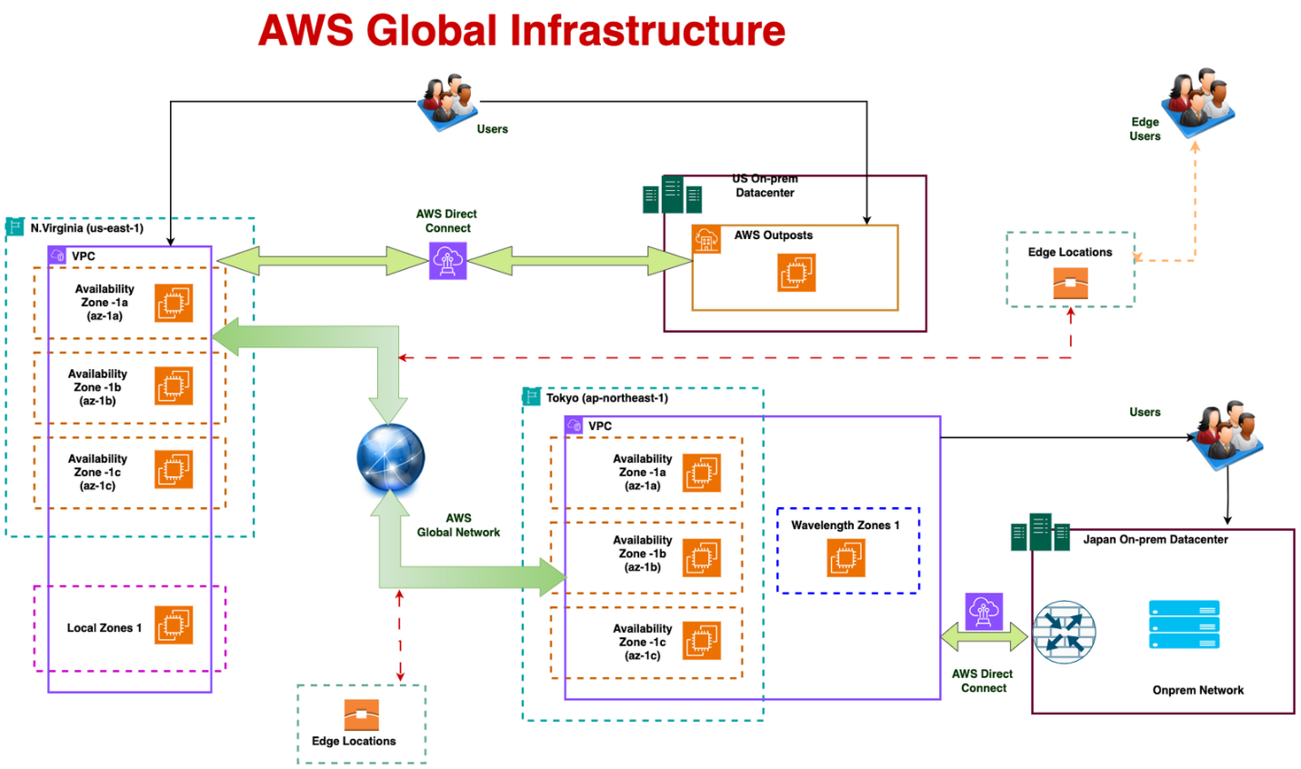

# AWS IAM

Containing the control of who may access the AWS resources, AWS IAM is a service. It allows the user to generate accounts and accord them only the required permissions. This assists in maintaining safety of the system. Using IAM, the user can permit or deny the actions on the individual or a group of people.

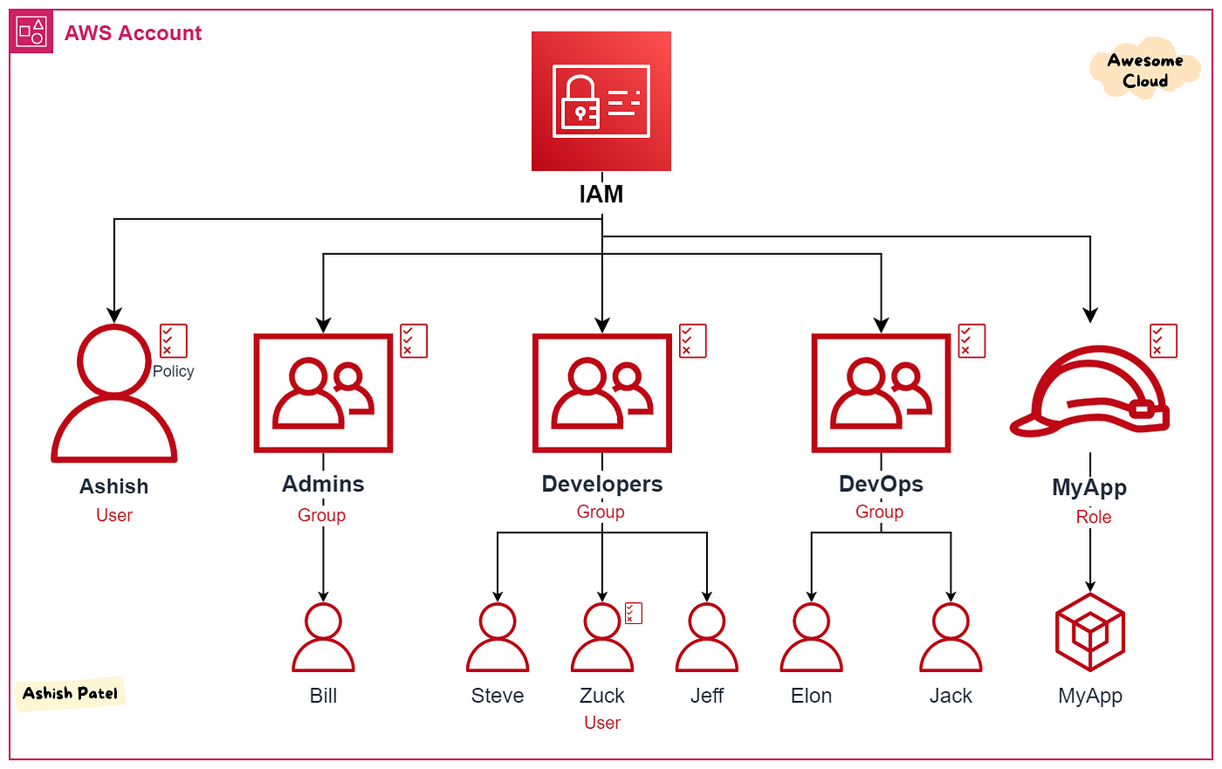

# AWS VPC

AWS VPC can be considered a personal cloud network. It allows user to have complete control to the network settings including IP address and traffic rules. Using VPC, the user can manage and protect his data and control the flow of data between the cloud and on-premise.

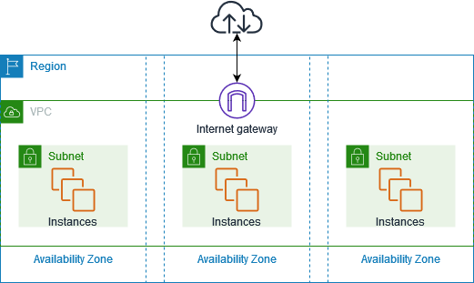

# AWS Lambda

AWS Lambda comprises a service whereby code is executed, without using a server. The user creates the code and defines when he/she wants it to be executed. Everything else is covered by AWS then. It is practical in that one can only pay to run the program and not acquire an entire server.

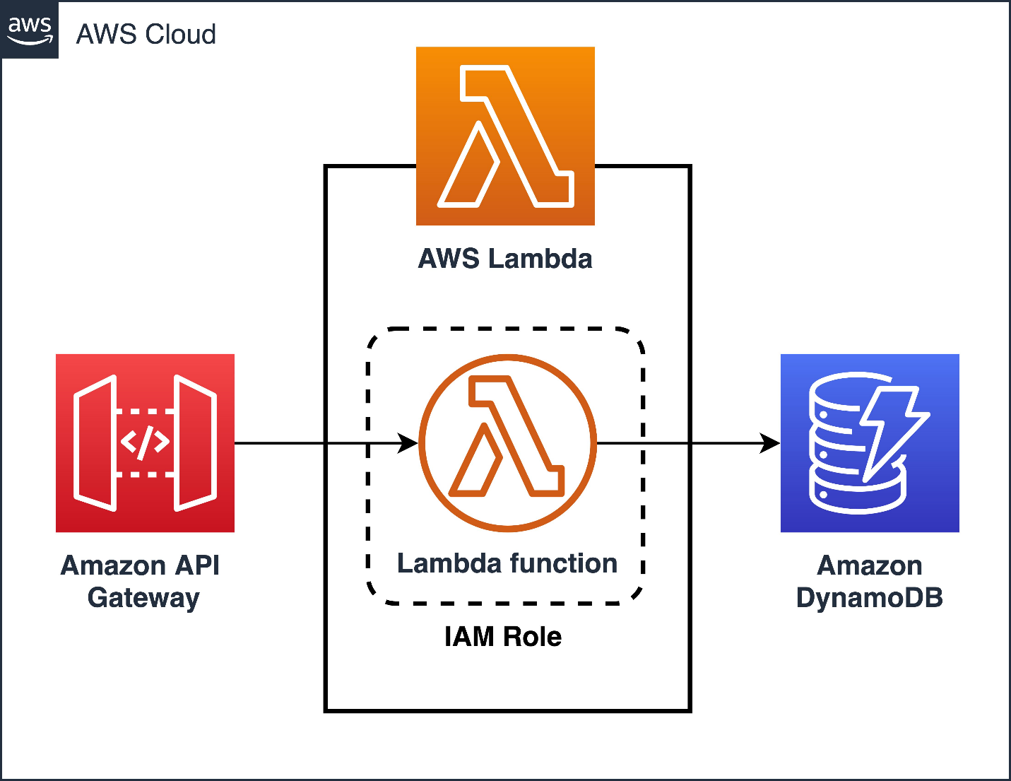

# AWS EBS

AWS EBS is a block storage facility compatible with EC2 virtual computer. It provides speedy and consistent storage of information that requires long term storage. EBS may be employed in storage of files, execution of databases, or y storage of backup information.

