**Relational Database Service (RDS)**

1. Go to AWS dashboard and select VPC.
2. Click on create VPC.

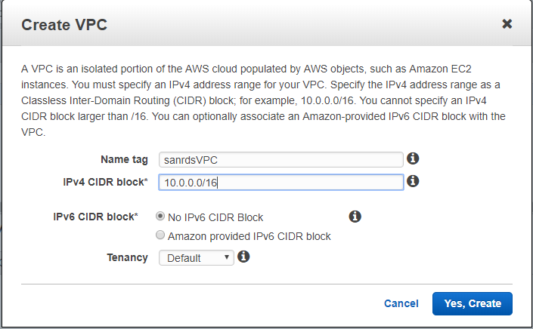

1. Select Subnet option and click on crate subnet.(two subnets)

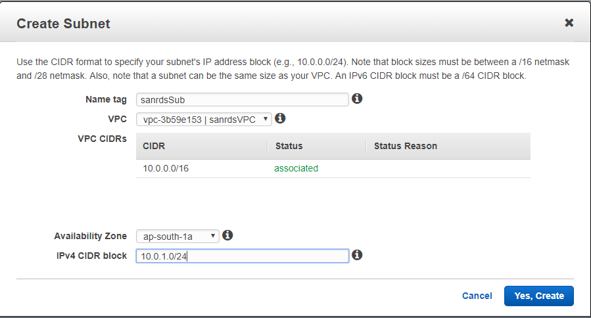

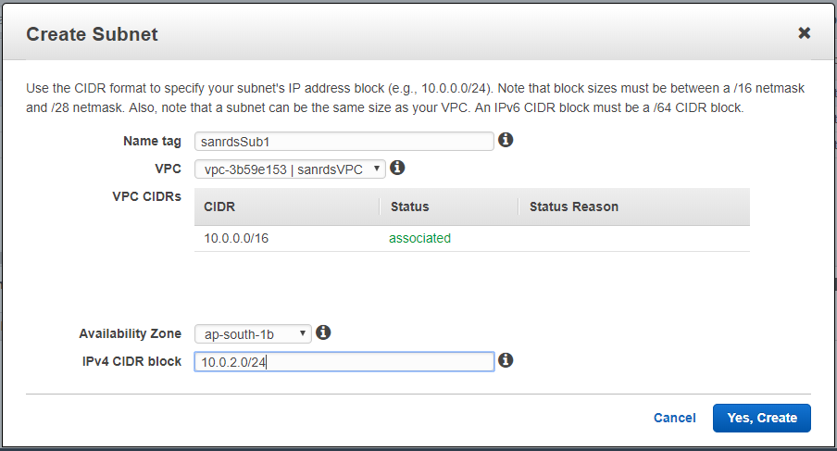

1. Select Internet Gateway option and click on Create Internet gateway tab.

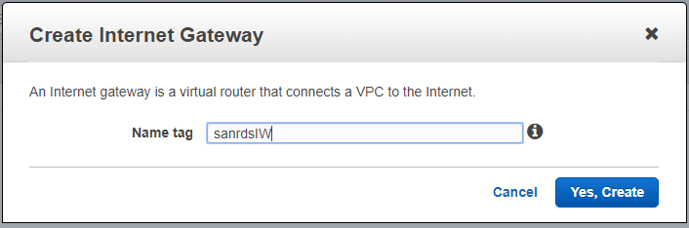

1. Click on Attach to VPC tab.

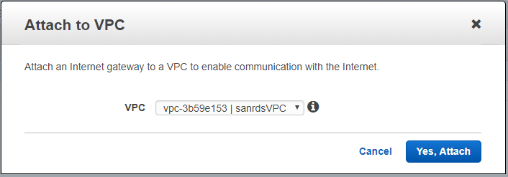

1. Add VPC and click on Yes Attach tab.
2. Select Rout tables option and click on Create rout table tab.

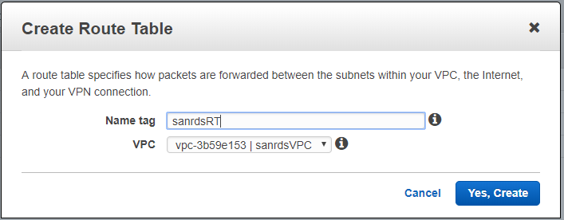

1. Select Routes tab and click on Edit.

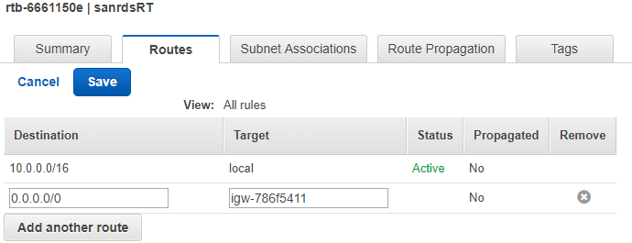

1. Select add another route e.g 0.0.0.0/0 add target and Click on save tab.
2. Select Subnet association.

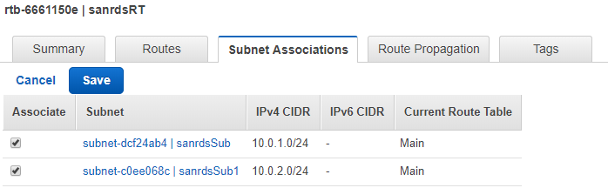

1. Select subnets and click on Save.
2. Select EC2 On AWS dashboard and Select Instance.
3. Configure Instance details.

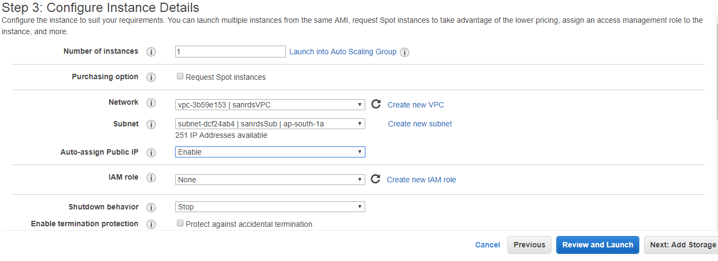

1. Add Network i.e VPC, add subnet, Auto assign IP as Enable.
2. Review and launch the Instance.
3. Connect to instance using putty.
4. Add My Sql/Aurora to security group.
5. Install my sql using below commands.

* wget <https://dev.mysql.com/get/mysql57-community-release-el7-9.noarch.rpm>
* sudo rpm -ivh mysql57-community-release-el7-9.noarch.rpm
* sudo yum install mysql-server
* sudo systemctl start mysqld OR service mysqld start

1. Go to AWS console and select Relational Database Service.
2. Click on Get Started Now tab.
3. Select My Sql engine and click on Next tab.



1. Specify DB Details.

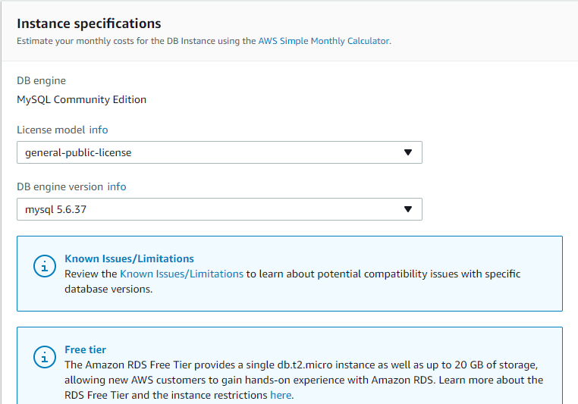

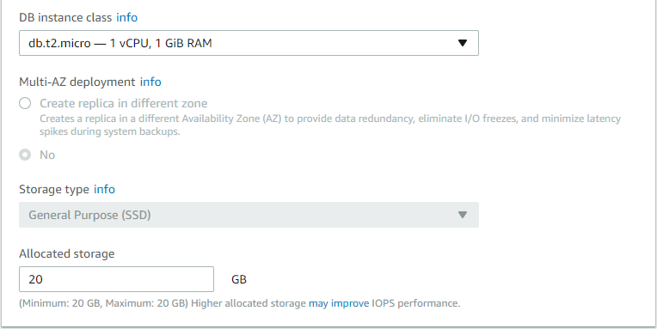

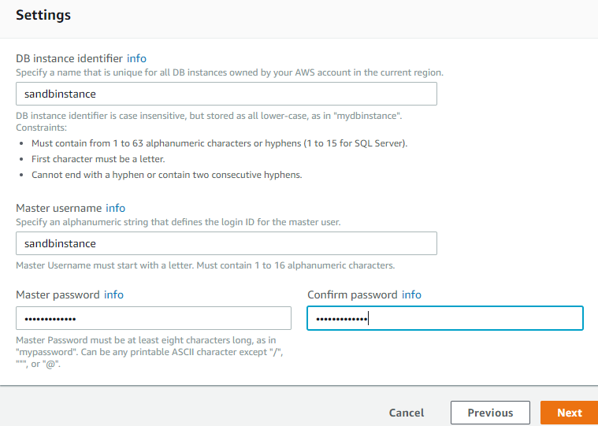

1. Click on Next tab.
2. Configure Advanced Settings.

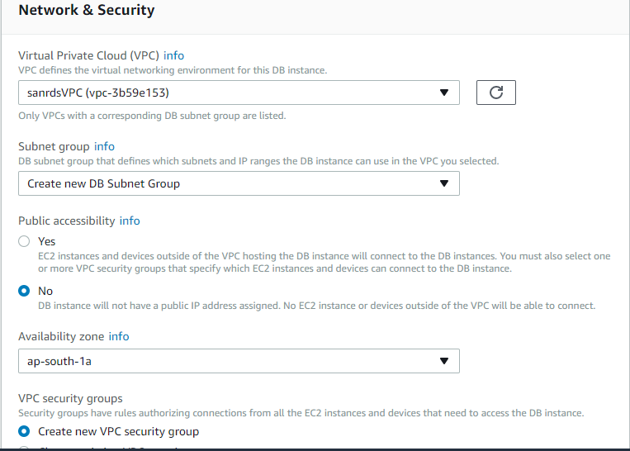

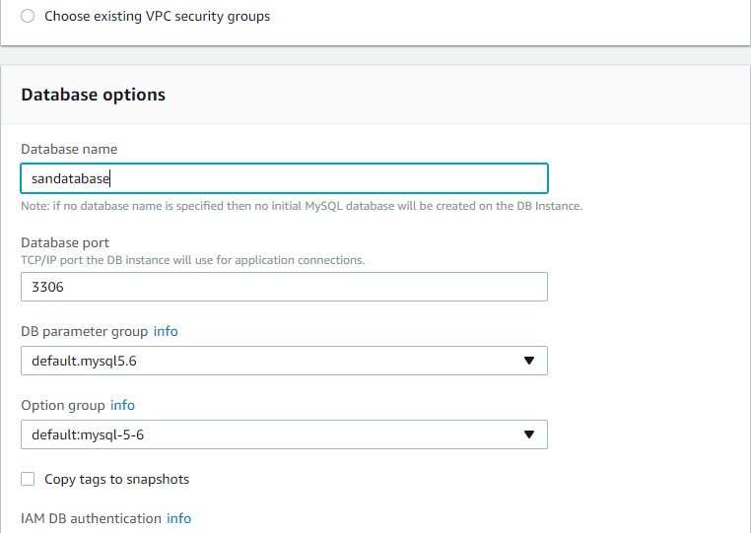

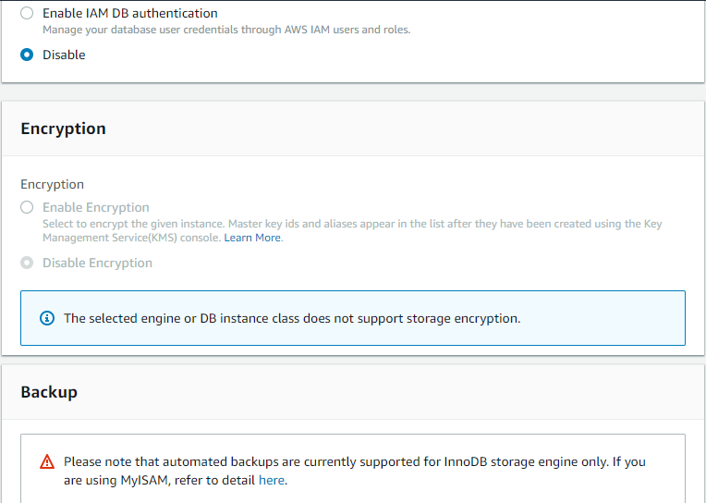

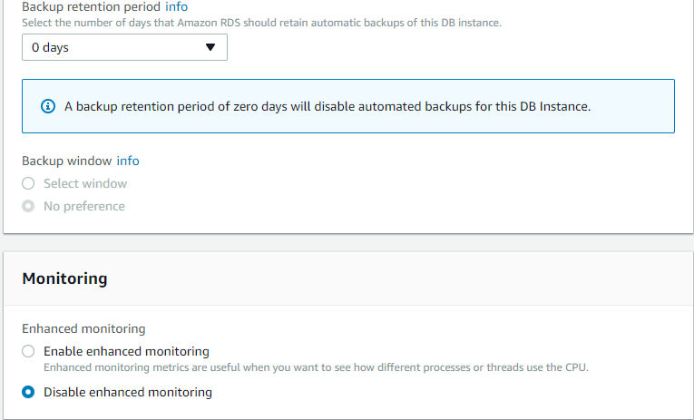

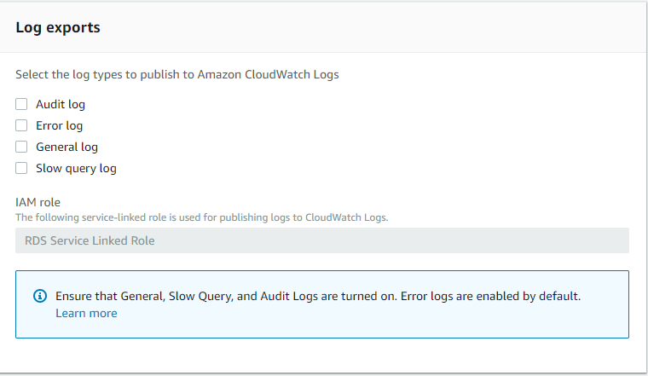

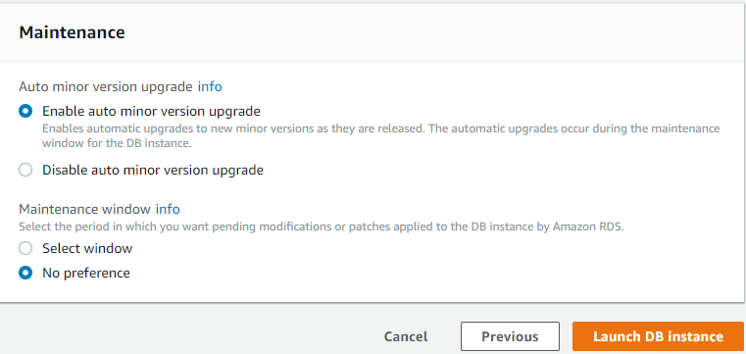

1. Click on Launch DB Instance tab.
2. Click on DB Instance and edit the security group and save.

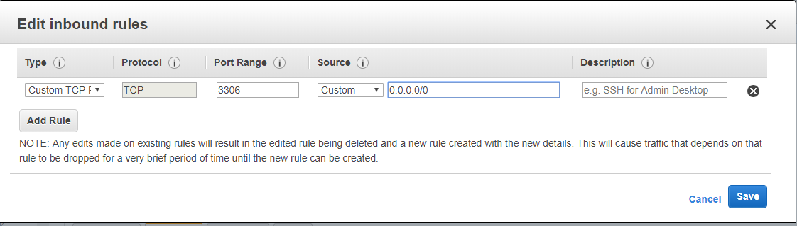

1. Connect to Ec2 instance (Redhat) using putty.
2. Connect to Mysql server using below command.

Mysql –h (**Endpoint name**) –P (**port number**) –u (**db user name**) –p(**password**)

E.g :- Mysql –h **sandbinstance.c5i0ngv7m1qe.ap-south-1.rds.amazonaws.com**  –P **3306** –u **sandbinstance** –p**sandbinstance**